Ashwin Ahuja

Tech Support for the Elderly

AQA A Level computer science coursework 2017



1 - Analysis 4

1.1 - Background to and identification of problem 4

1.1.1 - Elderly and Technology 4

1.1.2 - The Millennials 5

1.1.3 – Conclusion 6

1.2 – Description of current solutions 6

1.2.1 – Online forums 6

1.2.2 - Professional Technical Support 7

1.2.3 – Remote Technical Support 8

1.2.4 – Conclusion 8

1.3 - Identifying prospective end user(s) 8

1.3.1 – Elderly 8

1.3.2 – Teenagers 9

1.4 - Identifying user priorities (interviews) 9

1.4.1 - Gill Wilson 9

1.4.2 – Philip Fernandes 11

1.5 – Android vs iOS 13

1.6 – Phones vs Tablets 14

1.7 – Payment of helpers 14

1.8 – Acceptable limitations 15

1.9 – SMS System 15

1.10 - Objectives for the proposed system 15

1.10.1 - Elderly System 15

1.10.2 - Teenagers’ System 16

1.10.3 - General 17

1.11 – Explanations for objectives 17

2 – Design 20

2.0 - Overview of entire system 20

2.1 - Introduction 20

2.2 - Data 21

2.2.1 - Storing Data 21

2.2.2 - Communications with applications 29

2.3 – WebAPI 29

2.3.1 - General Structure of .NET Core API 30

2.3.2 - Communicating with JSON 30

2.3.3 - Communicating with the SMS Server 31

2.3.4 - Functions 31

2.3.5 - Securing data 40

2.3.6 - Verifying data entry 41

2.4 - Android App 42

2.4.1 - Important Features 42

2.4.2 - Helpers 43

2.4.3 - Elderly 56

2.5 – SMS Server System 73

2.6 – Testing Strategy 76

3 – Implementation 79

4 – Testing 80

4.1 – Test Series 1 80

4.2 – Test Series 2 85

4.3 – Test Series 3 86

4.4 – Test Series 4 88

4.12 and 4.17 90

5 – Evaluation 93

5.1 – User Feedback 96

5.1.1 – Mrs Wilson (AgeUK) 96

5.1.2 – Phil Fernandes 97

5.2 – Analysis 98

5.2.1 – Learnability 98

5.2.2 – Latency 98

5.2.3 – Improvements 99

5.2.4 – Extensions 99

Appendices 100

Appendix A – Web API Code 100

Backend 100

Types 101

Controllers 132

Main Files 161

Appendix B – Android App Code 171

Activities 171

Resource 239

Backend 262

Types 263

Root Folder 279

Appendix C – SMS Server Code 283

Appendix D – Test Data and Expected Results 285

Test Series 1 285

Test Series 2 440

Test Series 3 444

Test Series 4 487

Appendix E – User Manual for Elderly 519

Appendix F – User Manual for Helpers 519

Appendix G – Summary Marking Criteria 519

Appendix H – Bibliography 519

Appendix I – Table of Figures 519

# 1 - Analysis

## 1.1 - Background to and identification of problem

### 1.1.1 - Elderly and Technology

Today, the world is getting more connected by the internet, as people become reliant on it. For the first time, over 50% of people in the world (and over 80% of the western world) are connected by a single network. Ever since the CEO of IBM stated that the market for personal computers as around 5, people have attempted to prove him wrong with over 350,000 sold every year today. And alongside the rise of personal computers, mobiles and tablets are also continuing to expand, reaching an even greater group of people. And yet, the rise of the computer has left a generation behind. Elderly people today are termed the ‘generation that tech forgot’, living through a period of great technological advance, but ostracizes and isolated by it.

Figure 1: Internet use by age group, 2000 – 2012



Source:

As you can see from the graph, there is a stark difference between the number of people between the ages of 50 and 64 using the internet as opposed to the number above the age of 65. Yet, that number has increased vastly between 2000 and 2012, both as the demographic moves to include those who were once younger and as the technology became more wide-stream and the elderly attempt to use technology.

Yet, despite the changes in technology, only half the population over 65 use the internet. And this is despite all the major benefits that the internet can have for the elderly, from using Video Messaging services such as Skype to connect with relatives to using online diagnosis systems to help to diagnose any medical issues they may have. Yet, this is clearly not for lack of trying. Over 70% of the elderly, according to a YouGov poll, want to use technology and the internet. In fact, talking to a group of my elderly neighbours, one said ‘most of my friends and I do want to learn how to use technology but it’s very difficult’. Throughout my research, there were clearly two parts of the problem for allowing the elderly to use the internet, the first being teaching and the second being support.

For the elderly and the internet, the first method appears to be well covered, with hundreds of organisations teaching the elderly how to use the internet, having classes in libraries and universities. In fact, according to a recent survey, over 30% of those over the age of 70 are in some form of technology class. And according to most, these are relatively successful as the majority of people appear to appreciate them – a recent AgeUK session I attended had members who mentioned that they had gone from knowing nothing to knowing how to communicate with their family in only a few months.

Yet despite these solutions for the first problem, the second appears harder to solve. From methods such as smaller classes to online forums which can answer questions and solve problems which the elderly are having, there appears to be no single solution. How can the elderly receive personalised technical support?

Problems, as any computer scientist, or indeed anyone who has ever used technology has experienced, is simply a part of the problems associated with using technology in this day and age. Yet, young people today have the instinct to understand how the computers can break, from checking that the power wire is plugged in, to going onto the command line and debugging the wireless adapter of the computer. However, to the elderly, when learning has been shown to become more difficult, the process if far more complicated, as they are forced to consult a list of possible problems, looking at all various possibilities, inevitably excluding the actual problem that exists. It was compared to learning a language by an elderly person I spoke to. It is generally hard to learn effectively when you are older, while trivial if learnt as a child.

This is the purpose of technical support companies, who should be able to easily solve all the various problems that the elderly have. Yet, they are expensive, impersonal and often unreliable. Meanwhile, there is a vast array of people who have the requisite skills to solve problems without even realising it, and would be willing to help, yet don’t. In connecting these two groups, one can solve the second part of the problem for the elderly, therefore helping to allow the tremendous power of the internet to the elderly.

### 1.1.2 - The Millennials

Today, technology is engrained in the youth, as we rely upon Snapchat and Facebook Messenger to talk to friends, while using Wikipedia and the online Encyclopaedia Britannica to write essays for school. Through this, the group is highly technologically savvy. In fact, in a paper by Susan Herring of the Indiana University talks of the ‘technological divide’, where the majority of children, by the age of ten, are more technologically savvy than their parents. Meanwhile, by people of previous generations, the millennials are often thought of as the generation that don’t care. They claim that they are the generation that are so addicted to our phones and tablets that we don’t look up and see the problems that are being faced by large portions of society. Yet, the statistics fail to back it up, as more people are getting involved in social activism, more people are volunteering to help those in need, the elderly and infirm.

Yet, there is nothing that is currently harnessing the greatest skill of the youth, that they tend to be technologically savvy. When taking an informal survey of a number of my friends, the vast majority indicated that they had been approached by elderly neighbours asking them to help out with fixing a broken computer or tablet. Moreover, they indicated that the neighbours complained that it was a regular occurrence which could easily be fixed if they had a manner of reaching willing technological savvy people who could easily solve their problem.

Even more importantly, they indicated that they would be willing to help their neighbours. While they indicated that they would probably want to be paid for their services, the conversation I had with friends also indicated a genuine interest in helping their elderly neighbours and society in generally, as this could help to create a closer community.

### 1.1.3 – Conclusion

Today, there is a genuine challenge for the elderly, who are already struggling to learn how to use technology, to find good technical support, as existing systems appear to be expensive or ineffective. Meanwhile, there is a genuine group of people, the teenagers, who have the requisite skills to help, and appear eager to do so. By attempting to connect the two groups of people, one can solve two problems in one go, from the problem of how to get the youth more involved in society, to how to ensure that the elderly get the technical support that they need.

## 1.2 – Description of current solutions

### 1.2.1 – Online forums

One of the primary methods for solving any technological problems, for the elderly and the rest of society alike, is through the use of online forums which claim to provide solutions in easy to understand English, as well as containing solutions to almost every problem that has existed. This immediately throws up a problem, as the elderly need to have access to an internet connection. Additionally, they need a certain competency with the internet to be able to effectively search for and locate solutions to the problems.

Yet, even when they locate online forums, there are a number of problems with the systems. The forums can largely be split into two types – professional and amateur. In the professional forums, the authors of answers are largely professionals, often charge for visiting the site and are often run as a side service for companies which deal mostly with other issues – including professional technical support companies. One example of a ‘professional’ technical support forum is techsupportforum.com – a site where those giving answers are ‘IT professionals’. Yet, these sites are often not comprehensive, only answering a small subset of the possible problems that could occur. In fact, even looking up a basic router not working on techsupportforum yielded a single answer, suggesting that the software setup was incorrect. They failed to suggest simple, and often more likely, problems such as the router not being connected to power or to the telephone connection. Moreover, despite the best efforts of the authors the answers to problems were often complex and hard to follow without prior knowledge of technology – not providing simple enough instructions into how to solve the problem. This problem is even more prevalent in the second form of online forums, where they are largely community run, with answers being provided by people around the world with varying degrees of knowledge. Examples of these sites include r/techsupport (Reddit), StackExchange and even Yahoo Answers. Though they largely cover every possible problem that one might have, they generally fail to provide answers which are easy to understand for the elderly. Instead the answers are generally intended for people with a certain level of technological ability, certainly not elderly people with little experience of using the internet.

### 1.2.2 - Professional Technical Support

Another possible current method of elderly gaining technical support is through professional services offered by many companies both local and global. They offer a much more personal experience than online forums. The person visiting the elderly person can offer a tailored service, ensuring that the problem gets fixed, as well as educating the elderly person how it has been done. Meanwhile, the personal contact ensures that the elderly person is able to ask all the questions they need to ensure that they understand how to fix similar issues in the future. However, there are also a number of drawbacks in this approach. Firstly, since the tech-support is run like a business, the people are incentivised to ensure that there are a number of problems – therefore not sufficiently showing the elderly how they fixed the problem, instead ensuring that they get repeat business if the problem reappears. In fact, talking to a neighbour who had used a Barnes based small tech support company complained that they charged ‘ridiculous’ amounts without actually fixing the problems that my neighbour had. Even for one problem that they did manage to fix, my neighbour claimed that they declined to explain the problem, instead claiming it was too complex and unworthy of explanation.

The issue of cost is an important issue with professional tech support, as they charge vast fees for services which are generally short and not too complex. I gathered information based on call-out fees and hourly rates for ten companies in the UK to show this was widespread.

|  |  |  |  |
| --- | --- | --- | --- |
| Company Name | Location | Call Out Fee | Hourly Rate |
| HTL London | Central London | £100 | £50 |
| IT Guy | West London | £75 | £50 |
| Andrew Tsai Technical Support | North London | £25 | £70 |
| Mitchell Wayne Technologies | Birmingham | £30 | £50 |
| D-Tech-IT | Liverpool | £0 | £50 |
| EverythingTech | Manchester | £60 | £60 |
| Grant McGregor | Edinburgh | £50 | £65 |
| AVERAGE |  | **£49** | **£56** |

Figure 2: Survey of cost of professional technical support around the country

Meanwhile, in order to show the fact that the youth could help to solve this problem, I conducted an informal poll of ten teenagers who said that they would be interested in helping the elderly in my area, and they all suggested no call out fee, with an average hourly fee they would be willing to work for between £10 and £20.

Finally, it is important to state that it is also often challenging to find people in your area as the vast majority of technically qualified people attempt to join jobs in industry and banks as opposed to offering technical support. Even finding eight companies across the country which offer technical support offered a certain challenge.

### 1.2.3 – Remote Technical Support

While remote technical support can be much cheaper than professional technical support, with no call-out fees and with much lower hourly fees as the people can be located in cheaper parts of the world such as India and China, there are a number of flaws with this system. Firstly, this often would be unable to solve some issues, especially those which are associated with hardware rather than with software. Furthermore, the people are often unable to show how they are solving the problem, as they have limited English skills and even if they are able to talk in English, they have little training or experience talking to the elderly, and so are ineffective at communicating the most salient points, instead puzzling their clients.

Another large issue with remote technical support is the problems associated with scammers, who instead of genuinely solving software problems on a computer can instead use the opportunity to install Trojans and other viruses. This would then allow them to have complete access whenever they want, gaining access to everything from people’s accounts as they log onto them on the computer to their webcam. This has led to a number of well-documented cases of identity fraud as the scammers gain enough information to imitate their victims, taking all their money.

### 1.2.4 – Conclusion

Though each of the three current methods of technical support for the elderly have flaws, it is clear that from an ideological perspective the second, professional in-person tech support is by far the best, as the human contact allows the elderly to both learn from the problems as well as have the problems fixed the most effectively. Hence, if it would likely be important to ensure that I mostly inherit from that method, though attempting to fix the problems associated with cost and lack of availability of tech support people.

## 1.3 - Identifying prospective end user(s)

From the initial problem, there are clearly two main groups of end-users who will both determine the objectives of the system which must be produced. Hence, it is important to consider them each in turn.

### 1.3.1 – Elderly

For the elderly part of the system, it was important that the end-user would use technology as well as either be elderly or communicate with the elderly on a daily basis. In the end, I considered the two main possibilities for the main elderly end-user of my product, either a group of my neighbours who I had previously interacted with about the problem or an elderly technology expert. Though by including a group of my neighbours, I could achieve a greater range of opinions than simply one person, the perspective was still largely the same, as people from the same street, attending the same lessons, of a similar age. It was therefore important to seek out a person who had more general experience of the problem who could represent the entire elderly community who were trying to use technology. I therefore contacted a number of charities which give technology lessons to the elderly. I attempted to reach a person who had experience in teaching the elderly, and therefore was aware of the various problems that affected them. In the end, Mrs Gill Wilson, the IT Project Manager of AgeUK Richmond agreed to be the main end-user from the elderly perspective, ensuring that the user experience would be satisfactorily simple for a technologically challenged elderly person to user, while ensuring that it properly solved the problem of tech support for the elderly.

### 1.3.2 – Teenagers

The other aspect of the system is the teenagers part, where they can use the service to get work, solving technological problems of nearby elderly people. Thereby, it would be important that the system worked well for them, as otherwise few teenagers would signup rendering the system useless. In order to gain a teenager’s perspective, I interviewed Philip Fernandes, a technologically savvy eighteen year old at St Paul’s School who would be interested in using my system to help those around him.

## 1.4 - Identifying user priorities (interviews)

### 1.4.1 - Gill Wilson

**What are some common problems that the elderly face when using technology?**

A number of the most common problems are problems which would otherwise be obvious to those who had grown up with technology, for example failing to plug in one wire or not double clicking on a shortcut to open the application.

**How do most of the elderly currently get tech support?**

While we encourage the people we teach to attempt to find solutions to their problems online, we find that a number of them are forced to seek professional tech support as the online forums are difficult or impossible to understand or they require a certain amount of knowledge to even access.

**How effective is the professional tech support?**

From talking to some of the people I have taught about their experiences in using tech support that they have got from flyers and posters they see around, they have had very mixed experiences, with some finding that they are very good. Some talk about how they are very attentive, help them solve their problem while teaching them how the problem arose and how to detect and fix it in the future. However, others complain of particularly poor tech support, where they charge exorbitant amounts to spend a long time and not even fix the problem that they were asked to fix.

However, a general problem that I find throughout talking to people is the relative difficulty of getting tech support. Unless they receive a flyer, they are forced to ask around and attempt to find people who can help. In fact, they often are forced to rely upon asking family or neighbours who are often busy or unable to help.

**Would the elderly be comfortable getting tech support from teenagers?**

I think in many ways the elderly would be more comfortable with teenagers than others, as they often can be the nicest people. I’ve found in talking to teenage volunteers, that they are among the most enthusiastic people to help out. Especially when the amount of money that stand to gain is minimal (or nothing), only those who want to help will actually do so. Even more so, I think they would be rather effective, they’d probably be able to fix the problems as well as a professional, since the problems are generally rather simple.

I think though, that there is also a certain comfort in professionals, where there are specific references and reviews that they have if the person has been recommended by a friend. If you can emulate that with your system, possibly by getting customers to review the teenager who helps them, I think you could reduce this problem.

**What is the best way for the elderly to interact with a technological system? (Mobile app, website, phone call, SMS)**

There’s a growing trend that people aren’t really bothering to learn how to use desktop or laptop computers, instead they are trying to learn how to use a smartphone or tablet. I think that you therefore need to have some mobile interface. Maybe it should just be a website which could be accessed from all devices, but I’d actually recommend mobile apps. They appear to be the easiest for the elderly to use – they have been finding them easier than anything else I’ve seen.

But, I’d also be aware that if people are having technological issues they may not be being able to use their phones or tablets. It might be worthwhile having an SMS system. Maybe they could send an SMS to a phone number and then automatically a person would be set up to be sent to their house. I think SMS is probably the most reliable thing that most elderly people are relatively happy being able to use, so if you can tap into this then that would be very useful.

**For the mobile apps, iOS or Android?**

Ideally, both. However, if you had to pick one, I’d go with Android. From talking to people around the area, while lots of people have iPhones, more have android phones. This is becoming especially more significant as there is a boom in cheap Android smarthphones, and elderly people are purchasing these devices.

Another advantage of Android would be the immediate compatability with Android tablets. I think there’s, counter to what I would expect, mostly android tablets around the elderly. Things like the Hudl and other cheap Android tablets seem to have been especially popular with the elderly and they seem to be really taking to them. That being said, there are a large number of people with iOS devices, so if you could, I would suggest attempting to make a system to work with both.

**What are the major points that you would suggest in creating a user interface for the system?**

I think the most important thing by a long way is to keep it simple. Think, what do they really need. I mean all they actually need is a list of people, how far away they are and their reviews. Minimise how many screens they need to deal with and simplify each screen is as simple as possible. One piece of advice I once received and have always thought valuable is to always ensure that there are only two paths from any given screen. This ensures it is truly simple enough for anyone to be able to use the system.

Take it for granted that they don’t necessarily have the instinct of just trying things so try and make each screen very clear. What should they do to get from one screen to the other?

**With regards to payment, how do you think that the elderly would be most comfortable?**

I know that the teenagers would probably be most comfortable with payment over the internet and going directly to a bank account or something like that, I’d suggest that this would probably not work for the elderly who would anyway be unhappy buying things online, let alone paying some random website.

I’d therefore stick with cash payment, with them paying the teenagers directly. With regards to how much they should get paid, I think the main thing is being is as clear and transparent as possible. I don’t really think the amount particularly matter, as long as it is cheaper than the competition, though this is not really challenging. I might suggest something like 15-20 pounds per hour, or something like that.

### 1.4.2 – Philip Fernandes

**Have you got any experience helping the elderly in your area with technological issues?**

I have a little experience of helping the elderly, mostly just helping my neighbours when their internet wasn’t working. However, I love the fact that your system can help me do it more often – I find that idea very valuable and powerful. I also think that you could potentially have a huge number of people in the teenage group who would be willing to help out, especially if they get paid for their work.

**What are the most important aspects of the system for you?**

I think it’s basically a system to manage all the people that are requesting their help and being able to message them and arrange a time when to work. It might actually be helpful to have a calendar, booking like interface for each person so and elderly person could see when I might be free and request to get support at that point – even if it is that evening. Therefore, being able to have the ability to input when I would be free would be important – as well as other stuff like how far I would be willing to travel.

**Would you prefer a mobile app or a website?**

I think I would prefer the freedom of having both options available – a website would be useful so I could check the status of things even if I don’t have my phone. However, I think a mobile app would be very important. Certain things like messaging people are just more natural on a phone. Also, I carry my phone everywhere, so being able to check on jobs from there would streamline my life.

**iOS or Android?**

Though I think having both an android and iOS app would be useful, I’d say the android app is the most important. Just from my observations, I’ve found that not too many techie people have iPhones in my age group, probably because of the cost.

### 1.4.3 – Elderly neighbours

With regard to the elderly side of the platform, another important part of the research was talking to a number of my elderly neighbours, who would offer another important perspective towards to the problem. As compared to Mrs Wilson, they were more likely to actually use the product, therefore would be able to assess it as a client of the eventual service.

In talking to my elderly neighours, I largely focused on a few main parts: their use of technology, their problems (and any possible solutions they had attempted to find) and the possible solution to the problem of tech support.

**Their use of technology**

The answer to the question of how much technology they used varied from just utilised a mobile phone to comfortably accomplishing complex tasks like video editing on a laptop. The interesting commonality was that they were all the most comfortable with mobile devices, with the majority saying they were most comfortable with their phone, followed by tablets. This was another interesting point of interest – that the majority of the people I talked to owned tablets, whether they be cheap Tesco Hudls or Apple iPads. However, this was in no case as a replacement for smartphones.

I also talked in depth about how they had learnt how to use the technology in question. For the majority of people, they said this was largely taught by members of their family, perhaps supplemented by classes run by charities such as AgeUK. They all seemed less than happy about this: a number of the people I talked to seemed to feel that they were annoying their family and would have preferred to use other means, but often found group classes (the type of class mostly offered by charities) to be highly stressful environments which were not condusive to learning.

**Their experience of technical support**

Only one person had any experience of getting technical support from any source other than family, finding someone from the internet. She however found the experience terrible, saying that she paid vast sums of money for someone to come and flick her router on and off. She felt she had almost been robbed of the money and though the person who came was kind and courteous, she would not use the same service again.

Everyone else however, said that though they hadn’t sought better solutions, the problems of their technology not working was a very common problem, and in fact caused an enormous amount of anxiety. One particularly hyperbolic neighbour said that she was near tears after having spent an entire week trying to figure out how to transfer data from an old phone to a new one. This was an aspect of the problem that I had not considered before – just how large a minor technological problem can play on the mind of the elderly. Therefore, tackling the problem becomes even more important, both for simply fixing the problem and in order to help the mental state of the elderly.

**The possible solution**

Everyone I talked to seemed very enthusiastic about the possibility of an application which could solve the problem of technical support. They were indeed more overjoyed that they would be helped by teenagers, rather than adults. While one might have thought that this was simply because they were cheaper (I know I would), they also loved the idea of being able to talk to young people in their area, and said they would definitely prefer to use a service which used teenagers over one with adults (even if they were the same cost).

I was generally surprised that most of my neighbours were perfectly comfortable with the idea that the system would generally be run over the internet, as they were comfortable with the idea of using their phones. They even mentioned that even if one would struggle because of their phone not working, or issues such as that, it would be possible for the initial appointment to be booked by a friend who could then tell the teenager instead to help their friend. They also loved the idea of an SMS service which could be used instead of the app. One person made the comment that while she probably wouldn’t use it as she would be more comfortable with the application, she could see where others would use it.

I also generally asked my neighbours whether they had any particular advice for how to design my application. The overwhelming comment was that it should be simple. One person commented that she found most applications tried to do far too much, making it just too hard to do something simple. She advised that I attempt to remove as much unnecessary content from the application as possible, instead focusing on the core function – allowing elderly people get technical support from teenagers in their area.

## 1.5 – Android vs iOS

A primary decision in creating the system is considering whether to develop the application specifically for iOS or for Android. Though it could be possible in the future – as the product is rolled out and advertised more specifically, that an iOS application can be created, for now, it has been decided, in conjunction with the discussion with Mrs Wilson to concentrate on an Android application for the elderly.

For the teenagers, the decision was similarly made to focus on Android, after talking to Phil and learning that most of the teenage clients would have Android devices. This is reinforced by research which shows that over 80% of children aged below 21 have Android devices.

It was also considered whether a web interface could be used to ensure that everyone, whether they own iOS, Android or own no mobile device, could be developed. However, it was decided that in fact, this is largely unnecessary as the elderly people would find the internet harder to use than an app for their phone. In fact, Mrs Wilson mentioned that today most people are choosing for their first forays into connected devices being phones or tablets, rather than desktops and laptops, as previously.

With the decision made to target Android, it is also important to consider the compatibility of the application produced. As Mrs Wilson mentioned that many of the devices that the elderly are using tend to be cheap, they are likely to use outdated versions of Android software. Therefore, it is important to ensure that the application can work with old versions of software.



However, it is also important to consider that newer APIs also introduce many important features which would make producing the app simpler. For example, only from Android Ice Cream Sandwich onwards (4.0+) is there inbuilt software to help with REST API requests, which is likely to be an important feature of the application. Since over 97% of Android devices would work on an application designed for Android 4.0+, this would be a good version to set as a minimum compatibility version.

## 1.6 – Phones vs Tablets

Another important decision to be made is whether to design the applications specifically for mobiles or tablets. Though Android would automatically make the application compatible with all screen sizes, if the application were to be specifically designed for tablets, the UI should be designed for this, taking advantage of the larger screen size.

Since, in fact, a large part of the considerations in designing the UI of the application for the elderly is that it is as simple as possible, containing as little information per screen as entirely necessary, this decision is less important. Therefore, since a greater volume of Android phones exist than Android tablets, it would be better to produce an application specifically for Android phones, with a possible route to expansion being to produce a tablet specific application. Specifically, the UI will be designed to fit best for a 4.7” device, the most common screen size of phones sold today (and incidentally the screen size of my phone, therefore ensuring it is easy to test).

## 1.7 – Payment of helpers

Another important aspect to be considered is how the helpers will be paid for their services. Though Phil mentioned how he would be much happier if the payment were to be done through the apps, Mrs Wilson was very clear that this would be less than acceptable for the elderly. Though it might be possible for a system in the future where a local conduit is paid in cash by the elderly and then the helper would get paid over the app, this adds unnecessary complexity and therefore is unnecessary. Throughout the process, the most important point is to ensure that the system is as simple for the elderly person as possible. Therefore, the payment should happen over cash, directly from the elderly person to the helper.

As per Mrs Wilson’s advice, the system should also have a £20 per hour standard rate. Since the people will largely be coming from nearby, they do not need a callout fee and can simply be paid from this hourly rate.

## 1.8 – Acceptable limitations

One important aspect which was ignored for the purposes of the project was the fact that each teenager might have special areas of knowledge, while may not be very competent in others. This was largely because it was largely felt that the project was mostly targeting the trivial problems often faced by the elderly which could be fixed by almost any technology literate teenager, therefore would be unlikely to stretch the skills of the individual. Additionally, reviews could easily cover the specific task that the person did, therefore allowing future elderly people to read that they are competent at that task.

Additionally, the fact that the helper probably has a maximum distance that they would be happy to travel has been omitted for simplicity. Instead, the system will allowa helper could cancel the appointment for any reason, including if they are unwilling to make the long journey. However, the elderly person should be able to see the location of the helper, which would both add a sense of trust, as they would know where they were (and therefore happy that they are not getting scammed) and so they can see how far away the helpers are.

## 1.9 – SMS System

The SMS system, a possible idea mentioned by Mrs Wilson, would allow an entirely separate path by which the helpers could create an appointment with a helper, simply sending a text with information which would allow the system to create an appointment. This would allow elderly people who may not otherwise be able to use the application, in case they are unable to get their devices working for example, they could still get assistance. This is because SMS is much simpler to use and therefore is likely to be understood by the majority of the elderly people, as they may also be using it to keep in contact with others.

To define this, the amount of data required to be sent by the elderly person needs to be considered. There were a few options, from defining the date, time and helper, to simply sending a text with any content and then the next available appointment would be created. While the former requires too much information, as the elderly person must already know who they want, the latter may be too simple, as the elderly person may not be free at that exact time.

Therefore, a compromise was created, where the SMS system could work off a date and time. If no date is defined, it would default to today’s date, assuming that the elderly person wants an appointment as soon as possible.

## 1.10 - Objectives for the proposed system

### 1.10.1 - Elderly System

1. **Input**
   1. There must be an Android app, which works with all Android phones with software later than Android Ice Cream Sandwich (4.0).
   2. The elderly person should also be able to create an appointment with an SMS messages to a specified phone number.
   3. The SMS should only require the user to send a Date and Time and the information about the appointment should be communicated directly back to the user over SMS.
   4. To log onto the Android application, the system should remember the password of the user once they have logged in once, thereby allowing them to not need to remember the password.
2. **User Interface (on all systems)**
   1. The screens should be as simple as possible, removing unnecessary information to other screens if necessary.
   2. As a maximum, there should be two possible (very different) paths to follow from every screen, with the difference in what each button does being marked clearly.
   3. All text should be large, above 12pt, to ensure that the elderly person can see it easily, with worse eye-sight.
   4. There should be a screen where the user will be able to scroll through the nearby teenagers who can provide tech support.
   5. This screen should be organised by how near the helper is, therefore meaning that the helper is unlikely to have to travel from very far.
   6. For each teenager, the elderly person should be able to see their average rating (if they have been rated), location and all of their reviews.
   7. The user should be able to look at the various appointments a teenager has free, allowing them to choose a time which would suit them.
   8. They should be able to book an appointment for any available time at least within the next two weeks.
   9. The user should be able to see the list of upcoming and past appointments, seeing the details about the appointment.
   10. For appointments in the past, the user should be able to rate and review the helper, therefore helping future elderly people to decide whether the helper would be able to help them.
   11. For appointments in the future, the user should be able to cancel the appointment, if they are no longer free.

### 1.10.2 - Teenagers’ System

1. **Input**
   1. There must be an Android app through which the person should be able to interact with the system.
   2. There should be a system to ensure to remember the password for the android application, so that they would not have to remember the password every time they log onto the application.
2. **User interface**
   1. The user must be able to see everyone who has requested their help.
   2. They should be able to cancel any appointments which they are no longer able to be available for.
   3. The user should also be able to define when they are free for at least the next six weeks, allowing them to set the times that they would be free for appointments.

### 1.10.3 - General

1. The appointments should be two hours in length for all appointments.
2. The payment should be defined as £20 per hour for the appointments, therefore being £20 if the appointment takes up less than half the appointment slot, or £40 otherwise.
3. The system should be secure, with passwords hashed to ensure that they are not easy to utilise in case the server is hacked.

## 1.11 – Explanations for objectives

1. **Input**
   1. In talking to Mrs Wilson, she deemed it important that the system be at least available on both phones and tablets, especially on Android since this is what the majority of the people she worked with used. She importantly stated that this was by far more important than having a web version of the application.
   2. She also said that having a system which would receive SMS messages would be highly useful as most elderly people would be able to send SMS messages. Though it would be possible to insist upon a certain format for the messages to be sent in, it would make for a highly clunky interface. Therefore, if the system could simply interpret whatever the user is attempting to say, this would be optimal. It would also be very important that the system be as compressed as possible, for example removing the ability for the elderly person to choose a helper, instead selecting the person closest to them.
   3. As discussed above, this system offers the optimal compromise between allowing the elderly person flexibility, while still keeping it as simple as possible.
   4. One large issue faced by elderly people is dealing with passwords, especially storing (or remembering) them. Therefore, by ensuring that the system does not require them to remember their passwords to the system, this reduces the problems. This also means that there is no requirement for a ‘Forgot my password’ system. Though this means that anyone who is able to unlock the elderly person’s phone would be able to book an appointment, it was decided that this would be a worthwhile compromise.
2. **User Interface (on all systems)**
   1. Mrs Wilson was clear that the simplicity per screen was far more important than minimising the number of screens.
   2. She advised two paths from each screen as a maximum, as a guideline to help to reduce the complexity as much as possible.
   3. According to the United Kingdom government, all printed (and digital) materials should use size 12 as a minimum font size. Therefore, this would a worthwhile limit for this application as well.
   4. The ability to view a list of people who would be willing to help is important, so an elderly person can see the helper in more detail including where they are and seeing their reviews and ratings.
   5. Since the maximum distance that a helper is willing to travel has been omitted, this is important to ensure that the likelihood is that even if the elderly person has not specifically attempted to find someone nearby that the person they have chosen (who would be near the top of the list) would be reasonably near.
   6. By seeing the ratings and reviews of a teenager, the elderly person can make sure that the person is reliable and would be able to fix the problem they are having. Additionally, the review may include the nature of the problems they have fixed in the past, indicating whether the teenager has existing knowledge in the area. By being able to see their location, the elderly person can ensure the helper does not have to travel from very far.
   7. Especially in the case where the elderly person is free all day, the ability to simply request the teenager’s services is a useful one. However, it would also be important for an elderly person to get an appointment to work with their schedule.
   8. Two weeks ensures that the elderly person can book appointments well in advance, while still offering the opportunity for helpers to ensure their timetable is accurate for that period of time, since they have the ability to change their timetable many weeks ahead of when elderly people are able to book appointments.
   9. This ensures that the elderly person can check all the appointments they made in the past, allowing them to ensure they are around for the next appointment or to cancel it.
   10. Mrs Wilson described how this was important as the people who are helping out are teenagers and not professional, so a number of them may not be very good and a few bad people, if not obvious to the elderly when booking an appointment may ruin the system.
   11. If the problem has been solved, it would likely be no longer necessary for the appointment to occur, therefore the ability to cancel the appointment is an important one.
3. **Input**
   1. Philip and my own research indicated that the majority of technological people use Android phones so iOS can be omitted.
   2. Though less important for the helpers, who would be technologically savvy, this would be a welcome addition.
4. **User interface**
   1. This is relatively self-explanatory as the user must be able to see who has requested their services.
   2. Especially important for the helpers, this ensures that they can cancel an appointment if they are no longer available or if they have been requested by an elderly person who is outside of the radius which the teenager would be willing to travel within.
   3. The teenager may have an often-changing timetable of when they are free therefore it would be important that they can easily adjust this timetable.
5. This length was decided in conjunction with Mrs Wilson, who said this was the maximum time which an appointment would take. This fixed length of appointment also simplifies the system, ensuring the person can only book appointments at set (even hour) times.
6. This was decided in section 1.7.
7. Though it would be highly advisable (and this could be mentioned on the application) that passwords should not be reused, and therefore it shouldn’t matter if passwords for this system were stolen, it is likely that not everyone would follow this advice. Therefore, it would be important that passwords are stored securely, hashed in the database and never transmitted unencrypted over a network, in order to make it harder for them to be stolen.

# 2 – Design

## 2.0 - Overview of entire system



## 2.1 - Introduction

In designing the solution to the problem, much attention was paid to centralizing as much as possible of the system, both for reliability and security and to ensure that the minimal amounts of coding as possible could be done on the applications side. This ensures that the applications will be fast to run, as well as being easier to produce. Hence, the solution relies upon a server which will respond to requests to return information which can then be interpreted by the application.

While creating the user interface, I spent more time with my end user for the elderly specifying how I could specifically design the user interface to be as easy to use as possible, discussing everything from the sizes of button to the colours which would be the most obvious.

## 2.2 - Data

### 2.2.1 - Storing Data

Since all the data had to be accessible from all the various application, on all devices, the data had to be stored centrally. Therefore, I decided to use a centralised server which could act as a hub for the data, with the data being retrieved from it when necessary.

While I considered some databases such as MariaDB, I decided that the MySQL packages by Oracle provided the most secure features, while having acceptable documentation for the syntax of SQL commands. Additionally, as compared to Microsoft SQL Server, it could easily run on an Ubuntu 14.04 server that I already had access to, as it was already being used as an Apache Web Server.

In considering what data would be required to be stored, I went through the specification that I created and considered where the data would be needed to be stored. Starting from a general number of tables, I began to draw out the connections between the tables of data, ensuring that I got the database into third normal form, to ensure that the data would be stored most efficiently.

#### ER Diagram





#### User Data

Though the accounts for helpers and accounts for the elderly could easily be combined together, this would create a relationship between appointments and the accounts table which would not be desired. Therefore, separating these two ensures that the relationship is One-Many and is as efficient as possible. Additionally, this ensures that if in the future, more or less information is desired from one of the groups, then this could be easily adjusted without affecting the other group.

However, mostly the same information is being stored about both parties with the exception of the inclusion of a timetable id for the helpers.

Hence, we can consider them together for now.

|  |  |  |
| --- | --- | --- |
| Name | Variable Type | Description |
| id | Int | This is the key for the table, acting as the counter. This auto-increments every time a new user is added to the table – using this function when creating the MySQL table. |
| emailAddress | Varchar(50) | The email address acts as part of the contact information provided to both parties when an appointment is set up. It is also used as the piece of information which is used to login. This ensures that there is no additional username which is required to be memorised. |
| password | Varchar(50) | The password contains information (though hashed) of the password which the user needs to use to access the application and connect them to their account information. |
| firstname | Varchar(25) | Contains the user’s firstname. |
| surname | Varchar(25) | Contains the user’s surname. |
| firstLineOfAddress | Varchar(100) | Contains the user’s first line of the address. |
| secondLineOfAddress | Varchar(100) | Contains the user’s second line of their address. Optional piece of information, as some people do not require it to describe their location. |
| telephoneNumber | Varchar(100) | Contains the user’s telephone number. |
| postalCode | Varchar(25) | Contains the user’s postcode. |
| City | Varchar(25) | Contains the user’s city. |
| Country | Varchar(35) | Contains the user’s country. |
| *timetableId* | *Int* | *In the case of the helpers database, this contains the id of the weeklyTimetables database which contains information of the timetable.* |

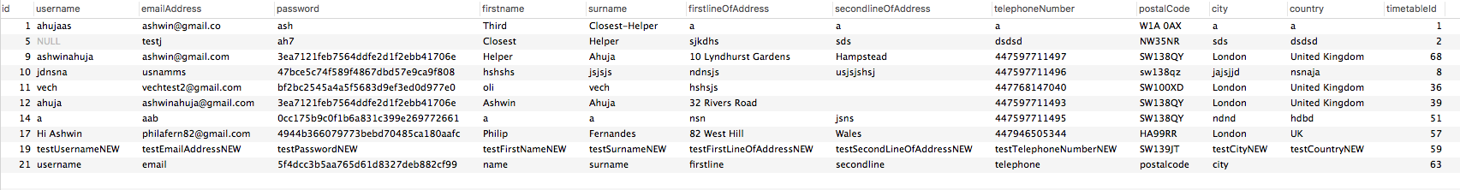

#### Timetables

While the timetables table could theoretically be combined with the main user’s database for the helpers, by separating these two tables, the system is marginally more clear and easier to work with.

The timetable system itself is separated into a few different tables. The first consists of a table with multiple columns, each corresponding to a week of the calendar (referred to by the Monday date of the week). There is also a default calendar which is used for all weeks which are not otherweise referred to specifically by a column. When an appointment is created, the timetable must be altered to make that time on that day no longer be free. If the week is already referred to by a column (there has been another appointment by anybody during that week), then the entry of the week can simply be changed. Otherwise, the column is created, and every other entry has a clone of their default week added in that column.

Each entry, in each column has an entry which refers to an entry in the weeks table, which contains the specific ids of the days to which the week refers. Finally, in the day table, the specific information about the day in question is stored, with details about each two hours slot and the person’s availability at this time.

|  |  |  |
| --- | --- | --- |
| Name | Variable Type | Description |
| Id | Int | This is the key of the table, and auto increments whenever a new entry is added. |
| defaultWeekId | Int | This contains the id of the default week which is created when the user first signs up to an account. |
| DD_MM_YYYY  (i.e. Week Beginning DD/MM/YYYY) | int | There may be n columns of this, where each column contains either a null, if this entry simply uses their default timetable for this week, or contains an id for another week entry linking to the week table.  Whenever a new column is added, a check is run whether the DD/MM/YYYY is in the past, and whether it can therefore be deleted. This ensures that the data remains reasonably small and cannot threaten to break the server. |

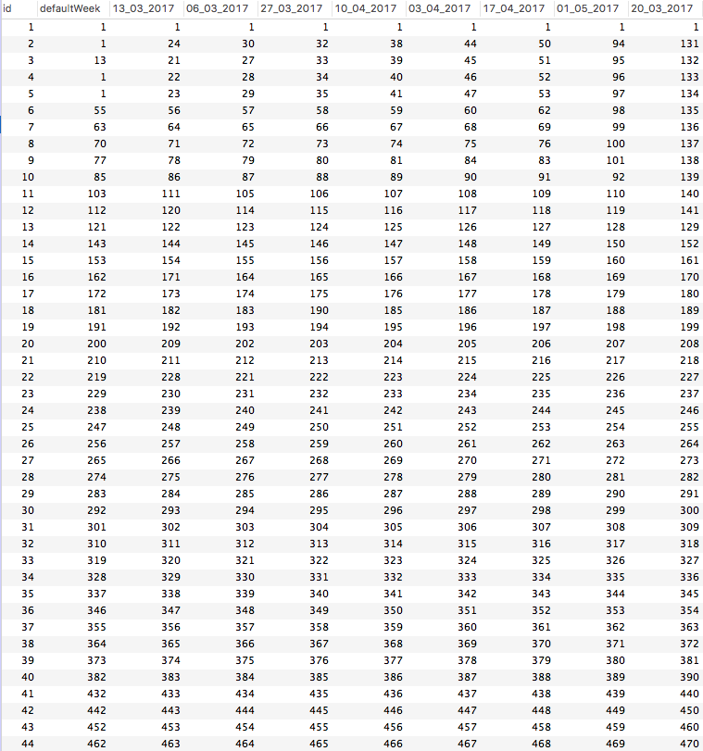

As mentioned, defaultWeekId and WeekBeginning… link to the week table, which provides links to an entry in the day table for each day of the week.

|  |  |  |
| --- | --- | --- |
| Name | Variable Type | Description |
| Id | int | This is the key of the table, and is referred to by the WeeklyTimetables table. |
| MondayId | Int | This contains a link to an entry of the day table, containing the specific time when a helper is free. |
| TuesdayId | Int | … |
| … | Int |  |

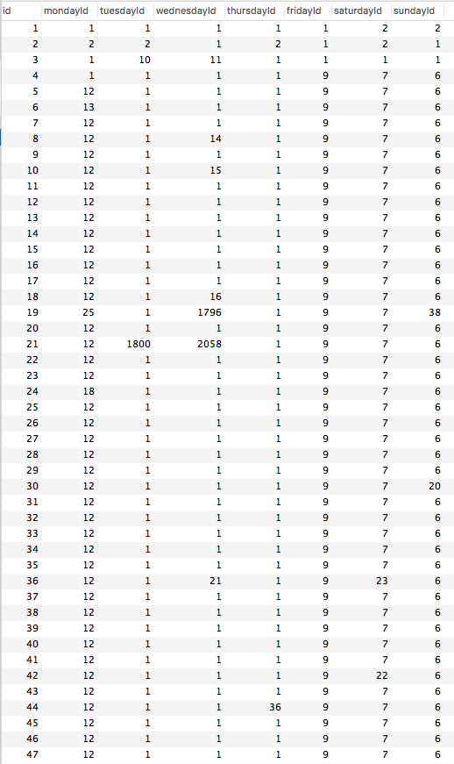

This then has links to the ids of entries in the day table, where the actual information as to whether a user is free is stored.

|  |  |  |
| --- | --- | --- |
| Name | Variable Type | Description |
| Id | Int | This is the key of the table, and is linked to by the entries of the week table. |
| a02 | Bool | This contains the information as to whether the user is free at this time. It was decided that 2 hour intervals were the correct length – offering simplicity for both booking appointments and for creating a timetable as a helper. |
| a24 | Bool | As above |
| … | Bool | As above. |
| a2224 | bool | As above. Though it was considered unlikely that appointments would be booked in some of these timeslots it was decided that it would be better if they existed anyway, never to be used.  However, it is important that in the User Interface for creating this timetable, that the work is minimised by defaulting that the timeslots which are the least likely are defaulted as being false. |

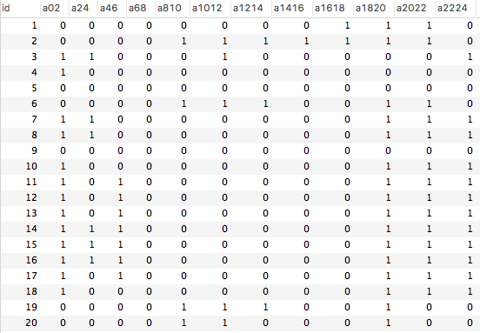

##### Default Calendar

When a new user is created, a new timetable is also created, with an initial timetable which consists of being free during the afternoon and evening during the week and during the entire day during the weekend. This was because we anticipate people being at school during the week, and therefore being busy during those times.

#### Appointments

The appointments information contains the information of the appointment for both the helper and the elderly person, with an entry being created when an elderly person creates an appointment, either via the app or via the SMS system.

|  |  |  |
| --- | --- | --- |
| Name | Variable Type | Description |
| Id | Int | This is the key for the table. |
| helperId | Int | This contains the information of who is the helper who has been assigned to solve the problem. |
| elderlyId | Int | This contains the information of the elderly person to be helped. |
| dateAndTime | DateTime | This contains the date and time of the appointment |
| dateAndTimeCreated | DateTime | This contains the date and time that the appointment has been created. |
| ratingId | Int | This contains the id (reference to the ratings table) of the rating given to the helper after this job has been completed. |
| reviewId | Int | This contains the id (reference to the reviews table) of the helper once the job has been completed. |

#### Ratings

The ratings table is where the ratings of the job are stored, with each appointment having one or no entry in the ratings table.

|  |  |  |
| --- | --- | --- |
| Name | Variable Type | Description |
| Id | int | Key of the table |
| starRating | Int (range between 0 and 10) | This contains the information of how many stars the helper has been given for this particular job. |

It’s important to note that it was decided that the options for the ratings of the helpers would only be integers between 1 and 10. This was decided in order to simplify the system as much as possible – ensuring that the system would be easy to use for the elderly person who is trying to rate their helper.

#### Reviews

The reviews table is where the reviews of the job are stored, with each appointment having one or no entry in the table.

|  |  |  |
| --- | --- | --- |
| Name | Variable Type | Description |
| id | int | Key of the table. |
| review | Varchar(10000) | This contains the review – which has been decided to have a maximum length of 10,000 character – around 1,500 words. This has largely been put as an exceedingly large maximum. We expect the length of each review to be significantly shorter. Therefore, the MySQL database has been programmed to reduce the amount of space used by this field to be reduced to the length of the text, once it has been added. |

### 2.2.2 - Communications with applications

There were a couple of immediate ways to communicate with the database to get all the required data from it. The first was through immediately communicating with it, while the second involved producing a local API which could be used to communicate to the SQL server and return the required information. The first, while inherently simpler, offers the challenges that code would have to be repeated on all applications when tasks like verification of data entry would be required. Even more importantly, it means that the security is much reduced as the data could be intercepted en-route as encrypting this transfer of data would be much more challenging. In fact, though Oracle do provide a system by which this connection can be established, they expressly suggest that you avoid it. Therefore, I decided to produce an API which could allow the code to be securely centralised.

## 2.3 – WebAPI (Appendix A – Web API Code)

I decided to use the REST standard for creating an API, which offers a number of important steps for communicating with HTTP requests, ensuring they are only of type: “GET”, “POST”, “PATCH”, “DELETE”, “PUT”. It also established the use of Json to both send and receive data between the client and the server.

I also decided to use a .NET core API, as I had prior knowledge of .NET programming, therefore would not have to learn how to use PHP, the other language which appears to be largely used for this. By using Microsoft’s IIS and .NET core libraries for Ubuntu 14.04 meant that I could largely test using my computer using a local SQL server as the database to communicate with as they were identical on my computer as on the server.

### 2.3.1 - General Structure of .NET Core API

The .NET core API effectively creates a tunnel through which a number of controllers can act as listeners, awaiting a command which meets the HTTP request type that they are defined to listen to – responding to the command when the command type and URL are in one of the controllers.

In order to produce this, there must be a number of files which define how the API works, including defining the namespace of the controllers and defining the dependencies and the runtimes that the API should work on.

All the controllers must inherit from the AspNetCore.Mvc.Controller class. In fact, in order to simplify in dealing with the SQL server, there is an intermediary class, SQLController (SQLStuff.cs), which inherits from Controller. This is inherited by all of the controllers. Hence, there is the following hierarchy chart.

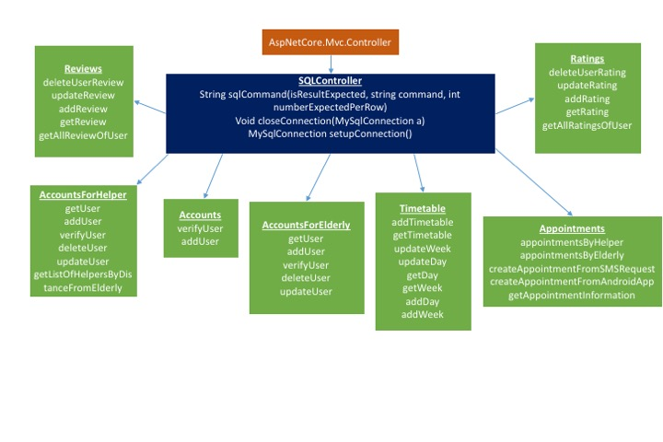

In order to communicate with the SQL server, the .NET Oracle SQL Server package is used, being acquired with a NuGet request to ensure that it can be retrieved every time the server script is run, thereby ensuring it exists everywhere.

### 2.3.2 - Communicating with JSON

Communicating with JSON was the obvious choice, with the only other option being XML. However, the greater availability of libraries to parse the JSON data on both the android application side and the Web API side meant that JSON was a better choice. An example of communicating with JSON in the WebAPI is available here: HttpCommandOut.cs

For the Web API, in order to deserialise data which is inputted to the WebApi, the ‘[From Body]’ tag is used, which calls the System.Net Json deserializer to process the data to the object which is defined in the definition of the function. When data is to be sent as Json, it is either passed directly as the object, as this would automatically be converted to Json or it is explicitly converted to Json using the NewtonSoft.Json library if this is necessary.

### 2.3.3 - Communicating with the SMS Server (SmsStuff.cs)

In order to communicate with the SMS server and the Google Maps API, which require GET and POST requests, the HttpWebClient library (accountsForHelper.cs) is used (in a composition fashion, in order to allow the rest of the system to function without adaptation).

### 2.3.4 - Functions

|  |  |  |  |  |  |
| --- | --- | --- | --- | --- | --- |
|  | Function Name | HTTP type | URL | Input | Output |
| Accounts (Accounts.cs) |  |  | /ac |  |  |
|  | HelloWorld | GET | /ac |  | “Hello World” |
|  | AddNewUser | POST | /ac/users/ad | User | Boolean (success or failure) |
|  | VerifyUser | POST | /ac/users/vf | UserToBeVerified | User (empty if failed, populated if successful) |
|  |  |  |  |  |  |
| AccountsForHelpers (accountsForHelper.cs) |  |  |  |  |  |
|  | HelloWorld | GET | /ach |  | “Hello World” |
|  | GetInfo | GET | /ach/users/gi{id} | Int id | Returns a user (see the definition of the user class below). |
|  | GetNearestHelpers | GET | /ach/users/gl{id} | Int Id of the current user, | List of the nearest helpers, to allow the elderly to pick which of the people to pick. |
|  | DeleteUser | DELETE | /ach/users/rm | Int id of the user | Returns a bool of success or failure. |
|  | UpdateUser | PATCH | /ach/users/up | Int id of user, user (see definition of class below) | Returns bool of success or failure |
|  | AddNewUser | POST | /ach/users/ad | User (see definition of class below) | Returns bool of success or failure |
|  | VerifyUser | POST | /ach/vf | UserToBeVerified (see definition of class below) | Returns id of userLoggedInto or null if failedToLogin |
|  | mergeSort | NA | NA | List of users and address of elderly to sort by nearest to | Sorted list of users |
|  | merge | NA | NA | Two lists of user to merge | One list of merged users |
|  | getDistance | GET | /ach/users/gd | Two string addresses | Double distance between the two in km |
|  | fileGetContents | NA | NA | String filename | String contents |
|  |  |  |  |  |  |
| AccountsForElderly (accountsForElderly.cs) |  |  |  |  |  |
|  | HelloWorld | GET | /ace |  | “Hello World” |
|  | GetInfo | GET | /ace/users/gi{id} | Int id | Returns a user (see the definition of the user class below). |
|  | GetInfoByTelephoneNumber | NA | NA | String telephoneNumber | Returns a user (see the definition of the user class below). |
|  | DeleteUser | DELETE | /ace/users/rm | Int id of the user | Returns a bool of success or failure. |
|  | UpdateUser | PATCH | /ace/users/up | Int id of user, user (see definition of class below) | Returns bool of success or failure |
|  | AddNewUser | POST | /ace/users/ad | User (see definition of class below) | Returns bool of success or failure |
|  | VerifyUser | POST | /ace/vf | UserToBeVerified (see definition of class below) | Returns id of userLoggedInto or null if failedToLogin |
|  |  |  |  |  |  |
|  |  |  |  |  |  |
|  |  |  |  |  |  |
| Timetables (Timetable.cs) |  |  | /tt |  |  |
|  | getTimetablesOfAUser | GET | /tt/gt | Int helperID | Returns timetable (see below for definition) |
|  | addNewTimetable | POST | /tt/adt | timetable | Returns bool for success or failure |
|  | UpdateWeek | NA | NA | week |  |
|  | AddDay | NA | NA | day | Int id (in database) |
|  | UpdateDay | POST | /tt/ud | day | Returns bool for success for success or failure. |
|  | addWeek | NA | NA | week | Int id of week |
|  | getWeek | NA | NA | Int id | week |
|  | getDay | GET | /tt/gd | Int id | day |
|  |  |  |  |  |  |
| Appointments (Appointments.cs) |  |  |  |  |  |
|  | Create Appointment From SMS Request | POST |  | DateTime time, string telephoneNumber | Returns appointment (see definition below) |
|  | Create New Appointment From Android App | POST |  | Appointment (see definition below) | Returns bool of success or failure |
|  | Get Appointment information | GET |  | Int AppointmentID | Returns appointment |
|  | Remove Appointment | DELETE |  | Int appointmentID | Returns bool of success or failure |
|  | Get Appointments by Elderly | GET |  | Int elderlyID | Return a list of appointments |
|  | Get Appointments by helper | GET |  | Int helperID | Returns a list of appointments |
|  |  |  |  |  |  |
| Ratings (Ratings.cs) |  |  |  |  |  |
|  | Get All Ratings Of a User | GET |  | Int helperId | Returns list of ratings (for definition see below) |
|  | Get One specific rating | GET |  | Int appointmentID | Returns rating |
|  | Add a rating to an appointment | POST |  | Int appointmentID, rating | Returns bool of success or failure |
|  | Update rating | PATCH |  | Int appointmentID, rating | Returns bool of success or failure |
|  | Delete rating | DELETE |  | Int appointmentID | Returns bool of success or failure |
|  |  |  |  |  |  |
| Reviews (Reviews.cs) |  |  |  |  |  |
|  | Get all reviews of a helper | GET |  | Int helperID | Returns a list of reviews |
|  | Get one specific review | GET |  | Int appointmentID | Returns review |
|  | Add a review to appointment | POST |  | Int appointmentID, review | Returns bool of success or failure |
|  | Update a review | PATCH |  | Int appointmentID, review | Returns bool of success or failure |
|  | Delete a review | DELETE |  | Int appointmentID | Returns bool of success or failure |
|  |  |  |  |  |  |

The classes which are used on both the clients and the server which define the types and objects for the objects user in communicating with the WebAPI are as follows:

For each item in the classes, they contain private items which are held as well as public getter and setter methods which allow the private items value to be changed. For simplicity, only the private item is referred to.

|  |  |  |
| --- | --- | --- |
| Class | Item Name | Type |
| User (User.cs) |  |  |
|  | Id | int |
|  | Username | String |
|  | emailAddress | String |
|  | Password | String |
|  | Firstname | String |
|  | Surname | String |
|  | firstlineOfAddress | String |
|  | secondLineOfAddress | String |
|  | telephoneNumber | String |
|  | postalCode | string |
|  | City | String |
|  | Country | String |
|  | timetable | timetable |
|  |  |  |
| Timetable (Timetable.cs) |  |  |
|  | id | Int |
|  | defaultWeek | week |
|  | listOfOtherWeeks | List<week> |
|  |  |  |
| Week (Week.cs) |  |  |
|  | id | int |
|  | weekBeginning | DateTime |
|  | monday | Day |
|  | tuesday | Day |
|  | Wednesday | Day |
|  | Thursday | Day |
|  | Friday | Day |
|  | Saturday | Day |
|  | Sunday | Day |
|  |  |  |
| Day (Day.cs) |  |  |
|  | id | int |
|  | timesFree | Bool[12] |
|  |  |  |
| Appointment (Appointment.cs) |  |  |
|  | Id |  |
|  | helperid | Int |
|  | elderlyid | int |
|  | dateAndTime | DateTime |
|  | dateAndTimeCreated | DateTime |
|  | Rating | Rating |
|  | review | Review |
|  |  |  |
| Rating (Rating.cs) |  |  |
|  | id | Int |
|  | rating | Int |
| Review (Review.cs) |  |  |
|  | Id | Int |
|  | review | String |
|  |  |  |
| UserToBeVerified (UserToBeVerified.cs) |  |  |
|  | emailAddress | String |
|  | password | String |
|  | helper | Boolean |
|  |  |  |
| DateTimeExtensions (DateTimeExtensions.cs) |  |  |
|  | Func getWeekBeginning (DateTime dt) | DateTime |
|  |  |  |

While the majority of these simply require a number of SQL commands to return specific data from the MySQL database, a couple of the functions require a little more explanation of how they will work.

#### Returning List of Nearest Helpers (accountsForHelper.cs)

In order to order the ordered list of helpers, there are broadly three stages which must be followed:

1. Get all helpers
2. Find the distance from the elderly person for each helper.
3. Sort the helpers by this distance.

**Get all helpers**

In order to get all the helpers, it is simply a question of calling a get command of all helpers (this command is only available internally and is not available outside of the API and can’t therefore be exploited).

Find the distance from the elderly person for each helper

There were two methods considered to find the distance between two addresses. The first, utilises, just the Google Maps API and treats the direction distance (distance on the road) as the distance. The second uses the Google Maps API to get the longitude and latitude and uses the Haversine Formula to extract the distance between two points using this formula.

It was decided that the former is better as it is more representative of the time taken by the helper to get to the elderly person’s house. Therefore, the Haversine formula is not needed.

**Sort the helpers by this distance**

In order to sort the helpers by this distance, a recursive MergeSort is used, recursively slitting the list into halves, sorting each half before combining them together using a merge. The process is outlined in the below pseudocode:

MergeSort (List a):

If (a.Count() == 1)

Return a;

Else

Return merge(MergeSort(firstHalfOfA), MergeSort(secondHalfOfA))

Merge (List a, List b):

List c

While(a and b have elements):

If (a[0].distance < b[0].distance)

c.Add(a[0]);

a.RemoveAt(0);

Else

c.Add(b[0]);

b.RemoveAt(0);

While(a has elements):

c.Add(a[0]);

a.RemoveAt(0);

While(b has elements):

c.Add(b[0]);

b.RemoveAt(0);

return c

#### Create New Appointment from SMS request (Appointments.cs)

In order to do this, the function completes the following tasks:

1. Gets the user information of the elderly person from the telephone number
2. Gets the list of nearby helpers to the elderly person
3. Parses the sms into a date and time
   1. ^
4. Find the first helper who is free at that date and time, book appointment (using create new appointment from Android App)
   1. *
5. Send an SMS to the original sender with the information about the appointment.

**Considering ^**

In order to parse the SMS and return the date and time that the user wants to have the appointment, there were a few possible ways of doing this. The first involves creating my own system to search for all possibilities including things like ‘tomorrow’ and ‘today’ which would each need to separately catered for.

Therefore, it would be simpler to make use of existing APIs. While it would be significantly more effective to use something like the IBM Watson Natural Language processing API, it proved much simpler to use a DateTimeNaturalLanguageParser for C# that I found published under the MIT license on GitHub (DateTimeRoutines.cs). While not perfectly effective – for example the year must always be stated otherwise, it does not return any of the correct date – it generally works.

**Pseudo Code of \***

Foreach helper in list of helper:

Timetable t = Get Timetable (helper.timetableId)

DateTime dt = findWeekBeginning(dateTimeSMS)

If dt.ToString() exists in t.weeks[x].weekBeginning:

Day correctDay = t.weeks[x].week.(dateTimeSMS.DayOfWeek.ToString() + “id”)

If correctDay.timesFree[dateTimeSMS.Hour / 2]:

Create appointment with this helper at this time

Send SMS to user with this information

Else

Next helper

Else

Day correctDay = t.defaultWeek.(dateTimeSMS.DayOfWeek.ToString() + “id”)

If correctDay.timesFree[dateTimeSMS.Hour / 2]:

Create appointment with this helper at this time

Send SMS to user with this information

Else

Next helper

If still haven’t found a helper, then send SMS saying “Noone could be found”

#### Create New Appointment from AndroidApp (Appointments.cs)

The function must complete the following tasks:

1. Convert the dateAndTime into the week beginning data and the day.
2. Check whether that week beginning is a special week for the helper, or whether it falls inside the default week.
   1. It does this by getting the timetable for the helper, and checks whether the date of the week beginning is the same as the week beginning date for any of the custom weeks.
      1. If it isn’t one of the weeks already there, then it creates a new column and clones the defaultWeek from all the items and puts their ids into the new column.
      2. Then, it recurs on the same function, this time confident that it will find the new column
3. Check whether the helper is free at the time on that day, looking inside the correct entry of the ‘day’ table.
4. If it is free, the appointment can be booked and the time should be changed to being used and the appointment added to the tableOfAppointments.

#### Retrieving timetable from database (Timetable.cs)

1. Go into the INFORMATION-SCHEMA for the table and retrieve the names of the columns.
2. Then retrieve the value of the entry for each of these columns – converting the name of the column into a DateTime value for the weekbeginning date for the column
   1. Then for each of these weeks, extract the week from the week value.
      1. Do this by extracting a day from the day ids from each day of the week table of the week entry.

### 2.3.5 - Securing data

An important part of the decision to choose to use a WebAPI was in order to maximise the security of the system, by ensuring that people couldn’t retrieve the placement of the server and simply issue SQL commands to retrieve all the data on all the users. There are a couple of other simple measures which can be taken to further maximise the security of the data, even if the connection is insecure.

#### Hashing Passwords (MD5Hash.cs)

By hashing password, we can maximise the security of the passwords in a couple of different ways. Firstly, from a user’s perspective, it assures them that we don’t have access to the password and thereby ensures that they are comfortable with using the site (though it would still be advisable to use a different password than others for this account). It also means that should hackers manage to penetrate the security of the server, which will be minimised as far as possible, through root security in Ubuntu 14.04, they will struggle to retrieve passwords from the hashed values of the passwords.

Therefore, the passwords will be stored as the hashed value – with the passwords being hashed using the MD5 cryptographic hash, which produces a 128-bit hash. This, while not perfectly secure, draws a good compromise between the time taken to hash on the client side (on the app) and security.

### 2.3.6 - Verifying data entry

It has been decided that for speed of the system, the main verification will be done on the application side, being completed without requiring the application to make any calls to the WebAPI. This also ensures that the end user can have more coherent error messages. However, there are a few things which cannot be checked by the application and therefore must be checked during the server’s functions

Therefore, the following checks must be carried out during verification:

|  |  |  |
| --- | --- | --- |
| Task | Input | Check |
| Adding or updating a user  (accountsForElderly.cs, accountsForHelper.cs) |  |  |
|  | emailAddress | Already used? |
|  | telephoneNumber | Already used? |

## 2.4 - Android App

While I had otherwise intended to create two android apps, one for the helpers and one for the elderly since I assumed that they would largely be entirely separated, I have found they are in fact rather similar, and by creating ‘one’ app, they could inherit large portions of the backend code from one another. Therefore, I am only creating one android app, though with two separate timelines for the elderly and for the helpers. Therefore, for the purposes of this report, I am going to deal with the design together, though they share a couple of screens.

For the Android apps, I chose to work in Xamarin.Android, which allows me to use existing skills in C# and XML and combine them to produce a functioning Android Application. This also means that I can reuse much of the code for the classes in the WebAPI in order to produce the Android Apps, for example the classes for the users and timetables.

### 2.4.1 - Important Features

#### Communicating with Web API

In order to communicate with the WebApi, the Android App makes use of the RESTSharp library, which deals with the communication entirely, allowing the programmer to just say the method, the data, and the URL of the communication. (An example of this is in the UserDetails function here: WelcomeHelpers.cs)

Unfortunately, these functions must be often repeated on a number of screens as there must be subtle changes in the URL and / or the data expected.

In order to serialise the data to be sent to the API and to deserialise the JSON input from the API, the NewtonSoft JSON library is used, with it defining the object and object type to convert to JSON.

#### Communicate with SMS Server (RegisterActivity.cs)

To communicate the SMS server, the Android App again makes use of the RESTSharp and NewtonSoft.Json Libraries which can be acquired using a NuGet packages and therefore are included as part of the package of the Android application when it is installed.

#### Remembering Logins (LoginActivity.cs)

In order to remember the login and password, the Android application stores the information in a SQL database, using the SQLite database to store the following information:

|  |  |
| --- | --- |
| Name | Type |
| emailAddress | VARCHAR(50) |
| password | VARCHAR(50) |

When the user logs in, the username and password is added to the database. The password is added in plaintext as it would be impossible for anyone to gain access to the database. When the login screen is reached again at any point, the application first checks through the database and attempts to login with information from the database.

### 2.4.2 - Helpers

#### Main Flowchart

The flowchart shows the system without the addition of in case of problems.

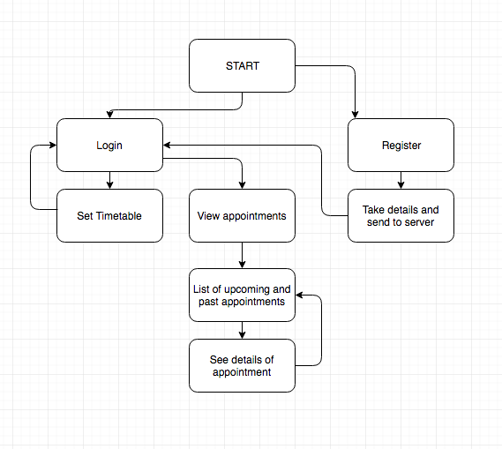

#### User Interface

##### Dialog Methods

In order to give critical information to the user, two main methods were used, where one entirely removes everything else from the page, and forces the user to look at it. This is an Android Alert Dialog. This is used mostly during the login and registration, where the information to be gained is vitally important to the function of the application and the success of the user to get into the application properly.

The other type are toast notifications, which are used more subtally, for example to tell the user that a change that they have made has gone through successfully, as in the below example.

|  |  |
| --- | --- |
| Alert Dialogs | Toast Notifications |

##### Start

|  |  |
| --- | --- |
| UI | Activity |
|  | **OnCreate:** Initialises view.  **LoginButtonClick:** When the button is clicked, go to the login screen.  **RegisterButtonClick:** When the button is clicked, go to the register screen. |

The start allows a user to create a new account or login by clicking one of the buttons.

##### Log In

|  |  |
| --- | --- |
|  | OnCreate: Go through the database and attempt to login with any of the accounts stored in the database or create a table if it doesn’t already exist.  LoginAsHelperClick: Attempt to login as a helper.  LoginAsElderlyClick: Attempt to login as an elderly.  checkIfEmpty: Shows a dialog box if all information is not present  login: Returns a true or false dependent on whether the login is successful. |

The login window provides two text boxes with text explaining what is to go in the boxes. The password boxes will, once filled in, appear as a series of dots, by using the Android password box, in order that those in the vicinity of the user not be able to see the password.

##### Register

The registration screen, common for both the elderly and helpers offers the opportunity for the users to enter all the required information to register. Though I considered creating a toggle switch for elderly or helper, this separate buttons method appears more clear and easy to use – this is very important for the elderly. Once the registration has gone through, there is an alert saying “registration succeeded” or “registration failed”. If the registration is successful, they receive a message with the verification code for the twilio call which they will receive within the next two minutes.

|  |  |
| --- | --- |
|  | OnCreate:  RegisterRegisterAsHelperClick:   * checkValid * registerTheUser * verifyNumber * checkVerify to the get the userId * if it doesn’t get verified, deleteUser (and force them to reregister)   RegisterRegisterAsElderlyClick:  checkValid:   * Checks if any fields are empty or if the telephone number is invalid. * If invalid then show dialog box and returns false   deleteUser:   * Sends the REST request to the API to delete the user account.   testVerify:   * Completes the same function as in login and returns the user.   register:   * POSTs the data to the API to add the account.   verifyNumber:   * POSTs the number to the SMS server and shows the return, the verification code, to verify the telephoneNumber. |

##### Logged in

Upon login, the user gets to access either part of the app, the appointment side, or the timetable side through two buttons.

|  |  |
| --- | --- |
|  | OnCreate:   * Populate the name textview using information from GetUserDetails.   SetTimetableClick:   * Open the setATimetable activity.   ListOfAppointmentClick:   * Open the listAnAppointment activity.   GetUserDetails:   * Send the REST request to the Web API and returns the user details. |

##### View Appointments

From any deeper than this in the app, there are always back buttons (on the android device) which allow the user to move back in the pages they have visited, therefore allowing them to visit every site. This screen easily shows all the appointments, displaying their times.

The view appointment screen simply offers the list of all of the appointments which exist. They are ordered such that the upcoming appointments are listed first (closest first) before they go backwards in time. For each appointment, it says the name of the elderly person with whom the appointment will (or has) occurs as well as the time.

All the appointments can be clicked on to get more details about the appointments.

|  |  |
| --- | --- |
|  | OnCreate:   * Get list of appointments. * Foreach of the appointments, get the name of the elderly person (using getUserDetails). * Populate the list view in the order of upcoming first (closest first), then going back in history   OnListItemClick:   * Call the activity to show more details about that appointment.   returnListOfAppointments:   * From the helperId, this makes a call to the REST api and returns the list of appointments.   getUserDetails:   * Makes a call to the Web API and returns information about the user. |

##### See details of Appointment

This is the view which is displayed when the user clicks on any one of the appointment. It offers more information about the appointment, including things like the time, contact number and address of the appointment. Additionally, if the appointment is in the future, the appointment can also be cancelled.

|  |  |
| --- | --- |
|  | OnCreate:   * GetAppointmentDetails of appointment to show in more details. * Populate the text views using details from GetUserDetails * If in the past, ensure that cancel appointment is not enabled. If in the future, it should be enabled.   CancelAppointmentClick:   * Send the request to the Web API.   GetUserDetails:   * Send request to Web API and return the user information.   GetAppointmentDetails   * Send request to Web API and return the appointment. |

##### Set Timetable

The process for setting up a timetable is split into a number of parts, with the person first choosing which week to tackle (with the next seven weeks displayed), followed by which day, followed by then changing the timetable for that particular day.

The first screen shows the week beginning dat for the next seven weeks, allowing them to click one of them and alter their timetable in any one of those weeks.

|  |  |
| --- | --- |
|  | **OnCreate:**   * Populates the view with the readable name (MMMM dd, yyyy) of the week beginning date of the next seven weeks which could be set.   **OnListItemClick:**   * Starts the activity of the setting timetable of week view – passing the date beginning date as a parameter. |

Upon clicking upon one of the weeks, the next screen displays the date of all the days in that week, each of which can be clicked to set the timetable for that day.

|  |  |
| --- | --- |
|  | **OnCreate:**   * Populates the view with the dates of all of the days of the week – therefore any of them can be selected and the free time can be changed.   **OnListItemClick:**   * Starts the activity of the setting the free times, passing the parameter of the exact day whose timetable should be changed (based on which item has been clicked). |

On clicking any one of the days, the screen for setting the timetable for that day is opened. It is a simple interface consisting of only toggle switched, which show whether the person is free for that specific time. Though the free and busy positions are not labelled, due to the clear ‘on-off’ colouring, it is reasonably obvious that on means free.

There is a submit button at the bottom which when clicked commits the changes to the timetable. When the change occurs, there is a toast notification, which tells the user that the change has successfully occurred.

|  |  |
| --- | --- |
|  | **OnCreate:**   * Initialises the view and calls the getCorrectStatusOfButtons   **getCorrectStatusOfButtons:**   * Calls the getTimetableOfHelper and finds the correct day value (either from a specific week or from the default week entry). * Populates the toggle switches on the view with ‘on’ or ‘off’ based on whether they are currently free at that time or not.   **submitButtonClick:**   * Calls assemble day and replaces the existing day in the timetable object of the user with this day. * If the week already exists, this is simply changing a day, otherwise a new week is created and the day can then be replaced. * Then a request is sent to the WebAPI to add the timetable and replace the timetableId in the the accountsTable.   **assembleDay:**   * Converts the status of the buttons into a day object.   **getTimetableOfHelper:**   * Sends a request to the WebAPI with the parameter of the id of the timetableId and returns the timetable of the user. |

### 2.4.3 - Elderly

#### Main Flowchart

The flowchart below is the main flowchart of the app, showing how a user can carry out all of the task- with each of the boxes corresponding to a single screen on the design. It must however be noted that this assumes successes in all activities, such as assuming that the password is valid and the user successfully logs in.

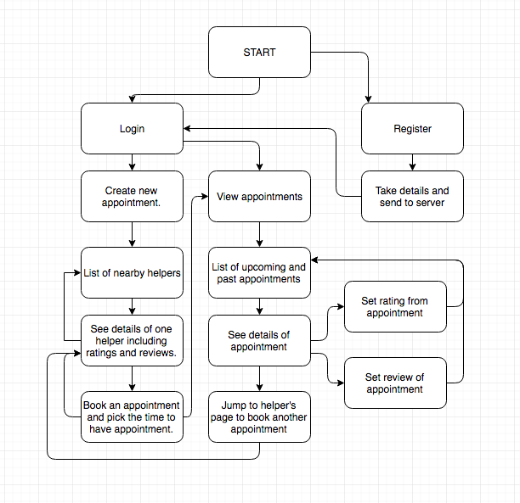

#### User Interface

##### Design Ethos and Colours

Foremost in my mind when designing the system for the elderly was the suggestion by Mrs Wilson that no screen should have more than two things happening on that screen. Therefore, a large (possibly excessively so) number of screens exist in the application in order to allow the user to be able to cope easily with each of the screens.

With regards to colours, additional research revealed that due to issues with eyesight, in particular the fact that the retina tends to break down more quickly than the rest of elderly eyesight, they tend to lose the ability to see colour. Therefore, it is more important to focus on contrast, to show differences in parts of the design. Therefore, the design generally consists of a ‘Black-White’ colour scheme, to maximise the contrast.

##### Start

The first few screens are entirely identical to those in the helpers side, so no additional commentary is provided.

|  |  |
| --- | --- |
|  | OnCreate: Initialises view.  LoginButtonClick: When the button is clicked, go to the login screen.  RegisterButtonClick: When the button is clicked, go to the register screen. |

##### Login

|  |  |
| --- | --- |
|  | OnCreate: Go through the database and attempt to login with any of the accounts stored in the database or create a table if it doesn’t already exist.  LoginAsHelperClick: Attempt to login as a helper.  LoginAsElderlyClick: Attempt to login as an elderly.  checkIfEmpty: Shows a dialog box if all information is not present  login: Returns a true or false dependent on whether the login is successful. |

##### Register

|  |  |
| --- | --- |
|  | OnCreate:  RegisterRegisterAsHelperClick:   * checkValid * registerTheUser * verifyNumber * checkVerify to the get the userId * if it doesn’t get verified, deleteUser   RegisterRegisterAsElderlyClick:  checkValid:   * Checks if any fields are empty or if the telephone number is invalid. * If invalid then show dialog box and returns false   deleteUser:   * Sends the REST request to the API to delete the user account.   testVerify:   * Completes the same function as in login and returns the user.   register:   * POSTs the data to the API to add the account.   verifyNumber:   * POSTs the number to the SMS server and shows the return, the verification code, to verify the telephoneNumber. |

##### Logged in Interface

Here, for the elderly, instead of offering the timetable, the user can book an appointment. However, the process for booking an appointment is similar to that of setting a timetable in the sense that it is dealt with in a number of pages, each one making more specific the time and person involved with the appointment.

|  |  |
| --- | --- |
|  | OnCreate:   * Sets up the view of the interface and populates the name of the elderly person.   + Does this by getting the name from the user returned by the GetUserDetails function. * It also checks if an appointment has just been booked. If this is true, then the user is redirected immediately to the page with the list of appointments, through Click2. * *The only reason this exists is so that, if the user were to now press the back button on their phones, they would return to this screen rather than to the booking confirmation screen.*   BookAnAppointmentClick:   * Starts the activity related to the booking of an appointment (where the nearest helpers are shown).   ListOfAppointmentsClick:   * Starts the activity related to listing all the appointments.   Click2:   * Calls the ListOfAppointmentsClick (with required event arguments.   GetUserDetails:   * Makes a call to the Web API and returns information about the user. |

##### Create new appointment

When the person goes into the booking section, they are presented with a list of the nearest helpers as well as their average rating. By clicking any one of the users, they are presented with more information about that helper as well as being offered the opportunity to see the users reviews.

|  |  |
| --- | --- |
|  | OnCreate:   * Gets the list of nearby users (using GetListOfNearbyUsers) and converts this into a list of names which can be displayed on the ListView. * Foreach of these names, the getAverageRating function is used to get the average rating of the user and display this alongside their name.   OnListItemClick:   * Start the helper details activity, passing the helperId of the particular item clicked as a parameter.   GetListOfNearbyUsers:   * Sends a request to the WebAPI to return the list of nearby users to the location of the elderlyId sent to the API.   GetAverageRating:   * Completes ReturnListOfAppointments for the helper id and for each appointment checks if the ratingId = 0 (it has no rating). If it has a rating, then it goes to the WebAPI, requests the rating and adds this to a counter. * This is divided by the number of ratings found to find the average rating for the user.   ReturnListOfAppointments:   * Sends request to the WebAPI to return a list of appointments, based on the helperId and parses the JSON input into an array of appointments. |

##### Book Appointment

The details which can be seen when clicking one of the users consist of everything from their name, to their contact number and address.

The user can also click to see reviews (this button is only enabled if the user has any reviews) or book an appointment with them.

|  |  |
| --- | --- |
|  | OnCreate:   * Populates the details of the helper (including name, address, telephone number etc). * Also, checks if there are reviews for the helper using ReviewsForUser. If there are, then the ‘See reviews’ button is enabled. Otherwise, it is hidden from the user.   SeeReviewsClick:   * Starts the see reviews activity.   BookAppointmentClick:   * Activity for setting the time to book the appointment is started.   ReviewsForUser:   * Checks if the response to WebAPI asking for list of reviews of user is empty or not.   GetUserDetails:   * Makes a call to the Web API and returns information about the user. |

##### See all reviews of helper

By clicking the see all reviews button, the user can see a simple list of all the reviews of a user, with no additional clutter around the review.

The only place that the user can go from here is back to the previous screen, by using the back buttons on the android device.

|  |  |
| --- | --- |
|  | OnCreate:   * Populates the ListView with the content from the array of reviews returned by GetListOfReviews (with parameter of the helperId)   GetListOfReviews:   * Sends request to the WebAPI with the helperId, and parses the JSON response into the array of reviews for that user. |

##### Set time to book appointment

If they instead click to book an appointment with the helper, they are presented with a list of weeks which they can book appointments in. This interface is similar in style to the ‘Set Timetable’ interface, in this case with a few changes.

Firstly, the number of weeks they can book an appointment in, is reduced, from seven weeks to only the next four weeks. Additionally, the week will only appear if the helper has any time in that week. Otherwise, the week will simply not appear.

The user can click on any one of the weeks to move onto the next screen.

|  |  |
| --- | --- |
|  | OnCreate:   * Populates the listview with the date of the weekbeginning date for the next several weeks in a readable way, first checking whether there are any appointments available in that week – using CheckIfAnyTimeInWeek.   + To do this, it first gets the timetable of the user – using GetTimetableOfUser   + Then, it checks if this week is one of the specific columns which are defined, if it is, then this week is used.   + Otherwise, the default week is used.   + This week is passed to the CheckIfAnyTimeInWeek function.   CheckIfAnyTimeInWeek:   * Returns false if and only if a checkIfAnyTimeInDay fails for all days in the week.   CheckIfAnyTimeInDay:   * Checks if there are any free times in the day – returns true if there are, false if not.   OnListItemClick:   * Starts the activity to choose the exact day to have the appointment, passing the weekbeginning date as a parameter and the weekId (the default week if it isn’t a custom week in the timetable).   GetTimetableOfHelper:   * Sends a request to the WebAPI with the parameter of the id of the timetableId and returns the timetable of the user. |

Once the user has selected a week, they can then select a day from that week to have an appointment. In the same way as the week list, this is presented in a simple list, with only days which have free times being available to be clicked on.

If any day is clicked, the user can then move onto the next screen, to select the time of the appointment.

|  |  |
| --- | --- |
|  | OnCreate:   * Get the week to be displayed using the GetWeek. * Populates the list view with all the days of the week – first checking if there is any time in that day before displaying it. * Also checks if the day is before today before displaying it.   GetWeek:   * Sends request to the WebAPI and parses the JSON response into a week.   CheckIfTimeInDay:   * Given the day, checks if there is any free appointments in that day – returning a false if there are not, returning a true if there are.   OnListItemClick:   * Starts the activity of selecting the time of the appointment passing the DateTime of the selected day as well as the dayId. |

In this screen, the user can select one of the available times to have the appointment, again being presented in a simple list.

|  |  |
| --- | --- |
|  | **OnCreate:**   * Populated the list based on which appointments are available during the selected day (day got using the GetDay function).   **GetDay:**   * Sends request to the WebAPI and parses the JSON response into a day**.**   **OnListItemClick:**   * Starts the activity of the submission of the appointment screen, passing the exact date and time of the appointment as a parameter, as well as the helper and elderlyId. |

Finally, when this is selected, the complete information about the appointment is displayed, with the user then being able to book the appointment by pressing the ‘Confirm’ button.

|  |  |
| --- | --- |
|  | **OnCreate:**   * Populates the screen with the details of the helper, using the GetUserDetails function and the details of the appointment passed from the previous activity.   **SubmitButtonClick:**   * Creates an appointment object and POSTs this to the WebAPI. * Displays a toast notification that the appointment has been created. * Starts the Welcome screen on elderly with a sentBack parameter as true.   + This then redirects the screen to the list of appointments with the welcome screen as the screen which is last in the stack of screens.   + Therefore, if the back button is pressed, the welcome screen is returned to.   **GetUserDetails:**   * Makes a call to the Web API and returns information about the user. |

##### View appointments

If, instead of booking an appointment at the main screen, the user clicked list of appointments, the user would be presented with a screen similar to this. This screen, identically to the ‘list of appointments’ screen for the helpers, displays all the appointments the elderly person has. These are arranged with the upcoming appointments first, before going into past appointments, latest first. For each appointment, the helper name and time and date is listed.

By clicking any one of the appointments, more details about the appointment can be retrieved.

|  |  |
| --- | --- |
|  | **OnCreate:**   * Get list of appointments. * Foreach of the appointments, get the name of the elderly person (using getUserDetails). * Populate the list view in the order of upcoming first (closest first), then going back in history   **OnListItemClick:**   * Call the activity to show more details about that appointment.   **returnListOfAppointments:**   * From the helperId, this makes a call to the REST api and returns the list of appointments.   **getUserDetails:**   * Makes a call to the Web API and returns information about the user. |

##### See details of appointments

In this screen, as opposed to the helper equivalent, the only difference is the fact that the ‘Set Rating’ and ‘Set Review’ buttons are available to be pressed if the appointment has already occurred.

|  |  |
| --- | --- |
|  | OnCreate:   * GetAppointmentDetails of appointment to show in more details. * Populate the text views using details from GetUserDetails * If in the past, ensure that cancel appointment is not enabled. If in the future, it should be enabled.   CancelAppointmentClick:   * Send the request to the Web API.   GetUserDetails:   * Send request to Web API and return the user information.   GetAppointmentDetails   * Send request to Web API and return the appointment.   SetRatingClick:   * Starts the rating activity.   SetReviewClick:   * Starts the review activity. |

##### Set rating

If the ‘Set Rating’ button is pressed, the user is taken to this screen, which allows them to set (or edit an existing) a rating. They do that by pressing on the desired location on the star – half stars are also possible. Therefore, they are effectively rating on a scale of 0 to 10.

When they first come to the screen, if a rating has already been added, the stars are prepopulated with this rating, otherwise they all appear empty.

By pressing the submit button, the rating is added to the database. The success of this addition is displayed by a toast notification which informs the user of this success.

|  |  |
| --- | --- |
|  | OnCreate:   * The view is initialised and the name of the helper populated (using the GetUserDetails function). * The rating is also populated by the GetRating function. If it has no rating, then it is populated as 0 stars. Otherwise, it gets the rating as it was given.   SubmitRatingClick:   * It is checked whether a rating exists or not. * If one already exists, the new rating is POSTed to the WebAPI so that it can be updated on the database. * If not, then it is sent to the WebAPI as a rating to be added, alongside the appointmentId, so the rating information can be added to the appointments table. * Finally, a toast notification is used to tell the user that the rating has been submitted.   GetRating:   * The rating (based on the ratingId) is retrieved from the database, using a request from the WebAPI.   getUserDetails:   * Makes a call to the Web API and returns information about the user. |

##### Set review

If the ‘Set Review’ button is pressed, the user is taken to this screen, which allows them to set (or edit an existing) a review. They do that by typing their review on the expanding textview, which allows them to write very long reviews if they so desire.

When they first come to the screen, if a review has already been added, the textview are prepopulated with this review, otherwise it appears empty.

By pressing the submit button, the review is added to the database. The success of this addition is displayed by a toast notification which informs the user of this success.

|  |  |
| --- | --- |
|  | OnCreate:   * The view is initialised and the name of the helper populated (using the GetUserDetails function). * The review is also populated by the GetReview function. If it has no review, then the review box is empty. Otherwise, it gets the review as it was given.   SubmitReviewClicked:   * It is checked whether a review exists or not. * If one already exists, the new review is POSTed to the WebAPI so that it can be updated on the database. * If not, then it is sent to the WebAPI as a review to be added, alongside the appointmentId, so the review information can be added to the appointments table. * Finally, a toast notification is used to tell the user that the review has been submitted.   GetReview:   * The review (based on the reviewId) is retrieved from the database, using a request from the WebAPI.   getUserDetails:   * Makes a call to the Web API and returns information about the user. |

## 2.5 – SMS Server System

The SMS system relies upon the Twilio system which provides a phone number and an API through which text messages can be received and sent. In order to communicate with the Twilio REST API, the helper library is used with Python.

This has only one class, and consists of four functions:

1. “@app.route('/sms', methods = ['GET','POST'])”
   1. This deals with incoming SMS messages and simply passes them onto the .NET core Web Api as well as sending a generic response: 'Thanks for your request. Your appointment details will be sent to you shortly'
2. “@app.route('/sendSms', methods = ['POST'])”
   1. This deals with any messages to be sent to other number and passes them on, using the Twilio helper library, to be sent.
   2. (This receives the required data in JSON, which it uses the Requests library to deal with)
3. “@app.route('/verifyNumber', methods = ['POST'])”
   1. This deals with verifying a new phone number (so it can text the Twilio number and receive messages from it),
   2. It POSTs lots of information to the Twilio REST API and receives a validation code which is then returned to the Android application.
4. “if __name__ == '__main__':”
   1. This defines important things like the port number on which the API should be run.

**Example of SMS Appointment Server in action (appointment allocated by .NET Core API)**



## 2.6 – Server Side Management

### 2.6.1 – Traffic Management

In order to ensure the server can respond to multiple sources of traffic, attempting to communicate with different APIs, an Nginx server was set up, with the config file being setup to have listeners on a number of different ports which can then forward the traffic to the correct open ports from the correct applications. This ensures that traffic from existing Apache Web Servers (which run multiple websites), the .NET core WebAPI and the Python SMS API can be dealt with individually. Additionally, the port for the database traffic can be configured such that only traffic from the localhost will be allowed. This is an effective safety mechanism to ensure that the database cannot be easily accessed and SQL commands cannot simply be run and the data retrieved from the database. Therefore, the network traffic route is therefore hence:

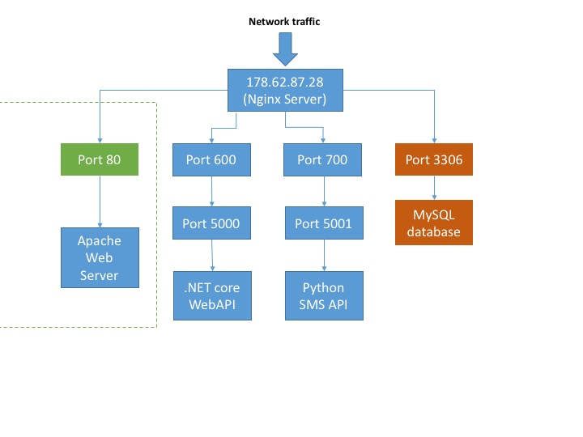

### 2.6.2 – Crontabs

The other important aspect on the server side was ensuring that all the various APIs and the database ran at the same time. In fact, normally, even running a single one of them would not occur at the same time normally, as they each took focus over a console window. Therefore, by creating a bash script which would execute each of them in the background was required. This would carry out the console commands that would be otherwise required to run the programs to be bypassed, as simply running the bash script would run all these commands, while allowing all the APIs to run in the background.

In case the server ever went down – the provider often complete a number of scheduled maintenance sessions, another measure was taken to ensure that the APIs would restart and there would be no problems. By defining a crontab, a specific script could be run at a particular time. Therefore using a crontab which would run at startup, the bash script to startup the APIs could be run at startup, therefore meaning that the service of the APIs would be up again, after any issues.

## 2.7 – Testing Strategy

The general aim of the testing is to test each part in turn, before testing the entirety of the system. Hence, the following test series were developed:

**Test Series 1: Testing the Web API (Black-Box Testing)**

In order to test the WebAPI, the requests from the Android App will be spoofed, using Postman, which allows one to send HTTP requests to each of the HTTP functions

The testing of the WebAPI gets further split into testing the following:

|  |  |
| --- | --- |
| Test Series Number | Purpose of Test Series |
| 1.1 | Test SQL command class |
| 1.2 | Test DateTime Parsing |
| 1.3 | Test HTTP GET (get it to send commands to a computer which will process and log the requests) |
| 1.4 | Test Accounts controller |
| 1.5 | Test AccountsForHelper controller |
| 1.6 | Test AccountsForElderly controller |
| 1.7 | Test Appointments controller |
| 1.8 | Test Ratings controller |
| 1.9 | Test Reviews controller |
| 1.10 | Test Timetable controller |

**Test Series 2: Testing the Python SMS Server API (Black-Box Testing)**

In order to test the Python SMS Server, the tests can be triggered by a combination of SMS messages from a phone and using Postman to trigger the API functions.

|  |  |
| --- | --- |
| Test Series Number | Purpose of Test Series |
| 2.1 | Test GET on ‘/’ |
| 2.2 | Test SMS receipt on /SMS |
| 2.3 | Test /sendSMS |
| 2.4 | Test /verifyNumber |

**Test Series 3: Testing the Android Application**

In order to test the Android Application, the flow of the android app is tested, ensuring that buttons send the application to correct places.

|  |  |
| --- | --- |
| Test Series Number | Purpose of Test Series |
| 3.1 | Test ‘Login or Register’ screen |
| 3.2 | Test ‘Login’ screen |
| 3.3 | Test ‘Register’ screen |
| 3.4 | Test ‘List of Appointments’ screen |
| 3.5 | Test ‘Appointment Details’ screen |
| 3.6 | Test ‘Ratings submit’ screen |
| 3.7 | Test ‘Review submit’ screen |
| 3.8 | Test ‘Helper details’ screen |
| 3.9 | Test ‘See reviews’ screen |
| 3.10 | Test ‘Book appointment weeks’ screen |
| 3.11 | Test ‘Book appointment days’ screen |
| 3.12 | Test ‘Book appointment times’ screen |
| 3.13 | Test ‘Book details confirm’ screen |
| 3.14 | Test ‘Appointment details (helper)’ screen |
| 3.15 | Test ‘Set Timetable’ screen |
| 3.16 | Test ‘Set Timetable days’ screen |
| 3.17 | Test ‘Set Timetable times’ screen |
| 3.18 | Test ‘Welcome Elderly’ screen |
| 3.19 | Test ‘Welcome Helper’ screen |
| 3.20 | Test ‘Book Appointment – List of nearby helpers’ screen |

**Test Series 4: Full system testing**

Since much of this data relies upon data which is not static, it is hard to have tests which have set results, since the results will vary based on when the test is completed. Therefore, it is important that the results are generally reasonably easy to verify by using an application with a GUI to look at the raw data in the database and ensure that things like the timetable point to correct days. The application which is being used for this is HeidiSQL.

|  |  |
| --- | --- |
| Test Series Number | Purpose of Test Series |
| 4.1 | Test registering |
| 4.2 | Test logging in |
|  | **ElderlyTests** |
| 4.4 | Test list of appointments |
| 4.5 | Test one appointment |
| 4.6 | Test rating |
| 4.7 | Test review |
|  | **ElderlyTests.BookAppointment** |
| 4.9 | Test list of helpers |
| 4.10 | Test helper details |
| 4.11 | Test book appointment |
| 4.12 | **General UI Testing** |
| 4.13 | Test SMS appointment creation system |
|  | **HelperTests** |
| 4.14 | Test set timetable (and subsequently booking appointments) |
| 4.17 | **General UI Testing** |

# 3 – Implementation

See the appendices for the code.

# 4 – Testing

## 4.1 – Test Series 1

|  |  |  |  |  |  |
| --- | --- | --- | --- | --- | --- |
| Test Number | Purpose / Description | Test Data | Reason | Expected Result | Passed |
| 1.1.1 | Test general select | **T1.1.1** | Normal Data | **E1.1.1** | Yes |
| 1.1.2 | Test incorrect syntax select | **T1.1.2** | Erroneous Data | **E1.1.2** | Yes |
| 1.1.3 | Test ungettable data in database | **T1.1.3** | Erroneous Data | **E1.1.2** | Yes |
| 1.1.4 | Test update data | **T1.1.4** | Normal Data | **E1.1.3** | Yes |
|  |  |  |  |  |  |
| 1.2.1 | Test with correct date and time | **T1.2.1** | Normal Data | **E1.2.1** | Yes |
| 1.2.2 | Test with keyword 'tomorrow' | **T1.2.2** | Normal Data | **E1.2.2** | Yes |
| 1.2.3 | Test without time | **T1.2.3** | Boundary Data | **E1.2.3** | Yes |
| 1.2.4 | Test without date | **T1.2.4** | Boundary Data | **E1.2.4** | Yes |
| 1.2.5 | Test with correct date and time with american format | **T1.2.5** | Normal Data | **E1.2.5** | Yes |
|  |  |  |  |  |  |
| 1.3.1 | Test with correct HTTP GET | **T1.3.1** | Normal Data | **E1.3.1** | Yes |
| 1.3.2 | Test with incorrect URL HTTP GET | **T1.3.2** | Erroneous Data | **E1.3.2** | Yes |
| 1.3.3 | Test with incorrect URL HTTP GET | **T1.3.3** | Erroneous Data | **E1.3.3** | Yes |
|  |  |  |  |  |  |
| 1.4.1 | Test "Hello World" | **T1.4.1** | Normal Data | **E1.4.1** | Yes |
| 1.4.2 | Test add new user | **T1.4.2** | Normal Data | **E1.4.2** | Yes |
| 1.4.3 | Test verify new user | **T1.4.3** | Normal Data | **E1.4.3** | Yes |
|  |  |  |  |  |  |
| 1.5.1 | Test "Hello World" | **T1.5.1** | Normal Data | **E1.5.1** | Yes |
| 1.5.2 | Test GetInfo Successful | **T1.5.2** | Normal Data | **E1.5.2** | Yes |
| 1.5.3 | Test GetInfo Fail | **T1.5.3** | Erroneous Data | **E1.5.3** | Yes |
| 1.5.4 | Test AddNewUser Success | **T1.5.4** | Normal Data | **E1.5.4** | Yes |
| 1.5.5 | Test AddNewUser AlreadyExists | **T1.5.5** | Erroneous Data | **E1.5.5** | Yes |
| 1.5.6 | Test Delete Success | **T1.5.6** | Normal Data | **E1.5.6** | Yes |
| 1.5.7 | Test Delete fail | **T1.5.7** | Erroneous Data | **E1.5.7** | Yes |
| 1.5.8 | Test update success | **T1.5.8** | Normal Data | **E1.5.8** | Yes |
| 1.5.9 | Test update failure | **T1.5.9** | Erroneous Data | **E1.5.9** | Yes |
| 1.5.10 | Test verifyUser wrongPassword | **T1.5.10** | Normal Data | **E1.5.10** | Yes |
| 1.5.11 | Test verifyUser success | **T1.5.11** | Normal Data | **E1.5.11** | Yes |
| 1.5.12 | Test GetListOfUsersByDistance success | **T1.5.12** | Normal Data | **E1.5.12** | Yes |
| 1.5.13 | Test GetListOfUsersByDistance incorrectId | **T1.5.13** | Erroneous Data | **E1.5.13** | Yes |
|  |  |  |  |  |  |
| 1.6.1 | Test "Hello World" | **T1.6.1** | Normal Data | **E1.6.1** | Yes |
| 1.6.2 | Test GetInfo Successful | **T1.6.2** | Normal Data | **E1.6.2** | Yes |
| 1.6.3 | Test GetInfo Fail | **T1.6.3** | Erroneous Data | **E1.6.3** | Yes |
| 1.6.4 | Test AddNewUser Success | **T1.6.4** | Normal Data | **E1.6.4** | Yes |
| 1.6.5 | Test AddNewUser AlreadyExists | **T1.6.5** | Erroneous Data | **E1.6.5** | Yes |
| 1.6.6 | Test Delete Success | **T1.6.6** | Normal Data | **E1.6.6** | Yes |
| 1.6.7 | Test Delete fail | **T1.6.7** | Erroneous Data | **E1.6.7** | Yes |
| 1.6.8 | Test update success | **T1.6.8** | Normal Data | **E1.6.8** | Yes |
| 1.6.9 | Test update failure | **T1.6.9** | Erroneous Data | **E1.6.9** | Yes |
| 1.6.10 | Test verifyUser wrongPassword | **T1.6.10** | Normal Data | **E1.6.10** | Yes |
| 1.6.11 | Test verifyUser success | **T1.6.11** | Normal Data | **E1.6.11** | Yes |
|  |  |  |  |  |  |
| 1.7.1 | Test create new SMS impossible | **T1.7.1** | Erroneous Data | **E1.7.1** | Yes |
| 1.7.2 | Test create new SMS correct | **T1.7.2** | Normal Data | **E1.7.2** | Yes |
| 1.7.3 | Test create new SMS unrecognised number | **T1.7.3** | Erroneous Data | **E1.7.3** | Yes |
| 1.7.4 | Test sendSMS | **T1.7.4** | Normal Data | **E1.7.4** | Yes |
| 1.7.5 | Test createNewAppointmentsForAndroidApp correct | **T1.7.5** | Normal Data | **E1.7.5** | Yes |
| 1.7.6 | Test GetAppointmentInformation fail | **T1.7.6** | Erroneous Data | **E1.7.6** | Yes |
| 1.7.7 | Test GetAppointmentInformation success | **T1.7.7** | Normal Data | **E1.7.7** | Yes |
| 1.7.8 | Test RemoveAppointment incorrectId | **T1.7.8** | Erroneous Data | **E1.7.8** | Yes |
| 1.7.9 | Test RemoveAppointment success | **T1.7.9** | Normal Data | **E1.7.9** | Yes |
| 1.7.10 | Test AppointmentsByElderly incorrectId | **T1.7.10** | Erroneous Data | **E1.7.10** | Yes |
| 1.7.11 | Test AppointmentsByElderly correctId | **T1.7.11** | Normal Data | **E1.7.11** | Yes |
| 1.7.12 | Test AppointmentsByHelper incorrectId | **T1.7.12** | Erroneous Data | **E1.7.12** | Yes |
| 1.7.13 | Test AppointmentsByHelper correctId | **T1.7.13** | Normal Data | **E1.7.13** | Yes |
|  |  |  |  |  |  |
|  |  |  |  |  |  |
| 1.8.1 | Test GetAllRatingsForHelper correct | **T1.8.1** | Normal Data | **E1.8.1** | Yes |
| 1.8.2 | Test GetAllRatingsForHelper incorrect | **T1.8.2** | Erroneous Data | **E1.8.2** | Yes |
| 1.8.3 | Test GetOneSpecificRating correct | **T1.8.3** | Normal Data | **E1.8.3** | Yes |
| 1.8.4 | Test GetOneSpecificRating incorrect | **T1.8.4** | Erroneous Data | **E1.8.4** | Yes |
| 1.8.5 | Test AddARating | **T1.8.5** | Normal Data | **E1.8.5** | Yes |
| 1.8.6 | Test UpdateRating | **T1.8.6** | Normal Data | **E1.8.6** | Yes |
| 1.8.7 | Test DeleteRating | **T1.8.7** | Normal Data | **E1.8.7** | Yes |
|  |  |  |  |  |  |
| 1.9.1 | Test GetAllReviewsForHelper correct | **T1.9.1** | Normal Data | **E1.9.1** | Yes |
| 1.9.2 | Test GetAllReviewsForHelper incorrect | **T1.9.2** | Erroneous Data | **E1.9.2** | Yes |
| 1.9.3 | Test GetOneSpecificreview correct | **T1.9.3** | Normal Data | **E1.9.3** | Yes |
| 1.9.4 | Test GetOneSpecificReview incorrect | **T1.9.4** | Erroneous Data | **E1.9.4** | Yes |
| 1.9.5 | Test AddAReview | **T1.9.5** | Normal Data | **E1.9.5** | Yes |
| 1.9.6 | Test UpdateReview | **T1.9.6** | Normal Data | **E1.9.6** | Yes |
| 1.9.7 | Test DeleteReview | **T1.9.7** | Normal Data | **E1.9.7** | Yes |
|  |  |  |  |  |  |
| 1.10.1 | Test AddTimetable | **T1.10.1** | Normal Data | **E1.10.1** | Yes |
| 1.10.2 | Test GetTimetable | **T1.10.2** | Normal Data | **E1.10.2** | Yes |
| 1.10.3 | Test GetTimetable fail | **T1.10.3** | Erroneous Data | **E1.10.3** | Yes |
| 1.10.4 | test getWeek fail | **T1.10.4** | Erroneous Data | **E1.10.4** | Yes |
| 1.10.5 | Test getWeek success | **T1.10.5** | Normal Data | **E1.10.5** | Yes |
| 1.10.6 | Test GetDay success | **T1.10.6** | Normal Data | **E1.10.6** | Yes |
| 1.10.7 | Test GetDay fail | **T1.10.7** | Erroneous Data | **E1.10.7** | Yes |

## 4.2 – Test Series 2

|  |  |  |  |  |  |
| --- | --- | --- | --- | --- | --- |
| Test Number | Purpose / Description | Test Data | Reason | Expected Result | Passed |
| 2.1.1 | Test GET on '/' | **T2.1.1** | Normal Data | **E2.1.1** | Yes |
| 2.2.1 | Test SMS receipt from validated number | **T2.2.1** | Normal Data | **E2.2.1** | Yes |
| 2.2.2 | Test SMS receipt from invalidated number | **T2.2.2** | Boundary Data | **E2.2.2** | Yes |
| 2.3.1 | Test /sendSMS correct | **T2.3.1** | Normal Data | **E2.3.1** | Yes |
| 2.3.2 | Test /sendSMS to invalidated number | **T2.3.2** | Erroneous Data | **E2.3.2** | Yes |
| 2.3.3 | Test /sendSMS with no body | **T2.3.3** | Boundary Data | **E2.3.3** | Yes |
| 2.3.4 | Test /sendSMS with different phone format | **T2.3.4** | Boundary Data | **E2.3.4** | Yes |
| 2.3.5 | Test /sendSMS with incorrect phone number | **T2.3.5** | Erroneous Data | **E2.3.5** | Yes |
| 2.3.6 | Test /sendSMS without correct information | **T2.3.6** | Erroneous Data | **E2.3.6** | Yes |
| 2.4.1 | Test /verifyNumber correct | **T2.4.1** | Normal Data | **E2.4.1** | Yes |
| 2.4.2 | Test /verifyNumber without correct information | **T2.4.2** | Erroneous Data | **E2.4.2** | Yes |

## 4.3 – Test Series 3

|  |  |  |  |  |  |
| --- | --- | --- | --- | --- | --- |
| Test Number | Purpose / Description | Test Data | Reason | Expected Result | Passed |
| 3.1.1 | Test login button | **T3.1.1** | Normal Data | **E3.1.1** | Yes |
| 3.1.2 | Test register button | **T3.1.2** | Normal Data | **E3.1.2** | Yes |
| 3.2.1 | Test back button | **T3.2.1** | Normal Data | **E3.2.1** | Yes |
| 3.2.2 | Test incomplete fields click | **T3.2.2** | Erroneous Data | **E3.2.2** | Yes |
| 3.3.1 | Test incomplete fields click | **T3.3.1** | Erroneous Data | **E3.3.1** | Yes |
| 3.3.2 | Test incomplete fields click | **T3.3.2** | Erroneous Data | **E3.3.2** | Yes |
| 3.3.3 | Test incomplete fields click | **T3.3.3** | Erroneous Data | **E3.3.3** | Yes |
| 3.3.4 | Test incomplete fields click | **T3.3.4** | Erroneous Data | **E3.3.4** | Yes |
| 3.3.5 | Test incomplete fields click | **T3.3.5** | Erroneous Data | **E3.3.5** | Yes |
| 3.3.6 | Test incomplete fields click | **T3.3.6** | Erroneous Data | **E3.3.6** | Yes |
| 3.3.7 | Test incomplete fields click | **T3.3.7** | Erroneous Data | **E3.3.7** | Yes |
| 3.3.8 | Test incomplete fields click | **T3.3.8** | Erroneous Data | **E3.3.8** | Yes |
| 3.3.9 | Test incomplete fields click | **T3.3.9** | Erroneous Data | **E3.3.9** | Yes |
| 3.3.10 | Test incomplete fields click | **T3.3.10** | Erroneous Data | **E3.3.10** | Yes |
| 3.3.11 | Test password not matching click | **T3.3.11** | Erroneous Data | **E3.3.11** | Yes |
| 3.3.12 | Test back button | **T3.3.12** | Normal Data | **E3.3.12** | Yes |
| 3.4.1 | Test clicking on appointment | **T3.4.1** | Normal Data | **E3.4.1** | Yes |
| 3.4.2 | Test back button | **T3.4.2** | Normal Data | **E3.4.2** | Yes |
| 3.5.1 | Test back button | **T3.5.1** | Normal Data | **E3.5.1** | Yes |
| 3.5.2 | Test set rating | **T3.5.2** | Normal Data | **E3.5.2** | Yes |
| 3.5.3 | Test set review | **T3.5.3** | Normal Data | **E3.5.3** | Yes |
| 3.6.1 | Test back button | **T3.6.1** | Normal Data | **E3.6.1** | Yes |
| 3.7.1 | Test back button | **T3.7.1** | Normal Data | **E3.7.1** | Yes |
| 3.8.1 | Test see reviews | **T3.8.1** | Normal Data | **E3.8.1** | Yes |
| 3.8.2 | Test book appointment | **T3.8.2** | Normal Data | **E3.8.2** | Yes |
| 3.9.1 | Test back button | **T3.9.1** | Normal Data | **E3.9.1** | Yes |
| 3.10.1 | Test back button | **T3.10.1** | Normal Data | **E3.10.1** | Yes |
| 3.10.2 | Test clicking on week | **T3.10.2** | Normal Data | **E3.10.2** | Yes |
| 3.11.1 | Test back button | **T3.11.1** | Normal Data | **E3.11.1** | Yes |
| 3.11.2 | Test clicking on day | **T3.11.2** | Normal Data | **E3.11.2** | Yes |
| 3.12.1 | Test back button | **T3.12.1** | Normal Data | **E3.12.1** | Yes |
| 3.12.2 | Test clicking on time | **T3.12.2** | Normal Data | **E3.12.2** | Yes |
| 3.13.1 | Test back button | **T3.13.1** | Normal Data | **E3.13.1** | Yes |
| 3.14.1 | Test back button | **T3.14.1** | Normal Data | **E3.14.1** | Yes |
| 3.15.1 | Test back button | **T3.15.1** | Normal Data | **E3.15.1** | Yes |
| 3.15.2 | Test clicking on week | **T3.15.2** | Normal Data | **E3.15.2** | Yes |
| 3.16.1 | Test back button | **T3.16.1** | Normal Data | **E3.16.1** | Yes |
| 3.16.2 | Test clicking on day | **T3.16.2** | Normal Data | **E3.16.2** | Yes |
| 3.17.1 | Test back button | **T3.17.1** | Normal Data | **E3.17.1** | Yes |
| 3.18.1 | Test clicking list of appointments | **T3.18.1** | Normal Data | **E3.18.1** | Yes |
| 3.18.2 | Test clicking book appointment | **T3.18.2** | Normal Data | **E3.18.2** | Yes |
| 3.19.1 | Test clicking set timetable | **T3.19.1** | Normal Data | **E3.19.1** | Yes |
| 3.19.2 | Test clicking list of appointments | **T3.19.2** | Normal Data | **E3.19.2** | Yes |
| 3.20.1 | Test clicking helper | **T3.20.1** | Normal Data | **E3.20.1** | Yes |
| 3.20.2 | Test back button | **T3.20.2** | Normal Data | **E3.20.2** | Yes |

## 4.4 – Test Series 4

|  |  |  |  |  |  |
| --- | --- | --- | --- | --- | --- |
| Test Number | Purpose / Description | Test Data | Reason | Expected Result | Passed |
| 4.1.1 | Test twilio verification success | **T4.1.1** | Normal Data | **E4.1.1** | Yes |
| 4.1.2 | Test no internet | **T4.1.2** | Boundary Data | **E4.1.2** | Yes |
| 4.2.1 | Test no internet | **T4.2.1** | Boundary Data | **E4.2.1** | Yes |
| 4.2.2 | Test incorrect password | **T4.2.2** | Boundary Data | **E4.2.2** | Yes |
| 4.2.3 | Test correct password | **T4.2.3** | Normal Data | **E4.2.3** | Yes |
| 4.2.4 | Test autologin | **T4.2.4** | Normal Data | **E4.2.4** | Yes |
| 4.4.1 | Test and see all appointments | **T4.4.1** | Normal Data | **E4.4.1** | Yes |
| 4.5.1 | Test and see one appointment accurate | **T4.5.1** | Normal Data | **E4.5.1** | Yes |
| 4.5.2 | Test past appointment | **T4.5.2** | Normal Data | **E4.5.2** | Yes |
| 4.5.3 | Test current appointment | **T4.5.3** | Normal Data | **E4.5.3** | Yes |
| 4.6.1 | Test rating | **T4.6.1** | Normal Data | **E4.6.1** | Yes |
| 4.7.1 | Test review | **T4.7.1** | Normal Data | **E4.7.1** | Yes |
| 4.9.1 | Test list of helpers on account with failed postcode | **T4.9.1** | Erroneous Data | **E4.9.1** | Yes |
| 4.9.2 | Test list of helpers on account with successful postcode | **T4.9.2** | Normal Data | **E4.9.2** | Yes |
| 4.10.1 | Test helper details | **T4.10.1** | Normal Data | **E4.10.1** | Yes |
| 4.10.2 | Test see reviews | **T4.10.2** | Normal Data | **E4.10.2** | Yes |
| 4.11.1 | Test book appointment in past | **T4.11.1** | Erroneous Data | **E4.11.1** | Yes |
| 4.11.2 | Test book appointment on used date | **T4.11.2** | Boundary Data | **E4.11.2** | Yes |
| 4.11.3 | Test book appointment successful | **T4.11.3** | Normal Data | **E4.11.3** | Yes |
| 4.11.4 | Test book appointment and then cancel | **T4.11.4** | Normal Data | **E4.11.4** | Yes |
| 4.11.5 | Test cancel appointment | **T4.11.5** | Normal Data | **E4.11.5** | Yes |
| 4.13.1 | Test SMS send success | **T4.13.1** | Normal Data | **E4.13.1** | Yes |
| 4.13.2 | Test SMS send incorrect data | **T4.13.2** | Erroneous Data | **E4.13.2** | Yes |
| 4.13.3 | Test SMS when no space in anyone | **T4.13.3** | Boundary Data | **E4.13.3** | Yes |
| 4.14.1 | Test set timetable and see if changes | **T4.14.1** | Normal Data | **E4.14.1** | Yes |
| 4.14.2 | Test set timetable and see if you can book appointment | **T4.14.2** | Normal Data | **E4.14.2** | Yes |

### 4.12 and 4.17

In order to attempt to complete test 4.12 and 4.17, the applications were placed into the hands of two random users (different to the end users), with a bare minimum explanation to see if they could complete the following tasks (determined as they tested all the important features of the application and would be enough for them to successfully have an appointment):

#### Elderly App

1. Create an account
2. Book an appointment with a nearby helper tomorrow after looking at the helper’s rating and reviews.
3. Cancel the appointment.
4. Book another appointment tomorrow.
5. (At this point, the raw data was altered by changing the data in the database (this is not accessable to the user) and the appointment changed to be in the past)
6. Rate the helper.
7. Review the helper.
8. Book an appointment with an SMS message for two days time at 12pm.

#### Helper App

1. Create an account
2. Set the timetable to reasonable hours for the next two weeks.
3. (At this point an appointment was created with the user using another device)
4. Cancel the newly created appointment.

Both test users managed to complete all tasks with no additional assistance, so the tests can be deemed to be successful.

# 5 – Evaluation

|  |  |  |
| --- | --- | --- |
| Objective | Objective met? | Details |
| 1 - Input |  |  |
| There must be an Android app, which works with all Android phones with software later than Android Ice Cream Sandwich (4.0). | Yes | Though the application has only been tested to be working above Android 5.0 (due to a lack of test devices), it has been simulated at lower device versions (including 4.0) and has been working. |
| The elderly person should also be able to create an appointment with an SMS messages to a specified phone number. | Yes | Tests 4.13 show that this system is working. |
| The SMS should only require the user to send a Date and Time and the information about the appointment should be communicated directly back to the user over SMS. | Yes | Tests 4.13 show that the system works when a date and time is sent over SMS and successfully returns errors when not all data is present.  4.13.1 shows the receipt of the information of an appointment. |
| To log onto the Android application, the system should remember the password of the user once they have logged in once, thereby allowing them to not need to remember the password. | Yes | Test 4.2.4 shows that the autologin system ensures that users do not need to log onto the system multiple times on the same device. |
| 2 - User Interface (on all systems) |  |  |
| The screens should be as simple as possible, removing unnecessary information to other screens if necessary. | Yes | Test 4.12 shows that the interface is very simple as a person with little instruction is able to use it.  Additionally, having given it to an elderly neighbour at a few points throughout the development, he now believes it is at a point at which anybody can use the system with little to no training. |
| As a maximum, there should be two possible (very different) paths to follow from every screen, with the difference in what each button does being marked clearly. | Yes | Looking at the design shows that there are never more than two different paths through the application at one time – with the exception of ListViews, where each lead to the same path, just with different data. |
| All text should be large, above 12pt, to ensure that the elderly person can see it easily, with worse eye-sight. | Yes | Looking at the code, it is clear to see that all text is at least of size 12pt. |
| There should be a screen where the user will be able to scroll through the nearby teenagers who can provide tech support. | Yes | This is the ‘Book Appointment’ screen, shown in section 2.4.3 and tested in 4.9.2. |
| This screen should be organised by how near the helper is, therefore meaning that the helper is unlikely to have to travel from very far. | Yes | This is tested and shown to be working in test 4.9.2. |
| For each teenager, the elderly person should be able to see their average rating (if they have been rated), location and all of their reviews. | Yes | The average rating is visible in the ‘Book Appointment’ screen (2.4.3), while the ‘See Reviews’ screen is described in 2.4.3 and tested in 4.10.2 |
| The user should be able to look at the various appointments a teenager has free, allowing them to choose a time which would suit them. | Yes | The user can view the times that the helpers are free over the next four weeks, therefore being able to choose whichever one of them suits the elderly person best. |
| They should be able to book an appointment for any available time at least within the next two weeks. | Yes | They can in fact pick any appointment within the next four weeks. |
| The user should be able to see the list of upcoming and past appointments, seeing the details about the appointment. | Yes | They can see all this information in the ‘List of Appointments’ screen, described in 2.4.2 and tested in 4.4.1. |
| For appointments in the past, the user should be able to rate and review the helper, therefore helping future elderly people to decide whether the helper would be able to help them. | Yes | Designed in 2.4.3 and tested in 4.5.2 vs 4.5.3. |
| For appointments in the future, the user should be able to cancel the appointment, if they are no longer free. | Yes | This was designed in 2.4 and tested in 4.5.4 |
| 3 – Teenager’s Input |  |  |
| There must be an Android app through which the person should be able to interact with the system. | Yes | There is an android app which has been designed in section 2.4 and tested in section 4. |
| There should be a system to ensure to remember the password for the android application, so that they would not have to remember the password every time they log onto the application. | Yes | Test 4.2.4 shows that the autologin system ensures that users do not need to log onto the system multiple times on the same device. |
| 4 – Teenager’s User Interface |  |  |
| The user must be able to see everyone who has requested their help. | Yes | They can see all this information in the ‘List of Appointments’ screen, described in 2.4.2 and tested in 4.4.1. |
| They should be able to cancel any appointments which they are no longer able to be available for. | Yes | This was designed in 2.4 and tested in 4.5.4 |
| The user should also be able to define when they are free for the next six weeks, allowing them to set the times that they would be free for appointments. | Yes | This ability was designed in 2.4.2 and tested in 4.14. The application allows the user to set their times that they are free for the next eight weeks, firstly choosing the week to edit, then the day and finally choosing the times that they are free for that day. |
| 5 - The appointments should be two hours in length for all appointments. | Yes | As throughout the design and in the implementation, the appointments are designed to be two hours long, running between even hours. |
| 6 - The payment should be defined as £20 per hour for the appointments, therefore being £20 if the appointment takes up less than half the appointment slot, or £40 otherwise. | Yes | The payment, while not being discussed throughout the app has been defined to be £20 per hour and this should be discussed in any user manual. |
| 7 - The system should be secure, with passwords hashed to ensure that they are not easy to utilise in case the server is hacked. | Yes | The passwords are hashed with MD5, see section 2.3.3 |

## 5.1 – User Feedback

### 5.1.1 – Mrs Wilson (AgeUK)

Mrs Wilson, on being shown the completed system, immediately found the system incredibly impressive, finding that it had not only met the specification that had been defined but most importantly that the system was very well designed, being aesthetically pleasing for both the elderly and the helpers.

In showing Mrs Wilson the system, I largely focused on the elderly side, as this was the part of the specification which she had helped to define. Upon picking up the application for the first time, she mentioned that the system was very easy to use, and could easily be used by any members of the elderly that she taught without too much trouble.

During the registration process, the only part which she found poorly documented and difficult to understand was the Twilio verification step, since if the elderly person left the code screen too quickly or failed to get the call the first time, then there was no method by which this could be resolved. She commented that it would be useful to have the opportunity to do this within the logged in section.

Another comment she made was the lack of a ‘forgot my password’ section which would be incredibly useful if an elderly person forgets their password. However, she particularly liked the autologin features (which we hadn’t previously discussed) finding that this feature makes the lack of a ‘forgot my password’ section far more acceptable. She also commented that biometrics on newer phones could be another feature which could be integrated to further reduce the amount of work elderly people would have to do.

Within the logged in section, she again loved the simplicity, with each screen having a well-defined purpose. She was somewhat surprised that I had managed to keep to her guideline of a maximum of two separate things on a single screen. She particularly enjoyed the booking system which she found very intuitive – with plenty of messages to the user wherever necessary but offering a simple process.

She commented on a problem that an elderly person could book an appointment with someone who was miles away. She recommended therefore, at the very least, the distance could be displayed for the elderly person to see – since this is already calculated in the backend.

Another minor issue she had found was that found the time delay in finding the nearest helpers was rather longer than she would have liked and therefore, if possible, this could be reduced. However, for the rest of the interface, she found it to be very snappy and without any latency.

Overwhelmingly however, the feedback was positive and she was excited for the possibilities for the application. She was already discussing how it could be rolled out to help elderly people around the country, and was excited to show this to some of the elderly people who she taught in the elderly technical support classes she ran.

### 5.1.2 – Phil Fernandes

Phil largely found that the system was exceedingly effective and easily met his requirements. He commented on the ease of use of the system, saying that anyone could definitely use the helper side of the software, which, though not a particularly important a thing (this was not a specification point), is always a positive.

He says the interface is intuitive and easy to use, as long as there is a little bit of understanding with regards to what the application does. Therefore, if the application were to be more broadly launched, it would be useful to produce a ‘User Manual’ or something to this effect which could briefly show how to use the application.

He mentioned that the one area where he anticipated that problems may have arisen from, the setting of the timetable and booking of timetables has an effective interface, by allowing the users to first choose the week, then the day and then edit the hour or book an appointment at a particular hour.

He said that there were a few possible issues which could be addressed is simplifying this process even more might be useful, attempting to bring in a calendar-esque interface, rather than this approach. Though perhaps harder to produce, the calendar approach would allow for more effective usage of the application.

He also mentioned that the aspect of no maximum distance for each helper user being unhelpful and something which should be added if there were to be time.

## 5.2 – Analysis

### 5.2.1 – Learnability

Throughout the process, the easy of use of the application by the elderly has been foremost in my mind, with a number of tests throughout the programming, to ensure that the application could be used by a random person without any instruction. This culminated in test 4.12, which shows that someone, given little to no instruction, can perform a set of tasks with the application. This, alongside the comments by Mrs Wilson and Phil seem to vindicate this effort as they all mention that they find it very easy to use and therefore usable by all elderly people without any issues.

However, even given this, it would almost certainly be useful, before the product were to be released, to produce a User Manual to outline the various things the application can do and outline how they can be done.

The User Manual would also offer an opportunity to shine a light on two areas where the least information is provided to users, payment and the SMS messaging system. At no point in the application is payment discussed, despite a fixed fee system having been decided in the Analysis. In the application however, there is no correct page where this information would fit. Additionally, the exact format for SMS messages to be sent by the elderly person to the server and the phone number to send them to is not properly defined and could be easily made mistakes on. Though not a particularly complex issue, not a challenging one to talk about, it would be an important thing to mention in any user manual.

### 5.2.2 – Latency

Mrs Wilson complained that there was too much of a time lag in the transition between two screens, the login screen and the welcome screen (for the elderly) and between the welcome screen and ‘Book Appointment’ (i.e. the list of nearby helpers) screen.

For the login screen, the time lag is almost certainly down to the time taken by the MD5 hashing algorithm. The MD5 algorithms gets its impressive security by being vastly complex an algorithm and therefore this conversion inevitably will take some time. Additionally, since this is only likely to be completed once every time the app is used, this seems acceptable.

For the book appointment screen, it seems far more a consequence of the speed of the Google Maps API, since it returns lots of information, including the route between the two points, traffic, etc. Since all I need in fact, is a longitude and latitude for each point, and then the distance can be calculated using Haversine Formula, this should be saved in the database and calculated upon registration. Alternatively, another API, such as the OpenMaps API could be used instead for simpler results. Another important matter to consider when considering the solution is that if this were to be scaled up, there might be problems due to the number of calls made to the Google Maps API – which limits this to ten per second, unless you pay for the paid account.

### 5.2.3 – Improvements

In order to improve the system, it would be better to store the location of each helper as a longitude and latitude in the database as this would allow for a much faster sorting of the system.

Additionally, it would be better to make use of a more significant Natural Language processing system, since the one I am currently using is very specific as to the information it requires to work. For example, if a year is not specified when the entirety of a date is specified then it assumes the date is today’s date, rather than parsing the rest of the date and assuming the year is this year (the far more logical assumption). Additionally, it relies upon the user abiding by a specific timing format (HH:MM). If I had used a library like IBM Watson’s inbuilt NLP API, it would be able to deal with all formats, in addition to dealing with things like ‘quarter past’ etc which are substituted instead of the time. It would also continue to work even if there are a few spelling mistakes, something which currently prevents the system from parsing the date.

### 5.2.4 – Extensions

**iOS Applications**

The first extension would be to ensure that the application could be produced for iOS to ensure that elderly people and teenagers with iOS phones and tablets could also use the system.

In fact, since the Android application was produced using Xamarin, this shouldn’t pose too much of a challenge as the vast majority of the code could be reused if the application for iOS were to be coded in Xamarin iOS.

**Tablet Specific Application**

Another extension would be to produce a tablet specific application, especially catering to cheap Android tablets, which have proved very successful with the elderly people, according to Mrs Wilson. Though the application as it currently stands can be used on a tablet (and has been informally tested on a Nexus 7 tablet), the system should be redesigned to cater for the larger screen and the added functionality which can be gotten from this.

**Variable time-slot appointments**

As mentioned by Phil, another change that could be made is introducing variable length appointments or offering a number of possible lengths. This would increase the efficiency of the process as the teenagers could help more elderly people in the same amount of time. This would be especially important when the elderly person knows the problem would be quick to solve but can’t solve it themselves.

**Maximum travelable distance for helpers**

The current solution has no method to stop elderly people booking appointments with teenagers who live hours, or even further, away. Therefore, if a maximum distance decision could be added when the helper signs up for an account, this can be taken into account into whether to display their account in the ‘Book an Appointment’ view for a specific elderly person, by simply comparing this decided maximum distance with the distance between the helper and the elderly person.

# Appendices

## Appendix A – Web API Code

### Backend

#### HttpCommandOut.cs

using System;

using System.Collections.Generic;

using System.Linq;

using System.Threading.Tasks;

using System.Net.Http;

using System.Net;

using System.IO;

namespace TestApi.Backend

{

public class HTTPCommandOut

{

/// <summary>

/// Completes a HTTP Get

///

/// </summary>

public HTTPCommandOut() { }

/// <summary>

/// Since it's asynchronous, it returns a task. However, in reality, the only

/// thing which is used from the task return is the result.

/// </summary>

/// <param name="url">This is the URL to complete the GET command from</param>

/// <returns>Returns a Task (of a stream). From here, the stream can be created and the contents read using a StreamReader</returns>

public async Task<Stream> get(string url)

{

using (var client = new HttpClient()) // The using ensures the HTTPClient cannot be used outside of scope.

{

client.BaseAddress = new Uri(url); // Important to note that since it is used directly as a URI, the url must be fully defined

// i.e. also including the http://

var response = await client.GetAsync(""); // Asynchronously calls the task

Stream stringResponse = await response.Content.ReadAsStreamAsync(); //Gets the response

StreamReader x = new StreamReader(stringResponse); //

return stringResponse; // Returns the task of the stream

}

}

}

}

#### SQLStuff.cs

using System;

using System.Collections.Generic;

using System.Linq;

using System.Threading.Tasks;

using Microsoft.AspNetCore.Mvc;

using MySql.Data.MySqlClient;

using MySql.Data.Common;

using MySql.Data.Types;

namespace TestApi.Sql

{

public class SQLStuffOnTopOfController : Controller

{

public const bool server = false; // on the test machine, this is set to false to set the url to point to the server. Otherwise, for speed, it should point to localhost

/// <summary>

/// Returns a command - follows the following process:

/// (1) Creates a new connection with the db.

/// (2) Completes the SQL query

/// (3) Returns the value got from the MySQL server

/// </summary>

/// <param name="isResultExpected">true if a result is expected, false if not</param>

/// <param name="command">String value of the query</param>

/// <param name="numberExpectedPerRow">Defaults at one, but otherwise knows how to split the response</param>

/// <returns></returns>

public static string sqlCommand(bool isResultExpected, string command, int numberExpectedPerRow = 1)

{

MySqlConnection dbConnection = setupConnection(); // Setup Connection and return MySqlConnection object

MySqlCommand commandForSql = new MySqlCommand(command, dbConnection);

if(isResultExpected)

{

MySqlDataReader a = commandForSql.ExecuteReader();

string toReturn = String.Empty;

while(a.Read())

{

for (int i = 0; i < numberExpectedPerRow; i++)

{

string ab = a.GetDataTypeName(i); //In case we are expecting a DateTime - deal with this

if (ab == "DATETIME")

{

toReturn += a.GetDateTime(i).ToString() + "#"; // Gets the DateTime as a DateTimeObject which can definitely be parsed by a DateTime.Parse()

}

else

toReturn += a.GetValue(i) + "#";

}

//# is used to seperate items in the same line

toReturn += "\n";

//NewLine ('\n') is used to seperate different lines

}

a.Close(); //For stability, the DataReader is closed

closeConnection(dbConnection); // Connection is closed

return toReturn;

}

else

{

commandForSql.ExecuteScalar(); // just execute the command

}

closeConnection(dbConnection); // Close the connection

return String.Empty; // if you haven't already returned the string, then return an empty string

}

public static void closeConnection(MySqlConnection a)

{

a.Close();

}

/// <summary>

/// Setup connection

/// (1) Defines the correct string for the connection

/// (2) Sets up the connection and returns the connection object.

/// </summary>

public static MySqlConnection setupConnection()

{

string connectionString = String.Empty;

if(server)

connectionString = "server=localhost;user id=ashwin;password=Poonam123;port=3306;database=ComputingProject;SslMode=None;Convert Zero DateTime=True;Allow Zero DateTime=True";

else

connectionString = "server=178.62.87.28;user id=ashwin;password=Poonam123;port=3306;database=ComputingProject;SslMode=None;Convert Zero DateTime=True;Allow Zero DateTime=True";

MySqlConnection dbConnection = new MySqlConnection(connectionString);

dbConnection.Open();

return dbConnection;

}

}

}

#### SmsStuff.cs

using System;

using System.Collections.Generic;

using System.Linq;

using System.Threading.Tasks;

using System.Net;

using System.Net.Http;

using System.IO;

using TestApi.Backend;

using TestApi.Controllers;

using Newtonsoft.Json;

using TestApi.Types;

using System.Text;

namespace TestApi.Backend

{

public class sms

{

/// <summary>

/// Send SMS to the number listed.

/// Method is asynchronous as it calls assynchronous methods in HTTPClient methods.

/// </summary>

/// <param name="from">The phone number to send the SMS to</param>

/// <param name="body">The contents of the message to send</param>

async void sendSMS(string from, string body)

{

Controllers.sms s = new Controllers.sms(); // Creates an SMS object

s.Body = body;

s.From = from;

string json = JsonConvert.SerializeObject(s); // Converts the object into JSON

string url = "http://178.62.87.28:700/sendSms"; // Defines the URL for the POST call to the SMS server.

var httpContent = new StringContent(json, Encoding.UTF8, "application/json"); // Adds the correct header to the JSON

using (var httpClient = new HttpClient())

{

var httpResponse = await httpClient.PostAsync(url, httpContent);

if (httpResponse.Content != null) // if there is a response - deal with it.

{

var responseContent = await httpResponse.Content.ReadAsStringAsync(); // gets the value of the response

}

}

}

}

}

#### DateTimeRoutines.cs

//********************************************************************************************

//Author: Sergey Stoyan, CliverSoft.com

// http://cliversoft.com

// stoyan@cliversoft.com

// sergey.stoyan@gmail.com

// 27 February 2007

//********************************************************************************************

using System;

using System.Collections.Generic;

using System.Text;

using System.IO;

using System.Text.RegularExpressions;

using System.Threading;

using System.Collections;

/// <summary>

/// API which is used to help to parse the SMS received by the user and therefore returns a date

/// and time which can be used to help to create an appointment.

/// </summary>

namespace TestApi.Backend

{

/// <summary>

/// Miscellaneous and parsing methods for DateTime

/// </summary>

public static class DateTimeRoutines

{

#region miscellaneous methods

/// <summary>

/// Amount of seconds elapsed between 1970-01-01 00:00:00 and the date-time.

/// </summary>

/// <param name="date_time">date-time</param>

/// <returns>seconds</returns>

public static uint GetSecondsSinceUnixEpoch(this DateTime date_time)

{

TimeSpan t = date_time - new DateTime(1970, 1, 1);

int ss = (int)t.TotalSeconds;

if (ss < 0)

return 0;

return (uint)ss;

}

#endregion

#region parsing definitions

/// <summary>

/// Defines a substring where date-time was found and result of conversion

/// </summary>

public class ParsedDateTime

{

/// <summary>

/// Index of first char of a date substring found in the string

/// </summary>

readonly public int IndexOfDate = -1;

/// <summary>

/// Length a date substring found in the string

/// </summary>

readonly public int LengthOfDate = -1;

/// <summary>

/// Index of first char of a time substring found in the string

/// </summary>

readonly public int IndexOfTime = -1;

/// <summary>

/// Length of a time substring found in the string

/// </summary>

readonly public int LengthOfTime = -1;

/// <summary>

/// DateTime found in the string

/// </summary>

readonly public DateTime DateTime;

/// <summary>

/// True if a date was found within the string

/// </summary>

readonly public bool IsDateFound;

/// <summary>

/// True if a time was found within the string

/// </summary>

readonly public bool IsTimeFound;

/// <summary>

/// UTC offset if it was found within the string

/// </summary>

readonly public TimeSpan UtcOffset;

/// <summary>

/// True if UTC offset was found in the string

/// </summary>

readonly public bool IsUtcOffsetFound;

/// <summary>

/// Utc gotten from DateTime if IsUtcOffsetFound is True

/// </summary>

public DateTime UtcDateTime;

internal ParsedDateTime(int index_of_date, int length_of_date, int index_of_time, int length_of_time, DateTime date_time)

{

IndexOfDate = index_of_date;

LengthOfDate = length_of_date;

IndexOfTime = index_of_time;

LengthOfTime = length_of_time;

DateTime = date_time;

IsDateFound = index_of_date > -1;

IsTimeFound = index_of_time > -1;

UtcOffset = new TimeSpan(25, 0, 0);

IsUtcOffsetFound = false;

UtcDateTime = new DateTime(1, 1, 1);

}

internal ParsedDateTime(int index_of_date, int length_of_date, int index_of_time, int length_of_time, DateTime date_time, TimeSpan utc_offset)

{

IndexOfDate = index_of_date;

LengthOfDate = length_of_date;

IndexOfTime = index_of_time;

LengthOfTime = length_of_time;

DateTime = date_time;

IsDateFound = index_of_date > -1;

IsTimeFound = index_of_time > -1;

UtcOffset = utc_offset;

IsUtcOffsetFound = Math.Abs(utc_offset.TotalHours) < 12;

if (!IsUtcOffsetFound)

UtcDateTime = new DateTime(1, 1, 1);

else

{

if (index_of_date < 0)//to avoid negative date exception when date is undefined

{

TimeSpan ts = date_time.TimeOfDay + utc_offset;

if (ts < new TimeSpan(0))

UtcDateTime = new DateTime(1, 1, 2) + ts;

else

UtcDateTime = new DateTime(1, 1, 1) + ts;

}

else

UtcDateTime = date_time + utc_offset;

}

}

}

/// <summary>

/// Date that is accepted in the following cases:

/// - no date was parsed by TryParseDateOrTime();

/// - no year was found by TryParseDate();

/// It is ignored if DefaultDateIsNow = true was set after DefaultDate

/// </summary>

public static DateTime DefaultDate

{

set

{

_DefaultDate = value;

DefaultDateIsNow = false;

}

get

{

if (DefaultDateIsNow)

return DateTime.Now;

else

return _DefaultDate;

}

}

static DateTime _DefaultDate = DateTime.Now;

/// <summary>

/// If true then DefaultDate property is ignored and DefaultDate is always DateTime.Now

/// </summary>

public static bool DefaultDateIsNow = true;

/// <summary>

/// Defines default date-time format.

/// </summary>

public enum DateTimeFormat

{

/// <summary>

/// month number goes before day number

/// </summary>

USA_DATE,

/// <summary>

/// day number goes before month number

/// </summary>

UK_DATE,

///// <summary>

///// time is specifed through AM or PM

///// </summary>

//USA_TIME,

}

#endregion

#region parsing derived methods for DateTime output

/// <summary>

/// Tries to find date and time within the passed string and return it as DateTime structure.

/// </summary>

/// <param name="str">string that contains date and/or time</param>

/// <param name="default_format">format to be used preferably in ambivalent instances</param>

/// <param name="date_time">parsed date-time output</param>

/// <returns>true if both date and time were found, else false</returns>

static public bool TryParseDateTime(this string str, DateTimeFormat default_format, out DateTime date_time)

{

ParsedDateTime parsed_date_time;

if (!TryParseDateTime(str, default_format, out parsed_date_time))

{

date_time = new DateTime(1, 1, 1);

return false;

}

date_time = parsed_date_time.DateTime;

return true;

}

/// <summary>

/// Tries to find date and/or time within the passed string and return it as DateTime structure.

/// If only date was found, time in the returned DateTime is always 0:0:0.

/// If only time was found, date in the returned DateTime is DefaultDate.

/// </summary>

/// <param name="str">string that contains date and(or) time</param>

/// <param name="default_format">format to be used preferably in ambivalent instances</param>

/// <param name="date_time">parsed date-time output</param>

/// <returns>true if date and/or time was found, else false</returns>

static public bool TryParseDateOrTime(this string str, DateTimeFormat default_format, out DateTime date_time)

{

ParsedDateTime parsed_date_time;

if (!TryParseDateOrTime(str, default_format, out parsed_date_time))

{

date_time = new DateTime(1, 1, 1);

return false;

}

date_time = parsed_date_time.DateTime;

return true;

}

/// <summary>

/// Tries to find time within the passed string and return it as DateTime structure.

/// It recognizes only time while ignoring date, so date in the returned DateTime is always 1/1/1.

/// </summary>

/// <param name="str">string that contains time</param>

/// <param name="default_format">format to be used preferably in ambivalent instances</param>

/// <param name="time">parsed time output</param>

/// <returns>true if time was found, else false</returns>

public static bool TryParseTime(this string str, DateTimeFormat default_format, out DateTime time)

{

ParsedDateTime parsed_time;

if (!TryParseTime(str, default_format, out parsed_time, null))

{

time = new DateTime(1, 1, 1);

return false;

}

time = parsed_time.DateTime;

return true;

}

/// <summary>

/// Tries to find date within the passed string and return it as DateTime structure.

/// It recognizes only date while ignoring time, so time in the returned DateTime is always 0:0:0.

/// If year of the date was not found then it accepts the current year.

/// </summary>

/// <param name="str">string that contains date</param>

/// <param name="default_format">format to be used preferably in ambivalent instances</param>

/// <param name="date">parsed date output</param>

/// <returns>true if date was found, else false</returns>

static public bool TryParseDate(this string str, DateTimeFormat default_format, out DateTime date)

{

ParsedDateTime parsed_date;

if (!TryParseDate(str, default_format, out parsed_date))

{

date = new DateTime(1, 1, 1);

return false;

}

date = parsed_date.DateTime;

return true;

}

#endregion

#region parsing derived methods for ParsedDateTime output

/// <summary>

/// Tries to find date and time within the passed string and return it as ParsedDateTime object.

/// </summary>

/// <param name="str">string that contains date-time</param>

/// <param name="default_format">format to be used preferably in ambivalent instances</param>

/// <param name="parsed_date_time">parsed date-time output</param>

/// <returns>true if both date and time were found, else false</returns>

static public bool TryParseDateTime(this string str, DateTimeFormat default_format, out ParsedDateTime parsed_date_time)

{

if (DateTimeRoutines.TryParseDateOrTime(str, default_format, out parsed_date_time)

&& parsed_date_time.IsDateFound

&& parsed_date_time.IsTimeFound

)

return true;

parsed_date_time = null;

return false;

}

/// <summary>

/// Tries to find time within the passed string and return it as ParsedDateTime object.

/// It recognizes only time while ignoring date, so date in the returned ParsedDateTime is always 1/1/1

/// </summary>

/// <param name="str">string that contains date-time</param>

/// <param name="default_format">format to be used preferably in ambivalent instances</param>

/// <param name="parsed_time">parsed date-time output</param>

/// <returns>true if time was found, else false</returns>

static public bool TryParseTime(this string str, DateTimeFormat default_format, out ParsedDateTime parsed_time)

{

return TryParseTime(str, default_format, out parsed_time, null);

}

/// <summary>

/// Tries to find date and/or time within the passed string and return it as ParsedDateTime object.

/// If only date was found, time in the returned ParsedDateTime is always 0:0:0.

/// If only time was found, date in the returned ParsedDateTime is DefaultDate.

/// </summary>

/// <param name="str">string that contains date-time</param>

/// <param name="default_format">format to be used preferably in ambivalent instances</param>

/// <param name="parsed_date_time">parsed date-time output</param>

/// <returns>true if date or time was found, else false</returns>

static public bool TryParseDateOrTime(this string str, DateTimeFormat default_format, out ParsedDateTime parsed_date_time)

{

parsed_date_time = null;

ParsedDateTime parsed_date;

ParsedDateTime parsed_time;

if (!TryParseDate(str, default_format, out parsed_date))

{

if (!TryParseTime(str, default_format, out parsed_time, null))

return false;

DateTime date_time = new DateTime(DefaultDate.Year, DefaultDate.Month, DefaultDate.Day, parsed_time.DateTime.Hour, parsed_time.DateTime.Minute, parsed_time.DateTime.Second);

parsed_date_time = new ParsedDateTime(-1, -1, parsed_time.IndexOfTime, parsed_time.LengthOfTime, date_time, parsed_time.UtcOffset);

}

else

{

if (!TryParseTime(str, default_format, out parsed_time, parsed_date))

{

DateTime date_time = new DateTime(parsed_date.DateTime.Year, parsed_date.DateTime.Month, parsed_date.DateTime.Day, 0, 0, 0);

parsed_date_time = new ParsedDateTime(parsed_date.IndexOfDate, parsed_date.LengthOfDate, -1, -1, date_time);

}

else

{

DateTime date_time = new DateTime(parsed_date.DateTime.Year, parsed_date.DateTime.Month, parsed_date.DateTime.Day, parsed_time.DateTime.Hour, parsed_time.DateTime.Minute, parsed_time.DateTime.Second);

parsed_date_time = new ParsedDateTime(parsed_date.IndexOfDate, parsed_date.LengthOfDate, parsed_time.IndexOfTime, parsed_time.LengthOfTime, date_time, parsed_time.UtcOffset);

}

}

return true;

}

#endregion

#region parsing base methods

/// <summary>

/// Tries to find time within the passed string (relatively to the passed parsed_date if any) and return it as ParsedDateTime object.

/// It recognizes only time while ignoring date, so date in the returned ParsedDateTime is always 1/1/1

/// </summary>

/// <param name="str">string that contains date</param>

/// <param name="default_format">format to be used preferably in ambivalent instances</param>

/// <param name="parsed_time">parsed date-time output</param>

/// <param name="parsed_date">ParsedDateTime object if the date was found within this string, else NULL</param>

/// <returns>true if time was found, else false</returns>

public static bool TryParseTime(this string str, DateTimeFormat default_format, out ParsedDateTime parsed_time, ParsedDateTime parsed_date)

{

parsed_time = null;

string time_zone_r;

if(default_format == DateTimeFormat.USA_DATE)

time_zone_r = @"(?:\s*(?'time_zone'UTC|GMT|CST|EST))?";

else

time_zone_r = @"(?:\s*(?'time_zone'UTC|GMT))?";

Match m;

if (parsed_date != null && parsed_date.IndexOfDate > -1)

{//look around the found date

//look for <date> hh:mm:ss <UTC offset>

m = Regex.Match(str.Substring(parsed_date.IndexOfDate + parsed_date.LengthOfDate), @"(?<=^\s*,?\s+|^\s*at\s*|^\s*[T\-]\s*)(?'hour'\d{2})\s*:\s*(?'minute'\d{2})\s*:\s*(?'second'\d{2})\s+(?'offset_sign'[\+\-])(?'offset_hh'\d{2}):?(?'offset_mm'\d{2})(?=$|[^\d\w])", RegexOptions.Compiled);

if (!m.Success)

//look for <date> [h]h:mm[:ss] [PM/AM] [UTC/GMT]

m = Regex.Match(str.Substring(parsed_date.IndexOfDate + parsed_date.LengthOfDate), @"(?<=^\s*,?\s+|^\s*at\s*|^\s*[T\-]\s*)(?'hour'\d{1,2})\s*:\s*(?'minute'\d{2})\s*(?::\s*(?'second'\d{2}))?(?:\s*(?'ampm'AM|am|PM|pm))?"+time_zone_r+@"(?=$|[^\d\w])", RegexOptions.Compiled);

if (!m.Success)

//look for [h]h:mm:ss [PM/AM] [UTC/GMT] <date>

m = Regex.Match(str.Substring(0, parsed_date.IndexOfDate), @"(?<=^|[^\d])(?'hour'\d{1,2})\s*:\s*(?'minute'\d{2})\s*(?::\s*(?'second'\d{2}))?(?:\s*(?'ampm'AM|am|PM|pm))?"+time_zone_r+@"(?=$|[\s,]+)", RegexOptions.Compiled);

if (!m.Success)

//look for [h]h:mm:ss [PM/AM] [UTC/GMT] within <date>

m = Regex.Match(str.Substring(parsed_date.IndexOfDate, parsed_date.LengthOfDate), @"(?<=^|[^\d])(?'hour'\d{1,2})\s*:\s*(?'minute'\d{2})\s*(?::\s*(?'second'\d{2}))?(?:\s*(?'ampm'AM|am|PM|pm))?"+time_zone_r+@"(?=$|[\s,]+)", RegexOptions.Compiled);

}

else//look anywhere within string

{

//look for hh:mm:ss <UTC offset>

m = Regex.Match(str, @"(?<=^|\s+|\s*T\s*)(?'hour'\d{2})\s*:\s*(?'minute'\d{2})\s*:\s*(?'second'\d{2})\s+(?'offset_sign'[\+\-])(?'offset_hh'\d{2}):?(?'offset_mm'\d{2})?(?=$|[^\d\w])", RegexOptions.Compiled);

if (!m.Success)

//look for [h]h:mm[:ss] [PM/AM] [UTC/GMT]

m = Regex.Match(str, @"(?<=^|\s+|\s*T\s*)(?'hour'\d{1,2})\s*:\s*(?'minute'\d{2})\s*(?::\s*(?'second'\d{2}))?(?:\s*(?'ampm'AM|am|PM|pm))?"+time_zone_r+@"(?=$|[^\d\w])", RegexOptions.Compiled);

}

if (!m.Success)

return false;

//try

//{

int hour = int.Parse(m.Groups["hour"].Value);

if (hour < 0 || hour > 23)

return false;

int minute = int.Parse(m.Groups["minute"].Value);

if (minute < 0 || minute > 59)

return false;

int second = 0;

if (!string.IsNullOrEmpty(m.Groups["second"].Value))

{

second = int.Parse(m.Groups["second"].Value);

if (second < 0 || second > 59)

return false;

}

if (string.Compare(m.Groups["ampm"].Value, "PM", true) == 0 && hour < 12)

hour += 12;

else if (string.Compare(m.Groups["ampm"].Value, "AM", true) == 0 && hour == 12)

hour -= 12;

DateTime date_time = new DateTime(1, 1, 1, hour, minute, second);

if (m.Groups["offset_hh"].Success)

{

int offset_hh = int.Parse(m.Groups["offset_hh"].Value);

int offset_mm = 0;

if (m.Groups["offset_mm"].Success)

offset_mm = int.Parse(m.Groups["offset_mm"].Value);

TimeSpan utc_offset = new TimeSpan(offset_hh, offset_mm, 0);

if (m.Groups["offset_sign"].Value == "-")

utc_offset = -utc_offset;

parsed_time = new ParsedDateTime(-1, -1, m.Index, m.Length, date_time, utc_offset);

return true;

}

if (m.Groups["time_zone"].Success)

{

TimeSpan utc_offset;

switch (m.Groups["time_zone"].Value)

{

case "UTC":

case "GMT":

utc_offset = new TimeSpan(0, 0, 0);

break;

case "CST":

utc_offset = new TimeSpan(-6, 0, 0);

break;

case "EST":

utc_offset = new TimeSpan(-5, 0, 0);

break;

default:

throw new Exception("Time zone: " + m.Groups["time_zone"].Value + " is not defined.");

}

parsed_time = new ParsedDateTime(-1, -1, m.Index, m.Length, date_time, utc_offset);

return true;

}

parsed_time = new ParsedDateTime(-1, -1, m.Index, m.Length, date_time);

//}

//catch(Exception e)

//{

// return false;

//}

return true;

}

/// <summary>

/// Tries to find date within the passed string and return it as ParsedDateTime object.

/// It recognizes only date while ignoring time, so time in the returned ParsedDateTime is always 0:0:0.

/// If year of the date was not found then it accepts the current year.

/// </summary>

/// <param name="str">string that contains date</param>

/// <param name="default_format">format to be used preferably in ambivalent instances</param>

/// <param name="parsed_date">parsed date output</param>

/// <returns>true if date was found, else false</returns>

static public bool TryParseDate(this string str, DateTimeFormat default_format, out ParsedDateTime parsed_date)

{

parsed_date = null;

if (string.IsNullOrEmpty(str))

return false;

//look for dd/mm/yy

Match m = Regex.Match(str, @"(?<=^|[^\d])(?'day'\d{1,2})\s*(?'separator'[\\/\.])+\s*(?'month'\d{1,2})\s*\'separator'+\s*(?'year'\d{2}|\d{4})(?=$|[^\d])", RegexOptions.Compiled | RegexOptions.IgnoreCase);

if (m.Success)

{

DateTime date;

if ((default_format ^ DateTimeFormat.USA_DATE) == DateTimeFormat.USA_DATE)

{

if (!convert_to_date(int.Parse(m.Groups["year"].Value), int.Parse(m.Groups["day"].Value), int.Parse(m.Groups["month"].Value), out date))

return false;

}

else

{

if (!convert_to_date(int.Parse(m.Groups["year"].Value), int.Parse(m.Groups["month"].Value), int.Parse(m.Groups["day"].Value), out date))

return false;

}

parsed_date = new ParsedDateTime(m.Index, m.Length, -1, -1, date);

return true;

}

//look for [yy]yy-mm-dd

m = Regex.Match(str, @"(?<=^|[^\d])(?'year'\d{2}|\d{4})\s*(?'separator'[\-])\s*(?'month'\d{1,2})\s*\'separator'+\s*(?'day'\d{1,2})(?=$|[^\d])", RegexOptions.Compiled | RegexOptions.IgnoreCase);

if (m.Success)

{

DateTime date;

if (!convert_to_date(int.Parse(m.Groups["year"].Value), int.Parse(m.Groups["month"].Value), int.Parse(m.Groups["day"].Value), out date))

return false;

parsed_date = new ParsedDateTime(m.Index, m.Length, -1, -1, date);

return true;

}

//look for month dd yyyy

m = Regex.Match(str, @"(?:^|[^\d\w])(?'month'Jan|Feb|Mar|Apr|May|Jun|Jul|Aug|Sep|Oct|Nov|Dec)[uarychilestmbro]*\s+(?'day'\d{1,2})(?:-?st|-?th|-?rd|-?nd)?\s*,?\s*(?'year'\d{4})(?=$|[^\d\w])", RegexOptions.Compiled | RegexOptions.IgnoreCase);

if (!m.Success)

//look for dd month [yy]yy

m = Regex.Match(str, @"(?:^|[^\d\w:])(?'day'\d{1,2})(?:-?st\s+|-?th\s+|-?rd\s+|-?nd\s+|-|\s+)(?'month'Jan|Feb|Mar|Apr|May|Jun|Jul|Aug|Sep|Oct|Nov|Dec)[uarychilestmbro]*(?:\s*,?\s*|-)'?(?'year'\d{2}|\d{4})(?=$|[^\d\w])", RegexOptions.Compiled | RegexOptions.IgnoreCase);

if (!m.Success)

//look for yyyy month dd

m = Regex.Match(str, @"(?:^|[^\d\w])(?'year'\d{4})\s+(?'month'Jan|Feb|Mar|Apr|May|Jun|Jul|Aug|Sep|Oct|Nov|Dec)[uarychilestmbro]*\s+(?'day'\d{1,2})(?:-?st|-?th|-?rd|-?nd)?(?=$|[^\d\w])", RegexOptions.Compiled | RegexOptions.IgnoreCase);

if (!m.Success)

//look for month dd hh:mm:ss MDT|UTC yyyy

m = Regex.Match(str, @"(?:^|[^\d\w])(?'month'Jan|Feb|Mar|Apr|May|Jun|Jul|Aug|Sep|Oct|Nov|Dec)[uarychilestmbro]*\s+(?'day'\d{1,2})\s+\d{2}\:\d{2}\:\d{2}\s+(?:MDT|UTC)\s+(?'year'\d{4})(?=$|[^\d\w])", RegexOptions.Compiled | RegexOptions.IgnoreCase);

if (!m.Success)

//look for month dd [yyyy]

m = Regex.Match(str, @"(?:^|[^\d\w])(?'month'Jan|Feb|Mar|Apr|May|Jun|Jul|Aug|Sep|Oct|Nov|Dec)[uarychilestmbro]*\s+(?'day'\d{1,2})(?:-?st|-?th|-?rd|-?nd)?(?:\s*,?\s*(?'year'\d{4}))?(?=$|[^\d\w])", RegexOptions.Compiled | RegexOptions.IgnoreCase);

if (m.Success)

{

int month = -1;

int index_of_date = m.Index;

int length_of_date = m.Length;

switch (m.Groups["month"].Value)

{

case "Jan":

case "JAN":

month = 1;

break;

case "Feb":

case "FEB":

month = 2;

break;

case "Mar":

case "MAR":

month = 3;

break;

case "Apr":

case "APR":

month = 4;

break;

case "May":

case "MAY":

month = 5;

break;

case "Jun":

case "JUN":

month = 6;

break;

case "Jul":

month = 7;

break;

case "Aug":

case "AUG":

month = 8;

break;

case "Sep":

case "SEP":

month = 9;

break;

case "Oct":

case "OCT":

month = 10;

break;

case "Nov":

case "NOV":

month = 11;

break;

case "Dec":

case "DEC":

month = 12;

break;

}

int year;

if (!string.IsNullOrEmpty(m.Groups["year"].Value))

year = int.Parse(m.Groups["year"].Value);

else

year = DefaultDate.Year;

DateTime date;

if (!convert_to_date(year, month, int.Parse(m.Groups["day"].Value), out date))

return false;

parsed_date = new ParsedDateTime(index_of_date, length_of_date, -1, -1, date);

return true;

}

return false;

}

static bool convert_to_date(int year, int month, int day, out DateTime date)

{

if (year >= 100)

{

if (year < 1000)

{

date = new DateTime(1, 1, 1);

return false;

}

}

else

if (year > 30)

year += 1900;

else

year += 2000;

try

{

date = new DateTime(year, month, day);

}

catch

{

date = new DateTime(1, 1, 1);

return false;

}

return true;

}

#endregion

}

}

### Types

#### Appointment.cs

using System;

namespace TestApi.Types

{

public class appointment : Object // Inherits from the object to get the compare function

{

private int _id;

private int _helperId;

private int _elderlyId;

private DateTime _dateAndTime;

private DateTime _dateCreated;

private int _ratingId;

private int _reviewId;

public int id {

get

{

return _id;

}

set

{

_id = value;

}

}

public int helperId

{

get

{

return _helperId;

}

set

{

_helperId = value;

}

}

public int elderlyId

{

get

{

return _elderlyId;

}

set

{

_elderlyId = value;

}

}

public DateTime dateAndTime

{

get

{

return _dateAndTime;

}

set

{

_dateAndTime = value;

}

}

public DateTime dateCreated

{

get

{

return _dateCreated;

}

set

{

_dateCreated = value;

}

}

public int ratingId

{

get

{

return _ratingId;

}

set

{

_ratingId = value;

}

}

public int reviewId

{

get

{

return _reviewId;

}

set

{

_reviewId = value;

}

}

public static bool Equals(appointment a, appointment b) // Check if two appointments are the same

{

if (a.id != b.id)

return false;

if (a.helperId != b.helperId)

return false;

if (a.elderlyId != b.elderlyId)

return false;

if (DateTime.Compare(a.dateAndTime, b.dateAndTime) != 0)

return false;

if (DateTime.Compare(a.dateCreated, b.dateCreated) != 0)

return false;

if (a.ratingId != b.ratingId)

return false;

if (a.reviewId != b.reviewId)

return false;

return true;

}

}

}

#### Day.cs

using System;

using System.Collections.Generic;

using System.Linq;

using System.Threading.Tasks;

namespace TestApi.Types

{

public class day

{

private int _id;

private bool[] _timesFree;

public int id {

get

{

return _id;

}

set

{

_id = value;

}

}

public bool[] timesFree

{

get

{

return _timesFree;

}

set

{

_timesFree = value;

}

}

}

}

#### Rating.cs

using System;

namespace TestApi.Controllers

{

public class rating

{

private int _id;

private int _starRating;

private int _helperId;

public int id

{

get

{

return _id;

}

set

{

_id = value;

}

}

public int starRating

{

get

{

return _starRating;

}

set

{

_starRating = value;

}

}

public int helperId

{

get

{

return _helperId;

}

set

{

_helperId = value;

}

}

}

}

#### Review.cs

using System;

namespace TestApi.Controllers

{

public class review

{

private int _id;

private int _helperId;

private string _comment;

public int id

{

get

{

return _id;

}

set

{

_id = value;

}

}

public int helperId

{

get

{

return _helperId;

}

set

{

_helperId = value;

}

}

public string comment

{

get

{

return _comment;

}

set

{

_comment = value;

}

}

}

}

#### SMS.cs

using System;

using System.Collections.Generic;

using System.Linq;

using System.Threading.Tasks;

namespace TestApi.Controllers

{

public class sms

{

private string _From;

private string _Body;

public string From {

get

{

return _From;

}

set

{

_From = value;

}

}

public string Body {

get

{

return _Body;

}

set

{

_Body = value;

}

}

}

}

#### Timetable.cs

using System;

using System.Collections.Generic;

using System.Linq;

using System.Threading.Tasks;

namespace TestApi.Types

{

public class names

{

private DateTime _weekBeginning;

private week _week;

public DateTime weekBeginning {

get

{

return _weekBeginning;

}

set

{

_weekBeginning = value;

}

}

public week week {

get

{

return _week;

}

set

{

_week = value;

}

}

}

public class timetable

{

private int _id;

private week _defaultWeek;

private List<names> _weeks = new List<names>();

public int id {

get

{

return _id;

}

set

{

_id = value;

}

}

public week defaultWeek {

get

{

return _defaultWeek;

}

set

{

_defaultWeek = value;

}

}

public List<names> weeks {

get

{

return _weeks;

}

set

{

_weeks = value;

}

}

}

}

#### User.cs

using System;

using System.Collections.Generic;

using System.Linq;

using System.Threading.Tasks;

namespace TestApi.Types

{

public class user

{

private int _id;

private string _username;

private string _firstname;

private string _surname;

private string _password;

private string _emailAddress;

private string _firstLineOfAddress;

private string _secondLineOfAddress;

private string _telephoneNumber;

private string _postalCode;

private string _city;

private string _country;

private bool _helper = false;

private int _timetableId;

private double _distance = double.MaxValue;

public int id {

get

{

return _id;

}

set

{

_id = value;

}

}

public string username {

get

{

return _username;

}

set

{

_username = value;

}

}

public string firstName {

get

{

return _firstname;

}

set

{

_firstname = value;

}

}

public string surname {

get

{

return _surname;

}

set

{

_surname = value;

}

}

public string password {

get

{

return _password;

}

set

{

_password = value;

}

}

public string emailAddress {

get

{

return _emailAddress;

}

set

{

_emailAddress = value;

}

}

public string firstLineOfAddress {

get

{

return _firstLineOfAddress;

}

set

{

_firstLineOfAddress = value;

}

}

public string secondLineOfAddress{

get

{

return _secondLineOfAddress;

}

set

{

_secondLineOfAddress = value;

}

}

public string telephoneNumber {

get

{

return _telephoneNumber;

}

set

{

_telephoneNumber = value;

}

}

public string postalCode{

get

{

return _postalCode;

}

set

{

_postalCode = value;

}

}

public string city {

get

{

return _city;

}

set

{

_city = value;

}

}

public string country {

get

{

return _country;

}

set

{

_country = value;

}

}

public bool helper {

get

{

return _helper;

}

set

{

_helper = value;

}

}

public int timetableId {

get

{

return _timetableId;

}

set

{

_timetableId = value;

}

}

public double distance {

get

{

return _distance;

}

set

{

_distance = value;

}

}

}

}

#### UserToBeVerified.cs

using System;

using System.Collections.Generic;

using System.Linq;

using System.Threading.Tasks;

namespace TestApi.Controllers

{

public class userToBeVerified

{

private string _emailAddress;

private string _password;

private bool _helper;

public string emailAddress {

get

{

return _emailAddress;

}

set

{

_emailAddress = value;

}

}

public string password {

get

{

return _password;

}

set

{

_password = value;

}

}

public bool helper {

get

{

return _helper;

}

set

{

_helper = value;

}

}

}

}

#### Week.cs

using System;

using System.Collections.Generic;

using System.Linq;

using System.Threading.Tasks;

namespace TestApi.Types

{

public class week

{

private int _id;

private day _monday;

private day _tuesday;

private day _wednesday;

private day _thursday;

private day _friday;

private day _saturday;

private day _sunday;

public int id {

get

{

return _id;

}

set

{

_id = value;

}

}

public day monday {

get

{

return _monday;

}

set

{

_monday = value;

}

}

public day tuesday {

get

{

return _tuesday;

}

set

{

_tuesday = value;

}

}

public day wednesday {

get

{

return _wednesday;

}

set

{

_wednesday = value;

}

}

public day thursday {

get

{

return _thursday;

}

set

{

_thursday = value;

}

}

public day friday {

get

{

return _friday;

}

set

{

_friday = value;

}

}

public day saturday {

get

{

return _saturday;

}

set

{

_saturday = value;

}

}

public day sunday {

get

{

return _sunday;

}

set

{

_sunday = value;

}

}

}

}

### Controllers

#### Accounts.cs

using System;

using System.Collections.Generic;

using System.Linq;

using System.Threading.Tasks;

using Microsoft.AspNetCore.Mvc;

using TestApi.Sql;

using TestApi.Backend;

using TestApi.Types;

namespace TestApi.Controllers

{

/// <summary>

/// Requests to be sent to .../api/ac...

/// </summary>

[Route("api/ac")]

public class accounts : SQLStuffOnTopOfController

{

/// <summary>

/// Useful test left - used by the app to test whether the API is working.

/// </summary>

/// <returns></returns>

[HttpGet("")]

public string GetHelloWorld()

{

return "Hello World!";

}

/// <summary>

/// Add a new user to the database

/// </summary>

/// <param name="a"> Gets the user from the json of the object (FROM BODY)</param>

/// <returns></returns>

[HttpPost("users/ad")]

public bool AddNewUser([FromBody] user a)

{

if (!a.helper) // Send it to the right command in either accountsForElderly or accountsFoHelper

{

accountsForElderly ae = new accountsForElderly();

return ae.AddNewUser(a);

}

else if (a.helper)

{

accountsForHelper ah = new accountsForHelper();

return ah.AddNewUser(a); // This is static so this can be done...

}

else

return false;

}

/// <summary>

/// VERIFY USER

/// Just sends the contents to the correct section - accounts for elderly or accounts for helpers.

/// Saves having to have a different login process.

/// </summary>

/// <param name="a"></param>

/// <returns></returns>

[HttpPost("users/vf")]

public user verifyUser([FromBody] userToBeVerified a)

{

if (!a.helper)

{

accountsForElderly ae = new accountsForElderly();

return ae.verifyUser(a);

}

else if (a.helper)

{

accountsForHelper ah = new accountsForHelper();

return ah.verifyUser(a);

}

else

return new user();

}

}

}

#### accountsForElderly.cs

using System;

using System.Collections.Generic;

using System.Linq;

using System.Threading.Tasks;

using Microsoft.AspNetCore.Mvc;

using TestApi.Sql;

using TestApi.Types;

namespace TestApi.Controllers

{

/// <summary>

/// This is one of the paths of the accounts for elderly people

/// Called through /api/ace

/// </summary>

[Route("api/ace")]

public class accountsForElderly : SQLStuffOnTopOfController

{

/// <summary>

/// Used as a test for the api if necessary.

///

/// </summary>

/// <returns>"Hello World"</returns>

[HttpGet("")]

public string GetHelloWorld()

{

return "Hello World!";

}

/// <summary>

/// Get user info by integer id

/// </summary>

/// <param name="id"></param>

/// <returns>

/// User with all associated properties

/// </returns>

[HttpGet("users/gi{id}")]

public user GetInfo(int id)

{

string response = sqlCommand(true, "SELECT * FROM accountsForElderly WHERE id=" + Convert.ToString(id)+";", 12);

user a = new user();

string[] completelySplitStrings = response.Split('#');

a.id = int.Parse(completelySplitStrings[0]);

a.username = completelySplitStrings[1];

a.emailAddress = completelySplitStrings[2];

a.password = completelySplitStrings[3];

a.firstName = completelySplitStrings[4];

a.surname = completelySplitStrings[5];

a.firstLineOfAddress = completelySplitStrings[6];

a.secondLineOfAddress = completelySplitStrings[7];

a.telephoneNumber = completelySplitStrings[8];

a.postalCode = completelySplitStrings[9];

a.city = completelySplitStrings[10];

a.country = completelySplitStrings[11];

return a;

}

/// <summary>

/// Returns the user of a particular phone number

/// Only called internally by the appointment calling system when an SMS is sent

/// </summary>

/// <param name="phoneNumber">Correct user is sent or an empty user if phone number not found</param>

/// <returns></returns>

public user getInfoByPhoneNumber(string phoneNumber)

{

string response = sqlCommand(true, "SELECT * FROM accountsForElderly WHERE telephoneNumber=" + phoneNumber + ";", 12);

user a = new user();

try

{

string[] completelySplitStrings = response.Split('#');

a.id = int.Parse(completelySplitStrings[0]);

a.username = completelySplitStrings[1];

a.emailAddress = completelySplitStrings[2];

a.password = completelySplitStrings[3];

a.firstName = completelySplitStrings[4];

a.surname = completelySplitStrings[5];

a.firstLineOfAddress = completelySplitStrings[6];

a.secondLineOfAddress = completelySplitStrings[7];

a.telephoneNumber = completelySplitStrings[8];

a.postalCode = completelySplitStrings[9];

a.city = completelySplitStrings[10];

a.country = completelySplitStrings[11];

}

catch(Exception) {}

return a;

}

/// <summary>

/// Add new user to database

/// </summary>

/// <param name="a">New user to be added</param>

/// <returns>Returns a boolean value as to whether the user has been successfully added,</returns>

[HttpPost("users/ad")]

public bool AddNewUser([FromBody] user a)

{

int response = int.Parse(sqlCommand(true, "SELECT count(1) FROM accountsForElderly WHERE emailAddress = '" + a.emailAddress + "'").Split('#')[0]); // Checks if the email address already exists or not

int response2 = int.Parse(sqlCommand(true, "SELECT count(1) FROM accountsForElderly WHERE telephoneNumber = '" + a.telephoneNumber + "'").Split('#')[0]); // Checks if the phone number already exists or not.

//Console.WriteLine(b);

if (response == 0 && response2 == 0)

{

sqlCommand(false, "INSERT INTO accountsForElderly (username, emailAddress, password, firstname, surname, firstlineOfAddress, secondlineOfAddress, telephoneNumber, postalCode, city, country) VALUES ('"+a.username + "','" + a.emailAddress + "','" + a.password + "','" + a.firstName + "','" + a.surname + "','" + a.firstLineOfAddress + "','" + a.secondLineOfAddress + "','" + a.telephoneNumber + "','" + a.postalCode + "','" + a.city + "','" + a.country + "');");

return true;

}

else

return false;

}

/// <summary>

/// Delete a user from the database based on their id.

/// </summary>

/// <param name="id"></param>

/// <returns></returns>

[HttpDelete("users/rm{id}")]

public bool Delete(int id)

{

try{

sqlCommand(false, "DELETE FROM accountsForElderly WHERE id=" + Convert.ToString(id)+";");

return true;

}

catch(Exception){

return false;

}

}

/// <summary>

/// Update the user changing it to the contents of the user whose json is sent to the api.

/// </summary>

/// <param name="a">User to be updated</param>

/// <returns>Boolean according to whether it was successful or not</returns>

[HttpPut("users/up")]

public bool Update([FromBody] user a)

{

int response = int.Parse(sqlCommand(true, "SELECT count(1) FROM accountsForElderly WHERE id = " + a.id + ";").Split('#')[0]);

if(response==0)

return false; // returns a false if there is no id

sqlCommand(false, String.Format("UPDATE accountsForElderly SET username='{0}',emailAddress='{1}',password='{2}',firstname='{3}',surname='{4}',firstlineOfAddress='{5}',secondlineOfAddress='{6}',telephoneNumber='{7}',postalCode='{8}',city='{9}',country='{10}' WHERE id={11}",a.username, a.emailAddress, a.password, a.firstName, a.surname, a.firstLineOfAddress, a.secondLineOfAddress,a.telephoneNumber, a.postalCode, a.city, a.country, a.id));

return true;

}

/// <summary>

/// Verify User

/// Returns a user

/// Empty if the login was unsuccessful

/// Otherwise populated with the contents of the user if it was successful

/// </summary>

/// <param name="b"></param>

/// <returns></returns>

[HttpPost("users/vf")]

public user verifyUser([FromBody] userToBeVerified b)

{

string output = ("SELECT count(1) FROM accountsForElderly WHERE emailAddress='" + b.emailAddress + "' AND password='" + b.password + "'").Split('#')[0];

if (int.Parse(sqlCommand(true, "SELECT count(1) FROM accountsForElderly WHERE emailAddress='" + b.emailAddress + "' AND password='" + b.password + "'", 1).Split('#')[0]) > 0)

{

string response = sqlCommand(true, "SELECT * FROM accountsForElderly WHERE emailAddress='" + b.emailAddress + "';", 12);

user a = new user();

string[] completelySplitStrings = response.Split('#');

a.id = int.Parse(completelySplitStrings[0]);

a.username = completelySplitStrings[1];

a.emailAddress = completelySplitStrings[2];

a.password = completelySplitStrings[3];

a.firstName = completelySplitStrings[4];

a.surname = completelySplitStrings[5];

a.firstLineOfAddress = completelySplitStrings[6];

a.secondLineOfAddress = completelySplitStrings[7];

a.telephoneNumber = completelySplitStrings[8];

a.postalCode = completelySplitStrings[9];

a.city = completelySplitStrings[10];

a.country = completelySplitStrings[11];

a.helper = false;

return a;

}

else

return new user() ;

}

}

}

#### accountsForHelper.cs

using System;

using System.Collections.Generic;

using System.Linq;

using System.Threading.Tasks;

using Microsoft.AspNetCore.Mvc;

using TestApi.Sql;

using Newtonsoft.Json.Linq;

using System.Net;

using System.Net.Http;

using System.IO;

using TestApi.Types;

namespace TestApi.Controllers

{

/// <summary>

/// AccountForHelper: All the functions for communicating with the helper database

/// </summary>

[Route("api/ach")]

public class accountsForHelper : SQLStuffOnTopOfController

{

/// <summary>

///

/// Test function

/// </summary>

/// <returns></returns>

[HttpGet("")]

public string GetHelloWorld()

{

return "Hello World!";

}

/// <summary>

/// Get a list of users

/// </summary>

/// <returns>

/// List of all the users in the file of users

/// Should soon be deprecated as this is definitely not safe and should not be used in a final project.

/// </returns>

[HttpGet("users")]

public List<user> Get()

{

string listOfUsers = sqlCommand(true, "SELECT * FROM accountsForHelpers", 13);

List<user> listToReturn = new List<user>();

string[] splitList = listOfUsers.Split('\n');

//string c = splitList[0];

for (int i = 0; i < splitList.Length - 1; i++)

{

user a = new user();

string[] completelySplitStrings = splitList[i].Split('#');

a.id = int.Parse(completelySplitStrings[0]);

a.username = completelySplitStrings[1];

a.emailAddress = completelySplitStrings[2];

a.password = completelySplitStrings[3];

a.firstName = completelySplitStrings[4];

a.surname = completelySplitStrings[5];

a.firstLineOfAddress = completelySplitStrings[6];

a.secondLineOfAddress = completelySplitStrings[7];

a.telephoneNumber = completelySplitStrings[8];

a.postalCode = completelySplitStrings[9];

a.city = completelySplitStrings[10];

a.country = completelySplitStrings[11];

int l = 0;

int.TryParse(completelySplitStrings[12], out l);

a.timetableId = l;

listToReturn.Add(a);

}

return listToReturn;

}

/// <summary>

/// Get user info by integer id

/// </summary>

/// <param name="id"></param>

/// <returns>

/// User with all associated properties

/// </returns>

[HttpGet("users/gi{id}")]

public user GetInfo(int id)

{

string response = sqlCommand(true, "SELECT * FROM accountsForHelpers WHERE id=" + Convert.ToString(id) + ";", 13);

user a = new user();

string[] completelySplitStrings = response.Split('#');

a.id = int.Parse(completelySplitStrings[0]);

a.username = completelySplitStrings[1];

a.emailAddress = completelySplitStrings[2];

a.password = completelySplitStrings[3];

a.firstName = completelySplitStrings[4];

a.surname = completelySplitStrings[5];

a.firstLineOfAddress = completelySplitStrings[6];

a.secondLineOfAddress = completelySplitStrings[7];

a.telephoneNumber = completelySplitStrings[8];

a.postalCode = completelySplitStrings[9];

a.city = completelySplitStrings[10];

a.country = completelySplitStrings[11];

a.timetableId = int.Parse(completelySplitStrings[12]);

a.helper = true;

return a;

}

/// <summary>

/// Add a new user to the database if and only if there is no user with the same email address and / or telephone number

/// </summary>

/// <param name="a"></param>

/// <returns></returns>

[HttpPost("users/ad")]

public bool AddNewUser([FromBody] user a)

{

int response = int.Parse(sqlCommand(true, "SELECT count(1) FROM accountsForHelpers WHERE emailAddress = '" + a.emailAddress + "'").Split('#')[0]);

int response2 = int.Parse(sqlCommand(true, "SELECT count(1) FROM accountsForHelpers WHERE telephoneNumber = '" + a.telephoneNumber + "'").Split('#')[0]);

if (response == 0 && response2 == 0)

{

timetables t = new timetables(); // Gets a new timetable and associates it with the user

timetable defaultTimetable = t.getTimetable(1); // The default timetable is timetable 1

t.addTimetable(defaultTimetable, false); // Insert the new timetable

int timetableId = int.Parse(sqlCommand(true, "SELECT max(id) FROM timetables", 1).Split('#')[0]); // and get the new timetablesId

sqlCommand(false, "INSERT INTO accountsForHelpers (username, emailAddress, password, firstname, surname, firstlineOfAddress, secondlineOfAddress, telephoneNumber, postalCode, city, country, timetableId) VALUES ('" + a.username + "','" + a.emailAddress + "','" + a.password + "','" + a.firstName + "','" + a.surname + "','" + a.firstLineOfAddress + "','" + a.secondLineOfAddress + "','" + a.telephoneNumber + "','" + a.postalCode + "','" + a.city + "','" + a.country + "'," + timetableId + ");");

return true;

}

else

return false; // Returns a false if thre user has not been added

}

/// <summary>

/// Remove the user based on the id of the user

/// </summary>

/// <param name="id">Integer id in the database</param>

/// <returns></returns>

[HttpDelete("users/rm{id}")]

public bool Delete(int id)

{

try {

sqlCommand(false, "DELETE FROM accountsForHelpers WHERE id=" + Convert.ToString(id) + ";");

return true;

}

catch (Exception) { //If it doesn't exist

return false;

}

}

/// <summary>

/// Update the user to a new user

/// </summary>

/// <param name="a"></param>

/// <returns></returns>

[HttpPut("users/up")]

public bool Update([FromBody] user a)

{

int response = int.Parse(sqlCommand(true, "SELECT count(1) FROM accountsForHelpers WHERE emailAddress = '" + a.emailAddress + "'").Split('#')[0]);

if (response != 0)

return false;

sqlCommand(false, String.Format("UPDATE accountsForHelpers SET username='{0}',emailAddress='{1}',password='{2}',firstname='{3}',surname='{4}',firstlineOfAddress='{5}',secondlineOfAddress='{6}',telephoneNumber='{7}',postalCode='{8}',city='{9}',country='{10}' WHERE id={11}", a.username, a.emailAddress, a.password, a.firstName, a.surname, a.firstLineOfAddress, a.secondLineOfAddress, a.telephoneNumber, a.postalCode, a.city, a.country, a.id));

return true;

}

/// <summary>

/// Verify the user - returns an empty user if doesn't exist.

/// Otherwise returns the contents of the new user.

/// </summary>

/// <param name="b"></param>

/// <returns></returns>

[HttpPost("users/vf")]

public user verifyUser([FromBody] userToBeVerified b)

{

if (int.Parse(sqlCommand(true, "SELECT count(1) FROM accountsForHelpers WHERE emailAddress='" + b.emailAddress + "' AND password='" + b.password + "'", 1).Split('#')[0]) > 0)

{

string response = sqlCommand(true, "SELECT * FROM accountsForHelpers WHERE emailAddress='" + b.emailAddress + "';", 12);

user a = new user();

string[] completelySplitStrings = response.Split('#');

a.id = int.Parse(completelySplitStrings[0]);

a.username = completelySplitStrings[1];

a.emailAddress = completelySplitStrings[2];

a.password = completelySplitStrings[3];

a.firstName = completelySplitStrings[4];

a.surname = completelySplitStrings[5];

a.firstLineOfAddress = completelySplitStrings[6];

a.secondLineOfAddress = completelySplitStrings[7];

a.telephoneNumber = completelySplitStrings[8];

a.postalCode = completelySplitStrings[9];

a.city = completelySplitStrings[10];

a.country = completelySplitStrings[11];

a.helper = true;

return a;

}

else

return new user();

}

/// <summary>

/// Return the list of helpers who are able to help (ordered by how near they are to the user)

/// </summary>

/// <param name="idOfElderlyPerson"></param>

/// <returns></returns>

[HttpGet("gl{idOfElderlyPerson}")]

public List<user> getListOfUsersByDistanceFromElderlyPerson(int idOfElderlyPerson = 4)

{

accountsForHelper ah = new accountsForHelper();

accountsForElderly ae = new accountsForElderly();

List<user> listOfAllElderly = ah.Get();

user elderlyPerson = ae.GetInfo(idOfElderlyPerson);

string address = elderlyPerson.postalCode; // Entirely rely upon the postcode since this is the most reliable.

//string address = elderlyPerson.firstLineOfAddress + ", " + elderlyPerson.secondLineOfAddress;

List<user> sortedList = mergeSort(listOfAllElderly, address);

return sortedList;

}

public static List<user> mergeSort(List<user> listOfAllElderly, string address)

{

if (listOfAllElderly.Count() == 1) // Base Case

return listOfAllElderly;

List<user> firstHalf = new List<user>(); // Split the entirety of the list into a first half and second half

List<user> secondHalf = new List<user>();

for (int i = 0; i < listOfAllElderly.Count() / 2; i++) // Effectively copy until half way (or just before halfway)

{

firstHalf.Add(listOfAllElderly[0]);

listOfAllElderly.RemoveAt(0);

}

for (int j = 0; j < listOfAllElderly.Count(); j++) // Take the rest

{

secondHalf.Add(listOfAllElderly[j]);

}

return merge(mergeSort(firstHalf, address), mergeSort(secondHalf, address), address); // Recursively mergesort

}

public static List<user> merge(List<user> listOne, List<user> ListTwo, string address)

{

List<user> sortedListToReturn = new List<user>(); // Setup the new merged (sorted list)

while(listOne.Count() != 0 || ListTwo.Count() != 0) // While there are objects in both lists

{

if (listOne.Count() <= 0) // If one list is empty

{

sortedListToReturn.Add(ListTwo[0]);

ListTwo.RemoveAt(0);

}

else if (ListTwo.Count() <= 0) // If other list is empty

{

sortedListToReturn.Add(listOne[0]);

listOne.RemoveAt(0);

}

else

{

accountsForHelper ah = new accountsForHelper();

accountsForElderly ae = new accountsForElderly();

string AddressOne = listOne[0].postalCode;

string AddressTwo = ListTwo[0].postalCode;

if (listOne[0].distance == double.MaxValue) // If distance hasn't been already found (defaults to max value of double)

listOne[0].distance = ah.getDistance(address, AddressOne);

double distanceOne = listOne[0].distance;

if (ListTwo[0].distance == double.MaxValue)

ListTwo[0].distance = ah.getDistance(address, AddressTwo);

double distanceTwo = ListTwo[0].distance;

if (distanceOne <= distanceTwo) // Adds something to list and removes that from the other list depending on which distance is shorter.

{

sortedListToReturn.Add(listOne[0]);

listOne.RemoveAt(0);

}

else

{

sortedListToReturn.Add(ListTwo[0]);

ListTwo.RemoveAt(0);

}

}

}

return sortedListToReturn;

}

/*

Gets the distance between two points.

*/

[HttpGet("users/gd")]

public double getDistance(string origin, string destination)

{

double distance = double.MaxValue; // In case of a failure of the API (especially if postcode is invalid)

string url = "http://maps.googleapis.com/maps/api/directions/json?origin=" + origin + "&destination=" + destination + "&sensor=false"; // Gets value of the Google API

string requesturl = url;

string content = fileGetContents(requesturl);

JObject o = JObject.Parse(content); // Parses the object

try

{

distance = (int)o.SelectToken("routes[0].legs[0].distance.value"); // Gets the value of the distance.

return distance / 1000;

}

catch

{

return distance;

}

}

/*

Completes the actual HTTP Request

*/

protected static string fileGetContents(string fileName)

{

string sContents = string.Empty;

string me = string.Empty;

try

{

if (fileName.ToLower().IndexOf("http:") > -1)

{

HttpClient wc = new HttpClient();

byte[] response = wc.GetByteArrayAsync(fileName).Result;

sContents = System.Text.Encoding.ASCII.GetString(response);

}

else

{

}

}

catch { }

return sContents;

}

}

}

#### Appointments.cs

using System;

using System.Collections.Generic;

using System.Linq;

using System.Threading.Tasks;

using Microsoft.AspNetCore.Mvc;

using MySql.Data.MySqlClient;

using MySql.Data.Common;

using MySql.Data.Types;

using System.Net.Http;

using Newtonsoft.Json;

using System.IO;

using System.Net;

using TestApi.Backend;

using TestApi.Sql;

using TestApi.Types;

using System.Text;

namespace TestApi.Controllers

{

[Route("api/app")]

public class appointments : SQLStuffOnTopOfController

{

/// <summary>

/// Responds to an SMS request - finds the nearest person who is available at the requested time.

/// </summary>

/// <param name="c">String of the contents received by the SMS server</param>

/// <returns></returns>

[HttpPostAttribute("sms{c}")]

public bool createNewAppointmentsFromSMSRequest(string c)

{

//Parses the string into an SMS object

string[] split = c.Split(',');

sms a = new sms();

a.From = split[0];

a.Body = split[1];

//Gets the date and time from the message

DateTime fromTheMessage = new DateTime();

bool foundTime = true;

bool goneInto = false;

if (a.Body.Contains("today") || a.Body.Contains("Today")) // If the message contains today in either capitalised or non capitalised format

{

goneInto = true;

foundTime = a.Body.TryParseTime(DateTimeRoutines.DateTimeFormat.UK_DATE, out fromTheMessage); // Get the time

DateTime newDt = new DateTime(DateTime.Now.Year, DateTime.Now.Month, DateTime.Now.Day, fromTheMessage.Hour, fromTheMessage.Minute, fromTheMessage.Second); // Create new object with today's date but the asked for time

fromTheMessage = newDt; // Makes the from the message this new datetime

}

if (a.Body.Contains("tomorrow") || a.Body.Contains("Tomorrow"))

{

goneInto = true;

foundTime = a.Body.TryParseTime(DateTimeRoutines.DateTimeFormat.UK_DATE, out fromTheMessage);

DateTime newDt = new DateTime(DateTime.Now.AddDays(1).Year, DateTime.Now.AddDays(1).Month, DateTime.Now.AddDays(1).Day, fromTheMessage.Hour, fromTheMessage.Minute, fromTheMessage.Second);

fromTheMessage = newDt;

}

if (!goneInto)

{

fromTheMessage = getDateTimeTest(a.Body); // Otherwise, if no today or tomorrow, go into the main test of finding date and time.

}

if(fromTheMessage.Year == 1 || !foundTime || fromTheMessage < DateTime.Now) // Doesn't continue if appointment in the past, or datetime not found or no time in today

{

a.Body = "You failed to create an appointment as your message text was not of the right type or you asked to create an appointment in the past. Ensure the time is in the format of HH:MM."; // sends error message as SMS

sendSMS(a.From, a.Body);

return false;

}

else

{

accountsForHelper ah = new accountsForHelper();

accountsForElderly ae = new accountsForElderly();

List<user> allElderlyUsers = ah.getListOfUsersByDistanceFromElderlyPerson(ae.getInfoByPhoneNumber(a.From).id); // Gets list of nearby helpers based on the phone number

bool foundAFreeUser = false;

while(!foundAFreeUser) // While no appointment can be created

{

foreach (user nextNearest in allElderlyUsers)

{

timetables ttt = new timetables();

timetable t = ttt.getTimetable(nextNearest.timetableId); // GetTimetable of the particular user

DateTime dt = fromTheMessage;

while(dt.DayOfWeek != DayOfWeek.Monday) { dt = dt.AddDays(-1); } // Gets the date to the date of the weekBeginning

int hour = fromTheMessage.Hour;

hour = hour / 2;

hour = hour * 2; // effectively rounds to the nearest two hour mark.

int nextHour = hour + 2;

string weekBeginning = dt.ToString("dd/MM/yyyy"); // Finds the stringValue of the weekBeginning

bool found = false;

week correctWeek = new week();

for (int i = 0; i < t.weeks.Count(); i++) // Tries to find if the week is in the custom weeks of the timetable or if it is in the default.

{

if (t.weeks[i].weekBeginning.ToString("dd/MM/yyyy") == weekBeginning) // This avoids issues in attempting to equate DateTimes.

{

found = true;

correctWeek = t.weeks[i].week;

}

}

if(!found)

{

correctWeek = t.defaultWeek; // sets the week to focus on as the default week

}

day correctDay = new day();

//GOT THE CORRECT WEEK

switch(fromTheMessage.DayOfWeek) // depending on the day of the week, focuses on the correct day.

{

case DayOfWeek.Monday:

correctDay = correctWeek.monday;

break;

case DayOfWeek.Tuesday:

correctDay = correctWeek.tuesday;

break;

case DayOfWeek.Wednesday:

correctDay = correctWeek.wednesday;

break;

case DayOfWeek.Thursday:

correctDay = correctWeek.thursday;

break;

case DayOfWeek.Friday:

correctDay = correctWeek.friday;

break;

case DayOfWeek.Saturday:

correctDay = correctWeek.saturday;

break;

case DayOfWeek.Sunday:

correctDay = correctWeek.sunday;

break;

default:

correctDay = correctWeek.monday;

break;

}

int index = hour / 2; // WHich part of the timesFree array to check

if(correctDay.timesFree[index])

{

foundAFreeUser = true; // Found a user!! Populates an appointment and creates it.

appointment app = new appointment();

app.helperId = nextNearest.id;

app.elderlyId = ae.getInfoByPhoneNumber(a.From).id;

app.dateAndTime = fromTheMessage;

app.dateCreated = DateTime.Now;

user helper = ah.GetInfo(app.helperId); // Gets the helper details for the SMS message

createNewAppointmentsForAndroidApp(app);

sendSMS(a.From, "You have an appointment with " + helper.firstName + " " + helper.surname + " at " + app.dateAndTime.ToString("H:mm") + " on " + app.dateAndTime.ToString("MMMM dd, yyyy"));

foundAFreeUser = true;

}

if (foundAFreeUser)

break;

}

if (!foundAFreeUser)

{

sendSMS(a.From, "Nobody could be found."); // If gone through everyone and noone available, then sends a message saying noone could be found. return false;

}

}

}

return true;

}

[HttpPut("sendSMS")]

public bool sendSMS3([FromBody] sms s) // Since the sendSMS2 is async, it can't be called with a result of a boolean.

//Therefore, this completes s, but returning a boolean conversion of the result.

{

if (sendSMS2(s).Result)

return true;

else

return false;

}

private async Task<bool> sendSMS2( sms s)

{

try // In case of server issues, the catch is there.

{

string json = JsonConvert.SerializeObject(s);

string url = "http://178.62.87.28:700/sendSms";

var httpContent = new StringContent(json, Encoding.UTF8, "application/json");

using (var httpClient = new HttpClient())

{

var httpResponse = await httpClient.PostAsync(url, httpContent);

if (httpResponse.Content != null) // Should be a response of "SUCCESS" but we can ignore this really

//This is here incase we want to do more stuff in the future with the response.

{

var responseContent = await httpResponse.Content.ReadAsStringAsync();

}

}

}

catch

{

return false;

}

return true;

}

public async void sendSMS(string from, string body) // Effectively the same, but used within this solution, rather than by the API.

// Therefore kept seperate to ensure that one doesn't break the other.

{

sms s = new sms();

s.Body = body;

s.From = from;

string json = JsonConvert.SerializeObject(s);

string url = "http://178.62.87.28:700/sendSms";

var httpContent = new StringContent(json, Encoding.UTF8, "application/json");

using (var httpClient = new HttpClient())

{

var httpResponse = await httpClient.PostAsync(url, httpContent);

if (httpResponse.Content != null)

{

var responseContent = await httpResponse.Content.ReadAsStringAsync();

}

}

}

/// <summary>

/// Gets the datetime from a string, calling the DateTimeRoutines class.

/// </summary>

/// <param name="input"></param>

/// <returns></returns>

[HttpGet("tdt{input}")]

public DateTime getDateTimeTest(string input)

{

DateTime dt;

input.TryParseDateOrTime(DateTimeRoutines.DateTimeFormat.USA_DATE, out dt);

if (dt.Year == 1)

input.TryParseDateOrTime(DateTimeRoutines.DateTimeFormat.UK_DATE, out dt);

return dt;

}

/// <summary>

/// Creates an appointment given the complete time and date and details of who the appointment is with

/// Only occurs when the system knows the appointment is available.

/// </summary>

/// <param name="a"></param>

/// <param name="recurring">If a new column needs to be created, it is, then the entire process is repeated. However, the appointment shouldn't be readded to the database.</param>

/// <returns></returns>

[HttpPost("an")]

public bool createNewAppointmentsForAndroidApp([FromBody] Types.appointment a, bool recurring = false)

{

if(!recurring)

{

string test = "INSERT INTO appointments (helperId, elderlyId, dateAndTime, dateAndTimeCreated) VALUES (" + a.helperId + "," + a.elderlyId + ",'" + a.dateAndTime.ToString("yyyy-MM-dd H:mm:ss") + "','" + a.dateCreated.ToString("yyyy-MM-dd H:mm:ss") + "');";

sqlCommand(false, test); // Insert the appointment into the SQL database.

}

string test2 = sqlCommand(true, "SELECT max(id) FROM appointments;", 1); // Gets the id of the appointment

a.id = int.Parse(test2.Split('#')[0]);

appointment b = getAppointmentInformation(a.id); // ensures it works with a complete appointment

accountsForElderly ae = new accountsForElderly();

accountsForHelper ah = new accountsForHelper();

timetables ttt = new timetables();

user helper = ah.GetInfo(a.helperId);

user elderlyPerson = ae.GetInfo(a.elderlyId);

timetable tt = ttt.getTimetable(helper.timetableId);

//Check if the week already exists, if it doesn't then it needs to be added.

//Get the week beginning of the appointment

DateTime dt = a.dateAndTime;

while (dt.DayOfWeek != DayOfWeek.Monday) { dt = dt.AddDays(-1); }

string toCheck = dt.ToString("dd/MM/yyyy");

bool found = false;

week correctWeek = new week(); ;

for (int i = 0; i < tt.weeks.Count(); i++)

{

if (tt.weeks[i].weekBeginning.ToString("dd/MM/yyyy") == toCheck)

{

found = true;

correctWeek = tt.weeks[i].week;

}

}

if(found) // We already have a custom week with this week

{

int weekId = correctWeek.id;

day correctDay = new day();

//GOT THE CORRECT WEEK, now let's get the correct day

switch (a.dateAndTime.DayOfWeek)

{

case DayOfWeek.Monday:

correctDay = correctWeek.monday;

break;

case DayOfWeek.Tuesday:

correctDay = correctWeek.tuesday;

break;

case DayOfWeek.Wednesday:

correctDay = correctWeek.wednesday;

break;

case DayOfWeek.Thursday:

correctDay = correctWeek.thursday;

break;

case DayOfWeek.Friday:

correctDay = correctWeek.friday;

break;

case DayOfWeek.Saturday:

correctDay = correctWeek.saturday;

break;

case DayOfWeek.Sunday:

correctDay = correctWeek.sunday;

break;

default:

correctDay = correctWeek.monday;

break;

}

int dayId = correctDay.id;

int indexOfWhichThingToUpdate = a.dateAndTime.Hour / 2; // Which member of the timesFree array.

day dayToMakeIt = correctDay; // Gets the correct day

dayToMakeIt.timesFree[indexOfWhichThingToUpdate] = false; // changes the value.

int newId = timetables.addDay(dayToMakeIt); // Doesn't update day, instead adds a new day

correctDay = dayToMakeIt; // Changes the day in the week.

correctDay.id = newId; // Changes the week id.

switch (a.dateAndTime.DayOfWeek) // updates the week

{

case DayOfWeek.Monday:

correctWeek.monday = correctDay;

break;

case DayOfWeek.Tuesday:

correctWeek.tuesday = correctDay;

break;

case DayOfWeek.Wednesday:

correctWeek.wednesday = correctDay;

break;

case DayOfWeek.Thursday:

correctWeek.thursday = correctDay;

break;

case DayOfWeek.Friday:

correctWeek.friday = correctDay;

break;

case DayOfWeek.Saturday:

correctWeek.saturday = correctDay;

break;

case DayOfWeek.Sunday:

correctWeek.sunday = correctDay;

break;

default:

correctWeek.monday = correctDay;

break;

}

timetables.updateWeek(correctWeek);

return true;

}

else // must create a new column of the database and populate it.

{

sqlCommand(false, "ALTER TABLE timetables ADD " + toCheck.Replace('/','_') + " INT NULL;"); // creates a new column

// toCheck is the weekBeginning eg 01/01/2016 - however the name of the columns are 01_01_2016 etc.

string beenReturn = sqlCommand(true, "SELECT id, defaultWeek FROM timetables", 2); // get's all the columns of timetable

string[] havingBeenSplit = beenReturn.Split('\n');

for(int i = 0; i < havingBeenSplit.Length - 1; i++)

{

string[] havingBeenSplitMore = havingBeenSplit[i].Split('#');

int idOfUser = int.Parse(havingBeenSplitMore[0]);

int defaultWeekIdOfUser = int.Parse(havingBeenSplitMore[1]);

week newWeek = timetables.getWeek2(defaultWeekIdOfUser); // get the default week from the database.

int newId = timetables.addWeek(newWeek); // Adds a copy of the default week to the database.

sqlCommand(false, "UPDATE timetables SET " + toCheck.Replace('/', '_') + " = " + newId + " WHERE id = " + idOfUser); // Updates the timetable

}

week weekToInsert = tt.defaultWeek;

int id = timetables.addWeek(weekToInsert);

sqlCommand(false, "UPDATE timetables SET " + toCheck.Replace('/','_') + " = " + id + " WHERE id = " + tt.id);

return createNewAppointmentsForAndroidApp(a, true); // Reccurs on the same process but this time ensuring that the appointment is not readded to the database of appointments

}

}

/// <summary>

/// Gets the appointment information

/// </summary>

/// <param name="id"></param>

/// <returns></returns>

[HttpGetAttribute("gi{id}")]

public Types.appointment getAppointmentInformation(int id)

{

string response = sqlCommand(true,"SELECT id, helperId, elderlyId, dateAndTime, dateAndTimeCreated, ratingId, reviewId FROM appointments WHERE id = '" + Convert.ToString(id) + "'", 7);

appointment appointmentToReturn = new appointment();

string[] responseSplit = response.Split('#');

appointmentToReturn.id = Convert.ToInt32(responseSplit[0]);

appointmentToReturn.helperId = Convert.ToInt32(responseSplit[1]);

appointmentToReturn.elderlyId = Convert.ToInt32(responseSplit[2]);

appointmentToReturn.dateAndTime = DateTime.Parse(responseSplit[3]);

appointmentToReturn.dateCreated = DateTime.Parse(responseSplit[4]);

int t1 = new int();

int t2 = new int();

int.TryParse(responseSplit[5], out t1) ;

int.TryParse(responseSplit[6], out t2);

appointmentToReturn.ratingId = t1;

appointmentToReturn.reviewId = t2;

return appointmentToReturn;

}

/// <summary>

/// Deletes appointment

/// </summary>

/// <param name="id"></param>

/// <returns></returns>

[HttpDeleteAttribute("re{id}")]

public bool removeAppointment(int id)

{

sqlCommand(false, "DELETE FROM appointments WHERE id = " + Convert.ToString(id));

return true;

}

/// <summary>

/// Gets all the appointments of an elderly person

/// </summary>

/// <param name="id"></param>

/// <returns></returns>

[HttpGetAttribute("gAE{id}")]

public List<appointment> appointmentsByElderly(int id)

{

string response = sqlCommand(true, "SELECT id, helperId, elderlyId, dateAndTime, dateAndTimeCreated, ratingId, reviewId FROM appointments WHERE elderlyId = '" + Convert.ToString(id) + "'", 7);

string[] lines = response.Split('\n');

List<appointment> listToReturn = new List<appointment>();

for (int i = 0; i < lines.Length - 1; i++)

{

string line = lines[i];

string[] responseSplit = line.Split('#');

appointment appointmentToReturn = new appointment();

appointmentToReturn.id = Convert.ToInt32(responseSplit[0]);

appointmentToReturn.helperId = Convert.ToInt32(responseSplit[1]);

appointmentToReturn.elderlyId = Convert.ToInt32(responseSplit[2]);

appointmentToReturn.dateAndTime = DateTime.Parse(responseSplit[3]);

appointmentToReturn.dateCreated = DateTime.Parse(responseSplit[4]);

appointmentToReturn.ratingId = Convert.ToInt32(responseSplit[5]);

appointmentToReturn.reviewId = Convert.ToInt32(responseSplit[6]);

listToReturn.Add(appointmentToReturn);

}

return listToReturn;

}

/// <summary>

/// Gets all the appointments of a helper

/// </summary>

/// <param name="id"></param>

/// <returns></returns>

[HttpGetAttribute("gAH{id}")]

public List<appointment> appointmentsByHelper(int id)

{

string response = sqlCommand(true, "SELECT id, helperId, elderlyId, dateAndTime, dateAndTimeCreated, ratingId, reviewId FROM appointments WHERE helperId = '" + Convert.ToString(id) + "'", 7);

string[] lines = response.Split('\n');

List<appointment> listToReturn = new List<appointment>();

for (int i = 0; i < lines.Length - 1; i++)

{

string line = lines[i];

string[] responseSplit = line.Split('#');

appointment appointmentToReturn = new appointment();

appointmentToReturn.id = Convert.ToInt32(responseSplit[0]);

appointmentToReturn.helperId = Convert.ToInt32(responseSplit[1]);

appointmentToReturn.elderlyId = Convert.ToInt32(responseSplit[2]);

appointmentToReturn.dateAndTime = DateTime.Parse(responseSplit[3]);

appointmentToReturn.dateCreated = DateTime.Parse(responseSplit[4]);

appointmentToReturn.ratingId = Convert.ToInt32(responseSplit[5]);

appointmentToReturn.reviewId = Convert.ToInt32(responseSplit[6]);

listToReturn.Add(appointmentToReturn);

}

return listToReturn;

}

}

}

#### Ratings.cs

using System;

using System.Collections.Generic;

using System.Linq;

using System.Threading.Tasks;

using Microsoft.AspNetCore.Mvc;

using MySql.Data.MySqlClient;

using MySql.Data.Common;

using MySql.Data.Types;

using TestApi.Backend;

using TestApi.Sql;

using TestApi.Types;

namespace TestApi.Controllers

{

[Route("api/[Controller]")]

public class ratings : SQLStuffOnTopOfController

{

/// <summary>

/// Get all ratings of a helper

/// </summary>

/// <param name="id"></param>

/// <returns></returns>

[HttpGetAttribute("ga{id}")]

public List<rating> getAllRatingsForUser(int id)

{

string listOfAllRatings = sqlCommand(true, "SELECT id, starRating, helperId FROM ratings WHERE helperId = " + Convert.ToString(id),3);

string[] splitListOfAllRatings = listOfAllRatings.Split('\n');

List<rating> ratingsToReturn = new List<rating>();

for (int i = 0; i < splitListOfAllRatings.Length - 1; i++) // Parses the ratings into a list of ratings.

{

rating a = new rating();

string[] b = splitListOfAllRatings[i].Split('#');

a.id = Convert.ToInt32(b[0]);

a.starRating = Convert.ToInt32(b[1]);

a.helperId = Convert.ToInt32(b[2]);

ratingsToReturn.Add(a);

}

return ratingsToReturn;

}

/// <summary>

/// Get one specific rating based on the ratingId

/// </summary>

/// <param name="ratingId"></param>

/// <returns></returns>

[HttpGetAttribute("go{ratingId}")]

public rating getOneSpecificRating(int ratingId)

{

string oneRating = sqlCommand(true, "SELECT r.id, r.starRating,r.helperId FROM ratings r WHERE r.id = " + Convert.ToString(ratingId),3);

rating toReturn = new rating();

string[] split = oneRating.Split('#');

toReturn.id = Convert.ToInt32(split[0]);

toReturn.starRating = Convert.ToInt32(split[1]);

toReturn.helperId = Convert.ToInt32(split[2]);

return toReturn;

}

/// <summary>

/// Add a rating

/// Appointment id is stored in the position of the ratingId - which isn't known yet.

/// </summary>

/// <param name="newRating"></param>

/// <returns></returns>

[HttpPost("ar")]

public bool addARating([FromBody] rating newRating)

{

int appointmentId = newRating.id;

int rating = newRating.starRating;

int helperId = newRating.helperId;

try

{

sqlCommand(false, "INSERT INTO ratings (starRating, helperId) VALUES('" + rating + "','" + helperId + "');");

int id = Convert.ToInt32(sqlCommand(true, "SELECT max(id) FROM ratings", 1).Split('#')[0]); // Gets the ratingId of newly added rating

sqlCommand(false, "UPDATE appointments SET ratingId = '" + Convert.ToString(id) + "' WHERE id = '" + appointmentId + "'");

return true;

}

catch

{

return false;

}

}

/// <summary>

/// Update rating

/// </summary>

/// <param name="newRating"></param>

/// <returns></returns>

[HttpPatchAttribute("ud")]

public bool updateUserRating([FromBody] rating newRating)

{

int ratingId = newRating.id;

int rating = newRating.starRating;

try

{

sqlCommand(false, "UPDATE ratings SET starRating = '" + Convert.ToString(rating) + "' WHERE id = '" + ratingId + "';");

return true;

}

catch

{

return false;

}

}

/// <summary>

/// Delete rating

/// </summary>

/// <param name="ratingId"></param>

/// <returns></returns>

[HttpDeleteAttribute("rm{ratingId}")]

public bool deleteUserRating(int ratingId)

{

if (Convert.ToInt32(sqlCommand(true, "SELECT count(1) FROM ratings WHERE id = '" + ratingId + "'", 1).Split('#')[0]) >= 1)

{

try

{

sqlCommand(false, "DELETE FROM ratings WHERE id = '" + Convert.ToString(ratingId) + "'", 1);

return true;

}

catch

{

return false;

}

}

else

{

return false;

}

}

}

}

#### Reviews.cs

using System;

using System.Collections.Generic;

using System.Linq;

using System.Threading.Tasks;

using Microsoft.AspNetCore.Mvc;

using MySql.Data.MySqlClient;

using MySql.Data.Common;

using MySql.Data.Types;

using TestApi.Sql;

using TestApi.Types;

namespace TestApi.Controllers

{

[Route("api/[Controller]")]

public class reviews : SQLStuffOnTopOfController

{

/// <summary>

/// Get all reviews of a user

/// </summary>

/// <param name="id"></param>

/// <returns></returns>

[HttpGetAttribute("ga{id}")]

public List<review> getAllReviewsOfAUser(int id)

{

string listOfAllReviews = sqlCommand(true, "SELECT id, review FROM reviews WHERE helperId = " + Convert.ToString(id), 2);

string[] splitListOfAllReviews = listOfAllReviews.Split('\n');

List<review> reviewsToReturn = new List<review>();

for (int i = 0; i < splitListOfAllReviews.Length - 1; i++) // Parses the reviews into a list of review objects.

{

review a = new review();

string[] b = splitListOfAllReviews[i].Split('#');

a.id = Convert.ToInt32(b[0]);

a.comment = b[1];

a.helperId = id;

reviewsToReturn.Add(a);

}

return reviewsToReturn;

}

/// <summary>

/// Gets one specific review based on the reviewId

/// </summary>

/// <param name="appointmentId"></param>

/// <returns></returns>

[HttpGetAttribute("go{appointmentId}")]

public review getOneSpecificReview(int appointmentId)

{

string oneReview = sqlCommand(true, "SELECT r.id, r.review, r.helperId FROM reviews r WHERE r.id = " + Convert.ToString(appointmentId), 3);

review toReturn = new review();

string[] split = oneReview.Split('#');

toReturn.id = Convert.ToInt32(split[0]);

toReturn.comment = split[1];

toReturn.helperId = Convert.ToInt32(split[2]);

return toReturn;

}

/// <summary>

/// Add a review

/// AppointmentId is stored in the reviewId location, which is not yet known.

/// </summary>

/// <param name="newReview"></param>

/// <returns></returns>

[HttpPost("ar")]

public bool addAreview([FromBody] review newReview)

{

string review = newReview.comment;

int appointmentId = newReview.id;

int helperId = newReview.helperId;

try

{

sqlCommand(false, "INSERT INTO reviews (review, helperId) VALUES('" + review + "','" + helperId + "');");

int id = Convert.ToInt32(sqlCommand(true, "SELECT max(id) FROM reviews", 1).Split('#')[0]);

sqlCommand(false, "UPDATE appointments SET reviewId = '" + Convert.ToString(id) + "' WHERE id = '" + appointmentId + "'");

return true;

}

catch

{

return false;

}

}

/// <summary>

/// Review is updated.

/// </summary>

/// <param name="newReview"></param>

/// <returns></returns>

[HttpPatchAttribute("ud")]

public bool updateUserreview([FromBody] review newReview)

{

string review = newReview.comment;

int reviewId = newReview.id;

try

{

sqlCommand(false, "UPDATE reviews SET review = '" + Convert.ToString(review) + "' WHERE id = '" + reviewId + "';");

return true;

}

catch

{

return false;

}

}

/// <summary>

/// Review is removed.

/// </summary>

/// <param name="reviewId"></param>

/// <returns></returns>

[HttpDeleteAttribute("rm{reviewId}")]

public bool deleteUserreview(int reviewId)

{

if (Convert.ToInt32(sqlCommand(true, "SELECT count(1) FROM reviews WHERE id = '" + reviewId + "'", 1).Split('#')[0]) >= 1)

{

try

{

sqlCommand(false, "DELETE FROM reviews WHERE id = '" + Convert.ToString(reviewId) + "'", 1);

return true;

}

catch

{

return false;

}

}

else

{

return false;

}

}

}

}

#### Timetable.cs

using System;

using System.Collections.Generic;

using System.Linq;

using System.Threading.Tasks;

using Microsoft.AspNetCore.Mvc;

using MySql.Data.MySqlClient;

using MySql.Data.Common;

using MySql.Data.Types;

using TestApi.Backend;

using TestApi.Sql;

using System.Runtime.Serialization;

using TestApi.Types;

using System.Globalization;

namespace TestApi.Controllers

{

/// <summary>

/// Things it needs to do - add a new week to the timetable or update. These can effectively be classed as the same thing

/// retrieve an existing timetable

/// create a new timetable and return the timetableid, set the defaultweek to 1

/// </summary>

[Route("api/tt")]

public class timetables : SQLStuffOnTopOfController

{

///

public int createTimetable()

{

sqlCommand(false, "INSERT INTO timetables (defaultWeek) VALUES (1)");

return int.Parse(sqlCommand(true, "SELECT max(id) FROM timetables", 1).Split('#')[0]);

}

/// <summary>

/// Add a timetable to the system

/// </summary>

/// <param name="t"></param>

/// <param name="doIt"></param>

[HttpPost("adt")]

public void addTimetable([FromBody] timetable t, bool doIt = true)

{

//First Deal with Default Week

t.defaultWeek.monday.id = addDay(t.defaultWeek.monday); // add each day to the database and get their ids

t.defaultWeek.tuesday.id = addDay(t.defaultWeek.tuesday);

t.defaultWeek.wednesday.id = addDay(t.defaultWeek.wednesday);

t.defaultWeek.thursday.id = addDay(t.defaultWeek.thursday);

t.defaultWeek.friday.id = addDay(t.defaultWeek.friday);

t.defaultWeek.saturday.id = addDay(t.defaultWeek.saturday);

t.defaultWeek.sunday.id = addDay(t.defaultWeek.sunday);

t.defaultWeek.id = addWeek(t.defaultWeek); // add the week

sqlCommand(false, "INSERT INTO timetables (defaultWeek) VALUES (" + t.defaultWeek.id + ");");

int oldId = t.id;

t.id = int.Parse(sqlCommand(true, "SELECT max(id) FROM timetables", 1).Split('#')[0]);

//Then Each Week

for (int i = 0; i < t.weeks.Count(); i++)

{

string nameOfColumn = t.weeks[i].weekBeginning.ToString("dd/MM/yyyy");

nameOfColumn = nameOfColumn.Replace('/', '_'); // Gets the name of the column

t.weeks[i].week.monday.id = addDay(t.weeks[i].week.monday);

t.weeks[i].week.tuesday.id = addDay(t.weeks[i].week.tuesday);

t.weeks[i].week.wednesday.id = addDay(t.weeks[i].week.wednesday);

t.weeks[i].week.thursday.id = addDay(t.weeks[i].week.thursday);

t.weeks[i].week.friday.id = addDay(t.weeks[i].week.friday);

t.weeks[i].week.saturday.id = addDay(t.weeks[i].week.saturday);

t.weeks[i].week.sunday.id = addDay(t.weeks[i].week.sunday);

t.weeks[i].week.id = addWeek(t.weeks[i].week);

try

{

sqlCommand(false,"UPDATE timetables SET " + nameOfColumn + "=" + t.weeks[i].week.id + " WHERE id = " + t.id + ";");

//This only doesn't throw an exception if the column already exists. If not, the catch is used to create a new column

}

catch

{

sqlCommand(false, "ALTER TABLE timetables ADD " + nameOfColumn + " INT NULL;"); // Add column

string beenReturn = sqlCommand(true, "SELECT id, defaultWeek FROM timetables", 2);

string[] havingBeenSplit = beenReturn.Split('\n');

for (int k = 0; k < havingBeenSplit.Length - 1; k++) // Similar to appointments, this effectively creates a copy of default week for each entry and populates the column

{

string[] havingBeenSplitMore = havingBeenSplit[k].Split('#');

int idOfUser = int.Parse(havingBeenSplitMore[0]);

int defaultWeekIdOfUser = int.Parse(havingBeenSplitMore[1]);

week newWeek = timetables.getWeek2(defaultWeekIdOfUser);

int newId = timetables.addWeek(newWeek);

sqlCommand(false, "UPDATE timetables SET " + nameOfColumn + " = " + newId + " WHERE id = " + idOfUser);

}

sqlCommand(false, "UPDATE timetables SET " + nameOfColumn + "=" + t.weeks[i].week.id + " WHERE id = " + t.id + ";");

}

}

if (doIt) // If set as an update

{

sqlCommand(false, "UPDATE accountsForHelpers SET timetableId = " + t.id + " WHERE timetableId = " + oldId + ";");

}

}

/// <summary>

/// Get a timetable

/// </summary>

/// <param name="i"></param>

/// <returns></returns>

[HttpGetAttribute("gt{i}")]

public Types.timetable getTimetable(int i)

{

string columnNames = sqlCommand(true, "SELECT COLUMN_NAME FROM INFORMATION_SCHEMA.COLUMNS WHERE TABLE_NAME = N'timetables'", 1); // Gets all the column names

string[] split = columnNames.Split('\n');

for(int k = 0; k < split.Length - 1; k++)

{

split[k] = split[k].Substring(0, split[k].Length - 1); // Remove spaces between the column names

}

int lengthOfInputExpected = split.Length - 1;

string input = sqlCommand(true, "SELECT * FROM timetables WHERE id = '" + i + "';",lengthOfInputExpected);

string[] inputSplit = input.Split('#');

TestApi.Types.timetable toReturn = new Types.timetable();

toReturn.id = int.Parse(inputSplit[0]);

toReturn.defaultWeek = getWeek(int.Parse(inputSplit[1])); // calls the get week on the defaultWeek

for(int j = 2; j < inputSplit.Length - 1; j++) // For each other week

{

Types.week week = new Types.week();

Types.names name = new Types.names();

if (String.IsNullOrEmpty(inputSplit[j]))

{ } // Incase it is empty

else

{

split[j] = split[j].Replace('_', '/');

name.weekBeginning = DateTime.ParseExact(split[j], "dd/MM/yyyy", CultureInfo.InvariantCulture); // Parse the column as a datebeginning date

name.week = getWeek(int.Parse(inputSplit[j]));

toReturn.weeks.Add(name); // See the timetable object to understand what names is.

}

}

return toReturn;

}

public static void updateWeek(week input)

{

string a = "UPDATE week SET mondayId = " + input.monday.id + ", tuesdayId = " + input.tuesday.id + ", wednesdayId = " + input.wednesday.id + ", thursdayId = " + input.thursday.id + ", fridayId = " + input.friday.id + ", saturdayId = " + input.saturday.id + ", sundayId = " + input.sunday.id + " WHERE id = " + input.id + ";";

sqlCommand(false, a);

}

public static int addDay(Types.day input)

{

// converts a timesFree into an integer array.

int[] timesFree2 = new int[12];

for (int k = 0; k < input.timesFree.Length; k++)

{

if (input.timesFree[k])

timesFree2[k] = 1;

else

timesFree2[k] = 0;

}

// Creates the SQL command to be executed

string a = "INSERT INTO day (a02, a24, a46, a68, a810,a1012,a1214,a1416,a1618,a1820,a2022,a2224) VALUES(";

for (int i = 0; i < timesFree2.Length-1; i++)

{

a += Convert.ToString(timesFree2[i]) + ",";

}

a += Convert.ToString(timesFree2[timesFree2.Length - 1]) + ");";

sqlCommand(false, a);

return int.Parse(sqlCommand(true, "SELECT max(id) FROM day", 1).Split('#')[0]); // gets the id of the day just added.

}

[HttpPostAttribute("ud")]

public bool updateDay([FromBody] Types.day input)

{

//Updates the day

int[] timesFree2 = new int[12];

for (int k = 0; k < input.timesFree.Length; k++)

{

if(input.timesFree[k])

timesFree2[k] = 1;

else

timesFree2[k] = 0;

}

string a = "UPDATE day SET a02 = " + timesFree2[0] + ", a24 = " + timesFree2[1] + ", a46 = " + timesFree2[2] + ", a68 = " + timesFree2[3] + ", a810 = " + timesFree2[4] + ",a1012=" + timesFree2[5] + ",a1214=" + timesFree2[6] + ",a1416=" + timesFree2[7] + ",a1618=" + timesFree2[8] + ",a1820=" + timesFree2[9] + ",a2022=" + timesFree2[10] + ",a2224=" + timesFree2[11] + " WHERE id =" + input.id + ";";

sqlCommand(false, a);

return true;

}

public static int addWeek(Types.week input)

{

//Adds a week

int[] days = new int[7];

days[0] = input.monday.id;

days[1] = input.tuesday.id;

days[2] = input.wednesday.id;

days[3] = input.thursday.id;

days[4] = input.friday.id;

days[5] = input.saturday.id;

days[6] = input.sunday.id;

string url = "INSERT INTO week (mondayId, tuesdayId, wednesdayId, thursdayId, fridayId, saturdayId, sundayId) VALUES (";

for (int i = 0; i < 6; i++)

url += Convert.ToString(days[i]) + ",";

url += Convert.ToString(days[6]) + ")";

sqlCommand(false, url);

return int.Parse(sqlCommand(true, "SELECT max(id) FROM week", 1).Split('#')[0]); // returns the weekId of the thing just added

}

[HttpGetAttribute("gw{i}")]

public Types.week getWeek(int i)

{

//Defines SQL command, executes it and parses the response into a week object which can be returned

string returned = sqlCommand(true, "SELECT id, mondayId, tuesdayId, wednesdayId, thursdayId, fridayId, saturdayId, sundayId FROM week WHERE id = '" + i + "'", 8);

string[] returnedSplit = returned.Split('#');

Types.week toReturn = new Types.week();

toReturn.id = int.Parse(returnedSplit[0]);

timetables ttt = new timetables();

toReturn.monday = ttt.getDay(int.Parse(returnedSplit[1]));

toReturn.tuesday = ttt.getDay(int.Parse(returnedSplit[2]));

toReturn.wednesday = ttt.getDay(int.Parse(returnedSplit[3]));

toReturn.thursday = ttt.getDay(int.Parse(returnedSplit[4]));

toReturn.friday = ttt.getDay(int.Parse(returnedSplit[5]));

toReturn.saturday = ttt.getDay(int.Parse(returnedSplit[6]));

toReturn.sunday = ttt.getDay(int.Parse(returnedSplit[7]));

return toReturn;

}

public static Types.week getWeek2(int i)

{

string returned = sqlCommand(true, "SELECT id, mondayId, tuesdayId, wednesdayId, thursdayId, fridayId, saturdayId, sundayId FROM week WHERE id = '" + i + "'", 8);

string[] returnedSplit = returned.Split('#');

Types.week toReturn = new Types.week();

toReturn.id = int.Parse(returnedSplit[0]);

timetables ttt = new timetables();

toReturn.monday = ttt.getDay(int.Parse(returnedSplit[1]));

toReturn.tuesday = ttt.getDay(int.Parse(returnedSplit[2]));

toReturn.wednesday = ttt.getDay(int.Parse(returnedSplit[3]));

toReturn.thursday = ttt.getDay(int.Parse(returnedSplit[4]));

toReturn.friday = ttt.getDay(int.Parse(returnedSplit[5]));

toReturn.saturday = ttt.getDay(int.Parse(returnedSplit[6]));

toReturn.sunday = ttt.getDay(int.Parse(returnedSplit[7]));

return toReturn;

}

/// <summary>

/// Gets the day

/// </summary>

/// <param name="i"></param>

/// <returns></returns>

[HttpGetAttribute("gd{i}")]

public Types.day getDay(int i)

{

//Defines the SQL command and parses response into a day object.

Types.day toReturn = new Types.day();

string[] responseSplit = sqlCommand(true, "SELECT id, a02, a24, a46, a68, a810, a1012, a1214, a1416, a1618, a1820, a2022, a2224 FROM day WHERE id = '" + i + "';", 13).Split('#');

toReturn.id = int.Parse(responseSplit[0]);

for (int j = 1; j < responseSplit.Length - 1; j++ )

{

if (responseSplit[j] == "0")

toReturn.timesFree[j - 1] = false;

else if (responseSplit[j] == "1")

toReturn.timesFree[j - 1] = true;

else

toReturn.timesFree[j - 1] = false;

}

return toReturn;

}

}

}

### Main Files

#### AppSettings.Json

{

"Logging": {

"IncludeScopes": false,

"LogLevel": {

"Default": "Debug",

"System": "Information",

"Microsoft": "Information"

}

},

"ApplicationSettings": {

"TwilioUrl": "https://api.twilio.com/2010-04-01/Accounts/Original Twilio Id/Messages.json",

"TwilioId": "Original Twilio Id",

"TwilioToken": "Original Twilio Token",

"TwilioPhoneNumber": "+15133277836"

}

}

#### Program.cs

using System;

using System.Collections.Generic;

using System.IO;

using System.Linq;

using System.Threading.Tasks;

using Microsoft.AspNetCore.Hosting;

using Microsoft.AspNetCore.Builder;

namespace TestApi

{

public class Program

{

public static void Main(string[] args)

{

var host = new WebHostBuilder()

.UseKestrel()

.UseContentRoot(Directory.GetCurrentDirectory())

.UseIISIntegration()

.UseStartup<Startup>()

.Build();

host.Run();

}

}

}

#### Project.json

{

"dependencies": {

"NETStandard.Library": "1.6.1",

"Microsoft.AspNetCore.Mvc": "1.0.1",

"Microsoft.AspNetCore.Routing": "1.0.1",

"Microsoft.AspNetCore.Server.IISIntegration": "1.0.0",

"Microsoft.AspNetCore.Server.Kestrel": "1.0.1",

"Microsoft.Extensions.Configuration.EnvironmentVariables": "1.0.0",

"Microsoft.Extensions.Configuration.FileExtensions": "1.0.0",

"Microsoft.Extensions.Configuration.Json": "1.0.0",

"Microsoft.Extensions.Logging": "1.0.0",

"Microsoft.Extensions.Logging.Console": "1.0.0",

"Microsoft.Extensions.Logging.Debug": "1.0.0",

"Microsoft.Extensions.Options.ConfigurationExtensions": "1.0.0",

"Mysql.Data.Core": "7.0.4-IR-191",

"Newtonsoft.Json": "9.0.1"

},

"tools": {

"Microsoft.AspNetCore.Server.IISIntegration.Tools": "1.0.0-preview2-final"

},

"frameworks": {

"netcoreapp1.0": {

"imports": [

"dotnet5.6",

"portable-net45+win8"

]

}

},

"buildOptions": {

"emitEntryPoint": true,

"preserveCompilationContext": true

},

"runtimeOptions": {

"configProperties": {

"System.GC.Server": true

}

},

"runtimes": {

"win7-x64": {}

},

"publishOptions": {

"include": [

"wwwroot",

"**/*.cshtml",

"appsettings.json",

"web.config"

]

},

"scripts": {

"postpublish": [ "dotnet publish-iis --publish-folder %publish:OutputPath% --framework %publish:FullTargetFramework%" ]

}

}

#### Startup.cs

using System;

using System.Collections.Generic;

using System.Linq;

using System.Threading.Tasks;

using Microsoft.AspNetCore.Builder;

using Microsoft.AspNetCore.Hosting;

using Microsoft.Extensions.Configuration;

using Microsoft.Extensions.DependencyInjection;

using Microsoft.Extensions.Logging;

namespace TestApi

{

public class Startup

{

public Startup(IHostingEnvironment env)

{

var builder = new ConfigurationBuilder()

.SetBasePath(env.ContentRootPath)

.AddJsonFile("appsettings.json", optional: true, reloadOnChange: true)

.AddJsonFile($"appsettings.{env.EnvironmentName}.json", optional: true)

.AddEnvironmentVariables();

Configuration = builder.Build();

}

public IConfigurationRoot Configuration { get; }

// This method gets called by the runtime. Use this method to add services to the container.

public void ConfigureServices(IServiceCollection services)

{

// Add framework services.

services.AddMvc();

}

// This method gets called by the runtime. Use this method to configure the HTTP request pipeline.

public void Configure(IApplicationBuilder app, IHostingEnvironment env, ILoggerFactory loggerFactory)

{

loggerFactory.AddConsole(Configuration.GetSection("Logging"));

loggerFactory.AddDebug();

app.UseMvc();

}

}

}

## Appendix B – Android App Code

### Activities

#### MainActivity.cs

using System;

using Android.App;

using Android.Content;

using Android.Runtime;

using Android.Views;

using Android.Widget;

using Android.OS;

using Android_Application.Activities; // Allows us to call the other activities

using System.IO;

using RestSharp;

using SQLite;

using Android_Application.Types;

namespace Android_Application

{

[Activity(Label = "Tech Support", MainLauncher = true, Icon = "@drawable/icon")] // Defines the name and icon of the app

public class MainActivity : Activity

{

protected override void OnCreate(Bundle bundle)

{

base.OnCreate(bundle);

// Set our view from the "main" layout resource

RequestWindowFeature(WindowFeatures.NoTitle);

SetContentView(Resource.Layout.loginOrRegister); // Selects the correct layout

// Get our button from the layout resource,

// and attach an event to it

Button loginOrRegisterLogin = FindViewById<Button>(Resource.Id.loginOrRegisterLogin);

loginOrRegisterLogin.Click += LoginOrRegisterLogin_Click;

Button loginOrRegisterRegister = FindViewById<Button>(Resource.Id.loginOrRegisterRegister);

loginOrRegisterRegister.Click += loginOrRegisterRegister_Click;

}

private void LoginOrRegisterLogin_Click(object sender, EventArgs e) //When you click login button

{

StartActivity(typeof(Activities.LoginActivity)); // Starts login

}

private void loginOrRegisterRegister_Click(object sender, EventArgs e)

{

StartActivity(typeof(Android_Application.Activities.RegisterActivity)); // Starts register

}

}

}

#### AppointmentActivity.cs

using System;

using System.Collections.Generic;

using System.Linq;

using System.Text;

using Android.App;

using Android.Content;

using Android.OS;

using Android.Runtime;

using Android.Views;

using Android.Widget;

using RestSharp;

using Newtonsoft.Json;

using Android_Application.Types;

namespace Android_Application.Activities

{

[Activity(Label = "AppointmentsActivity")]

public class AppointmentsActivity : Activity

{

protected override void OnCreate(Bundle savedInstanceState)

{

base.OnCreate(savedInstanceState);

//Gets the parameters from previous screen

int appointmentId = Intent.GetIntExtra("appointmentId", 16);

int currentUser = Intent.GetIntExtra("currentUserId", 20);

bool currentUserHelper = Intent.GetBooleanExtra("currentUserHelper", false);

//Sets up screen

RequestWindowFeature(WindowFeatures.NoTitle);

SetContentView(Resource.Layout.appointmentDetailsScreen);

//Defines views in the screen

TextView appointmentDetailsDate = FindViewById<TextView>(Resource.Id.appointmentDetailsDate);

TextView appointmentDetailsTime = FindViewById<TextView>(Resource.Id.appointmentDetailsTime);

TextView appointmentDetailsName = FindViewById<TextView>(Resource.Id.appointmentDetailsName);

TextView appointmentDetailsContactNumber = FindViewById<TextView>(Resource.Id.appointmentDetailsContactNumber);

TextView appointmentDetailsFirstLineOfAddress = FindViewById<TextView>(Resource.Id.appointmentDetailsFirstLineOfAddressOfAppointment);

TextView appointmentDetailsSecondLineOfAddress = FindViewById<TextView>(Resource.Id.appointmentDetailsSecondLineOfAddressOfAppointment);

TextView appointmentDetailsCityAddress = FindViewById<TextView>(Resource.Id.appointmentDetailsCityAddressOfAppointment);

TextView appointmentDetailsPostalCode = FindViewById<TextView>(Resource.Id.appointmentDetailsPostalCodeOfAppointment);

Button appointmentDetailsOfCancelAppointment = FindViewById<Button>(Resource.Id.cancelAppointment);

Button appointmentDetailsSetRating = FindViewById<Button>(Resource.Id.setRating);

Button appointmentDetailsSetReview = FindViewById<Button>(Resource.Id.setReview);

//Populates the view

try

{

appointment appointmentDetails = getAppointmentDetails(appointmentId);

appointmentDetailsDate.Text = appointmentDetails.dateAndTime.ToString("MMMM dd, yyyy");

appointmentDetailsTime.Text = appointmentDetails.dateAndTime.ToString("H:mm");

user helper = new user();

user elderly = new user();

if (currentUserHelper)

{

helper = getUserDetails(currentUser, true);

elderly = getUserDetails(appointmentDetails.elderlyId, false);

appointmentDetailsName.Text = elderly.firstName + " " + elderly.surname; // populates name and contact number views

appointmentDetailsContactNumber.Text = elderly.telephoneNumber;

}

else

{

helper = getUserDetails(appointmentDetails.helperId, true);

elderly = getUserDetails(appointmentDetails.elderlyId, false);

appointmentDetailsName.Text = helper.firstName + " " + helper.surname;

appointmentDetailsContactNumber.Text = helper.telephoneNumber;

}

//Populates address views

appointmentDetailsFirstLineOfAddress.Text = elderly.firstLineOfAddress;

if (String.IsNullOrEmpty(elderly.secondLineOfAddress))

appointmentDetailsSecondLineOfAddress.Visibility = ViewStates.Gone;

else

{

appointmentDetailsSecondLineOfAddress.Text = elderly.secondLineOfAddress;

}

appointmentDetailsCityAddress.Text = elderly.city;

appointmentDetailsPostalCode.Text = elderly.postalCode;

//Enables cancel appointment if current

if (appointmentDetails.dateAndTime > DateTime.Now)

{

appointmentDetailsOfCancelAppointment.Enabled = true;

appointmentDetailsSetRating.Enabled = false;

appointmentDetailsSetReview.Enabled = false;

}

//Disables cancel appointment if old - also enables set review and setrating if the person is an elderly person

else

{

appointmentDetailsOfCancelAppointment.Enabled = false;

if (!currentUserHelper)

{

appointmentDetailsSetRating.Enabled = true;

appointmentDetailsSetReview.Enabled = true;

}

else

{

appointmentDetailsSetRating.Enabled = false;

appointmentDetailsSetReview.Enabled = false;

}

}

//Sets up click events

appointmentDetailsOfCancelAppointment.Click += (sender, e) => AppointmentDetailsOfCancelAppointment_Click(sender, e, appointmentId);

appointmentDetailsSetRating.Click += (sender, e) => AppointmentDetailsSetRating_Click(sender, e, appointmentId, appointmentDetails.ratingId);

appointmentDetailsSetReview.Click += (sender, e) => AppointmentDetailsSetReview_Click(sender, e, appointmentId, appointmentDetails.reviewId);

}

catch

{

//If internet is not working

Toast.MakeText(BaseContext, "Ensure that you are connected to the internet", ToastLength.Short).Show();

StartActivity(typeof(MainActivity));

}

}

private void AppointmentDetailsSetReview_Click(object sender, EventArgs e, int appointmentId, int reviewId)

{

//Goes into set review activity

var activity = new Intent(this, typeof(Android_Application.Activities.reviewActivity));

activity.PutExtra("appointmentId", appointmentId);

activity.PutExtra("reviewId", reviewId);

StartActivity(activity);

}

private void AppointmentDetailsSetRating_Click(object sender, EventArgs e, int appointmentId, int ratingId)

{

var activity = new Intent(this, typeof(Android_Application.Activities.RatingsActivity));

activity.PutExtra("appointmentId", appointmentId);

activity.PutExtra("ratingId", ratingId);

StartActivity(activity);

Finish();

//throw new NotImplementedException();

}

private void AppointmentDetailsOfCancelAppointment_Click(object sender, EventArgs e, int id)

{

try

{

string url = "http://178.62.87.28:600/api/app/re" + Convert.ToString(id);

var client = new RestClient(url);

var request = new RestRequest();

request.Method = Method.DELETE;

request.AddHeader("Accept", "application/json");

request.Parameters.Clear();

client.Execute(request);

Finish();

}

catch

{

Toast.MakeText(BaseContext, "Ensure that you are connected to the internet", ToastLength.Short).Show();

StartActivity(typeof(MainActivity));

}

}

private user getUserDetails(int id, bool helper)

{

try

{

string url = String.Empty;

if (helper)

url = "http://178.62.87.28:600/api/ach/users/gi" + Convert.ToString(id);

else

url = "http://178.62.87.28:600/api/ace/users/gi" + Convert.ToString(id);

var client = new RestClient(url);

var request = new RestRequest();

request.Method = Method.GET;

request.AddHeader("Accept", "application/json");

request.Parameters.Clear();

var response = client.Execute(request);

string result = response.Content;

user toReturn = JsonConvert.DeserializeObject<user>(result);

return toReturn;

}

catch

{

Toast.MakeText(BaseContext, "Ensure that you are connected to the internet", ToastLength.Short).Show();

StartActivity(typeof(MainActivity));

return new user();

}

}

private appointment getAppointmentDetails(int id)

{

try

{

string url = "http://178.62.87.28:600/api/app/gi" + Convert.ToString(id);

var client = new RestClient(url);

var request = new RestRequest();

request.Method = Method.GET;

request.AddHeader("Accept", "application/json");

request.Parameters.Clear();

var response = client.Execute(request);

string result = response.Content;

appointment toReturn = JsonConvert.DeserializeObject<appointment>(result);

return toReturn;

}

catch

{

Toast.MakeText(BaseContext, "Ensure that you are connected to the internet", ToastLength.Short).Show();

StartActivity(typeof(MainActivity));

return new appointment();

}

}

}

}

#### bookAppointment.cs

using System;

using System.Collections.Generic;

using System.Linq;

using System.Text;

using Android.App;

using Android.Content;

using Android.OS;

using Android.Runtime;

using Android.Views;

using Android.Widget;

using Android_Application.Types;

using RestSharp;

using Newtonsoft.Json;

using Android_Application.Backend;

namespace Android_Application.Activities

{

[Activity(Label = "bookAppointment")]

public class bookAppointment : ListActivity

{

// Define global variables which can be accessed within the class

int helperId;

int elderlyId;

string[] toDisplayArray;

List<DateTime> existingWeeksDateTime = new List<DateTime>();

List<DateTime> originalList;

List<week> existingWeeksWeek;

timetable ttOfHelper;

protected override void OnCreate(Bundle savedInstanceState)

{

try

{

//Get parameters from previous screen

base.OnCreate(savedInstanceState);

helperId = Intent.GetIntExtra("helperId", 8);

elderlyId = Intent.GetIntExtra("elderlyId", 20);

//Setup view

RequestWindowFeature(WindowFeatures.NoTitle);

//Get timetable of helper

ttOfHelper = new timetable();

ttOfHelper = getTimetableOfHelper(helperId);

//Populates the screen with available weeks

List<string> toDisplay = new List<string>();

existingWeeksWeek = new List<week>();

for (int i = 0; i < ttOfHelper.weeks.Count(); i++)

{

if (ttOfHelper.weeks[i].weekBeginning < DateTime.Now.AddDays(-7) && ttOfHelper.weeks[i].weekBeginning < DateTime.Now.AddDays(28)) // Do nothing if before now or after 6 weeks time

{ }

else

{

//Since the weekId is necessary to be known, first we add all the custom weeks

existingWeeksDateTime.Add(ttOfHelper.weeks[i].weekBeginning);

existingWeeksWeek.Add(ttOfHelper.weeks[i].week);

}

}

originalList = new List<DateTime>(existingWeeksDateTime); // creates a list

if (existingWeeksDateTime.Count() < 4) // only next four weeks

{

DateTime dt = DateTime.Now.StartOfWeek(DayOfWeek.Monday); // gets the week beginning date of current week

for (int i = 0; i < 4; i++)

{

if (existingWeeksDateTime.Contains(dt)) // check if the list already contains the date

{

//CHECK IF THERE IS ANY FREE TIME

int index = originalList.IndexOf(dt);

bool freeTime = checkIfAnyTime(existingWeeksWeek[index]); // if no time, then don't show it.

if (!freeTime)

{

existingWeeksDateTime.RemoveAt(index);

}

else

{ }

}

else // not in custom list

{

bool freeTime = checkIfAnyTime(ttOfHelper.defaultWeek); // check if there would be free time

if (!freeTime)

{ }

else

{ existingWeeksDateTime.Add(dt); } // If possible to get appointments, then add it to the list to be displayed

}

dt = dt.AddDays(7);

}

}

existingWeeksDateTime = SortAscending(existingWeeksDateTime); // Sort the list of dateTimes

for (int i = 0; i < existingWeeksDateTime.Count(); i++)

{

toDisplay.Add(existingWeeksDateTime[i].ToString("MMMM dd, yyyy")); // Set the display format

}

toDisplayArray = new string[toDisplay.Count()]; // Array to display

for (int j = 0; j < toDisplayArray.Length; j++)

{

toDisplayArray[j] = toDisplay[j];

}

ListAdapter = new ArrayAdapter<String>(this, Android.Resource.Layout.SimpleListItem1, toDisplayArray);

}

catch

{

Toast.MakeText(BaseContext, "Ensure that you are connected to the internet", ToastLength.Short).Show();

StartActivity(typeof(MainActivity));

}

}

protected bool checkIfAnyTime(week week)

{

// Checks if there is any time in a week

if(!checkDay(week.monday) && !checkDay(week.tuesday) && !checkDay(week.wednesday) && !checkDay(week.thursday) && !checkDay(week.friday) && !checkDay(week.saturday) && !checkDay(week.saturday) && !checkDay(week.sunday))

{

return false;

}

else

{

return true;

}

}

/// <summary>

/// Checks if there is any time in a day

/// </summary>

/// <param name="day"></param>

/// <returns></returns>

protected bool checkDay(day day)

{

for (int i = 0; i < day.timesFree.Length; i++)

{

if (day.timesFree[i])

return true;

}

return false;

}

/// <summary>

/// Sorts a list of DateTimes in an ascending order - from earliest to latest.

/// </summary>

/// <param name="list"></param>

/// <returns></returns>

static List<DateTime> SortAscending(List<DateTime> list)

{

list.Sort((a, b) => a.CompareTo(b));

return list;

}

//When an item is clicked

protected override void OnListItemClick(ListView l, View v, int position, long id)

{

//Firstly, attempts to find the weekId of the item clicked.

base.OnListItemClick(l, v, position, id);

string dateTimeOfSelectedItem = existingWeeksDateTime[position].ToString("dd/MM/yyyy");

DateTime dateTime = existingWeeksDateTime[position];

int weekId;

if(originalList.Contains(dateTime)) // see if custom week

{

int index = originalList.IndexOf(dateTime);

weekId = existingWeeksWeek[index].id;

}

else

{

weekId = ttOfHelper.defaultWeek.id;

}

//starts new activity to select day

var newActivity = new Intent(this, typeof(bookAppointmentDays));

newActivity.PutExtra("weekId", weekId);

newActivity.PutExtra("weekBeginning", dateTimeOfSelectedItem);

newActivity.PutExtra("helperId", helperId);

newActivity.PutExtra("elderlyId", elderlyId);

StartActivity(newActivity);

}

private timetable getTimetableOfHelper(int id)

{

//Make call to the WebAPI, and parse JSON input into a 'timetable' object

try

{

int timetableId = getUserDetails(id, true).timetableId;

string url = "http://178.62.87.28:600/api/tt/gt" + Convert.ToString(timetableId);

var client = new RestClient(url);

var request = new RestRequest();

request.Method = Method.GET;

request.AddHeader("Accept", "application/json");

request.Parameters.Clear();

var response = client.Execute(request);

string result = response.Content;

timetable toReturn = JsonConvert.DeserializeObject<timetable>(result);

return toReturn;

}

catch

{

Toast.MakeText(BaseContext, "Ensure that you are connected to the internet", ToastLength.Short).Show();

StartActivity(typeof(MainActivity));

return new timetable();

}

}

private user getUserDetails(int id, bool helper)

{

//Make call to the WebAPI, and parse JSON input into a 'user' object

try

{

string url = String.Empty;

if (helper)

url = "http://178.62.87.28:600/api/ach/users/gi" + Convert.ToString(id);

else

url = "http://178.62.87.28:600/api/ace/users/gi" + Convert.ToString(id);

var client = new RestClient(url);

var request = new RestRequest();

request.Method = Method.GET;

request.AddHeader("Accept", "application/json");

request.Parameters.Clear();

var response = client.Execute(request);

string result = response.Content;

user toReturn = JsonConvert.DeserializeObject<user>(result);

return toReturn;

}

catch

{

Toast.MakeText(BaseContext, "Ensure that you are connected to the internet", ToastLength.Short).Show();

StartActivity(typeof(MainActivity));

return new user();

}

}

}

}

#### bookAppointmentDays.cs

using System;

using System.Collections.Generic;

using System.Linq;

using System.Text;

using Android.App;

using Android.Content;

using Android.OS;

using Android.Runtime;

using Android.Views;

using Android.Widget;

using RestSharp;

using Android_Application.Backend;

using Android_Application.Types;

using Newtonsoft.Json;

namespace Android_Application.Activities

{

[Activity(Label = "bookAppointmentDays")]

public class bookAppointmentDays : ListActivity

{

week weekToBeDisplayed;

int helperId;

int elderlyId;

DateTime dtOfWeekBeginning;

List<string> listOfDisplayed;

protected override void OnCreate(Bundle savedInstanceState)

{

try

{

base.OnCreate(savedInstanceState);

weekToBeDisplayed = getWeek(Intent.GetIntExtra("weekId", 1));

helperId = Intent.GetIntExtra("helperId", 8);

elderlyId = Intent.GetIntExtra("elderlyId", 20);

dtOfWeekBeginning = DateTime.Parse(Intent.GetStringExtra("weekBeginning"));

listOfDisplayed = new List<string>();

//MONDAY

if (checkDay(weekToBeDisplayed.monday) && DateTime.Now <= dtOfWeekBeginning.AddDays(1))

{

listOfDisplayed.Add(dtOfWeekBeginning.AddDays(0).DayOfWeek.ToString() + " " + dtOfWeekBeginning.AddDays(0).ToString("MMMM dd, yyyy"));

}

//TUESDAY

if (checkDay(weekToBeDisplayed.tuesday) && DateTime.Now <= dtOfWeekBeginning.AddDays(2))

{

listOfDisplayed.Add(dtOfWeekBeginning.AddDays(1).DayOfWeek.ToString() + " " + dtOfWeekBeginning.AddDays(1).ToString("MMMM dd, yyyy"));

}

//WEDNESDAY

if (checkDay(weekToBeDisplayed.wednesday) && DateTime.Now <= dtOfWeekBeginning.AddDays(3))

{

listOfDisplayed.Add(dtOfWeekBeginning.AddDays(2).DayOfWeek.ToString() + " " + dtOfWeekBeginning.AddDays(2).ToString("MMMM dd, yyyy"));

}

//THURSDAY

if (checkDay(weekToBeDisplayed.thursday) && DateTime.Now <= dtOfWeekBeginning.AddDays(4))

{

listOfDisplayed.Add(dtOfWeekBeginning.AddDays(3).DayOfWeek.ToString() + " " + dtOfWeekBeginning.AddDays(3).ToString("MMMM dd, yyyy"));

}

//FRIDAY

if (checkDay(weekToBeDisplayed.friday) && DateTime.Now <= dtOfWeekBeginning.AddDays(5))

{

listOfDisplayed.Add(dtOfWeekBeginning.AddDays(4).DayOfWeek.ToString() + " " + dtOfWeekBeginning.AddDays(4).ToString("MMMM dd, yyyy"));

}

//SATURDAY

if (checkDay(weekToBeDisplayed.saturday) && DateTime.Now <= dtOfWeekBeginning.AddDays(6))

{

listOfDisplayed.Add(dtOfWeekBeginning.AddDays(5).DayOfWeek.ToString() + " " + dtOfWeekBeginning.AddDays(5).ToString("MMMM dd, yyyy"));

}

//SUNDAY

if (checkDay(weekToBeDisplayed.sunday) && DateTime.Now <= dtOfWeekBeginning.AddDays(7))

{

listOfDisplayed.Add(dtOfWeekBeginning.AddDays(6).DayOfWeek.ToString() + " " + dtOfWeekBeginning.AddDays(6).ToString("MMMM dd, yyyy"));

}

string[] thingsToBeDisplayed = listOfDisplayed.ToArray();

if (listOfDisplayed.Count() == 0)

{

Toast.MakeText(BaseContext, "No times available on this week", ToastLength.Short).Show();

Finish();

}

RequestWindowFeature(WindowFeatures.NoTitle);

ListAdapter = new ArrayAdapter<String>(this, Android.Resource.Layout.SimpleListItem1, thingsToBeDisplayed);

}

catch

{

Toast.MakeText(BaseContext, "Ensure that you are connected to the internet", ToastLength.Short).Show();

StartActivity(typeof(MainActivity));

}

// Create your application here

}

protected week getWeek(int id)

{

try

{

string url = "http://178.62.87.28:600/api/tt/gw" + Convert.ToString(id);

var client = new RestClient(url);

var request = new RestRequest();

request.Method = Method.GET;

request.AddHeader("Accept", "application/json");

request.Parameters.Clear();

var response = client.Execute(request);

string result = response.Content;

week toReturn = JsonConvert.DeserializeObject<week>(result);

return toReturn;

}

catch

{

Toast.MakeText(BaseContext, "Ensure that you are connected to the internet", ToastLength.Short).Show();

StartActivity(typeof(MainActivity));

return new week();

}

}

protected bool checkDay(day day)

{

for (int i = 0; i < day.timesFree.Length; i++)

{

if (day.timesFree[i])

return true;

}

return false;

}

protected override void OnListItemClick(ListView l, View v, int position, long id)

{

base.OnListItemClick(l, v, position, id);

//helperId

//elderlyId

//date

//dayId

int dayId = 1;

int numberToAdvance = 0;

string a = listOfDisplayed[position];

if(a.Contains("Monday"))

{

dayId = weekToBeDisplayed.monday.id;

numberToAdvance = 0;

}

else if (a.Contains("Tuesday"))

{

dayId = weekToBeDisplayed.tuesday.id;

numberToAdvance = 1;

}

else if (a.Contains("Wednesday"))

{

dayId = weekToBeDisplayed.wednesday.id;

numberToAdvance = 2;

}

else if (a.Contains("Thursday"))

{

dayId = weekToBeDisplayed.thursday.id;

numberToAdvance = 3;

}

else if (a.Contains("Friday"))

{

dayId = weekToBeDisplayed.friday.id;

numberToAdvance = 4;

}

else if (a.Contains("Saturday"))

{

dayId = weekToBeDisplayed.saturday.id;

numberToAdvance = 5;

}

else if (a.Contains("Sunday"))

{

dayId = weekToBeDisplayed.sunday.id;

numberToAdvance = 6;

}

DateTime dayToSend = dtOfWeekBeginning.AddDays(numberToAdvance);

string dateTimeToSend = dayToSend.ToString("dd/MM/yyyy");

var newActivity = new Intent(this, typeof(bookAppointmentTimes));

newActivity.PutExtra("dayId", dayId);

newActivity.PutExtra("helperId", helperId);

newActivity.PutExtra("elderlyId", elderlyId);

newActivity.PutExtra("dateTime", dateTimeToSend);

StartActivity(newActivity);

}

}

}

#### bookAppointmentDetailsConfirm.cs

using System;

using System.Collections.Generic;

using System.Linq;

using System.Text;

using Android.App;

using Android.Content;

using Android.OS;

using Android.Runtime;

using Android.Views;

using Android.Widget;

using RestSharp;

using Android_Application.Types;

using Android_Application.Backend;

using Newtonsoft.Json;

using System.Globalization;

namespace Android_Application.Activities

{

[Activity(Label = "bookAppointmentDetailsConfirm")]

public class bookAppointmentDetailsConfirm : Activity

{

//Global variables used throughout the program

int helperId;

int elderlyId;

int index;

int dayId;

DateTime dateTimeOfAppointment;

protected override void OnCreate(Bundle savedInstanceState)

{

try

{

//Sets up the view

base.OnCreate(savedInstanceState);

RequestWindowFeature(WindowFeatures.NoTitle);

SetContentView(Resource.Layout.appointmentDetails);

//Gets the parameters passed when the activity was called

helperId = Intent.GetIntExtra("helperId", 8);

elderlyId = Intent.GetIntExtra("elderlyId", 20);

dayId = Intent.GetIntExtra("dayId", 1);

index = Intent.GetIntExtra("index", 1);

dateTimeOfAppointment = DateTime.ParseExact(Intent.GetStringExtra("dateTime"), "dd/MM/yyyy HH:mm", CultureInfo.InvariantCulture);

//Populates the elements of the view

TextView nameOfHelper = FindViewById<TextView>(Resource.Id.nameOfHelper);

TextView dateOfAppointment = FindViewById<TextView>(Resource.Id.dateOfAppointment);

TextView timeOfAppointment = FindViewById<TextView>(Resource.Id.timeOfAppointment);

Button submitButton = FindViewById<Button>(Resource.Id.confirmAppointment);

submitButton.Click += SubmitButton_Click;

user helper = getUserDetails(helperId, true);

nameOfHelper.Text = helper.firstName + " " + helper.surname;

dateOfAppointment.Text = dateTimeOfAppointment.ToString("MMMM dd, yyyy");

timeOfAppointment.Text = dateTimeOfAppointment.ToString("HH:mm");

}

catch

{

Toast.MakeText(BaseContext, "Ensure that you are connected to the internet", ToastLength.Short).Show();

StartActivity(typeof(MainActivity));

}

}

private void SubmitButton_Click(object sender, EventArgs e)

{

//Submit button is clicked - appointment is to be booked.

try

{

appointment newAppointment = new appointment();

newAppointment.dateAndTime = dateTimeOfAppointment;

newAppointment.dateCreated = DateTime.Now;

newAppointment.elderlyId = elderlyId;

newAppointment.helperId = helperId;

string url = String.Empty;

string data = JsonConvert.SerializeObject(newAppointment);

url = "http://178.62.87.28:600/api/app/an";

var client = new RestClient(url);

var request = new RestRequest();

request.Method = Method.POST;

request.AddHeader("Accept", "application/json");

request.Parameters.Clear();

request.AddParameter("application/json", data, ParameterType.RequestBody);

var response = client.Execute(request);

string result = response.Content;

//Goes into welcome elderly with a sentBack parameter - so it is passed to the listOfAppointments

var newActivity = new Intent(this, typeof(welcomeElderly));

newActivity.PutExtra("currentUserId", elderlyId);

newActivity.PutExtra("sentBack", true);

StartActivity(newActivity);

}

catch

{

Toast.MakeText(BaseContext, "Ensure that you are connected to the internet", ToastLength.Short).Show();

StartActivity(typeof(MainActivity));

}

}

private user getUserDetails(int id, bool helper)

{

//Make call to the WebAPI, and parse JSON input into a 'user' object

try

{

string url = String.Empty;

if (helper)

url = "http://178.62.87.28:600/api/ach/users/gi" + Convert.ToString(id);

else

url = "http://178.62.87.28:600/api/ace/users/gi" + Convert.ToString(id);

var client = new RestClient(url);

var request = new RestRequest();

request.Method = Method.GET;

request.AddHeader("Accept", "application/json");

request.Parameters.Clear();

var response = client.Execute(request);

string result = response.Content;

user toReturn = JsonConvert.DeserializeObject<user>(result);

return toReturn;

}

catch

{

Toast.MakeText(BaseContext, "Ensure that you are connected to the internet", ToastLength.Short).Show();

StartActivity(typeof(MainActivity));

return new user();

}

}

}

}

#### bookAppointmentTimes.cs

using System;

using System.Collections.Generic;

using System.Linq;

using System.Text;

using Android.App;

using Android.Content;

using Android.OS;

using Android.Runtime;

using Android.Views;

using Android.Widget;

using RestSharp;

using Newtonsoft.Json;

using Android_Application.Types;

using Android_Application.Backend;

using System.Globalization;

namespace Android_Application.Activities

{

[Activity(Label = "bookAppointmentTimes")]

public class bookAppointmentTimes : ListActivity

{

//Global variables which are used throughout the program

int helperId;

int elderlyId;

DateTime dt;

day day;

int dayId;

List<string> times = new List<string>();

protected override void OnCreate(Bundle savedInstanceState)

{

try

{

//Gets all the parameters which are passed to the activity

base.OnCreate(savedInstanceState);

helperId = Intent.GetIntExtra("helperId", 8);

elderlyId = Intent.GetIntExtra("elderlyId", 20);

dayId = Intent.GetIntExtra("dayId", 1);

//Populates the listView

/*

* For each time, check if it free and check if it is in the past.

* */

day = getDay(dayId);

dt = DateTime.Parse(Intent.GetStringExtra("dateTime"));

for (int i = 0; i < day.timesFree.Count(); i++)

{

if (day.timesFree[i])

{

DateTime dt2 = new DateTime();

dt2 = dt.AddHours(2 * i);

if (DateTime.Now < dt2)

{

times.Add(Convert.ToString(2 * i) + ":00 to " + Convert.ToString(2 * (i + 1)) + ":00");

}

}

else

{ }

}

string[] timesForList = times.ToArray();

if (times.Count() == 0)

{

//If no available times

Toast.MakeText(BaseContext,"No times available on this day - Please try a different day",ToastLength.Long).Show();

Finish();

}

RequestWindowFeature(WindowFeatures.NoTitle);

ListAdapter = new ArrayAdapter<String>(this, Android.Resource.Layout.SimpleListItem1, timesForList);

}

catch

{

Toast.MakeText(BaseContext, "Ensure that you are connected to the internet", ToastLength.Short).Show();

StartActivity(typeof(MainActivity));

}

}

protected day getDay (int id)

{

//Make call to the WebAPI, and parse JSON input into a 'day' object

try

{

string url = "http://178.62.87.28:600/api/tt/gd" + Convert.ToString(id);

var client = new RestClient(url);

var request = new RestRequest();

request.Method = Method.GET;

request.AddHeader("Accept", "application/json");

request.Parameters.Clear();

var response = client.Execute(request);

string result = response.Content;

day toReturn = JsonConvert.DeserializeObject<day>(result);

return toReturn;

}

catch

{

Toast.MakeText(BaseContext, "Ensure that you are connected to the internet", ToastLength.Short).Show();

StartActivity(typeof(MainActivity));

return new day();

}

}

protected override void OnListItemClick(ListView l, View v, int position, long id)

{

//When an item is clicked, find the time which was clicked

base.OnListItemClick(l, v, position, id);

string a = times[position];

string b = a.Split(' ')[0];

DateTime dateTimeToSend = dt.AddHours(DateTime.ParseExact(b,"HH:mm", CultureInfo.InvariantCulture).Hour);

//Start activity to confirm details of an appointment and allow them to confirm it.

var newActivity = new Intent(this, typeof(bookAppointmentDetailsConfirm));

newActivity.PutExtra("dayId", dayId);

newActivity.PutExtra("helperId", helperId);

newActivity.PutExtra("elderlyId", elderlyId);

string x = dateTimeToSend.ToString("dd/MM/yyyy HH:mm");

newActivity.PutExtra("dateTime", x);

StartActivity(newActivity);

//When returned, pass back to previous screen

Finish();

}

}

}

#### bookNewAppointment.cs

using System;

using System.Collections.Generic;

using System.Linq;

using System.Text;

using Android.App;

using Android.Content;

using Android.OS;

using Android.Runtime;

using Android.Views;

using Android.Widget;

using RestSharp;

using Android_Application.Types;

using Newtonsoft.Json;

namespace Android_Application.Activities

{

[Activity(Label = "bookNewAppointment")]

public class bookNewAppointment : ListActivity

{

//Global variables used throughout the code

public user[] listOfPeopleNearby;

int currentUserId;

protected override void OnCreate(Bundle savedInstanceState)

{

try

{

//Gets parameters from the previous activity.

base.OnCreate(savedInstanceState);

currentUserId = Intent.GetIntExtra("currentUserId", 20);

//Gets list of nearby people

listOfPeopleNearby = getListOfNearbyUsers(currentUserId);

int x = 0;

try

{

if (listOfPeopleNearby.Length < 100)

x = listOfPeopleNearby.Length;

else

x = 100;

}

//limits the view to 100 people

catch

{

Toast.MakeText(BaseContext, "Ensure that you are connected to the internet", ToastLength.Short).Show();

StartActivity(typeof(MainActivity));

}

string[] thingsToShow = new string[x];

for (int i = 0; i < x; i++)

{

//For each person to display, show name and their average rating (to the nearest tenth)

string temp = listOfPeopleNearby[i].firstName + " " + listOfPeopleNearby[i].surname;

double averageRating = getAverageRating(listOfPeopleNearby[i].id);

if (!Double.IsNaN(averageRating))

temp += " (" + Convert.ToString(Math.Round(averageRating, 1)) + "/10)";

thingsToShow[i] = temp;

}

RequestWindowFeature(WindowFeatures.NoTitle);

ListAdapter = new ArrayAdapter<String>(this, Android.Resource.Layout.SimpleListItem1, thingsToShow);

}

catch

{

Toast.MakeText(BaseContext, "Ensure that you are connected to the internet", ToastLength.Short).Show();

StartActivity(typeof(MainActivity));

}

}

protected override void OnListItemClick(ListView l, View v, int position, long id)

{

//If item is clicked

base.OnListItemClick(l, v, position, id);

user selected = listOfPeopleNearby[position];

//Start activity of seeing more details about that person

var newActivity = new Intent(this, typeof(helperDetails));

newActivity.PutExtra("currentUserId", currentUserId);

newActivity.PutExtra("helperId", selected.id);

StartActivity(newActivity);

}

protected user[] getListOfNearbyUsers(int id)

{

//Make call to the WebAPI, and parse JSON input into a list of the 'user' object

try

{

string url = "http://178.62.87.28:600/api/ach/gl" + Convert.ToString(id);

var client = new RestClient(url);

var request = new RestRequest();

request.Method = Method.GET;

request.AddHeader("Accept", "application/json");

request.Parameters.Clear();

var response = client.Execute(request);

string result = response.Content;

user[] toReturn = JsonConvert.DeserializeObject<user[]>(result);

return toReturn;

}

catch

{

Toast.MakeText(BaseContext, "Ensure that you are connected to the internet", ToastLength.Short).Show();

StartActivity(typeof(MainActivity));

user[] toReturn = new user[1];

return toReturn;

}

}

protected double getAverageRating(int id)

{

//Make call to the WebAPI, getting a list of the ratings. Then gets the average rating from this.

try

{

string url = "http://178.62.87.28:600/api/ratings/ga" + Convert.ToString(id);

var client = new RestClient(url);

var request = new RestRequest();

request.Method = Method.GET;

request.AddHeader("Accept", "application/json");

request.Parameters.Clear();

var response = client.Execute(request);

string result = response.Content;

try

{

rating[] toReturn = JsonConvert.DeserializeObject<rating[]>(result);

double x = 0;

for (int i = 0; i < toReturn.Length; i++)

{

x += toReturn[i].starRating;

}

x = x / toReturn.Length;

return x;

}

catch

{

return 11;

}

}

catch

{

Toast.MakeText(BaseContext, "Ensure that you are connected to the internet", ToastLength.Short).Show();

StartActivity(typeof(MainActivity));

return 0;

}

}

private appointment[] returnListOfAppointments(int id, bool helper)

{

////Make call to the WebAPI, and parse JSON input into a list of 'appointments' object

try

{

string url = "http://178.62.87.28:600/api/app/g";

if (helper)

url += "AH" + Convert.ToString(id);

else

url += "AE" + Convert.ToString(id);

var client = new RestClient(url);

var request = new RestRequest();

request.Method = Method.GET;

request.AddHeader("Accept", "application/json");

request.Parameters.Clear();

var response = client.Execute(request);

string result = response.Content;

appointment[] toReturn = JsonConvert.DeserializeObject<appointment[]>(result);

return toReturn;

}

catch

{

Toast.MakeText(BaseContext, "Ensure that you are connected to the internet", ToastLength.Short).Show();

StartActivity(typeof(MainActivity));

appointment[] a = new appointment[1];

return a;

}

}

private user getUserDetails(int id, bool helper)

{

//Make call to the WebAPI, and parse JSON input into a 'user' object

try

{

string url = String.Empty;

if (helper)

url = "http://178.62.87.28:600/api/ach/users/gi" + Convert.ToString(id);

else

url = "http://178.62.87.28:600/api/ace/users/gi" + Convert.ToString(id);

var client = new RestClient(url);

var request = new RestRequest();

request.Method = Method.GET;

request.AddHeader("Accept", "application/json");

request.Parameters.Clear();

var response = client.Execute(request);

string result = response.Content;

user toReturn = JsonConvert.DeserializeObject<user>(result);

return toReturn;

}

catch

{

Toast.MakeText(BaseContext, "Ensure that you are connected to the internet", ToastLength.Short).Show();

StartActivity(typeof(MainActivity));

return new user();

}

}

private appointment getAppointmentDetails(int id)

{

try

{

string url = "http://178.62.87.28:600/api/app/gi" + Convert.ToString(id);

var client = new RestClient(url);

var request = new RestRequest();

request.Method = Method.GET;

request.AddHeader("Accept", "application/json");

request.Parameters.Clear();

var response = client.Execute(request);

string result = response.Content;

appointment toReturn = JsonConvert.DeserializeObject<appointment>(result);

return toReturn;

}

catch

{

Toast.MakeText(BaseContext, "Ensure that you are connected to the internet", ToastLength.Short).Show();

StartActivity(typeof(MainActivity));

return new appointment();

}

}

}

}

#### helperDetails.cs

using System;

using System.Collections.Generic;

using System.Linq;

using System.Text;

using Android.App;

using Android.Content;

using Android.OS;

using Android.Runtime;

using Android.Views;

using Android.Widget;

using RestSharp;

using Android_Application.Types;

using Newtonsoft.Json;

using Android_Application.Backend;

namespace Android_Application.Activities

{

[Activity(Label = "helperDetails")]

public class helperDetails : Activity

{

int currentUserId;

int helperId;

protected override void OnCreate(Bundle savedInstanceState)

{

base.OnCreate(savedInstanceState);

//Gets parameters from the previous activity

currentUserId = Intent.GetIntExtra("currentUserId", 20);

helperId = Intent.GetIntExtra("helperId", 2);

RequestWindowFeature(WindowFeatures.NoTitle);

SetContentView(Resource.Layout.helperDetails);

//Sets up views

user helper = getUserDetails(helperId, true);

TextView name = FindViewById<TextView>(Resource.Id.helperDetailsName);

TextView firstLine = FindViewById<TextView>(Resource.Id.helperDetailsFirstLine);

TextView secondLine = FindViewById<TextView>(Resource.Id.helperDetailsSecondLine);

TextView city = FindViewById<TextView>(Resource.Id.helperDetailsCity);

TextView postalCode = FindViewById<TextView>(Resource.Id.helperDetailsPostcode);

TextView country = FindViewById<TextView>(Resource.Id.helperDetailsCountry);

TextView telephone = FindViewById<TextView>(Resource.Id.helperDetailsContactNumber);

Button seeReviews = FindViewById<Button>(Resource.Id.helperDetailsSeeReviews);

Button bookAppointment = FindViewById<Button>(Resource.Id.helperDetailsBookAppointment);

//Populates them

try

{

name.Text = helper.firstName + " " + helper.surname;

firstLine.Text = helper.firstLineOfAddress;

if (!String.IsNullOrEmpty(helper.secondLineOfAddress))

secondLine.Text = helper.secondLineOfAddress;

else

secondLine.Visibility = ViewStates.Gone;

city.Text = helper.city;

country.Text = helper.country;

postalCode.Text = helper.postalCode;

telephone.Text = helper.telephoneNumber;

if (reviewForUser(helper.id))

seeReviews.Enabled = true;

else

seeReviews.Enabled = false;

bookAppointment.Click += BookAppointment_Click;

seeReviews.Click += SeeReviews_Click;

}

catch

{

Toast.MakeText(BaseContext, "Ensure that you are connected to the internet", ToastLength.Short).Show();

StartActivity(typeof(MainActivity));

}

}

private void SeeReviews_Click(object sender, EventArgs e)

{

//If see review is clicked, goes into activity to see reviews

var newActivity = new Intent(this, typeof(Android_Application.Activities.SeeAllReviewOfHelper));

newActivity.PutExtra("helperId", helperId);

StartActivity(newActivity);

this.Recreate();

}

private void BookAppointment_Click(object sender, EventArgs e)

{

//Goes into the activity to book an appointment with this helper

var newActivity = new Intent(this, typeof(bookAppointment));

newActivity.PutExtra("helperId", helperId);

newActivity.PutExtra("elderlyId", currentUserId);

StartActivity(newActivity);

}

private bool reviewForUser(int id)

{

//Make call to the WebAPI, and parse JSON input into a 'review' object. Then it returns a true if any of them is a 'real' review (not a null) or false if there are no reviews

//Therefore, if there are no reviews, the button is not enabled.

try

{

string url = "http://178.62.87.28:600/api/reviews/ga" + Convert.ToString(id);

var client = new RestClient(url);

var request = new RestRequest();

request.Method = Method.GET;

request.AddHeader("Accept", "application/json");

request.Parameters.Clear();

var response = client.Execute(request);

string result = response.Content;

if (result == "[]")

return false;

else

return true;

}

catch

{

Toast.MakeText(BaseContext, "Ensure that you are connected to the internet", ToastLength.Short).Show();

StartActivity(typeof(MainActivity));

return false;

}

}

private user getUserDetails(int id, bool helper)

{

//Make call to the WebAPI, and parse JSON input into a 'user' object

try

{

string url = String.Empty;

if (helper)

url = "http://178.62.87.28:600/api/ach/users/gi" + Convert.ToString(id);

else

url = "http://178.62.87.28:600/api/ace/users/gi" + Convert.ToString(id);

var client = new RestClient(url);

var request = new RestRequest();

request.Method = Method.GET;

request.AddHeader("Accept", "application/json");

request.Parameters.Clear();

var response = client.Execute(request);

string result = response.Content;

user toReturn = JsonConvert.DeserializeObject<user>(result);

return toReturn;

}

catch

{

Toast.MakeText(BaseContext, "Ensure that you are connected to the internet", ToastLength.Short).Show();

StartActivity(typeof(MainActivity));

return new user();

}

}

}

}

#### listOfAppointments.cs

using System;

using System.Collections.Generic;

using System.Linq;

using System.Text;

using Android.App;

using Android.Content;

using Android.OS;

using Android.Runtime;

using Android.Views;

using Android.Widget;

using RestSharp;

using Android_Application.Types;

using Newtonsoft.Json;

namespace Android_Application.Activities

{

[Activity(Label = "listOfAppointments")]

public class listOfAppointments : ListActivity

{

//Global variables

appointment[] listOfAppointments2;

int currentUserId;

bool currentUserHelper;

protected override void OnCreate(Bundle savedInstanceState)

{

//Gets parameters from previous activity

base.OnCreate(savedInstanceState);

currentUserId = Intent.GetIntExtra("currentUserId", 20);

currentUserHelper = Intent.GetBooleanExtra("currentUserHelper", false);

listOfAppointments2 = returnListOfAppointments(currentUserId, currentUserHelper);

//Populates the list

try

{

//Sorts the list into order of time

Array.Sort(listOfAppointments2, delegate (appointment x, appointment y) { return x.dateAndTime.CompareTo(y.dateAndTime); });

List<appointment> newList = listOfAppointments2.OfType<appointment>().ToList();

List<appointment> secondList = new List<appointment>();

//Get list of all appointments which are old and get them at the beginning

while (newList.Count() > 0 && newList[0].dateAndTime < DateTime.Now)

{

secondList.Insert(0, newList[0]);

newList.RemoveAt(0);

}

List<appointment> thirdList = new List<appointment>();

thirdList = newList.Concat(secondList).ToList();

//Therefore, order is now... nearest to latest in future, then just gone backwards in history

listOfAppointments2 = thirdList.ToArray();

string[] thingsToShowOnListView = new string[listOfAppointments2.Length];

for (int i = 0; i < listOfAppointments2.Length; i++)

{

//Gets the exact details of what to show on the view about the appointment

string name = String.Empty;

user x = new user();

if (currentUserHelper)

x = getUserDetails(listOfAppointments2[i].elderlyId, false);

else

x = getUserDetails(listOfAppointments2[i].helperId, true);

name = x.firstName + " " + x.surname;

thingsToShowOnListView[i] = "With " + name + " at " + listOfAppointments2[i].dateAndTime.ToString("H:mm") + " on " + listOfAppointments2[i].dateAndTime.ToString("MMMM dd, yyyy");

}

RequestWindowFeature(WindowFeatures.NoTitle);

ListAdapter = new ArrayAdapter<String>(this, Android.Resource.Layout.SimpleListItem1, thingsToShowOnListView);

}

catch

{

Toast.MakeText(BaseContext, "Ensure that you are connected to the internet", ToastLength.Short).Show();

StartActivity(typeof(MainActivity));

}

}

protected override void OnListItemClick(ListView l, View v, int position, long id)

{

//If clicked, it starts the appointments details activity

base.OnListItemClick(l, v, position, id);

appointment appointmentSelected = listOfAppointments2[position];

var activityToStart = new Intent(this, typeof(AppointmentsActivity));

activityToStart.PutExtra("appointmentId", appointmentSelected.id);

activityToStart.PutExtra("currentUserId", currentUserId);

activityToStart.PutExtra("currentUserHelper", currentUserHelper);

StartActivity(activityToStart);

}

private appointment[] returnListOfAppointments(int id, bool helper)

{

//Make call to the WebAPI, and parse JSON input into an array of 'appointment' object

string url = "http://178.62.87.28:600/api/app/g";

if (helper)

url += "AH" + Convert.ToString(id);

else

url += "AE" + Convert.ToString(id);

var client = new RestClient(url);

var request = new RestRequest();

request.Method = Method.GET;

request.AddHeader("Accept", "application/json");

request.Parameters.Clear();

var response = client.Execute(request);

string result = response.Content;

appointment[] toReturn = JsonConvert.DeserializeObject<appointment[]>(result);

return toReturn;

}

private user getUserDetails(int id, bool helper)

{

//Make call to the WebAPI, and parse JSON input into a 'user' object

try

{

string url = String.Empty;

if (helper)

url = "http://178.62.87.28:600/api/ach/users/gi" + Convert.ToString(id);

else

url = "http://178.62.87.28:600/api/ace/users/gi" + Convert.ToString(id);

var client = new RestClient(url);

var request = new RestRequest();

request.Method = Method.GET;

request.AddHeader("Accept", "application/json");

request.Parameters.Clear();

var response = client.Execute(request);

string result = response.Content;

user toReturn = JsonConvert.DeserializeObject<user>(result);

return toReturn;

}

catch

{

Toast.MakeText(BaseContext, "Ensure that you are connected to the internet", ToastLength.Short).Show();

StartActivity(typeof(MainActivity));

return new user();

}

}

private appointment getAppointmentDetails(int id)

{

//Make call to the WebAPI, and parse JSON input into an 'appointment' object

try

{

string url = "http://178.62.87.28:600/api/app/gi" + Convert.ToString(id);

var client = new RestClient(url);

var request = new RestRequest();

request.Method = Method.GET;

request.AddHeader("Accept", "application/json");

request.Parameters.Clear();

var response = client.Execute(request);

string result = response.Content;

appointment toReturn = JsonConvert.DeserializeObject<appointment>(result);

return toReturn;

}

catch

{

Toast.MakeText(BaseContext, "Ensure that you are connected to the internet", ToastLength.Short).Show();

StartActivity(typeof(MainActivity));

return new appointment();

}

}

}

}

#### LoginActivity.cs

using System;

using System.Collections.Generic;

using System.Linq;

using System.Text;

using System.Net;

using Android.App;

using Android.Content;

using Android.OS;

using Android.Runtime;

using Android.Views;

using Android.Widget;

using Newtonsoft.Json;

using System.Security.Cryptography;

using System.Net.Http;

using System.Threading.Tasks;

using RestSharp;

using Android_Application.Types;

using System.IO;

using Android_Application.Backend;

using SQLite;

using SQLitePCL;

namespace Android_Application.Activities

{

[Activity(Label = "LoginActivity")]

public class LoginActivity : Activity

{

//Database info

string dbPath = Path.Combine(System.Environment.GetFolderPath(System.Environment.SpecialFolder.Personal), "dbUser.db3");

SQLiteConnection db;

protected override void OnCreate(Bundle savedInstanceState)

{

//Setup view

base.OnCreate(savedInstanceState);

RequestWindowFeature(WindowFeatures.NoTitle);

SetContentView(Resource.Layout.login);

//setup view parts

Button loginLoginAsHelper = FindViewById<Button>(Resource.Id.loginLoginAsHelper);

Button loginLoginAsElderly = FindViewById<Button>(Resource.Id.loginLoginAsElderly);

EditText loginEmailAddress = FindViewById<EditText>(Resource.Id.loginEmailAddress);

EditText loginPassword = FindViewById<EditText>(Resource.Id.loginPassword);

//setup event handlers

loginLoginAsHelper.Click += LoginLoginAsHelper_Click;

loginLoginAsElderly.Click += LoginLoginAsElderly_Click;

//Check if there are any existing logins and passwords.

//If there are, then try and login with them.

db = new SQLiteConnection(dbPath);

try

{

var table = db.Table<SQLLiteLogin>();

foreach(var item in table)

{

user x = login(item.emailAddress, item.password, item.helper).Result;

//Try and login and go onto correct activities if login is successful

if (x.id != 0)

{

if (!item.helper)

{

var newActivity = new Intent(this, typeof(welcomeElderly));

newActivity.PutExtra("currentUserId", x.id);

StartActivity(newActivity);

}

else

{

var newActivity = new Intent(this, typeof(welcomeHelper));

newActivity.PutExtra("currentUserId", x.id);

StartActivity(newActivity);

}

}

}

}

catch

{

//If no table already, create one.

db.CreateTable<SQLLiteLogin>();

}

}

private void LoginLoginAsElderly_Click(object sender, EventArgs e)

{

//If login

try

{

//Access correct views

EditText eA = FindViewById<EditText>(Resource.Id.loginEmailAddress);

EditText p = FindViewById<EditText>(Resource.Id.loginPassword);

//Checks not empty

if (checkIfEmpty(eA, p))

return;

//Try and login

user x = login(eA.Text, p.Text, false).Result;

bool successfulLogin;

if (x.id == 0)

successfulLogin = false;

else

successfulLogin = true;

if (successfulLogin)

{

//Dialog box saying successful login

Dialogs newDialog = new Dialogs("Login Success", "You've successfully logged in", this);

SQLLiteLogin c = new SQLLiteLogin();

c.emailAddress = eA.Text;

c.password = p.Text;

c.helper = false;

db.Insert(c);

//Inserts the login into the database for a successful auto login next time

//Starts the correct activity

var newActivity = new Intent(this, typeof(welcomeElderly));

newActivity.PutExtra("currentUserId", x.id);

StartActivity(newActivity);

}

else

{

Dialogs newDialog = new Dialogs("Login Failed", "You've got your email address or password wrong.", this);

}

}

catch

{

Toast.MakeText(BaseContext, "Ensure that you are connected to the internet", ToastLength.Short).Show();

StartActivity(typeof(MainActivity));

}

}

private void LoginLoginAsHelper_Click(object sender, EventArgs e)

{

// Effectively the same as for helper.

try

{

EditText eA = FindViewById<EditText>(Resource.Id.loginEmailAddress);

EditText p = FindViewById<EditText>(Resource.Id.loginPassword);

if (checkIfEmpty(eA, p))

return;

user x = login(eA.Text, p.Text, true).Result;

bool successfulLogin;

if (x.id == 0)

successfulLogin = false;

else

successfulLogin = true;

if (successfulLogin)

{

Dialogs newDialog = new Dialogs("Login Success", "You've successfully logged in", this);

SQLLiteLogin c = new SQLLiteLogin();

c.emailAddress = eA.Text;

c.password = p.Text;

c.helper = true;

db.Insert(c);

var newActivity = new Intent(this, typeof(welcomeHelper));

newActivity.PutExtra("currentUserId", x.id);

StartActivity(newActivity);

}

else

{

Dialogs newDialog = new Dialogs("Login Failed", "You've got your email address or password wrong", this);

}

}

catch

{

Toast.MakeText(BaseContext, "Ensure that you are connected to the internet", ToastLength.Short).Show();

StartActivity(typeof(MainActivity));

}

}

private bool checkIfEmpty(EditText eA, EditText p)

{

//Check if things are valid

if (String.IsNullOrEmpty(eA.Text) || String.IsNullOrEmpty(p.Text))

{

//Dialog created

AlertDialog.Builder a = new AlertDialog.Builder(this);

a.SetTitle("Login Failed");

a.SetMessage("You have not filled in all required information.");

Dialog dialog = a.Create();

dialog.Show();

return true;

}

else

return false;

}

private async Task<user> login(string emailAddress, string password, bool helper)

{

//Try and login with provided information

try

{

userToBeVerified user = new userToBeVerified(); // create usertobeverified object

user.emailAddress = emailAddress;

user.password = MD5Hash.MD5HashReturn(password); // MD5 hash password

user.helper = helper;

//Serialized object, POSTS to WebAPI and deserialises input into a user object

String data = JsonConvert.SerializeObject(user);

var client = new RestClient("http://178.62.87.28:600/api/ac/users/vf");

var request = new RestRequest();

request.Method = Method.POST;

request.AddHeader("Accept", "application/json");

request.Parameters.Clear();

request.AddParameter("application/json", data, ParameterType.RequestBody);

var response = client.Execute(request);

string result = response.Content;

user userreturned = JsonConvert.DeserializeObject<user>(result);

return userreturned;

}

catch

{

Toast.MakeText(BaseContext, "Ensure that you are connected to the internet", ToastLength.Short).Show();

StartActivity(typeof(MainActivity));

return new user();

}

}

}

}

#### RatingsActivity.cs

using System;

using System.Collections.Generic;

using System.Linq;

using System.Text;

using Android.App;

using Android.Content;

using Android.OS;

using Android.Runtime;

using Android.Views;

using Android.Widget;

using RestSharp;

using Newtonsoft.Json;

using Android_Application.Types;

namespace Android_Application.Activities

{

[Activity(Label = "RatingsActivity")]

public class RatingsActivity : Activity

{

protected override void OnCreate(Bundle savedInstanceState)

{

base.OnCreate(savedInstanceState);

//Gets parameters from the previous activity

int appointmentId = Intent.GetIntExtra("appointmentId", 0);

int ratingId = Intent.GetIntExtra("ratingId", 0);

RequestWindowFeature(WindowFeatures.NoTitle);

SetContentView(Resource.Layout.ratingsScreen);

//Gets views of the screen

TextView nameOfHelper = FindViewById<TextView>(Resource.Id.ratingNameOfHelper);

RatingBar ratingBar = FindViewById<RatingBar>(Resource.Id.ratingBar);

Button submitRating = FindViewById<Button>(Resource.Id.submitRating);

//Get's existing rating if one exists

if (ratingId != 0)

{

//POPULATE RATING

ratingBar.Progress = rating(ratingId);

}

else

{

ratingBar.Progress = 0;

}

//POPULATE THE NAME

try

{

user x = getUserDetails(getAppointmentDetails(appointmentId).helperId, true);

nameOfHelper.Text = x.firstName + " " + x.surname;

}

catch

{

Toast.MakeText(BaseContext, "Ensure that you are connected to the internet", ToastLength.Short).Show();

StartActivity(typeof(MainActivity));

}

//Get event handler

submitRating.Click += (sender, e) => SubmitRating_Click(sender, e, appointmentId, ratingId);

}

private void SubmitRating_Click(object sender, EventArgs e, int appointmentId, int ratingId)

{

//Make call to the WebAPI, POSTing the next rating

try

{

RatingBar ratingBar = FindViewById<RatingBar>(Resource.Id.ratingBar);

rating newRating = new Types.rating();

newRating.starRating = ratingBar.Progress;

newRating.helperId = getAppointmentDetails(appointmentId).helperId;

//uses the ratingId bit as a place to keep appointmentId if it is a new rating

if (ratingId == 0)

newRating.id = appointmentId;

else

newRating.id = ratingId;

string data = JsonConvert.SerializeObject(newRating);

string url = String.Empty;

if (ratingId == 0)

url = "http://178.62.87.28:600/api/ratings/ar"; // add if it a new rating

else

url = "http://178.62.87.28:600/api/ratings/ud"; // update if it is an existing rating

var client = new RestClient(url);

var request = new RestRequest();

if (ratingId == 0)

request.Method = Method.POST;

else

request.Method = Method.PATCH;

request.AddHeader("Accept", "application/json");

request.Parameters.Clear();

request.AddParameter("application/json", data, ParameterType.RequestBody);

var response = client.Execute(request);

string result = response.Content;

Toast.MakeText(BaseContext, "Rating submitted.", ToastLength.Short).Show();

}

catch

{

Toast.MakeText(BaseContext, "Ensure that you are connected to the internet", ToastLength.Short).Show();

StartActivity(typeof(MainActivity));

}

}

private int rating(int id)

{

//Make call to the WebAPI, and gets the integer value of the rating from the rating object.

try

{

string url = "http://178.62.87.28:600/api/ratings/go" + Convert.ToString(id);

var client = new RestClient(url);

var request = new RestRequest();

request.Method = Method.GET;

request.AddHeader("Accept", "application/json");

request.Parameters.Clear();

var response = client.Execute(request);

string result = response.Content;

rating toReturn = JsonConvert.DeserializeObject<rating>(result);

return toReturn.starRating;

}

catch

{

Toast.MakeText(BaseContext, "Ensure that you are connected to the internet", ToastLength.Short).Show();

StartActivity(typeof(MainActivity));

return 0;

}

}

private user getUserDetails(int id, bool helper)

{

//Make call to the WebAPI, and parse JSON input into a 'user' object

try

{

string url = String.Empty;

if (helper)

url = "http://178.62.87.28:600/api/ach/users/gi" + Convert.ToString(id);

else

url = "http://178.62.87.28:600/api/ace/users/gi" + Convert.ToString(id);

var client = new RestClient(url);

var request = new RestRequest();

request.Method = Method.GET;

request.AddHeader("Accept", "application/json");

request.Parameters.Clear();

var response = client.Execute(request);

string result = response.Content;

user toReturn = JsonConvert.DeserializeObject<user>(result);

return toReturn;

}

catch

{

Toast.MakeText(BaseContext, "Ensure that you are connected to the internet", ToastLength.Short).Show();

StartActivity(typeof(MainActivity));

return new user();

}

}

private appointment getAppointmentDetails(int id)

{

//Make call to the WebAPI, and parse JSON input into a 'appointment' object

try

{

string url = "http://178.62.87.28:600/api/app/gi" + Convert.ToString(id);

var client = new RestClient(url);

var request = new RestRequest();

request.Method = Method.GET;

request.AddHeader("Accept", "application/json");

request.Parameters.Clear();

var response = client.Execute(request);

string result = response.Content;

appointment toReturn = JsonConvert.DeserializeObject<appointment>(result);

return toReturn;

}

catch

{

Toast.MakeText(BaseContext, "Ensure that you are connected to the internet", ToastLength.Short).Show();

StartActivity(typeof(MainActivity));

return new appointment();

}

}

}

}

#### RegisterActivity.cs

using System;

using System.Collections.Generic;

using System.Linq;

using System.Text;

using Android_Application.Backend;

using Android.App;

using Android.Content;

using Android.OS;

using Android.Runtime;

using Android.Views;

using Android.Widget;

using RestSharp;

using Newtonsoft.Json;

using Android_Application.Types;

using System.Threading.Tasks;

namespace Android_Application.Activities

{

[Activity(Label = "RegisterActivity")]

public class RegisterActivity : Activity

{

protected override void OnCreate(Bundle savedInstanceState)

{

try

{

//Sets up view

base.OnCreate(savedInstanceState);

RequestWindowFeature(WindowFeatures.NoTitle);

SetContentView(Resource.Layout.register);

//Defines items in view

EditText registerFirstName = FindViewById<EditText>(Resource.Id.registerFirstName);

EditText registerSurname = FindViewById<EditText>(Resource.Id.registerSurname);

EditText registerUsername = FindViewById<EditText>(Resource.Id.registerUsername);

EditText registerEmailAddress = FindViewById<EditText>(Resource.Id.registerEmailAddress);

EditText registerPassword = FindViewById<EditText>(Resource.Id.registerPassword);

EditText registerFirstLine = FindViewById<EditText>(Resource.Id.registerFirstLine);

EditText registerSecondLine = FindViewById<EditText>(Resource.Id.registerSecondLine);

EditText registerCity = FindViewById<EditText>(Resource.Id.registerCity);

EditText registerCountry = FindViewById<EditText>(Resource.Id.registerCountry);

EditText registerPostalCode = FindViewById<EditText>(Resource.Id.registerPostalCode);

EditText registerTelephoneNumber = FindViewById<EditText>(Resource.Id.registerTelephoneNumber);

Button registerRegisterAsHelper = FindViewById<Button>(Resource.Id.registerRegisterAsHelper);

Button registerRegisterAsElderly = FindViewById<Button>(Resource.Id.registerRegisterAsElderly);

// Create your application here

//Sets up event handlers

registerRegisterAsElderly.Click += RegisterRegisterAsElderly_Click;

registerRegisterAsHelper.Click += RegisterRegisterAsHelper_Click;

}

catch

{

Toast.MakeText(BaseContext, "Ensure that you are connected to the internet", ToastLength.Short).Show();

StartActivity(typeof(MainActivity));

}

}

private void RegisterRegisterAsHelper_Click(object sender, EventArgs e)

{

if (!checkValid()) // Check that the contents of the screen are valid (things are filled in)

{

Dialogs newDialog = new Dialogs("Registration Unsuccessful", "Not all required fields have been filled or your passwords do not match.", this);

return;

}

EditText registerFirstName = FindViewById<EditText>(Resource.Id.registerFirstName);

EditText registerSurname = FindViewById<EditText>(Resource.Id.registerSurname);

EditText registerUsername = FindViewById<EditText>(Resource.Id.registerUsername);

EditText registerEmailAddress = FindViewById<EditText>(Resource.Id.registerEmailAddress);

EditText registerPassword = FindViewById<EditText>(Resource.Id.registerPassword);

EditText registerFirstLine = FindViewById<EditText>(Resource.Id.registerFirstLine);

EditText registerSecondLine = FindViewById<EditText>(Resource.Id.registerSecondLine);

EditText registerCity = FindViewById<EditText>(Resource.Id.registerCity);

EditText registerCountry = FindViewById<EditText>(Resource.Id.registerCountry);

EditText registerPostalCode = FindViewById<EditText>(Resource.Id.registerPostalCode);

EditText registerTelephoneNumber = FindViewById<EditText>(Resource.Id.registerTelephoneNumber);

Button registerRegisterAsHelper = FindViewById<Button>(Resource.Id.registerRegisterAsHelper);

Button registerRegisterAsElderly = FindViewById<Button>(Resource.Id.registerRegisterAsElderly);

//Creates a user object and populates it

user user = new user();

user.city = registerCity.Text;

user.country = registerCountry.Text;

user.emailAddress = registerEmailAddress.Text;

user.firstLineOfAddress = registerFirstLine.Text;

user.secondLineOfAddress = registerSecondLine.Text;

user.surname = registerSurname.Text;

user.password = MD5Hash.MD5HashReturn(registerPassword.Text); //Password is MD5 hashed

string telephoneNumber = registerTelephoneNumber.Text;

if (telephoneNumber[0] == '0')

{

telephoneNumber = "44" + telephoneNumber.Substring(1); // phone numbers are stored as 44...

}

user.telephoneNumber = telephoneNumber;

user.username = registerUsername.Text;

user.postalCode = registerPostalCode.Text;

user.firstName = registerFirstName.Text;

user.helper = true;

if (register(user)) // try and register user

{

//SUCCESS

string returnFromVerificationProcess = string.Empty;

TwilioRegistration newUser = new TwilioRegistration();

//try to get a phone verification

newUser.Number = telephoneNumber;

newUser.friendlyName = registerFirstName.Text + " " + registerSurname.Text;

returnFromVerificationProcess = verifyNumber(newUser); // verify number

if (returnFromVerificationProcess.Length > 10) // indicative of failure

{

Dialogs newDialog2 = new Dialogs("Registration Unsuccessful", "Phone number was invalid or has already been used for another account", this);

user addedUser = testVerify(user.emailAddress, registerPassword.Text, false).Result; // effectively used to get the id of the user which has been added

deleteUser(addedUser.id, false); // then delete it

}

else

{

Dialogs newDialog = new Dialogs("Registration Successful", "You should now respond to the incoming call with the following code: " + returnFromVerificationProcess, this);

}

}

else

{

Dialogs newDialog = new Dialogs("Registration Unsuccessful", "There is already an account with that email address or phone number", this);

}

return;

//

//

}

private bool checkValid()

{

//Check if any important fields are empty

//AND if the passwords do not match

EditText registerFirstName = FindViewById<EditText>(Resource.Id.registerFirstName);

EditText registerSurname = FindViewById<EditText>(Resource.Id.registerSurname);

EditText registerUsername = FindViewById<EditText>(Resource.Id.registerUsername);

EditText registerEmailAddress = FindViewById<EditText>(Resource.Id.registerEmailAddress);

EditText registerPassword = FindViewById<EditText>(Resource.Id.registerPassword);

EditText registerConfirmPassword = FindViewById<EditText>(Resource.Id.registerConfirmPassword);

EditText registerFirstLine = FindViewById<EditText>(Resource.Id.registerFirstLine);

EditText registerSecondLine = FindViewById<EditText>(Resource.Id.registerSecondLine);

EditText registerCity = FindViewById<EditText>(Resource.Id.registerCity);

EditText registerCountry = FindViewById<EditText>(Resource.Id.registerCountry);

EditText registerPostalCode = FindViewById<EditText>(Resource.Id.registerPostalCode);

EditText registerTelephoneNumber = FindViewById<EditText>(Resource.Id.registerTelephoneNumber);

Button registerRegisterAsHelper = FindViewById<Button>(Resource.Id.registerRegisterAsHelper);

Button registerRegisterAsElderly = FindViewById<Button>(Resource.Id.registerRegisterAsElderly);

if (String.IsNullOrEmpty(registerFirstName.Text))

return false;

if (String.IsNullOrEmpty(registerSurname.Text))

return false;

if (String.IsNullOrEmpty(registerUsername.Text))

return false;

if (String.IsNullOrEmpty(registerEmailAddress.Text))

return false;

if (String.IsNullOrEmpty(registerPassword.Text))

return false;

if (String.IsNullOrEmpty(registerConfirmPassword.Text))

return false;

if (String.IsNullOrEmpty(registerFirstLine.Text))

return false;

if (String.IsNullOrEmpty(registerPostalCode.Text))

return false;

if (String.IsNullOrEmpty(registerCity.Text))

return false;

if (String.IsNullOrEmpty(registerTelephoneNumber.Text))

return false;

if (registerPassword.Text != registerConfirmPassword.Text)

return false;

return true;

}

private void RegisterRegisterAsElderly_Click(object sender, EventArgs e)

{

//Effectively the same as the register as helper click

if (!checkValid())

{

Dialogs newDialog = new Dialogs("Registration Unsuccessful", "Not all required fields have been filled.", this);

return;

}

EditText registerFirstName = FindViewById<EditText>(Resource.Id.registerFirstName);

EditText registerSurname = FindViewById<EditText>(Resource.Id.registerSurname);

EditText registerUsername = FindViewById<EditText>(Resource.Id.registerUsername);

EditText registerEmailAddress = FindViewById<EditText>(Resource.Id.registerEmailAddress);

EditText registerPassword = FindViewById<EditText>(Resource.Id.registerPassword);

EditText registerFirstLine = FindViewById<EditText>(Resource.Id.registerFirstLine);

EditText registerSecondLine = FindViewById<EditText>(Resource.Id.registerSecondLine);

EditText registerCity = FindViewById<EditText>(Resource.Id.registerCity);

EditText registerCountry = FindViewById<EditText>(Resource.Id.registerCountry);

EditText registerPostalCode = FindViewById<EditText>(Resource.Id.registerPostalCode);

EditText registerTelephoneNumber = FindViewById<EditText>(Resource.Id.registerTelephoneNumber);

Button registerRegisterAsHelper = FindViewById<Button>(Resource.Id.registerRegisterAsHelper);

Button registerRegisterAsElderly = FindViewById<Button>(Resource.Id.registerRegisterAsElderly);

user user = new user();

user.city = registerCity.Text;

user.country = registerCountry.Text;

user.emailAddress = registerEmailAddress.Text;

user.firstLineOfAddress = registerFirstLine.Text;

user.secondLineOfAddress = registerSecondLine.Text;

user.surname = registerSurname.Text;

string telephoneNumber = registerTelephoneNumber.Text;

if (telephoneNumber[0] == '0')

{

telephoneNumber = "44" + telephoneNumber.Substring(1);

}

user.telephoneNumber = telephoneNumber;

user.username = registerUsername.Text;

user.postalCode = registerPostalCode.Text;

user.firstName = registerFirstName.Text;

user.password = MD5Hash.MD5HashReturn(registerPassword.Text);

user.helper = false;

if (register(user))

{

string returnFromVerificationProcess = string.Empty;

TwilioRegistration newUser = new TwilioRegistration();

newUser.Number = telephoneNumber;

newUser.friendlyName = registerFirstName.Text + " " + registerSurname.Text;

returnFromVerificationProcess = verifyNumber(newUser);

if (returnFromVerificationProcess.Length > 10)

{

Dialogs newDialog2 = new Dialogs("Registration Unsuccessful", "There is already an account with that phone number", this);

user addedUser = testVerify(user.emailAddress, registerPassword.Text, false).Result;

deleteUser(addedUser.id, false);

}

else

{

Dialogs newDialog = new Dialogs("Registration Successful", "You should now respond to the incoming call with the following code: " + returnFromVerificationProcess, this);

}

}

else

{

Dialogs newDialog = new Dialogs("Registration Unsuccessful", "There is already an account with that email address or phone number", this);

}

return;

}

private void deleteUser(int id, bool helper)

{

//Make call to the WebAPI to delete the user based on it's user id

//URL differs based on whether trying to delete a helper or an elderly person

try

{

string url = String.Empty;

if (helper)

url = "http://178.62.87.28:600/api/ach/users/rm" + Convert.ToString(id);

else

url = "http://178.62.87.28:600/api/ace/users/rm" + Convert.ToString(id);

var client = new RestClient(url);

var request = new RestRequest();

request.Method = Method.DELETE;

request.AddHeader("Accept", "application/json");

request.Parameters.Clear();

var response = client.Execute(request);

}

catch

{

Toast.MakeText(BaseContext, "Ensure that you are connected to the internet", ToastLength.Short).Show();

StartActivity(typeof(MainActivity));

}

}

private async Task<user> testVerify(string emailAddress, string password, bool helper)

{

//Effectively tries to login and returns the user...

try

{

userToBeVerified user = new userToBeVerified();

user.emailAddress = emailAddress;

user.password = MD5Hash.MD5HashReturn(password);

//user.password = password;

user.helper = helper;

String data = JsonConvert.SerializeObject(user);

var client = new RestClient("http://178.62.87.28:600/api/ac/users/vf");

var request = new RestRequest();

request.Method = Method.POST;

request.AddHeader("Accept", "application/json");

request.Parameters.Clear();

request.AddParameter("application/json", data, ParameterType.RequestBody);

var response = client.Execute(request);

string result = response.Content;

user userreturned = JsonConvert.DeserializeObject<user>(result);

return userreturned;

}

catch

{

Toast.MakeText(BaseContext, "Ensure that you are connected to the internet", ToastLength.Short).Show();

StartActivity(typeof(MainActivity));

return new user();

}

}

private bool register(user user)

{

//Makes a POST call to the WebAPI and therefore attempts to register the user.

try

{

String data = JsonConvert.SerializeObject(user);

var client = new RestClient("http://178.62.87.28:600/api/ac/users/ad");

var request = new RestRequest();

request.Method = Method.POST;

request.AddHeader("Accept", "application/json");

request.Parameters.Clear();

request.AddParameter("application/json", data, ParameterType.RequestBody);

var response = client.Execute(request);

string result = response.Content;

return bool.Parse(result);

}

catch

{

Toast.MakeText(BaseContext, "Ensure that you are connected to the internet", ToastLength.Short).Show();

StartActivity(typeof(MainActivity));

return false;

}

}

private string verifyNumber(TwilioRegistration user)

{

//Verifies the number by making a POST call to the SMS server

try

{

String data = JsonConvert.SerializeObject(user);

var client = new RestClient("http://178.62.87.28:700/verifyNumber");

var request = new RestRequest();

request.Method = Method.POST;

request.AddHeader("Accept", "application/json");

request.Parameters.Clear();

request.AddParameter("application/json", data, ParameterType.RequestBody);

var response = client.Execute(request);

string result = response.Content;

return result;

}

catch

{

Toast.MakeText(BaseContext, "Ensure that you are connected to the internet", ToastLength.Short).Show();

StartActivity(typeof(MainActivity));

return String.Empty;

}

}

}

}

#### ReviewActivity.cs

using System;

using System.Collections.Generic;

using System.Linq;

using System.Text;

using Android.App;

using Android.Content;

using Android.OS;

using Android.Runtime;

using Android.Views;

using Android.Widget;

using RestSharp;

using Newtonsoft.Json;

using Android_Application.Types;

namespace Android_Application.Activities

{

[Activity(Label = "reviewActivity")]

public class reviewActivity : Activity

{

protected override void OnCreate(Bundle savedInstanceState)

{

base.OnCreate(savedInstanceState);

//Get parameters from previous activity

int appointmentId = Intent.GetIntExtra("appointmentId", 0);

int reviewId = Intent.GetIntExtra("reviewId", 0);

//Sets up view

RequestWindowFeature(WindowFeatures.NoTitle);

SetContentView(Resource.Layout.reviewScreen);

//Sets up items in view

TextView nameOfHelper = FindViewById<TextView>(Resource.Id.reviewNameOfHelper);

EditText reviewComment = FindViewById<EditText>(Resource.Id.reviewComment);

Button submitReview = FindViewById<Button>(Resource.Id.submitReview);

if (reviewId != 0)

{

//POPULATE RATING

reviewComment.Text = review(reviewId);

}

else

{

reviewComment.Text = String.Empty;

}

//POPULATE THE NAME

try

{

user x = getUserDetails(getAppointmentDetails(appointmentId).helperId, true);

nameOfHelper.Text = x.firstName + " " + x.surname;

}

catch

{

Toast.MakeText(BaseContext, "Ensure that you are connected to the internet", ToastLength.Short).Show();

StartActivity(typeof(MainActivity));

}

submitReview.Click += (sender, e) => SubmitReview_Click(sender, e, appointmentId, reviewId);

}

private void SubmitReview_Click(object sender, EventArgs e, int appointmentId, int ratingId)

{

//Submits the review

/*

* If existing review, it is updated - otherwise it is added with the appointment id also passed to the WebAPI to be placed in the database.

*

*/

try

{

EditText reviewComment = FindViewById<EditText>(Resource.Id.reviewComment);

review newReview = new Types.review();

newReview.comment = reviewComment.Text;

newReview.helperId = getAppointmentDetails(appointmentId).helperId;

if (ratingId == 0)

newReview.id = appointmentId;

else

newReview.id = ratingId;

string data = JsonConvert.SerializeObject(newReview);

string url = String.Empty;

if (ratingId == 0)

url = "http://178.62.87.28:600/api/reviews/ar";

else

url = "http://178.62.87.28:600/api/reviews/ud";

var client = new RestClient(url);

var request = new RestRequest();

if (ratingId == 0)

request.Method = Method.POST;

else

request.Method = Method.PATCH;

request.AddHeader("Accept", "application/json");

request.Parameters.Clear();

request.AddParameter("application/json", data, ParameterType.RequestBody);

var response = client.Execute(request);

string result = response.Content;

Toast.MakeText(BaseContext, "Review submitted.", ToastLength.Short).Show();

}

catch

{

Toast.MakeText(BaseContext, "Ensure that you are connected to the internet", ToastLength.Short).Show();

StartActivity(typeof(MainActivity));

}

}

private string review(int id)

{

//Make call to the WebAPI, and returns the review (as a string) after it being deserialised

try

{

string url = "http://178.62.87.28:600/api/reviews/go" + Convert.ToString(id);

var client = new RestClient(url);

var request = new RestRequest();

request.Method = Method.GET;

request.AddHeader("Accept", "application/json");

request.Parameters.Clear();

var response = client.Execute(request);

string result = response.Content;

review toReturn = JsonConvert.DeserializeObject<review>(result);

return toReturn.comment;

}

catch

{

Toast.MakeText(BaseContext, "Ensure that you are connected to the internet", ToastLength.Short).Show();

StartActivity(typeof(MainActivity));

return String.Empty;

}

}

private user getUserDetails(int id, bool helper)

{

try

{

string url = String.Empty;

if (helper)

url = "http://178.62.87.28:600/api/ach/users/gi" + Convert.ToString(id);

else

url = "http://178.62.87.28:600/api/ace/users/gi" + Convert.ToString(id);

var client = new RestClient(url);

var request = new RestRequest();

request.Method = Method.GET;

request.AddHeader("Accept", "application/json");

request.Parameters.Clear();

var response = client.Execute(request);

string result = response.Content;

user toReturn = JsonConvert.DeserializeObject<user>(result);

return toReturn;

}

catch

{

Toast.MakeText(BaseContext, "Ensure that you are connected to the internet", ToastLength.Short).Show();

StartActivity(typeof(MainActivity));

return new user();

}

}

private appointment getAppointmentDetails(int id)

{

//Make call to the WebAPI, and parse JSON input into an 'appointment' object

try

{

string url = "http://178.62.87.28:600/api/app/gi" + Convert.ToString(id);

var client = new RestClient(url);

var request = new RestRequest();

request.Method = Method.GET;

request.AddHeader("Accept", "application/json");

request.Parameters.Clear();

var response = client.Execute(request);

string result = response.Content;

appointment toReturn = JsonConvert.DeserializeObject<appointment>(result);

return toReturn;

}

catch

{

Toast.MakeText(BaseContext, "Ensure that you are connected to the internet", ToastLength.Short).Show();

StartActivity(typeof(MainActivity));

return new appointment();

}

}

}

}

#### SeeAllReviewsOfHelper.cs

using System;

using System.Collections.Generic;

using System.Linq;

using System.Text;

using Android.App;

using Android.Content;

using Android.OS;

using Android.Runtime;

using Android.Views;

using Android.Widget;

using Newtonsoft.Json;

using RestSharp;

using Android_Application.Types;

namespace Android_Application.Activities

{

[Activity(Label = "SeeAllReviewOfHelper")]

public class SeeAllReviewOfHelper : ListActivity

{

//Global variables

int helperId;

review[] listOfReviews;

protected override void OnCreate(Bundle savedInstanceState)

{

//get parameters from previous activity

base.OnCreate(savedInstanceState);

helperId = Intent.GetIntExtra("helperId", 8);

RequestWindowFeature(WindowFeatures.NoTitle);

//populate screen

listOfReviews = getListOfReviews(helperId);

try

{

string[] toDisplay = new string[listOfReviews.Length];

for (int i = 0; i < listOfReviews.Length; i++)

{

toDisplay[i] = listOfReviews[i].comment;

}

ListAdapter = new ArrayAdapter<String>(this, Android.Resource.Layout.SimpleListItem1, toDisplay);

}

catch

{

Toast.MakeText(BaseContext, "Ensure that you are connected to the internet", ToastLength.Short).Show();

StartActivity(typeof(MainActivity));

}

// Create your application here

}

private review[] getListOfReviews(int id)

{

//Make call to the WebAPI, and parse JSON input into an array of 'review' object

try

{

string url = "http://178.62.87.28:600/api/reviews/ga" + Convert.ToString(id);

var client = new RestClient(url);

var request = new RestRequest();

request.Method = Method.GET;

request.AddHeader("Accept", "application/json");

request.Parameters.Clear();

var response = client.Execute(request);

string result = response.Content;

review[] toReturn = JsonConvert.DeserializeObject<review[]>(result);

return toReturn;

}

catch

{

Toast.MakeText(BaseContext, "Ensure that you are connected to the internet", ToastLength.Short).Show();

StartActivity(typeof(MainActivity));

review[] a = new review[1];

return a;

}

}

}

}

#### SetTimetableDays.cs

using System;

using System.Collections.Generic;

using System.Linq;

using System.Text;

using Android.App;

using Android.Content;

using Android.OS;

using Android.Runtime;

using Android.Views;

using Android.Widget;

using System.Globalization;

namespace Android_Application.Activities

{

[Activity(Label = "setTimetableDays")]

public class setTimetableDays : ListActivity

{

//Global variables

int helperId;

string[] listOfThingsToDisplay;

protected override void OnCreate(Bundle savedInstanceState)

{

try

{

//Get parameters from previous activity

base.OnCreate(savedInstanceState);

helperId = Intent.GetIntExtra("helperId", 8);

DateTime d = DateTime.ParseExact(Intent.GetStringExtra("dateTime"), "dd/MM/yyyy", CultureInfo.InvariantCulture);

//gets a list of the days of the week to display on the screen

listOfThingsToDisplay = new string[7];

for (int i = 0; i < listOfThingsToDisplay.Length; i++)

{

DateTime dt = d.AddDays(i);

listOfThingsToDisplay[i] = dt.ToString("MMMM dd, yyyy");

}

RequestWindowFeature(WindowFeatures.NoTitle);

ListAdapter = new ArrayAdapter<String>(this, Android.Resource.Layout.SimpleListItem1, listOfThingsToDisplay);

}

catch

{

Toast.MakeText(BaseContext, "Ensure that you are connected to the internet", ToastLength.Short).Show();

StartActivity(typeof(MainActivity));

}

}

protected override void OnListItemClick(ListView l, View v, int position, long id)

{

//Starts the activity of setting the free time of the clicked day

base.OnListItemClick(l, v, position, id);

DateTime toPass = DateTime.ParseExact(listOfThingsToDisplay[position], "MMMM dd, yyyy", CultureInfo.InvariantCulture);

string toPassString = toPass.ToString("dd/MM/yyyy");

var newActivity = new Intent(this, typeof(setTimetableTimes));

newActivity.PutExtra("helperId", helperId);

newActivity.PutExtra("dateTime", toPassString);

StartActivity(newActivity);

}

}

}

#### SetTimetableTimes.cs

using System;

using System.Collections.Generic;

using System.Linq;

using System.Text;

using Android.App;

using Android.Content;

using Android.OS;

using Android.Runtime;

using Android.Views;

using Android.Widget;

using Android_Application.Types;

using RestSharp;

using Newtonsoft.Json;

using System.Globalization;

using Android_Application.Backend;

namespace Android_Application.Activities

{

[Activity(Label = "setTimetableTimes")]

public class setTimetableTimes : Activity

{

timetable t;

DateTime dt;

protected override void OnCreate(Bundle savedInstanceState)

{

try

{

//Get things from previous activity

base.OnCreate(savedInstanceState);

t = getTimetableOfHelper(Intent.GetIntExtra("helperId", 8));

dt = DateTime.ParseExact(Intent.GetStringExtra("dateTime"), "dd/MM/yyyy", CultureInfo.InvariantCulture);

//Setup view

RequestWindowFeature(WindowFeatures.NoTitle);

SetContentView(Resource.Layout.setTimetableTimes);

//Setup items in the views

Switch a02 = FindViewById<Switch>(Resource.Id.a02);

Switch a24 = FindViewById<Switch>(Resource.Id.a24);

Switch a46 = FindViewById<Switch>(Resource.Id.a46);

Switch a68 = FindViewById<Switch>(Resource.Id.a68);

Switch a810 = FindViewById<Switch>(Resource.Id.a810);

Switch a1012 = FindViewById<Switch>(Resource.Id.a1012);

Switch a1214 = FindViewById<Switch>(Resource.Id.a1214);

Switch a1416 = FindViewById<Switch>(Resource.Id.a1416);

Switch a1618 = FindViewById<Switch>(Resource.Id.a1618);

Switch a1820 = FindViewById<Switch>(Resource.Id.a1820);

Switch a2022 = FindViewById<Switch>(Resource.Id.a2022);

Switch a2224 = FindViewById<Switch>(Resource.Id.a2224);

getCorrectStatusOfButtons(); // Literally, get correct status of buttons

Button submitButton = FindViewById<Button>(Resource.Id.setTimetableSubmit);

//Event handlers

submitButton.Click += SubmitButton_Click;

}

catch

{

Toast.MakeText(BaseContext, "Ensure that you are connected to the internet", ToastLength.Short).Show();

StartActivity(typeof(MainActivity));

}

}

private void getCorrectStatusOfButtons()

{

//Setup items

Switch a02 = FindViewById<Switch>(Resource.Id.a02);

Switch a24 = FindViewById<Switch>(Resource.Id.a24);

Switch a46 = FindViewById<Switch>(Resource.Id.a46);

Switch a68 = FindViewById<Switch>(Resource.Id.a68);

Switch a810 = FindViewById<Switch>(Resource.Id.a810);

Switch a1012 = FindViewById<Switch>(Resource.Id.a1012);

Switch a1214 = FindViewById<Switch>(Resource.Id.a1214);

Switch a1416 = FindViewById<Switch>(Resource.Id.a1416);

Switch a1618 = FindViewById<Switch>(Resource.Id.a1618);

Switch a1820 = FindViewById<Switch>(Resource.Id.a1820);

Switch a2022 = FindViewById<Switch>(Resource.Id.a2022);

Switch a2224 = FindViewById<Switch>(Resource.Id.a2224);

day day = new day();

bool found = false;

//Try to find which day of the timetable is relevant

for (int i = 0; i < t.weeks.Count(); i++)

{

if (t.weeks[i].weekBeginning == dt.StartOfWeek(DayOfWeek.Monday)) // For each week in the timetable (custom weeks) check if it the one we are looking for

{

found = true;

switch (dt.DayOfWeek) // find exactly which day it is

{

case DayOfWeek.Monday:

day = t.weeks[i].week.monday;

break;

case DayOfWeek.Tuesday:

day = t.weeks[i].week.tuesday;

break;

case DayOfWeek.Wednesday:

day = t.weeks[i].week.wednesday;

break;

case DayOfWeek.Thursday:

day = t.weeks[i].week.thursday;

break;

case DayOfWeek.Friday:

day = t.weeks[i].week.friday;

break;

case DayOfWeek.Saturday:

day = t.weeks[i].week.saturday;

break;

case DayOfWeek.Sunday:

day = t.weeks[i].week.sunday;

break;

default:

day = t.weeks[i].week.monday;

break;

}

}

}

if(!found) // instead need to use the defaultweek as the correct week

{

switch (dt.DayOfWeek)

{

case DayOfWeek.Monday:

day = t.defaultWeek.monday;

break;

case DayOfWeek.Tuesday:

day = t.defaultWeek.tuesday;

break;

case DayOfWeek.Wednesday:

day = t.defaultWeek.wednesday;

break;

case DayOfWeek.Thursday:

day = t.defaultWeek.thursday;

break;

case DayOfWeek.Friday:

day = t.defaultWeek.friday;

break;

case DayOfWeek.Saturday:

day = t.defaultWeek.saturday;

break;

case DayOfWeek.Sunday:

day = t.defaultWeek.sunday;

break;

default:

day = t.defaultWeek.monday;

break;

}

}

//populate the switches based on the day we have found.

a02.Checked = day.timesFree[0];

a24.Checked = day.timesFree[1];

a46.Checked = day.timesFree[2];

a68.Checked = day.timesFree[3];

a810.Checked = day.timesFree[4];

a1012.Checked = day.timesFree[5];

a1214.Checked = day.timesFree[6];

a1416.Checked = day.timesFree[7];

a1618.Checked = day.timesFree[8];

a1820.Checked = day.timesFree[9];

a2022.Checked = day.timesFree[10];

a2224.Checked = day.timesFree[11];

return;

}

private void SubmitButton_Click(object sender, EventArgs e)

{

//if submit button is pressed

bool found = false;

for (int i = 0; i < t.weeks.Count(); i++) // find which week we need to update or if it is the default week

{

if(t.weeks[i].weekBeginning == dt.StartOfWeek(DayOfWeek.Monday)) // if it this week

{

//If yes

found = true;

switch (dt.DayOfWeek) // Find which day to update

{

case DayOfWeek.Monday:

t.weeks[i].week.monday = assembleDay(); // Change the day as required

break;

case DayOfWeek.Tuesday:

t.weeks[i].week.tuesday = assembleDay();

break;

case DayOfWeek.Wednesday:

t.weeks[i].week.wednesday = assembleDay();

break;

case DayOfWeek.Thursday:

t.weeks[i].week.thursday = assembleDay();

break;

case DayOfWeek.Friday:

t.weeks[i].week.friday = assembleDay();

break;

case DayOfWeek.Saturday:

t.weeks[i].week.saturday = assembleDay();

break;

case DayOfWeek.Sunday:

t.weeks[i].week.sunday = assembleDay();

break;

default:

t.weeks[i].week.monday = assembleDay();

break;

}

}

}

if(!found) // nope, not found

{

names x = new names(); // create a new week in the views

x.weekBeginning = dt.StartOfWeek(DayOfWeek.Monday); // populate the week beginning

week week = t.defaultWeek; // now make a clone of the default week

switch (dt.DayOfWeek) // then change one of the days as required.

{

case DayOfWeek.Monday:

week.monday = assembleDay();

break;

case DayOfWeek.Tuesday:

week.tuesday = assembleDay();

break;

case DayOfWeek.Wednesday:

week.wednesday = assembleDay();

break;

case DayOfWeek.Thursday:

week.thursday = assembleDay();

break;

case DayOfWeek.Friday:

week.friday = assembleDay();

break;

case DayOfWeek.Saturday:

week.saturday = assembleDay();

break;

case DayOfWeek.Sunday:

week.sunday = assembleDay();

break;

default:

week.monday = assembleDay();

break;

}

x.week = week;

t.weeks.Add(x); // add it to the existing timetable

}

try

{

//Now add the timetable and therefore it is updated

String data = JsonConvert.SerializeObject(t);

var client = new RestClient("http://178.62.87.28:600/api/tt/adt");

var request = new RestRequest();

request.Method = Method.POST;

request.AddHeader("Accept", "application/json");

request.Parameters.Clear();

request.AddParameter("application/json", data, ParameterType.RequestBody);

client.Execute(request);

Toast.MakeText(BaseContext, "The day has been successfully updated.", ToastLength.Short).Show(); // Notify the user that the day has been updated

}

catch

{

Toast.MakeText(BaseContext, "Ensure that you are connected to the internet", ToastLength.Short).Show();

StartActivity(typeof(MainActivity));

}

}

private day assembleDay()

{

//Convert the position of the switches into a 'day' object based on their position

Switch a02 = FindViewById<Switch>(Resource.Id.a02);

Switch a24 = FindViewById<Switch>(Resource.Id.a24);

Switch a46 = FindViewById<Switch>(Resource.Id.a46);

Switch a68 = FindViewById<Switch>(Resource.Id.a68);

Switch a810 = FindViewById<Switch>(Resource.Id.a810);

Switch a1012 = FindViewById<Switch>(Resource.Id.a1012);

Switch a1214 = FindViewById<Switch>(Resource.Id.a1214);

Switch a1416 = FindViewById<Switch>(Resource.Id.a1416);

Switch a1618 = FindViewById<Switch>(Resource.Id.a1618);

Switch a1820 = FindViewById<Switch>(Resource.Id.a1820);

Switch a2022 = FindViewById<Switch>(Resource.Id.a2022);

Switch a2224 = FindViewById<Switch>(Resource.Id.a2224);

day day = new day();

day.timesFree[0] = a02.Checked;

day.timesFree[1] = a24.Checked;

day.timesFree[2] = a46.Checked;

day.timesFree[3] = a68.Checked;

day.timesFree[4] = a810.Checked;

day.timesFree[5] = a1012.Checked;

day.timesFree[6] = a1214.Checked;

day.timesFree[7] = a1416.Checked;

day.timesFree[8] = a1618.Checked;

day.timesFree[9] = a1820.Checked;

day.timesFree[10] = a2022.Checked;

day.timesFree[11] = a2224.Checked;

return day;

}

private timetable getTimetableOfHelper(int id)

{

//Make call to the WebAPI, and parse JSON input into a 'timetable' object

try

{

int timetableId = getUserDetails(id, true).timetableId;

string url = "http://178.62.87.28:600/api/tt/gt" + Convert.ToString(timetableId);

var client = new RestClient(url);

var request = new RestRequest();

request.Method = Method.GET;

request.AddHeader("Accept", "application/json");

request.Parameters.Clear();

var response = client.Execute(request);

string result = response.Content;

timetable toReturn = JsonConvert.DeserializeObject<timetable>(result);

return toReturn;

}

catch

{

Toast.MakeText(BaseContext, "Ensure that you are connected to the internet", ToastLength.Short).Show();

StartActivity(typeof(MainActivity));

return new timetable();

}

}

private user getUserDetails(int id, bool helper)

{

//Make call to the WebAPI, and parse JSON input into a 'user' object

try

{

string url = String.Empty;

if (helper)

url = "http://178.62.87.28:600/api/ach/users/gi" + Convert.ToString(id);

else

url = "http://178.62.87.28:600/api/ace/users/gi" + Convert.ToString(id);

var client = new RestClient(url);

var request = new RestRequest();

request.Method = Method.GET;

request.AddHeader("Accept", "application/json");

request.Parameters.Clear();

var response = client.Execute(request);

string result = response.Content;

user toReturn = JsonConvert.DeserializeObject<user>(result);

return toReturn;

}

catch

{

Toast.MakeText(BaseContext, "Ensure that you are connected to the internet", ToastLength.Short).Show();

StartActivity(typeof(MainActivity));

return new user();

}

}

}

}

#### SetTimetableWeeks.cs

using System;

using System.Collections.Generic;

using System.Linq;

using System.Text;

using Android.App;

using Android.Content;

using Android.OS;

using Android.Runtime;

using Android.Views;

using Android.Widget;

using Android_Application.Backend;

using RestSharp;

using System.Globalization;

namespace Android_Application.Activities

{

[Activity(Label = "setTimetableWeeks")]

public class setTimetableWeeks : ListActivity

{

int helperId;

string[] listOfThingsToDisplay;

protected override void OnCreate(Bundle savedInstanceState)

{

try

{

//Gets parameters from the previous screen

base.OnCreate(savedInstanceState);

helperId = Intent.GetIntExtra("helperId", 8);

listOfThingsToDisplay = new string[8];

//Places the next 8 weeks in the screen and creates an array of them

for (int i = 0; i < listOfThingsToDisplay.Length; i++)

{

DateTime dt = DateTime.Now.AddDays(7 * i).StartOfWeek(DayOfWeek.Monday);

listOfThingsToDisplay[i] = dt.ToString("MMMM dd, yyyy");

}

//display them

RequestWindowFeature(WindowFeatures.NoTitle);

ListAdapter = new ArrayAdapter<String>(this, Android.Resource.Layout.SimpleListItem1, listOfThingsToDisplay);

}

catch

{

Toast.MakeText(BaseContext, "Ensure that you are connected to the internet", ToastLength.Short).Show();

StartActivity(typeof(MainActivity));

}

}

protected override void OnListItemClick(ListView l, View v, int position, long id)

{

//Start the activity to choose which day's timetable to change, passing the week beginning date.

base.OnListItemClick(l, v, position, id);

DateTime toPass = DateTime.ParseExact(listOfThingsToDisplay[position], "MMMM dd, yyyy", CultureInfo.InvariantCulture);

string toPassString = toPass.ToString("dd/MM/yyyy");

var newActivity = new Intent(this, typeof(setTimetableDays));

newActivity.PutExtra("helperId", helperId);

newActivity.PutExtra("dateTime", toPassString);

StartActivity(newActivity);

}

}

}

#### WelcomeElderly.cs

using System;

using System.Collections.Generic;

using System.Linq;

using System.Text;

using Android.App;

using Android.Content;

using Android.OS;

using Android.Runtime;

using Android.Views;

using Android.Widget;

using RestSharp;

using Newtonsoft.Json;

using Android_Application.Types;

namespace Android_Application.Activities

{

[Activity(Label = "welcomeElderly")]

public class welcomeElderly : Activity

{

/// <summary>

/// What goes into this:

/// the id of the user

///

/// </summary>

/// <param name="savedInstanceState"></param>

int currentUserId;

protected override void OnCreate(Bundle savedInstanceState)

{

try

{

//Gets parameters from previous activity

base.OnCreate(savedInstanceState);

currentUserId = Intent.GetIntExtra("currentUserId", 20);

bool sentBack = Intent.GetBooleanExtra("sentBack", false);

//If appointment just booked, then go to list of appointments

if (sentBack)

{

click2();

}

//Sets up view

RequestWindowFeature(WindowFeatures.NoTitle);

SetContentView(Resource.Layout.loginWelcomeElderly);

//Sets up items in view

TextView nameOfUser = FindViewById<TextView>(Resource.Id.welcomeElderlyName);

Button listOfAppointments = FindViewById<Button>(Resource.Id.welcomeElderlyListOfAppointments);

Button bookAnAppointment = FindViewById<Button>(Resource.Id.welcomeElderlyBookAnAppointment);

//Populates name of user

user example = getUserDetails(currentUserId, false);

nameOfUser.Text = example.firstName + " " + example.surname;

//Sets up event handlers

listOfAppointments.Click += ListOfAppointments_Click;

bookAnAppointment.Click += BookAnAppointment_Click;

}

catch

{

Toast.MakeText(BaseContext, "Ensure that you are connected to the internet", ToastLength.Short).Show();

StartActivity(typeof(MainActivity));

}

}

private void BookAnAppointment_Click(object sender, EventArgs e)

{

//Starts the book appointment activity

var newActivity = new Intent(this, typeof(bookNewAppointment));

newActivity.PutExtra("currentUserId", currentUserId);

StartActivity(newActivity);

}

private void ListOfAppointments_Click(object sender, EventArgs e)

{

//Starts the list of appointments activity

var newActivity = new Intent(this, typeof(listOfAppointments));

newActivity.PutExtra("currentUserId", currentUserId);

newActivity.PutExtra("currentUserHelper", false);

StartActivity(newActivity);

}

private void click2()

{

//Starts list of appointment activity

Intent newActivity = new Intent(this, typeof(listOfAppointments));

newActivity.AddFlags(ActivityFlags.ClearTop);

newActivity.PutExtra("currentUserId", currentUserId);

newActivity.PutExtra("currentUserHelper", false);

StartActivity(newActivity);

}

private user getUserDetails(int id, bool helper)

{

//Make call to the WebAPI, and parse JSON input into a 'user' object

try

{

string url = String.Empty;

if (helper)

url = "http://178.62.87.28:600/api/ach/users/gi" + Convert.ToString(id);

else

url = "http://178.62.87.28:600/api/ace/users/gi" + Convert.ToString(id);

var client = new RestClient(url);

var request = new RestRequest();

request.Method = Method.GET;

request.AddHeader("Accept", "application/json");

request.Parameters.Clear();

var response = client.Execute(request);

string result = response.Content;

user toReturn = JsonConvert.DeserializeObject<user>(result);

return toReturn;

}

catch

{

Toast.MakeText(BaseContext, "Ensure that you are connected to the internet", ToastLength.Short).Show();

StartActivity(typeof(MainActivity));

return new user();

}

}

}

}

#### WelcomeHelpers.cs

using System;

using System.Collections.Generic;

using System.Linq;

using System.Text;

using Android.App;

using Android.Content;

using Android.OS;

using Android.Runtime;

using Android.Views;

using Android.Widget;

using RestSharp;

using Newtonsoft.Json;

using SQLite;

using Android_Application.Types;

namespace Android_Application.Activities

{

[Activity(Label = "welcomeHelper")]

public class welcomeHelper : Activity

{

int currentUserId;

protected override void OnCreate(Bundle savedInstanceState)

{

try

{

//Sets up the view

base.OnCreate(savedInstanceState);

currentUserId = Intent.GetIntExtra("currentUserId", 20);

RequestWindowFeature(WindowFeatures.NoTitle);

SetContentView(Resource.Layout.loginWelcomeHelpers);

//Sets up things in the view

TextView WelcomeHelperName = FindViewById<TextView>(Resource.Id.welcomeHelperName);

Button listOfAppointments = FindViewById<Button>(Resource.Id.welcomeHelperListOfAppointments);

Button setTimetable = FindViewById<Button>(Resource.Id.welcomeHelperSetTimetable);

//populates the name

user example = getUserDetails(currentUserId, true);

WelcomeHelperName.Text = example.firstName + " " + example.surname;

//Sets up event handlers

listOfAppointments.Click += ListOfAppointments_Click;

setTimetable.Click += SetTimetable_Click;

}

catch

{

Toast.MakeText(BaseContext, "Ensure that you are connected to the internet", ToastLength.Short).Show();

StartActivity(typeof(MainActivity));

}

}

private void SetTimetable_Click(object sender, EventArgs e)

{

//Goes into set timetable activity

var newActivity = new Intent(this, typeof(setTimetableWeeks));

newActivity.PutExtra("helperId", currentUserId);

StartActivity(newActivity);

}

private void ListOfAppointments_Click(object sender, EventArgs e)

{

//Goes into the list of appointments activity

var newActivity = new Intent(this, typeof(listOfAppointments));

newActivity.PutExtra("currentUserId", currentUserId);

newActivity.PutExtra("currentUserHelper", true);

StartActivity(newActivity);

}

private user getUserDetails(int id, bool helper)

{

//Make call to the WebAPI, and parse JSON input into a 'user' object

try

{

string url = String.Empty;

if (helper)

url = "http://178.62.87.28:600/api/ach/users/gi" + Convert.ToString(id);

else

url = "http://178.62.87.28:600/api/ace/users/gi" + Convert.ToString(id);

var client = new RestClient(url);

var request = new RestRequest();

request.Method = Method.GET;

request.AddHeader("Accept", "application/json");

request.Parameters.Clear();

var response = client.Execute(request);

string result = response.Content;

user toReturn = JsonConvert.DeserializeObject<user>(result);

return toReturn;

}

catch

{

Toast.MakeText(BaseContext, "Ensure that you are connected to the internet", ToastLength.Short).Show();

StartActivity(typeof(MainActivity));

return new user();

}

}

}

}

### Resources

#### Layouts

##### AppointmentDetails.axml

<?xml version="1.0" encoding="utf-8"?>

<LinearLayout xmlns:android="http://schemas.android.com/apk/res/android"

android:orientation="vertical"

android:layout_width="match_parent"

android:layout_height="match_parent">

<TextView

android:text="Name of Helper:"

android:textAppearance="?android:attr/textAppearanceLarge"

android:layout_width="match_parent"

android:layout_height="wrap_content"

android:id="@+id/textView1" />

<TextView

android:text=""

android:textAppearance="?android:attr/textAppearanceMedium"

android:layout_width="match_parent"

android:layout_height="wrap_content"

android:id="@+id/nameOfHelper" />

<TextView

android:text="Date of Appointment:"

android:textAppearance="?android:attr/textAppearanceLarge"

android:layout_width="match_parent"

android:layout_height="wrap_content"

android:id="@+id/textView3" />

<TextView

android:text=""

android:textAppearance="?android:attr/textAppearanceMedium"

android:layout_width="match_parent"

android:layout_height="wrap_content"

android:id="@+id/dateOfAppointment" />

<TextView

android:text="Time of Appointment:"

android:textAppearance="?android:attr/textAppearanceLarge"

android:layout_width="match_parent"

android:layout_height="wrap_content"

android:id="@+id/textView5" />

<TextView

android:text=""

android:textAppearance="?android:attr/textAppearanceMedium"

android:layout_width="match_parent"

android:layout_height="wrap_content"

android:id="@+id/timeOfAppointment" />

<Button

android:text="Confirm"

android:layout_width="match_parent"

android:layout_height="wrap_content"

android:id="@+id/confirmAppointment" />

</LinearLayout>

##### AppointmentDetailsScreen.axml

<?xml version="1.0" encoding="utf-8"?>

<LinearLayout xmlns:android="http://schemas.android.com/apk/res/android"

android:orientation="vertical"

android:layout_width="match_parent"

android:layout_height="match_parent">

<LinearLayout

android:orientation="horizontal"

android:layout_width="match_parent"

android:layout_height="wrap_content"

android:id="@+id/linearLayout2">

<TextView

android:text="Appointment Date: "

android:textAppearance="?android:attr/textAppearanceMedium"

android:layout_width="wrap_content"

android:layout_height="match_parent"

android:id="@+id/textView1" />

<TextView

android:layout_width="match_parent"

android:layout_height="match_parent"

android:id="@+id/appointmentDetailsDate" />

</LinearLayout>

<LinearLayout

android:orientation="horizontal"

android:layout_width="match_parent"

android:layout_height="wrap_content"

android:id="@+id/linearLayout2">

<TextView

android:text="Appointment Time: "

android:textAppearance="?android:attr/textAppearanceMedium"

android:layout_width="wrap_content"

android:layout_height="match_parent"

android:id="@+id/textView1" />

<TextView

android:layout_width="match_parent"

android:layout_height="match_parent"

android:id="@+id/appointmentDetailsTime" />

</LinearLayout>

<LinearLayout

android:orientation="horizontal"

android:layout_width="match_parent"

android:layout_height="wrap_content"

android:id="@+id/linearLayout2">

<TextView

android:text="Name: "

android:textAppearance="?android:attr/textAppearanceMedium"

android:layout_width="wrap_content"

android:layout_height="match_parent"

android:id="@+id/textView1" />

<TextView

android:layout_width="match_parent"

android:layout_height="match_parent"

android:id="@+id/appointmentDetailsName" />

</LinearLayout>

<LinearLayout

android:orientation="horizontal"

android:layout_width="match_parent"

android:layout_height="wrap_content"

android:id="@+id/linearLayout2">

<TextView

android:text="Contact Number: "

android:textAppearance="?android:attr/textAppearanceMedium"

android:layout_width="wrap_content"

android:layout_height="match_parent"

android:id="@+id/textView1" />

<TextView

android:layout_width="match_parent"

android:layout_height="match_parent"

android:id="@+id/appointmentDetailsContactNumber" />

</LinearLayout>

<TextView

android:text="Address of Appointment: "

android:textAppearance="?android:attr/textAppearanceMedium"

android:layout_width="wrap_content"

android:layout_height="wrap_content"

android:id="@+id/textView1" />

<TextView

android:layout_width="wrap_content"

android:layout_height="wrap_content"

android:visibility="visible"

android:id="@+id/appointmentDetailsFirstLineOfAddressOfAppointment" />

<TextView

android:layout_width="wrap_content"

android:layout_height="wrap_content"

android:id="@+id/appointmentDetailsSecondLineOfAddressOfAppointment" />

<TextView

android:layout_width="wrap_content"

android:layout_height="wrap_content"

android:id="@+id/appointmentDetailsCityAddressOfAppointment" />

<TextView

android:layout_width="wrap_content"

android:layout_height="wrap_content"

android:id="@+id/appointmentDetailsPostalCodeOfAppointment" />

<TextView

android:textAppearance="?android:attr/textAppearanceLarge"

android:layout_width="match_parent"

android:layout_height="wrap_content"

android:id="@+id/textView4" />

<Button

android:text="Cancel Appointment"

android:layout_width="match_parent"

android:layout_height="85dp"

android:visibility="visible"

android:id="@+id/cancelAppointment" />

<Button

android:text="Set Rating"

android:layout_width="match_parent"

android:layout_height="85.0dp"

android:enabled="false"

android:visibility="visible"

android:id="@+id/setRating" />

<Button

android:text="Set Review"

android:layout_width="match_parent"

android:layout_height="85dp"

android:enabled="false"

android:visibility="visible"

android:id="@+id/setReview" />

</LinearLayout>

##### BookAppointment.axml

<?xml version="1.0" encoding="utf-8"?>

<LinearLayout xmlns:android="http://schemas.android.com/apk/res/android"

android:orientation="vertical"

android:layout_width="match_parent"

android:layout_height="match_parent">

</LinearLayout>

##### HelperDetails.axml

<?xml version="1.0" encoding="utf-8"?>

<LinearLayout xmlns:android="http://schemas.android.com/apk/res/android"

android:orientation="vertical"

android:layout_width="match_parent"

android:layout_height="match_parent">

<TextView

android:textAppearance="?android:attr/textAppearanceLarge"

android:layout_width="match_parent"

android:layout_height="wrap_content"

android:id="@+id/helperDetailsName"

android:gravity="center"

android:text="Test" />

<TextView

android:textAppearance="?android:attr/textAppearanceLarge"

android:layout_width="match_parent"

android:layout_height="wrap_content"

android:id="@+id/textView1" />

<TextView

android:textAppearance="?android:attr/textAppearanceLarge"

android:layout_width="match_parent"

android:layout_height="wrap_content"

android:id="@+id/helperDetailsFirstLine"

android:gravity="center" />

<TextView

android:textAppearance="?android:attr/textAppearanceLarge"

android:layout_width="match_parent"

android:layout_height="wrap_content"

android:id="@+id/helperDetailsSecondLine"

android:gravity="center" />

<TextView

android:text="Large Text"

android:textAppearance="?android:attr/textAppearanceLarge"

android:layout_width="match_parent"

android:layout_height="wrap_content"

android:id="@+id/helperDetailsCity"

android:gravity="center" />

<TextView

android:text="Large Text"

android:textAppearance="?android:attr/textAppearanceLarge"

android:layout_width="match_parent"

android:layout_height="wrap_content"

android:id="@+id/helperDetailsPostcode"

android:gravity="center" />

<TextView

android:text="Large Text"

android:textAppearance="?android:attr/textAppearanceLarge"

android:layout_width="match_parent"

android:layout_height="wrap_content"

android:id="@+id/helperDetailsCountry"

android:gravity="center" />

<TextView

android:textAppearance="?android:attr/textAppearanceLarge"

android:layout_width="match_parent"

android:layout_height="wrap_content"

android:id="@+id/textView1" />

<TextView

android:text="Large Text"

android:textAppearance="?android:attr/textAppearanceLarge"

android:layout_width="match_parent"

android:layout_height="wrap_content"

android:id="@+id/helperDetailsContactNumber"

android:gravity="center" />

<TextView

android:textAppearance="?android:attr/textAppearanceLarge"

android:layout_width="match_parent"

android:layout_height="wrap_content"

android:id="@+id/textView1" />

<Button

android:text="See Reviews"

android:layout_width="match_parent"

android:layout_height="85dp"

android:id="@+id/helperDetailsSeeReviews"

/>

<Button

android:layout_width="match_parent"

android:layout_height="85dp"

android:id="@+id/helperDetailsBookAppointment"

android:text="Book Appointment"

/>

</LinearLayout>

##### Login.axml

<?xml version="1.0" encoding="utf-8"?>

<LinearLayout xmlns:android="http://schemas.android.com/apk/res/android"

android:orientation="vertical"

android:layout_width="match_parent"

android:layout_height="match_parent">

<TextView

android:textAppearance="?android:attr/textAppearanceMedium"

android:layout_width="match_parent"

android:layout_height="wrap_content"

android:id="@+id/textView3" />

<TextView

android:text="Email Address"

android:textAppearance="?android:attr/textAppearanceLarge"

android:layout_width="match_parent"

android:layout_height="wrap_content"

android:id="@+id/textView1" />

<TextView

android:textAppearance="?android:attr/textAppearanceMedium"

android:layout_width="match_parent"

android:layout_height="wrap_content"

android:id="@+id/textView3" />

<EditText

android:layout_width="match_parent"

android:layout_height="wrap_content"

android:id="@+id/loginEmailAddress" />

<TextView

android:textAppearance="?android:attr/textAppearanceMedium"

android:layout_width="match_parent"

android:layout_height="wrap_content"

android:id="@+id/textView4" />

<TextView

android:text="Password"

android:textAppearance="?android:attr/textAppearanceLarge"

android:layout_width="match_parent"

android:layout_height="wrap_content"

android:id="@+id/textView2" />

<TextView

android:textAppearance="?android:attr/textAppearanceMedium"

android:layout_width="match_parent"

android:layout_height="wrap_content"

android:id="@+id/textView3" />

<EditText

android:inputType="textPassword"

android:layout_width="match_parent"

android:layout_height="wrap_content"

android:id="@+id/loginPassword" />

<TextView

android:textAppearance="?android:attr/textAppearanceMedium"

android:layout_width="match_parent"

android:layout_height="wrap_content"

android:id="@+id/textView3" />

<Button

android:text="Login as Helper"

android:layout_width="match_parent"

android:layout_height="wrap_content"

android:id="@+id/loginLoginAsHelper" />

<Button

android:text="Login As Elderly"

android:layout_width="match_parent"

android:layout_height="wrap_content"

android:id="@+id/loginLoginAsElderly" />

<TextView

android:textAppearance="?android:attr/textAppearanceMedium"

android:layout_width="match_parent"

android:layout_height="wrap_content"

android:id="@+id/textView3" />

<TextView

android:textAppearance="?android:attr/textAppearanceMedium"

android:layout_width="match_parent"

android:layout_height="wrap_content"

android:id="@+id/jnksdks" />

</LinearLayout>

##### LoginOrRegister.axml

<?xml version="1.0" encoding="utf-8"?>

<LinearLayout xmlns:android="http://schemas.android.com/apk/res/android"

android:orientation="vertical"

android:layout_width="match_parent"

android:layout_height="match_parent">

<TextView

android:textAppearance="?android:attr/textAppearanceMedium"

android:layout_width="match_parent"

android:layout_height="wrap_content"

android:id="@+id/textView1" />

<Button

android:text="Login"

android:layout_width="match_parent"

android:layout_height="200dp"

android:id="@+id/loginOrRegisterLogin"

android:textSize="12pt" />

<TextView

android:textAppearance="?android:attr/textAppearanceMedium"

android:layout_width="match_parent"

android:layout_height="wrap_content"

android:id="@+id/textView1" />

<Button

android:text="Register"

android:layout_width="match_parent"

android:layout_height="200dp"

android:id="@+id/loginOrRegisterRegister"

android:textSize="12pt" />

</LinearLayout>

##### loginWelcomeElderly.axml

<?xml version="1.0" encoding="utf-8"?>

<LinearLayout xmlns:android="http://schemas.android.com/apk/res/android"

android:orientation="vertical"

android:layout_width="match_parent"

android:layout_height="match_parent">

<TextView

android:text="Welcome: "

android:textAppearance="?android:attr/textAppearanceMedium"

android:layout_width="match_parent"

android:layout_height="wrap_content"

android:gravity="center"

android:id="@+id/textView1"

android:textAlignment="center" />

<TextView

android:textAppearance="?android:attr/textAppearanceMedium"

android:layout_width="match_parent"

android:layout_height="wrap_content"

android:gravity="center"

android:id="@+id/welcomeElderlyName" />

<TextView

android:textAppearance="?android:attr/textAppearanceLarge"

android:layout_width="match_parent"

android:layout_height="wrap_content"

android:id="@+id/textView2" />

<Button

android:text="Book an Appointment"

android:layout_width="match_parent"

android:layout_height="85dp"

android:id="@+id/welcomeElderlyBookAnAppointment"

/>

<Button

android:text="List of Appoinments"

android:layout_width="match_parent"

android:layout_height="85dp"

android:id="@+id/welcomeElderlyListOfAppointments"

/>

</LinearLayout>

##### loginWelcomeHelpers.axml

<?xml version="1.0" encoding="utf-8"?>

<LinearLayout xmlns:android="http://schemas.android.com/apk/res/android"

android:orientation="vertical"

android:layout_width="match_parent"

android:layout_height="match_parent">

<TextView

android:text="Welcome: "

android:textAppearance="?android:attr/textAppearanceMedium"

android:layout_width="match_parent"

android:layout_height="wrap_content"

android:gravity="center"

android:id="@+id/textView1"

android:textAlignment="center" />

<TextView

android:textAppearance="?android:attr/textAppearanceMedium"

android:layout_width="match_parent"

android:layout_height="wrap_content"

android:gravity="center"

android:id="@+id/welcomeHelperName" />

<TextView

android:textAppearance="?android:attr/textAppearanceLarge"

android:layout_width="match_parent"

android:layout_height="wrap_content"

android:id="@+id/textView2" />

<Button

android:text="Set Timetable"

android:layout_width="match_parent"

android:layout_height="85dp"

android:id="@+id/welcomeHelperSetTimetable"/>

<Button

android:text="List of Appoinments"

android:layout_width="match_parent"

android:layout_height="85dp"

android:id="@+id/welcomeHelperListOfAppointments" />

</LinearLayout>

##### ratingsScreen.axml

<?xml version="1.0" encoding="utf-8"?>

<LinearLayout xmlns:android="http://schemas.android.com/apk/res/android"

android:orientation="vertical"

android:layout_width="match_parent"

android:layout_height="match_parent">

<TextView

android:text="Name of Helper"

android:textAppearance="?android:attr/textAppearanceLarge"

android:layout_width="match_parent"

android:layout_height="wrap_content"

android:id="@+id/textView1" />

<TextView

android:textAppearance="?android:attr/textAppearanceMedium"

android:layout_width="match_parent"

android:layout_height="wrap_content"

android:id="@+id/ratingNameOfHelper" />

<TextView

android:text="Set Rating"

android:textAppearance="?android:attr/textAppearanceLarge"

android:layout_width="match_parent"

android:layout_height="wrap_content"

android:id="@+id/textView3" />

<TextView

android:textAppearance="?android:attr/textAppearanceLarge"

android:layout_width="match_parent"

android:layout_height="wrap_content"

android:id="@+id/textView2" />

<RatingBar

android:layout_width="244.5dp"

android:layout_height="wrap_content"

android:id="@+id/ratingBar"

android:max="5"

android:progress="0"

android:secondaryProgress="0" />

<Button

android:text="Submit"

android:layout_width="match_parent"

android:layout_height="85dp"

android:id="@+id/submitRating"

android:textSize="20pt" />

</LinearLayout>

##### Register.axml

<?xml version="1.0" encoding="utf-8"?>

<LinearLayout xmlns:android="http://schemas.android.com/apk/res/android"

android:orientation="vertical"

android:layout_width="match_parent"

android:layout_height="match_parent"

android:minWidth="25px"

android:minHeight="25px"

android:weightSum="100">

<ScrollView

android:minWidth="25px"

android:minHeight="25px"

android:layout_width="match_parent"

android:layout_height="wrap_content"

android:id="@+id/scrollView1"

android:layout_weight="100">

<LinearLayout

android:orientation="vertical"

android:minWidth="25px"

android:minHeight="25px"

android:layout_width="match_parent"

android:layout_height="match_parent"

android:id="@+id/linearLayout1">

<TextView

android:textAppearance="?android:attr/textAppearanceMedium"

android:layout_width="wrap_content"

android:layout_height="match_parent"

android:id="@+id/textView2" />

<LinearLayout

android:orientation="horizontal"

android:layout_width="match_parent"

android:layout_height="wrap_content"

android:id="@+id/linearLayout2">

<TextView

android:text="First Name: "

android:textAppearance="?android:attr/textAppearanceMedium"

android:layout_width="wrap_content"

android:layout_height="match_parent"

android:id="@+id/textView1" />

<EditText

android:layout_width="match_parent"

android:layout_height="match_parent"

android:id="@+id/registerFirstName" />

</LinearLayout>

<TextView

android:textAppearance="?android:attr/textAppearanceMedium"

android:layout_width="wrap_content"

android:layout_height="match_parent"

android:id="@+id/textView2" />

<LinearLayout

android:orientation="horizontal"

android:layout_width="match_parent"

android:layout_height="wrap_content"

android:id="@+id/linearLayout2">

<TextView

android:text="Surname:"

android:textAppearance="?android:attr/textAppearanceMedium"

android:layout_width="wrap_content"

android:layout_height="match_parent"

android:id="@+id/textView1" />

<EditText

android:layout_width="match_parent"

android:layout_height="match_parent"

android:id="@+id/registerSurname" />

</LinearLayout>

<TextView

android:textAppearance="?android:attr/textAppearanceMedium"

android:layout_width="wrap_content"

android:layout_height="match_parent"

android:id="@+id/textView2" />

<LinearLayout

android:orientation="horizontal"

android:layout_width="match_parent"

android:layout_height="wrap_content"

android:id="@+id/linearLayout2">

<TextView

android:text="Email Address:"

android:textAppearance="?android:attr/textAppearanceMedium"

android:layout_width="wrap_content"

android:layout_height="match_parent"

android:id="@+id/textView1" />

<EditText

android:layout_width="match_parent"

android:layout_height="match_parent"

android:id="@+id/registerEmailAddress" />

</LinearLayout>

<TextView

android:textAppearance="?android:attr/textAppearanceMedium"

android:layout_width="wrap_content"

android:layout_height="match_parent"

android:id="@+id/textView2" />

<LinearLayout

android:orientation="horizontal"

android:layout_width="match_parent"

android:layout_height="wrap_content"

android:id="@+id/linearLayout2">

<TextView

android:text="Username:"

android:textAppearance="?android:attr/textAppearanceMedium"

android:layout_width="wrap_content"

android:layout_height="match_parent"

android:id="@+id/textView1" />

<EditText

android:layout_width="match_parent"

android:layout_height="match_parent"

android:id="@+id/registerUsername" />

</LinearLayout>

<TextView

android:textAppearance="?android:attr/textAppearanceMedium"

android:layout_width="wrap_content"

android:layout_height="match_parent"

android:id="@+id/textView2" />

<LinearLayout

android:orientation="horizontal"

android:layout_width="match_parent"

android:layout_height="wrap_content"

android:id="@+id/linearLayout2">

<TextView

android:text="Password:"

android:textAppearance="?android:attr/textAppearanceMedium"

android:layout_width="wrap_content"

android:layout_height="match_parent"

android:id="@+id/textView1" />

<EditText

android:inputType="textPassword"

android:layout_width="match_parent"

android:layout_height="match_parent"

android:id="@+id/registerPassword" />

</LinearLayout>

<TextView

android:textAppearance="?android:attr/textAppearanceMedium"

android:layout_width="wrap_content"

android:layout_height="match_parent"

android:id="@+id/textView2" />

<LinearLayout

android:orientation="horizontal"

android:layout_width="match_parent"

android:layout_height="wrap_content"

android:id="@+id/linearLayout2">

<TextView

android:text="Confirm Password:"

android:textAppearance="?android:attr/textAppearanceMedium"

android:layout_width="wrap_content"

android:layout_height="match_parent"

android:id="@+id/textView1" />

<EditText

android:inputType="textPassword"

android:id="@+id/registerConfirmPassword"

android:layout_width="match_parent"

android:layout_height="match_parent" />

</LinearLayout>

<TextView

android:textAppearance="?android:attr/textAppearanceMedium"

android:layout_width="wrap_content"

android:layout_height="match_parent"

android:id="@+id/textView2" />

<LinearLayout

android:orientation="horizontal"

android:layout_width="match_parent"

android:layout_height="wrap_content"

android:id="@+id/linearLayout2">

<TextView

android:text="First Line of Address:"

android:textAppearance="?android:attr/textAppearanceMedium"

android:layout_width="wrap_content"

android:layout_height="match_parent"

android:id="@+id/textView1" />

<EditText

android:layout_width="match_parent"

android:layout_height="match_parent"

android:id="@+id/registerFirstLine" />

</LinearLayout>

<TextView

android:textAppearance="?android:attr/textAppearanceMedium"

android:layout_width="wrap_content"

android:layout_height="match_parent"

android:id="@+id/textView2" />

<LinearLayout

android:orientation="horizontal"

android:layout_width="match_parent"

android:layout_height="wrap_content"

android:id="@+id/linearLayout2">

<TextView

android:text="Second Line of Address:"

android:textAppearance="?android:attr/textAppearanceMedium"

android:layout_width="wrap_content"

android:layout_height="match_parent"

android:id="@+id/textView1" />

<EditText

android:layout_width="match_parent"

android:layout_height="match_parent"

android:id="@+id/registerSecondLine" />

</LinearLayout>

<TextView

android:textAppearance="?android:attr/textAppearanceMedium"

android:layout_width="wrap_content"

android:layout_height="match_parent"

android:id="@+id/textView2" />

<LinearLayout

android:orientation="horizontal"

android:layout_width="match_parent"

android:layout_height="wrap_content"

android:id="@+id/linearLayout2">

<TextView

android:text="City:"

android:textAppearance="?android:attr/textAppearanceMedium"

android:layout_width="wrap_content"

android:layout_height="match_parent"

android:id="@+id/textView1" />

<EditText

android:layout_width="match_parent"

android:layout_height="match_parent"

android:id="@+id/registerCity" />

</LinearLayout>

<TextView

android:textAppearance="?android:attr/textAppearanceMedium"

android:layout_width="wrap_content"

android:layout_height="match_parent"

android:id="@+id/textView2" />

<LinearLayout

android:orientation="horizontal"

android:layout_width="match_parent"

android:layout_height="wrap_content"

android:id="@+id/linearLayout2">

<TextView

android:text="Country: "

android:textAppearance="?android:attr/textAppearanceMedium"

android:layout_width="wrap_content"

android:layout_height="match_parent"

android:id="@+id/textView1" />

<EditText

android:layout_width="match_parent"

android:layout_height="match_parent"

android:id="@+id/registerCountry" />

</LinearLayout>

<TextView

android:textAppearance="?android:attr/textAppearanceMedium"

android:layout_width="wrap_content"

android:layout_height="match_parent"

android:id="@+id/textView2" />

<LinearLayout

android:orientation="horizontal"

android:layout_width="match_parent"

android:layout_height="wrap_content"

android:id="@+id/linearLayout2">

<TextView

android:text="Postal Code:"

android:textAppearance="?android:attr/textAppearanceMedium"

android:layout_width="wrap_content"

android:layout_height="match_parent"

android:id="@+id/textView1" />

<EditText

android:layout_width="match_parent"

android:layout_height="match_parent"

android:id="@+id/registerPostalCode" />

</LinearLayout>

<TextView

android:textAppearance="?android:attr/textAppearanceMedium"

android:layout_width="wrap_content"

android:layout_height="match_parent"

android:id="@+id/textView2" />

<LinearLayout

android:orientation="horizontal"

android:layout_width="match_parent"

android:layout_height="wrap_content"

android:id="@+id/linearLayout2">

<TextView

android:text="Telephone Number: "

android:textAppearance="?android:attr/textAppearanceMedium"

android:layout_width="wrap_content"

android:layout_height="match_parent"

android:id="@+id/textView1" />

<EditText

android:layout_width="match_parent"

android:layout_height="match_parent"

android:id="@+id/registerTelephoneNumber" />

</LinearLayout>

<TextView

android:textAppearance="?android:attr/textAppearanceMedium"

android:layout_width="wrap_content"

android:layout_height="match_parent"

android:id="@+id/textView2" />

<LinearLayout

android:orientation="horizontal"

android:layout_width="match_parent"

android:layout_height="wrap_content"

android:id="@+id/linearLayout2"

android:weightSum="100">

<Button

android:text="Register as Helper"

android:layout_width="wrap_content"

android:layout_height="match_parent"

android:id="@+id/registerRegisterAsHelper"

android:layout_weight="50" />

<Button

android:text="Register as Elderly"

android:layout_width="wrap_content"

android:layout_height="match_parent"

android:id="@+id/registerRegisterAsElderly"

android:layout_weight="50" />

</LinearLayout>

<TextView

android:textAppearance="?android:attr/textAppearanceMedium"

android:layout_width="wrap_content"

android:layout_height="match_parent"

android:id="@+id/textView2" />

</LinearLayout>

</ScrollView>

</LinearLayout>

##### ReviewScreen.axml

<?xml version="1.0" encoding="utf-8"?>

<LinearLayout xmlns:android="http://schemas.android.com/apk/res/android"

android:orientation="vertical"

android:layout_width="match_parent"

android:layout_height="match_parent">

<TextView

android:text="Name of Helper"

android:textAppearance="?android:attr/textAppearanceLarge"

android:layout_width="match_parent"

android:layout_height="wrap_content"

android:id="@+id/textView1" />

<TextView

android:textAppearance="?android:attr/textAppearanceLarge"

android:layout_width="match_parent"

android:layout_height="wrap_content"

android:id="@+id/reviewNameOfHelper" />

<TextView

android:text="Set Review"

android:textAppearance="?android:attr/textAppearanceLarge"

android:layout_width="match_parent"

android:layout_height="wrap_content"

android:id="@+id/textView3" />

<EditText

android:inputType="textMultiLine"

android:layout_width="match_parent"

android:layout_height="200dp"

android:id="@+id/reviewComment" />

<Button

android:text="Submit"

android:layout_width="match_parent"

android:layout_height="wrap_content"

android:id="@+id/submitReview" />

</LinearLayout>

##### setTimetableTimes.axml

<?xml version="1.0" encoding="utf-8"?>

<LinearLayout xmlns:android="http://schemas.android.com/apk/res/android"

android:orientation="vertical"

android:layout_width="match_parent"

android:layout_height="match_parent"

android:minWidth="25px"

android:minHeight="25px">

<LinearLayout

android:orientation="horizontal"

android:minWidth="25px"

android:minHeight="25px"

android:layout_width="match_parent"

android:layout_height="wrap_content"

android:id="@+id/linearLayout1">

<TextView

android:text="12am to 2am"

android:textAppearance="?android:attr/textAppearanceLarge"

android:layout_width="wrap_content"

android:layout_height="match_parent"

android:id="@+id/textView1" />

<Switch

android:layout_width="match_parent"

android:gravity="right"

android:layout_height="match_parent"

android:id="@+id/a02" />

</LinearLayout>

<LinearLayout

android:orientation="horizontal"

android:minWidth="25px"

android:minHeight="25px"

android:layout_width="match_parent"

android:layout_height="wrap_content"

android:id="@+id/linearLayout1">

<TextView

android:text="2am to 4am"

android:textAppearance="?android:attr/textAppearanceLarge"

android:layout_width="wrap_content"

android:layout_height="match_parent"

android:id="@+id/textView1" />

<Switch

android:layout_width="match_parent"

android:gravity="right"

android:layout_height="match_parent"

android:id="@+id/a24" />

</LinearLayout>

<LinearLayout

android:orientation="horizontal"

android:minWidth="25px"

android:minHeight="25px"

android:layout_width="match_parent"

android:layout_height="wrap_content"

android:id="@+id/linearLayout1">

<TextView

android:text="4am to 6am"

android:textAppearance="?android:attr/textAppearanceLarge"

android:layout_width="wrap_content"

android:layout_height="match_parent"

android:id="@+id/textView1" />

<Switch

android:layout_width="match_parent"

android:gravity="right"

android:layout_height="match_parent"

android:id="@+id/a46" />

</LinearLayout>

<LinearLayout

android:orientation="horizontal"

android:minWidth="25px"

android:minHeight="25px"

android:layout_width="match_parent"

android:layout_height="wrap_content"

android:id="@+id/linearLayout1">

<TextView

android:text="6am to 8am"

android:textAppearance="?android:attr/textAppearanceLarge"

android:layout_width="wrap_content"

android:layout_height="match_parent"

android:id="@+id/textView1" />

<Switch

android:layout_width="match_parent"

android:gravity="right"

android:layout_height="match_parent"

android:id="@+id/a68" />

</LinearLayout>

<LinearLayout

android:orientation="horizontal"

android:minWidth="25px"

android:minHeight="25px"

android:layout_width="match_parent"

android:layout_height="wrap_content"

android:id="@+id/linearLayout1">

<TextView

android:text="8am to 10am"

android:textAppearance="?android:attr/textAppearanceLarge"

android:layout_width="wrap_content"

android:layout_height="match_parent"

android:id="@+id/textView1" />

<Switch

android:layout_width="match_parent"

android:gravity="right"

android:layout_height="match_parent"

android:id="@+id/a810" />

</LinearLayout>

<LinearLayout

android:orientation="horizontal"

android:minWidth="25px"

android:minHeight="25px"

android:layout_width="match_parent"

android:layout_height="wrap_content"

android:id="@+id/linearLayout1">

<TextView

android:text="10am to 12pm"

android:textAppearance="?android:attr/textAppearanceLarge"

android:layout_width="wrap_content"

android:layout_height="match_parent"

android:id="@+id/textView1" />

<Switch

android:layout_width="match_parent"

android:gravity="right"

android:layout_height="match_parent"

android:id="@+id/a1012" />

</LinearLayout>

<LinearLayout

android:orientation="horizontal"

android:minWidth="25px"

android:minHeight="25px"

android:layout_width="match_parent"

android:layout_height="wrap_content"

android:id="@+id/linearLayout1">

<TextView

android:text="12pm to 2pm"

android:textAppearance="?android:attr/textAppearanceLarge"

android:layout_width="wrap_content"

android:layout_height="match_parent"

android:id="@+id/textView1" />

<Switch

android:layout_width="match_parent"

android:gravity="right"

android:layout_height="match_parent"

android:id="@+id/a1214" />

</LinearLayout>

<LinearLayout

android:orientation="horizontal"

android:minWidth="25px"

android:minHeight="25px"

android:layout_width="match_parent"

android:layout_height="wrap_content"

android:id="@+id/linearLayout1">

<TextView

android:text="2pm to 4pm"

android:textAppearance="?android:attr/textAppearanceLarge"

android:layout_width="wrap_content"

android:layout_height="match_parent"

android:id="@+id/textView1" />

<Switch

android:layout_width="match_parent"

android:gravity="right"

android:layout_height="match_parent"

android:id="@+id/a1416" />

</LinearLayout>

<LinearLayout

android:orientation="horizontal"

android:minWidth="25px"

android:minHeight="25px"

android:layout_width="match_parent"

android:layout_height="wrap_content"

android:id="@+id/linearLayout1">

<TextView

android:text="4pm to 6pm"

android:textAppearance="?android:attr/textAppearanceLarge"

android:layout_width="wrap_content"

android:layout_height="match_parent"

android:id="@+id/textView1" />

<Switch

android:layout_width="match_parent"

android:gravity="right"

android:layout_height="match_parent"

android:id="@+id/a1618" />

</LinearLayout>

<LinearLayout

android:orientation="horizontal"

android:minWidth="25px"

android:minHeight="25px"

android:layout_width="match_parent"

android:layout_height="wrap_content"

android:id="@+id/linearLayout1">

<TextView

android:text="6pm to 8pm"

android:textAppearance="?android:attr/textAppearanceLarge"

android:layout_width="wrap_content"

android:layout_height="match_parent"

android:id="@+id/textView1" />

<Switch

android:layout_width="match_parent"

android:gravity="right"

android:layout_height="match_parent"

android:id="@+id/a1820" />

</LinearLayout>

<LinearLayout

android:orientation="horizontal"

android:minWidth="25px"

android:minHeight="25px"

android:layout_width="match_parent"

android:layout_height="wrap_content"

android:id="@+id/linearLayout1">

<TextView

android:text="8pm to 10pm"

android:textAppearance="?android:attr/textAppearanceLarge"

android:layout_width="wrap_content"

android:layout_height="match_parent"

android:id="@+id/textView1" />

<Switch

android:layout_width="match_parent"

android:gravity="right"

android:layout_height="match_parent"

android:id="@+id/a2022" />

</LinearLayout>

<LinearLayout

android:orientation="horizontal"

android:minWidth="25px"

android:minHeight="25px"

android:layout_width="match_parent"

android:layout_height="wrap_content"

android:id="@+id/linearLayout1">

<TextView

android:text="10pm to 12am"

android:textAppearance="?android:attr/textAppearanceLarge"

android:layout_width="wrap_content"

android:layout_height="match_parent"

android:id="@+id/textView1" />

<Switch

android:layout_width="match_parent"

android:gravity="right"

android:layout_height="match_parent"

android:id="@+id/a2224" />

</LinearLayout>

<Button

android:text="Submit"

android:layout_width="match_parent"

android:layout_height="wrap_content"

android:id="@+id/setTimetableSubmit" />

</LinearLayout>

### Backend

#### DateTimeExtensions.cs

using System;

using System.Collections.Generic;

using System.Linq;

using System.Text;

using Android.App;

using Android.Content;

using Android.OS;

using Android.Runtime;

using Android.Views;

using Android.Widget;

namespace Android_Application.Backend

{

public static class DateTimeExtensions

{

public static DateTime StartOfWeek(this DateTime dt, DayOfWeek startOfWeek = DayOfWeek.Monday) // Gets the date of the start of the week, given a date

{

int diff = dt.DayOfWeek - startOfWeek;

if (diff < 0)

{

diff += 7;

}

return dt.AddDays(-1 * diff).Date;

}

}

}

#### Dialogs.cs

using System;

using System.Collections.Generic;

using System.Linq;

using System.Text;

using Android.App;

using Android.Content;

using Android.OS;

using Android.Runtime;

using Android.Views;

using Android.Widget;

namespace Android_Application.Backend

{

class Dialogs

{

internal Dialogs(string title, string content, Context y)

{

AlertDialog.Builder a = new AlertDialog.Builder(y);

a.SetTitle(title);

a.SetMessage(content);

Dialog dialog = a.Create();

dialog.Show();

}

}

}

#### MD5Hash.cs

using System;

using System.Collections.Generic;

using System.Linq;

using System.Text;

using Android.App;

using Android.Content;

using Android.OS;

using Android.Runtime;

using Android.Views;

using Android.Widget;

using System.Security.Cryptography;

namespace Android_Application.Backend

{

class MD5Hash

{

//Hashes something with MD5 - using the .NET crypto libraries.

//UTILISES SAMPLE CODE FROM: https://msdn.microsoft.com/en-us/library/system.security.cryptography.md5(v=vs.110).aspx

internal static string MD5HashReturn(string text)

{

MD5 md5 = new MD5CryptoServiceProvider();

//compute hash from the bytes of text

md5.ComputeHash(ASCIIEncoding.ASCII.GetBytes(text));

//get hash result after compute it

byte[] result = md5.Hash;

StringBuilder strBuilder = new StringBuilder();

for (int i = 0; i < result.Length; i++)

{

//change it into 2 hexadecimal digits

//for each byte

strBuilder.Append(result[i].ToString("x2"));

}

return strBuilder.ToString();

}

}

}

### Types

#### Appointment.cs

using System;

namespace Android_Application.Types

{

public class appointment : Object // Inherits from the object to get the compare function

{

private int _id;

private int _helperId;

private int _elderlyId;

private DateTime _dateAndTime;

private DateTime _dateCreated;

private int _ratingId;

private int _reviewId;

public int id {

get

{

return _id;

}

set

{

_id = value;

}

}

public int helperId

{

get

{

return _helperId;

}

set

{

_helperId = value;

}

}

public int elderlyId

{

get

{

return _elderlyId;

}

set

{

_elderlyId = value;

}

}

public DateTime dateAndTime

{

get

{

return _dateAndTime;

}

set

{

_dateAndTime = value;

}

}

public DateTime dateCreated

{

get

{

return _dateCreated;

}

set

{

_dateCreated = value;

}

}

public int ratingId

{

get

{

return _ratingId;

}

set

{

_ratingId = value;

}

}

public int reviewId

{

get

{

return _reviewId;

}

set

{

_reviewId = value;

}

}

public static bool Equals(appointment a, appointment b) // Check if two appointments are the same

{

if (a.id != b.id)

return false;

if (a.helperId != b.helperId)

return false;

if (a.elderlyId != b.elderlyId)

return false;

if (DateTime.Compare(a.dateAndTime, b.dateAndTime) != 0)

return false;

if (DateTime.Compare(a.dateCreated, b.dateCreated) != 0)

return false;

if (a.ratingId != b.ratingId)

return false;

if (a.reviewId != b.reviewId)

return false;

return true;

}

}

}

#### Day.cs

using System;

using System.Collections.Generic;

using System.Linq;

using System.Threading.Tasks;

namespace Android_Application.Types

{

public class day

{

private int _id;

private bool[] _timesFree;

public int id {

get

{

return _id;

}

set

{

_id = value;

}

}

public bool[] timesFree

{

get

{

return _timesFree;

}

set

{

_timesFree = value;

}

}

}

}

#### Rating.cs

using System;

namespace Android_Application.Types

{

public class rating

{

private int _id;

private int _starRating;

private int _helperId;

public int id

{

get

{

return _id;

}

set

{

_id = value;

}

}

public int starRating

{

get

{

return _starRating;

}

set

{

_starRating = value;

}

}

public int helperId

{

get

{

return _helperId;

}

set

{

_helperId = value;

}

}

}

}

#### Review.cs

using System;

namespace Android_Application.Types

{

public class review

{

private int _id;

private int _helperId;

private string _comment;

public int id

{

get

{

return _id;

}

set

{

_id = value;

}

}

public int helperId

{

get

{

return _helperId;

}

set

{

_helperId = value;

}

}

public string comment

{

get

{

return _comment;

}

set

{

_comment = value;

}

}

}

}

#### SMS.cs

using System;

using System.Collections.Generic;

using System.Linq;

using System.Threading.Tasks;

namespace Android_Application.Types

{

public class sms

{

private string _From;

private string _Body;

public string From {

get

{

return _From;

}

set

{

_From = value;

}

}

public string Body {

get

{

return _Body;

}

set

{

_Body = value;

}

}

}

}

#### SQLLiteLogin.cs

using System;

using System.Collections.Generic;

using System.Linq;

using System.Text;

using Android.App;

using Android.Content;

using Android.OS;

using Android.Runtime;

using Android.Views;

using Android.Widget;

using SQLite;

using SQLitePCL;

namespace Android_Application.Types

{

public class SQLLiteLogin

{

[PrimaryKey, AutoIncrement]

public int id { get; set; }

public string emailAddress { get; set; }

public string password { get; set; }

public bool helper { get; set; }

public SQLLiteLogin()

{ }

}

}

#### Timetable.cs

using System;

using System.Collections.Generic;

using System.Linq;

using System.Threading.Tasks;

namespace Android_Application.Types

{

public class names

{

private DateTime _weekBeginning;

private week _week;

public DateTime weekBeginning {

get

{

return _weekBeginning;

}

set

{

_weekBeginning = value;

}

}

public week week {

get

{

return _week;

}

set

{

_week = value;

}

}

}

public class timetable

{

private int _id;

private week _defaultWeek;

private List<names> _weeks = new List<names>();

public int id {

get

{

return _id;

}

set

{

_id = value;

}

}

public week defaultWeek {

get

{

return _defaultWeek;

}

set

{

_defaultWeek = value;

}

}

public List<names> weeks {

get

{

return _weeks;

}

set

{

_weeks = value;

}

}

}

}

#### TwilioRegistration.cs

using System;

using System.Collections.Generic;

using System.Linq;

using System.Text;

using Android.App;

using Android.Content;

using Android.OS;

using Android.Runtime;

using Android.Views;

using Android.Widget;

namespace Android_Application.Types

{

public class TwilioRegistration

{

public string Number { get; set; }

public string friendlyName { get; set; }

}

}

#### User.cs

using System;

using System.Collections.Generic;

using System.Linq;

using System.Threading.Tasks;

namespace Android_Application.Types

{

public class user

{

private int _id;

private string _username;

private string _firstname;

private string _surname;

private string _password;

private string _emailAddress;

private string _firstLineOfAddress;

private string _secondLineOfAddress;

private string _telephoneNumber;

private string _postalCode;

private string _city;

private string _country;

private bool _helper = false;

private int _timetableId;

private double _distance = double.MaxValue;

public int id {

get

{

return _id;

}

set

{

_id = value;

}

}

public string username {

get

{

return _username;

}

set

{

_username = value;

}

}

public string firstName {

get

{

return _firstname;

}

set

{

_firstname = value;

}

}

public string surname {

get

{

return _surname;

}

set

{

_surname = value;

}

}

public string password {

get

{

return _password;

}

set

{

_password = value;

}

}

public string emailAddress {

get

{

return _emailAddress;

}

set

{

_emailAddress = value;

}

}

public string firstLineOfAddress {

get

{

return _firstLineOfAddress;

}

set

{

_firstLineOfAddress = value;

}

}

public string secondLineOfAddress{

get

{

return _secondLineOfAddress;

}

set

{

_secondLineOfAddress = value;

}

}

public string telephoneNumber {

get

{

return _telephoneNumber;

}

set

{

_telephoneNumber = value;

}

}

public string postalCode{

get

{

return _postalCode;

}

set

{

_postalCode = value;

}

}

public string city {

get

{

return _city;

}

set

{

_city = value;

}

}

public string country {

get

{

return _country;

}

set

{

_country = value;

}

}

public bool helper {

get

{

return _helper;

}

set

{

_helper = value;

}

}

public int timetableId {

get

{

return _timetableId;

}

set

{

_timetableId = value;

}

}

public double distance {

get

{

return _distance;

}

set

{

_distance = value;

}

}

}

}

#### userToBeVerified.cs

using System;

using System.Collections.Generic;

using System.Linq;

using System.Threading.Tasks;

namespace Android_Application.Types

{

public class userToBeVerified

{

private string _emailAddress;

private string _password;

private bool _helper;

public string emailAddress {

get

{

return _emailAddress;

}

set

{

_emailAddress = value;

}

}

public string password {

get

{

return _password;

}

set

{

_password = value;

}

}

public bool helper {

get

{

return _helper;

}

set

{

_helper = value;

}

}

}

}

#### Week.cs

using System;

using System.Collections.Generic;

using System.Linq;

using System.Threading.Tasks;

namespace Android_Application.Types

{

public class week

{

private int _id;

private day _monday;

private day _tuesday;

private day _wednesday;

private day _thursday;

private day _friday;

private day _saturday;

private day _sunday;

public int id {

get

{

return _id;

}

set

{

_id = value;

}

}

public day monday {

get

{

return _monday;

}

set

{

_monday = value;

}

}

public day tuesday {

get

{

return _tuesday;

}

set

{

_tuesday = value;

}

}

public day wednesday {

get

{

return _wednesday;

}

set

{

_wednesday = value;

}

}

public day thursday {

get

{

return _thursday;

}

set

{

_thursday = value;

}

}

public day friday {

get

{

return _friday;

}

set

{

_friday = value;

}

}

public day saturday {

get

{

return _saturday;

}

set

{

_saturday = value;

}

}

public day sunday {

get

{

return _sunday;

}

set

{

_sunday = value;

}

}

}

}

### Root Folder

#### App.config

<?xml version="1.0" encoding="utf-8"?>

<configuration>

    <runtime>

        <assemblyBinding xmlns="urn:schemas-microsoft-com:asm.v1">

            <dependentAssembly>

                <assemblyIdentity name="System.Net.Http" publicKeyToken="B03F5F7F11D50A3A" culture="neutral"/>

                <bindingRedirect oldVersion="0.0.0.0-4.0.0.0" newVersion="4.0.0.0"/>

            </dependentAssembly>

            <dependentAssembly>

                <assemblyIdentity name="System.Runtime" publicKeyToken="B03F5F7F11D50A3A" culture="neutral"/>

                <bindingRedirect oldVersion="0.0.0.0-4.1.0.0" newVersion="4.1.0.0"/>

            </dependentAssembly>

        </assemblyBinding>

    </runtime>

</configuration>

#### Packages.config

<?xml version="1.0" encoding="utf-8"?>

<packages>

<package id="Microsoft.Bcl" version="1.1.10" targetFramework="monoandroid71" />

<package id="Microsoft.Bcl.Build" version="1.0.21" targetFramework="monoandroid71" />

<package id="Microsoft.Net.Http" version="2.2.29" targetFramework="monoandroid71" />

<package id="Microsoft.NETCore.Platforms" version="1.0.1" targetFramework="monoandroid71" />

<package id="Microsoft.Win32.Primitives" version="4.0.1" targetFramework="monoandroid71" />

<package id="NETStandard.Library" version="1.6.0" targetFramework="monoandroid71" />

<package id="Newtonsoft.Json" version="9.0.1" targetFramework="monoandroid71" />

<package id="RestSharp" version="105.2.3" targetFramework="monoandroid71" />

<package id="sqlite-net-pcl" version="1.3.1" targetFramework="monoandroid71" />

<package id="SQLitePCLRaw.bundle_green" version="1.1.2" targetFramework="monoandroid71" />

<package id="SQLitePCLRaw.core" version="1.1.2" targetFramework="monoandroid71" />

<package id="SQLitePCLRaw.lib.e_sqlite3.android" version="1.1.2" targetFramework="monoandroid71" />

<package id="SQLitePCLRaw.provider.e_sqlite3.android" version="1.1.2" targetFramework="monoandroid71" />

<package id="System.AppContext" version="4.1.0" targetFramework="monoandroid71" />

<package id="System.Collections" version="4.0.11" targetFramework="monoandroid71" />

<package id="System.Collections.Concurrent" version="4.0.12" targetFramework="monoandroid71" />

<package id="System.Console" version="4.0.0" targetFramework="monoandroid71" />

<package id="System.Diagnostics.Debug" version="4.0.11" targetFramework="monoandroid71" />

<package id="System.Diagnostics.Tools" version="4.0.1" targetFramework="monoandroid71" />

<package id="System.Diagnostics.Tracing" version="4.1.0" targetFramework="monoandroid71" />

<package id="System.Globalization" version="4.0.11" targetFramework="monoandroid71" />

<package id="System.Globalization.Calendars" version="4.0.1" targetFramework="monoandroid71" />

<package id="System.IO" version="4.1.0" targetFramework="monoandroid71" />

<package id="System.IO.Compression" version="4.1.0" targetFramework="monoandroid71" />

<package id="System.IO.Compression.ZipFile" version="4.0.1" targetFramework="monoandroid71" />

<package id="System.IO.FileSystem" version="4.0.1" targetFramework="monoandroid71" />

<package id="System.IO.FileSystem.Primitives" version="4.0.1" targetFramework="monoandroid71" />

<package id="System.Linq" version="4.1.0" targetFramework="monoandroid71" />

<package id="System.Linq.Expressions" version="4.1.0" targetFramework="monoandroid71" />

<package id="System.Net.Http" version="4.1.0" targetFramework="monoandroid71" />

<package id="System.Net.Primitives" version="4.0.11" targetFramework="monoandroid71" />

<package id="System.Net.Sockets" version="4.1.0" targetFramework="monoandroid71" />

<package id="System.ObjectModel" version="4.0.12" targetFramework="monoandroid71" />

<package id="System.Reflection" version="4.1.0" targetFramework="monoandroid71" />

<package id="System.Reflection.Extensions" version="4.0.1" targetFramework="monoandroid71" />

<package id="System.Reflection.Primitives" version="4.0.1" targetFramework="monoandroid71" />

<package id="System.Resources.ResourceManager" version="4.0.1" targetFramework="monoandroid71" />

<package id="System.Runtime" version="4.1.0" targetFramework="monoandroid71" />

<package id="System.Runtime.Extensions" version="4.1.0" targetFramework="monoandroid71" />

<package id="System.Runtime.Handles" version="4.0.1" targetFramework="monoandroid71" />

<package id="System.Runtime.InteropServices" version="4.1.0" targetFramework="monoandroid71" />

<package id="System.Runtime.InteropServices.RuntimeInformation" version="4.0.0" targetFramework="monoandroid71" />

<package id="System.Runtime.Numerics" version="4.0.1" targetFramework="monoandroid71" />

<package id="System.Security.Cryptography.Algorithms" version="4.2.0" targetFramework="monoandroid71" />

<package id="System.Security.Cryptography.Encoding" version="4.0.0" targetFramework="monoandroid71" />

<package id="System.Security.Cryptography.Primitives" version="4.0.0" targetFramework="monoandroid71" />

<package id="System.Security.Cryptography.X509Certificates" version="4.1.0" targetFramework="monoandroid71" />

<package id="System.Text.Encoding" version="4.0.11" targetFramework="monoandroid71" />

<package id="System.Text.Encoding.Extensions" version="4.0.11" targetFramework="monoandroid71" />

<package id="System.Text.RegularExpressions" version="4.1.0" targetFramework="monoandroid71" />

<package id="System.Threading" version="4.0.11" targetFramework="monoandroid71" />

<package id="System.Threading.Tasks" version="4.0.11" targetFramework="monoandroid71" />

<package id="System.Threading.Timer" version="4.0.1" targetFramework="monoandroid71" />

<package id="System.Xml.ReaderWriter" version="4.0.11" targetFramework="monoandroid71" />

<package id="System.Xml.XDocument" version="4.0.11" targetFramework="monoandroid71" />

</packages>

#### AndroidManifest.xml

<?xml version="1.0" encoding="utf-8"?>

<manifest xmlns:android="http://schemas.android.com/apk/res/android" package="AshwinAhuja.TechSupport" android:versionName="3.1.0" android:installLocation="auto" android:versionCode="3">

<uses-sdk android:minSdkVersion="16" />

<uses-permission android:name="android.permission.INTERNET" />

<uses-permission android:name="android.permission.ACCESS_COARSE_LOCATION" />

<uses-permission android:name="android.permission.ACCESS_FINE_LOCATION" />

<uses-permission android:name="android.permission.ACCESS_NETWORK_STATE" />

<uses-permission android:name="android.permission.ACCESS_NOTIFICATION_POLICY" />

<uses-permission android:name="android.permission.ACCESS_WIFI_STATE" />

<application android:label="Tech Support" android:icon="@drawable/Icon" />

<application android:name="TechSupport" />

<application android:label="TechSupport" android:icon="@drawable/Icon"></application>

</manifest>

#### AssemblyInfo.cs

using System.Reflection;

using System.Runtime.CompilerServices;

using System.Runtime.InteropServices;

using Android.App;

// General Information about an assembly is controlled through the following

// set of attributes. Change these attribute values to modify the information

// associated with an assembly.

[assembly: AssemblyTitle("Tech Support")]

[assembly: AssemblyDescription("")]

[assembly: AssemblyConfiguration("")]

[assembly: AssemblyCompany("")]

[assembly: AssemblyProduct("Tech Support")]

[assembly: Application(Label = "Tech Support")]

[assembly: AssemblyCopyright("Copyright © 2017")]

[assembly: AssemblyTrademark("")]

[assembly: AssemblyCulture("")]

[assembly: ComVisible(false)]

// Version information for an assembly consists of the following four values:

//

// Major Version

// Minor Version

// Build Number

// Revision

//

// You can specify all the values or you can default the Build and Revision Numbers

// by using the '*' as shown below:

// [assembly: AssemblyVersion("1.0.*")]

[assembly: AssemblyVersion("1.0.0.0")]

[assembly: AssemblyFileVersion("1.0.0.0")]

## Appendix C – SMS Server Code

#### App.py

#!flask/bin/python

from twilio.rest import TwilioRestClient

from flask import Flask, request

from twilio import twiml

import requests

account_sid = "AC501288d47afc284142feded345c61a0e" # My specific account ID from twilio

auth_token = "786c97bcb800f367d67e9a2bd882c58a" # My specific authentication token from Twilio

client = TwilioRestClient(account_sid, auth_token) # Setup object for Twilio API

app = Flask(__name__)

@app.route('/', methods = ['GET']) # Test function - useful to test if the API is working (returns Hello World)

def helloWorld():

return "Hello World!"

@app.route('/sms', methods = ['GET','POST']) #This is the function which the Twilio API sends a message to if a message is received on the number

def index():

number = request.form['From'] # Gets the number from which it is sent

message_body = request.form['Body'] #Gets the body of the text

response = twiml.Response()

headers = {'content-type': 'application/json'}

url = "http://localhost:5000/api/app/sms" + number + "," + message_body

r = requests.post(url) # Sends a message to the WebAPI with the number and contents of the message.

response.message('Thanks for your request. Your appointment details will be sent to you shortly') # Also responds to the message directly (in case the WebAPI is broken or takes a while)

return str(response)

@app.route('/sendSms', methods = ['POST']) #When called by the WebAPI

def sendMessage():

data = request.json

number = data['From'] # Parses the JSON and gets the number and message_body of the text to be sent

message_body = data['Body']

message = client.messages.create(body=message_body,

to=number,

from_="+441202237638") #Defines the message

return "SUCCESS" # Returns a string "SUCCESS" instead of a boolean as the Flask API does not allow for returning booleans

@app.route('/verifyNumber', methods = ['POST']) # When called by the Android Application

def verifyNumber():

data = request.json # Parses the JSON object into number and friendlyName

number = data['Number']

friendlyName = data['friendlyName']

caller_id = client.caller_ids.validate("+" + number, friendly_name = friendlyName) # Sends request to the Twilio API and gets the validation code

a = caller_id ['validation_code']

return a # returns the validation code

if __name__ == '__main__': # Entry point for application

    app.debug=True #Allows things to be printed to the screen

    app.run(port=5001) # Begins the listener

## Appendix D – Test Data and Expected Results

### Test Series 1

#### 1.1

##### T1.1.1

SELECT * FROM accountsForElderly WHERE id = 1

##### E1.1.1

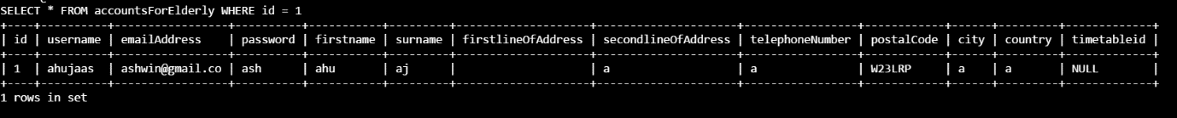

##### T1.1.2

SELECT notAField FROM accountsForElderly WHERE id = 1

##### E1.1.2



##### T1.1.3

SELECT * FROM accountsForElderly WHERE id = 1008

##### E1.1.3

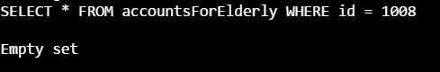

##### T1.1.4

UPDATE accountsForElderly SET username = "ahujaa" WHERE id = 1

##### E1.1.4

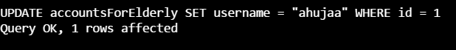

#### 1.2

##### T1.2.1

"27th April 2016 at 10:00"

##### E1.2.1

27/04/2016 10:00

##### T1.2.2

"tomorrow at 20:00"

##### E1.2.2

01/04/2017 20:00:00

##### T1.2.3

"27th April 2017 at an undefined time"

##### E1.2.3

27/04/2017 00:00:00

##### T1.2.4

"10:00"

##### E1.2.4

31/03/2017 10:00:00

##### T1.2.5

"3/30/2017 12:00"

##### E1.2.5

30/03/2017 12:00:00

#### 1.3

##### T1.3.1

GET http://localhost:5000/api/ac

##### E1.3.1

"Hello World"

##### T1.3.2

GET http://localNOThost:5000/api/ac

##### E1.3.2

Could Not Get A Response

##### T1.3.3

GET http://localhost:5000/api/ac22

##### E1.3.3

404 Not Found

#### 1.4

##### T1.4.1

GET http://localhost:5000/api/ac

##### E1.4.1

"Hello World"

##### T1.4.2

POST http://localhost:5000/api/ac/users/ad

**Parameters**

"{

""id"": 0,

""username"": ""testUsername"",

""firstName"": ""testFirstName"",

""surname"": ""testSurname"",

""password"": ""testPassword"",

""emailAddress"": ""testEmailAddress"",

""firstLineOfAddress"": ""testFirstLineOfAddress"",

""secondLineOfAddress"": ""testSecondLineOfAddress"",

""telephoneNumber"": ""testTelephoneNumber"",

""postalCode"": ""testPostcode"",

""city"": ""testCity"",

""country"": ""testCountry"",

""helper"": false,

""timetableId"": 1,

""distance"": 1.7976931348623157e+308

}"

##### E1.4.2

true

**&**

Check if new entry in elderly person database with entered properties

##### T1.4.3

POST http://localhost:5000/api/ac/users/vf

**Parameters**

"{

""password"": ""testPassword"",

""emailAddress"": ""testEmailAddress"",

""helper"": false

}"

##### E1.4.3

"{

""id"": 34,

""username"": ""testUsername"",

""firstName"": ""testFirstName"",

""surname"": ""testSurname"",

""password"": ""testPassword"",

""emailAddress"": ""testEmailAddress"",

""firstLineOfAddress"": ""testFirstLineOfAddress"",

""secondLineOfAddress"": ""testSecondLineOfAddress"",

""telephoneNumber"": ""testTelephoneNumber"",

""postalCode"": ""testPostcode"",

""city"": ""testCity"",

""country"": ""testCountry"",

""helper"": false,

""timetableId"": 0,

""distance"": 1.7976931348623157e+308

}"

#### 1.5

##### T1.5.1

GET http://localhost:5000/api/ach

##### E1.5.1

"Hello World"

##### T1.5.2

GET http://localhost:5000/api/ach/users/gi9

##### E1.5.2

"{

""id"": 9,

""username"": ""ashwinahuja"",

""firstName"": ""Helper"",

""surname"": ""Ahuja"",

""password"": ""3ea7121feb7564ddfe2d1f2ebb41706e"",

""emailAddress"": ""ashwin@gmail.com"",

""firstLineOfAddress"": ""10 Lyndhurst Gardens"",

""secondLineOfAddress"": ""Hampstead"",

""telephoneNumber"": ""447597711497"",

""postalCode"": ""SW138QY"",

""city"": ""London"",

""country"": ""United Kingdom"",

""helper"": true,

""timetableId"": 53,

""distance"": 1.7976931348623157e+308

}"

##### T1.5.3

GET http://localhost:5000/api/ach/users/gi1008

##### E1.5.3

500 Internal Server Error

##### T1.5.4

POST http://localhost:5000/api/ach/users/ad

**Parameters**

"{

""id"": 0,

""username"": ""testUsername"",

""firstName"": ""testFirstName"",

""surname"": ""testSurname"",

""password"": ""testPassword"",

""emailAddress"": ""testEmailAddress"",

""firstLineOfAddress"": ""testFirstLineOfAddress"",

""secondLineOfAddress"": ""testSecondLineOfAddress"",

""telephoneNumber"": ""testTelephoneNumber"",

""postalCode"": ""SW139JT"",

""city"": ""testCity"",

""country"": ""testCountry"",

""helper"": true,

""timetableId"": 1,

""distance"": 1.7976931348623157e+308

}"

##### E1.5.4

TRUE

**&**

Check if new entry exists in the database

##### T1.5.5

POST http://localhost:5000/api/ach/users/ad

**Parameters**

"{

""id"": 0,

""username"": ""testUsername"",

""firstName"": ""testFirstName"",

""surname"": ""testSurname"",

""password"": ""testPassword"",

""emailAddress"": ""testEmailAddress"",

""firstLineOfAddress"": ""testFirstLineOfAddress"",

""secondLineOfAddress"": ""testSecondLineOfAddress"",

""telephoneNumber"": ""testTelephoneNumber"",

""postalCode"": ""SW139JT"",

""city"": ""testCity"",

""country"": ""testCountry"",

""helper"": true,

""timetableId"": 1,

""distance"": 1.7976931348623157e+308

}"

##### E1.5.5

FALSE

**&**

Check no new entry in database

##### T1.5.6

DELETE http://localhost:5000/api/ach/users/rm18

##### E1.5.6

TRUE

**&**

Check the entry is removed in database

##### T1.5.7

DELETE http://localhost:5000/api/ach/users/rm19

##### E1.5.7

FALSE

##### T1.5.8

PUT http://localhost:5000/api/ach/users/up

**Parameters**

"{

""id"": 19,

""username"": ""testUsernameNEW"",

""firstName"": ""testFirstNameNEW"",

""surname"": ""testSurnameNEW"",

""password"": ""testPasswordNEW"",

""emailAddress"": ""testEmailAddressNEW"",

""firstLineOfAddress"": ""testFirstLineOfAddressNEW"",

""secondLineOfAddress"": ""testSecondLineOfAddressNEW"",

""telephoneNumber"": ""testTelephoneNumberNEW"",

""postalCode"": ""SW139JT"",

""city"": ""testCityNEW"",

""country"": ""testCountryNEW"",

""helper"": true,

""timetableId"": 1,

""distance"": 1.7976931348623157e+308

}"

##### E1.5.8

TRUE

**&**

Check entry is updated in database

##### T1.5.9

PUT http://localhost:5000/api/ach/users/up

**Parameters**

"{

""id"": 1008,

""username"": ""testUsernameNEW"",

""firstName"": ""testFirstNameNEW"",

""surname"": ""testSurnameNEW"",

""password"": ""testPasswordNEW"",

""emailAddress"": ""testEmailAddressDoesntExist"",

""firstLineOfAddress"": ""testFirstLineOfAddressNEW"",

""secondLineOfAddress"": ""testSecondLineOfAddressNEW"",

""telephoneNumber"": ""testTelephoneNumberNEW"",

""postalCode"": ""SW139JT"",

""city"": ""testCityNEW"",

""country"": ""testCountryNEW"",

""helper"": true,

""timetableId"": 1,

""distance"": 1.7976931348623157e+308

}"

##### E1.5.9

FALSE

##### T1.5.10

POST http://localhost:5000/api/ach/users/vf

**Parameters**

"{

""password"": ""testPasswordNEW"",

""emailAddress"": ""testEmailAddressWRONG"",

""helper"": true

}"

##### E1.5.10

"{

""id"": 0,

""username"": null,

""firstName"": null,

""surname"": null,

""password"": null,

""emailAddress"": null,

""firstLineOfAddress"": null,

""secondLineOfAddress"": null,

""telephoneNumber"": null,

""postalCode"": null,

""city"": null,

""country"": null,

""helper"": false,

""timetableId"": 0,

""distance"": 1.7976931348623157e+308

}"

##### T1.5.11

POST http://localhost:5000/api/ach/users/vf

**Parameters**

"{

""password"": ""testPasswordNEW"",

""emailAddress"": ""testEmailAddressNEW"",

""helper"": true

}"

##### E1.5.11

"{

""id"": 19,

""username"": ""testUsernameNEW"",

""firstName"": ""testFirstNameNEW"",

""surname"": ""testSurnameNEW"",

""password"": ""testPasswordNEW"",

""emailAddress"": ""testEmailAddressNEW"",

""firstLineOfAddress"": ""testFirstLineOfAddressNEW"",

""secondLineOfAddress"": ""testSecondLineOfAddressNEW"",

""telephoneNumber"": ""testTelephoneNumberNEW"",

""postalCode"": ""SW139JT"",

""city"": ""testCityNEW"",

""country"": ""testCountryNEW"",

""helper"": true,

""timetableId"": 0,

""distance"": 1.7976931348623157e+308

}"

##### T1.5.12

GET http://localhost:5000/api/ach/gl28

##### E1.5.12

"[

{

""id"": 10,

""username"": ""jdnsna"",

""firstName"": ""hshshs"",

""surname"": ""jsjsjs"",

""password"": ""47bce5c74f589f4867dbd57e9ca9f808"",

""emailAddress"": ""usnamms"",

""firstLineOfAddress"": ""ndnsjs"",

""secondLineOfAddress"": ""usjsjshsj"",

""telephoneNumber"": ""447597711496"",

""postalCode"": ""sw138qz"",

""city"": ""jajsjjd"",

""country"": ""nsnaja"",

""helper"": false,

""timetableId"": 8,

""distance"": 23.712

},

{

""id"": 9,

""username"": ""ashwinahuja"",

""firstName"": ""Helper"",

""surname"": ""Ahuja"",

""password"": ""3ea7121feb7564ddfe2d1f2ebb41706e"",

""emailAddress"": ""ashwin@gmail.com"",

""firstLineOfAddress"": ""10 Lyndhurst Gardens"",

""secondLineOfAddress"": ""Hampstead"",

""telephoneNumber"": ""447597711497"",

""postalCode"": ""SW138QY"",

""city"": ""London"",

""country"": ""United Kingdom"",

""helper"": false,

""timetableId"": 53,

""distance"": 23.828

},

{

""id"": 12,

""username"": ""ahuja"",

""firstName"": ""Ashwin"",

""surname"": ""Ahuja"",

""password"": ""3ea7121feb7564ddfe2d1f2ebb41706e"",

""emailAddress"": ""ashwinahuja@gmail.com"",

""firstLineOfAddress"": ""32 Rivers Road"",

""secondLineOfAddress"": """",

""telephoneNumber"": ""447597711493"",

""postalCode"": ""SW138QY"",

""city"": ""London"",

""country"": ""United Kingdom"",

""helper"": false,

""timetableId"": 39,

""distance"": 23.828

},

{

""id"": 14,

""username"": ""a"",

""firstName"": ""a"",

""surname"": ""a"",

""password"": ""0cc175b9c0f1b6a831c399e269772661"",

""emailAddress"": ""aab"",

""firstLineOfAddress"": ""nsn"",

""secondLineOfAddress"": ""jsns"",

""telephoneNumber"": ""447597711495"",

""postalCode"": ""SW138QY"",

""city"": ""ndnd"",

""country"": ""hdbd"",

""helper"": false,

""timetableId"": 51,

""distance"": 23.828

},

{

""id"": 19,

""username"": ""testUsernameNEW"",

""firstName"": ""testFirstNameNEW"",

""surname"": ""testSurnameNEW"",

""password"": ""testPasswordNEW"",

""emailAddress"": ""testEmailAddressNEW"",

""firstLineOfAddress"": ""testFirstLineOfAddressNEW"",

""secondLineOfAddress"": ""testSecondLineOfAddressNEW"",

""telephoneNumber"": ""testTelephoneNumberNEW"",

""postalCode"": ""SW139JT"",

""city"": ""testCityNEW"",

""country"": ""testCountryNEW"",

""helper"": false,

""timetableId"": 59,

""distance"": 24.26

},

{

""id"": 11,

""username"": ""vech"",

""firstName"": ""oli"",

""surname"": ""vech"",

""password"": ""bf2bc2545a4a5f5683d9ef3ed0d977e0"",

""emailAddress"": ""vechtest2@gmail.com"",

""firstLineOfAddress"": ""hshsjs"",

""secondLineOfAddress"": """",

""telephoneNumber"": ""447768147040"",

""postalCode"": ""SW100XD"",

""city"": ""London"",

""country"": ""United Kingdom"",

""helper"": false,

""timetableId"": 36,

""distance"": 25.322

},

{

""id"": 1,

""username"": ""ahujaas"",

""firstName"": ""Third"",

""surname"": ""Closest-Helper"",

""password"": ""ash"",

""emailAddress"": ""ashwin@gmail.co"",

""firstLineOfAddress"": ""a"",

""secondLineOfAddress"": ""a"",

""telephoneNumber"": ""a"",

""postalCode"": ""W1A 0AX"",

""city"": ""a"",

""country"": ""a"",

""helper"": false,

""timetableId"": 1,

""distance"": 34.661

},

{

""id"": 5,

""username"": """",

""firstName"": ""Closest"",

""surname"": ""Helper"",

""password"": ""ah7"",

""emailAddress"": ""testj"",

""firstLineOfAddress"": ""sjkdhs"",

""secondLineOfAddress"": ""sds"",

""telephoneNumber"": ""dsdsd"",

""postalCode"": ""NW35NR"",

""city"": ""sds"",

""country"": ""dsdsd"",

""helper"": false,

""timetableId"": 2,

""distance"": 35.877

},

{

""id"": 17,

""username"": ""Hi Ashwin"",

""firstName"": ""Philip"",

""surname"": ""Fernandes "",

""password"": ""4944b366079773bebd70485ca180aafc"",

""emailAddress"": ""philafern82@gmail.com "",

""firstLineOfAddress"": ""82 West Hill "",

""secondLineOfAddress"": ""Wales "",

""telephoneNumber"": ""447946505344"",

""postalCode"": ""HA99RR "",

""city"": ""London"",

""country"": ""UK"",

""helper"": false,

""timetableId"": 57,

""distance"": 64.213

}

]"

**&**

Check that the people are arranged in order of distance to: KT10 9HZ

##### T1.5.13

GET http://localhost:5000/api/ach/gl1008

##### E1.5.13

500 Internal Server Error

#### 1.6

##### T1.6.1

GET http://localhost:5000/api/ace

##### E1.6.1

"Hello World"

##### T1.6.2

GET http://localhost:5000/api/ace/users/gi20

##### E1.6.2

"{

""id"": 20,

""username"": ""ahujaas"",

""firstName"": ""Ashwin"",

""surname"": ""Ahuja"",

""password"": ""3ea7121feb7564ddfe2d1f2ebb41706e"",

""emailAddress"": ""ashwin.ahuja@gmail.com"",

""firstLineOfAddress"": ""32 Riverview Gardens"",

""secondLineOfAddress"": """",

""telephoneNumber"": ""447597711495"",

""postalCode"": ""SW138QY"",

""city"": ""London"",

""country"": ""United Kingdom"",

""helper"": false,

""timetableId"": 0,

""distance"": 1.7976931348623157e+308

}"

##### T1.6.3

GET http://localhost:5000/api/ace/users/gi1008

##### E1.6.3

HTTP 500 Server Error

##### T1.6.4

POST http://localhost:5000/api/ace/users/ad

**Parameters**

"{

""id"": 20,

""username"": ""ahujaas"",

""firstName"": ""Ashwin"",

""surname"": ""Ahuja"",

""password"": ""3ea7121feb7564ddfe2d1f2ebb41706e"",

""emailAddress"": ""NEW EMAIL ADDRESS"",

""firstLineOfAddress"": ""32 Riverview Gardens"",

""secondLineOfAddress"": """",

""telephoneNumber"": ""NEW TELEPHONE NUMBER"",

""postalCode"": ""SW138QY"",

""city"": ""London"",

""country"": ""United Kingdom"",

""helper"": false,

""timetableId"": 0,

""distance"": 1.7976931348623157e+308

}"

##### E1.6.4

TRUE

**&**

Check user added to the database.

##### T1.6.5

POST http://localhost:5000/api/ace/users/ad

**Parameters**

"{

""id"": 20,

""username"": ""ahujaas"",

""firstName"": ""Ashwin"",

""surname"": ""Ahuja"",

""password"": ""3ea7121feb7564ddfe2d1f2ebb41706e"",

""emailAddress"": ""ashwin.ahuja@gmail.com"",

""firstLineOfAddress"": ""32 Riverview Gardens"",

""secondLineOfAddress"": """",

""telephoneNumber"": ""447597711495"",

""postalCode"": ""SW138QY"",

""city"": ""London"",

""country"": ""United Kingdom"",

""helper"": false,

""timetableId"": 0,

""distance"": 1.7976931348623157e+308

}"

##### E1.6.5

FALSE

**&**

Check user not added

##### T1.6.6

DELETE http://localhost:5000/api/ace/users/rm20

##### E1.6.6

TRUE

**&**

Check that database entry has been deleted

##### T1.6.7

DELETE http://localhost:5000/api/ace/users/rm21

##### E1.6.7

FALSE

##### T1.6.8

PUT http://localhost:5000/api/ace/users/up

**Parameters**

"{

""id"": 20,

""username"": ""ahujaas"",

""firstName"": ""Ashwin"",

""surname"": ""Ahuja"",

""password"": ""3ea7121feb7564ddfe2d1f2ebb41706e"",

""emailAddress"": ""NEW EMAIL ADDRESS VERSION TWO"",

""firstLineOfAddress"": ""32 Riverview Gardens"",

""secondLineOfAddress"": """",

""telephoneNumber"": ""NEW TELEPHONE NUMBER VERSION TWO"",

""postalCode"": ""SW138QY"",

""city"": ""London"",

""country"": ""United Kingdom"",

""helper"": false,

""timetableId"": 0,

""distance"": 1.7976931348623157e+308

}"

##### E1.6.8

TRUE

**&**

Check that database entry has been updated

##### T1.6.9

PUT http://localhost:5000/api/ace/users/up

**Parameters**

"{

""id"": 1008,

""username"": ""ahujaas"",

""firstName"": ""Ashwin"",

""surname"": ""Ahuja"",

""password"": ""3ea7121feb7564ddfe2d1f2ebb41706e"",

""emailAddress"": ""NEW EMAIL ADDRESS VERSION TWO"",

""firstLineOfAddress"": ""32 Riverview Gardens"",

""secondLineOfAddress"": """",

""telephoneNumber"": ""NEW TELEPHONE NUMBER VERSION TWO"",

""postalCode"": ""SW138QY"",

""city"": ""London"",

""country"": ""United Kingdom"",

""helper"": false,

""timetableId"": 0,

""distance"": 1.7976931348623157e+308

}"

##### E1.6.9

FALSE

**&**

Check nothing updated in database

##### T1.6.10

POST http://localhost:5000/api/ach/users/vf

**Parameters**

"{

""password"": ""testPasswordNEW"",

""emailAddress"": ""NEW EMAIL ADDRESS VERSION TWO"",

""helper"": false

}"

##### E1.6.10

"{

""id"": 0,

""username"": null,

""firstName"": null,

""surname"": null,

""password"": null,

""emailAddress"": null,

""firstLineOfAddress"": null,

""secondLineOfAddress"": null,

""telephoneNumber"": null,

""postalCode"": null,

""city"": null,

""country"": null,

""helper"": false,

""timetableId"": 0,

""distance"": 1.7976931348623157e+308

}"

##### T1.6.11

POST http://localhost:5000/api/ach/users/vf

**Parameters**

"{

""password"": ""3ea7121feb7564ddfe2d1f2ebb41706e"",

""emailAddress"": ""NEW EMAIL ADDRESS VERSION TWO"",

""helper"": false

}"

##### E1.6.11

"{

""id"": 20,

""username"": ""ahujaas"",

""firstName"": ""Ashwin"",

""surname"": ""Ahuja"",

""password"": ""3ea7121feb7564ddfe2d1f2ebb41706e"",

""emailAddress"": ""NEW EMAIL ADDRESS VERSION TWO"",

""firstLineOfAddress"": ""32 Riverview Gardens"",

""secondLineOfAddress"": """",

""telephoneNumber"": ""NEW TELEPHONE NUMBER VERSION TWO"",

""postalCode"": ""SW138QY"",

""city"": ""London"",

""country"": ""United Kingdom"",

""helper"": false,

""timetableId"": 0,

""distance"": 1.7976931348623157e+308

}"

#### 1.7

##### T1.7.1

POST http://localhost:5000/api/app/sms+447597711495,20th April 2017 at 10:00

**&**

Ensure that there is no helper which is free at 10am on 20th April 2017 (by going into the timetable of each and changing it to false at that time)

##### E1.7.1

FALSE

**&**

SMS received saying "Nobody could be found."

##### T1.7.2

POST http://localhost:5000/api/app/sms+447597711495,9th April 2017 at 00:00

##### E1.7.2

TRUE

**&**

SMS received saying "You have an appointment with … at 10:00 on 9th April 2017"

##### T1.7.3

POST http://localhost:5000/api/app/sms+44797711495,21st April 2017 at 00:00

**&**

Ensure that the number (+447597711495) is removed from the all elderly accounts.

##### E1.7.3

FALSE

**&**

No SMS received

##### T1.7.4

PUT http://localhost:5000/api/app/sendSMS

**Parameters**

"{

""Body"":""Hello Test Send"",

""From"":""+447597711495""

}"

##### E1.7.4

TRUE

**&**

SMS received

##### T1.7.5

GET http://localhost:5000/api/app/gi1008

##### E1.7.5

"{

""id"": 0,

""helperId"": null,

""elderlyId"": null,

""dateAndTime"": null,

""dateCreated"": null,

""ratingId"": 0,

""reviewId"": 0

}"

##### T1.7.6

GET http://localhost:5000/api/app/gi71

##### E1.7.6

"{

""id"": 71,

""helperId"": 10,

""elderlyId"": 20,

""dateAndTime"": ""2017-03-15T02:00:00"",

""dateCreated"": ""2017-03-13T13:34:01"",

""ratingId"": 0,

""reviewId"": 0

}"

##### T1.7.7

DELETE http://localhost:5000/api/app/re18

##### E1.7.7

FALSE

##### T1.7.8

DELETE http://localhost:5000/api/app/re71

##### E1.7.8

TRUE

**&**

Appointment deleted on database

##### T1.7.9

GET http://localhost:5000/api/app/gae1008

##### E1.7.9

[]

##### T1.7.10

GET http://localhost:5000/api/app/gae20

##### E1.7.10

"[

{

""id"": 63,

""helperId"": 9,

""elderlyId"": 20,

""dateAndTime"": ""2016-03-15T18:00:00"",

""dateCreated"": ""2017-03-13T07:22:49"",

""ratingId"": 8,

""reviewId"": 7

},

{

""id"": 64,

""helperId"": 9,

""elderlyId"": 20,

""dateAndTime"": ""2016-03-19T20:00:00"",

""dateCreated"": ""2017-03-13T07:22:59"",

""ratingId"": 7,

""reviewId"": 6

},

{

""id"": 66,

""helperId"": 9,

""elderlyId"": 20,

""dateAndTime"": ""2017-03-13T22:00:00"",

""dateCreated"": ""2017-03-13T10:08:15"",

""ratingId"": 0,

""reviewId"": 0

},

{

""id"": 67,

""helperId"": 9,

""elderlyId"": 20,

""dateAndTime"": ""2017-03-13T10:00:00"",

""dateCreated"": ""2017-03-13T16:10:22"",

""ratingId"": 0,

""reviewId"": 0

},

{

""id"": 68,

""helperId"": 9,

""elderlyId"": 20,

""dateAndTime"": ""2017-03-13T10:00:00"",

""dateCreated"": ""2017-03-13T16:52:25"",

""ratingId"": 0,

""reviewId"": 0

},

{

""id"": 69,

""helperId"": 9,

""elderlyId"": 20,

""dateAndTime"": ""2017-03-14T10:00:00"",

""dateCreated"": ""2017-03-13T16:55:49"",

""ratingId"": 0,

""reviewId"": 0

},

{

""id"": 72,

""helperId"": 1,

""elderlyId"": 20,

""dateAndTime"": ""2017-03-15T02:00:00"",

""dateCreated"": ""2017-03-13T13:34:01"",

""ratingId"": 0,

""reviewId"": 0

},

{

""id"": 73,

""helperId"": 9,

""elderlyId"": 20,

""dateAndTime"": ""2017-03-15T02:00:00"",

""dateCreated"": ""2017-03-13T13:34:01"",

""ratingId"": 0,

""reviewId"": 0

},

{

""id"": 74,

""helperId"": 9,

""elderlyId"": 20,

""dateAndTime"": ""2017-03-15T14:00:00"",

""dateCreated"": ""2017-03-13T13:35:33"",

""ratingId"": 12,

""reviewId"": 10

},

{

""id"": 75,

""helperId"": 10,

""elderlyId"": 20,

""dateAndTime"": ""2017-03-29T18:00:00"",

""dateCreated"": ""2017-03-14T10:12:37"",

""ratingId"": 0,

""reviewId"": 0

},

{

""id"": 79,

""helperId"": 11,

""elderlyId"": 20,

""dateAndTime"": ""2017-03-13T20:00:00"",

""dateCreated"": ""2017-03-14T10:53:01"",

""ratingId"": 0,

""reviewId"": 0

},

{

""id"": 80,

""helperId"": 11,

""elderlyId"": 20,

""dateAndTime"": ""2017-03-13T20:00:00"",

""dateCreated"": ""2017-03-14T10:53:27"",

""ratingId"": 0,

""reviewId"": 0

},

{

""id"": 81,

""helperId"": 11,

""elderlyId"": 20,

""dateAndTime"": ""2017-03-14T16:00:00"",

""dateCreated"": ""2017-03-14T10:53:54"",

""ratingId"": 0,

""reviewId"": 11

},

{

""id"": 85,

""helperId"": 9,

""elderlyId"": 20,

""dateAndTime"": ""2017-03-19T08:00:00"",

""dateCreated"": ""2017-03-17T10:18:17"",

""ratingId"": 0,

""reviewId"": 0

},

{

""id"": 102,

""helperId"": 9,

""elderlyId"": 20,

""dateAndTime"": ""2017-03-19T20:00:00"",

""dateCreated"": ""2017-03-19T08:38:42"",

""ratingId"": 0,

""reviewId"": 0

},

{

""id"": 103,

""helperId"": 9,

""elderlyId"": 20,

""dateAndTime"": ""2017-03-20T10:00:00"",

""dateCreated"": ""2017-03-19T12:10:48"",

""ratingId"": 0,

""reviewId"": 0

},

{

""id"": 105,

""helperId"": 9,

""elderlyId"": 20,

""dateAndTime"": ""2017-03-25T18:00:00"",

""dateCreated"": ""2017-03-19T13:54:31"",

""ratingId"": 0,

""reviewId"": 0

},

{

""id"": 106,

""helperId"": 9,

""elderlyId"": 20,

""dateAndTime"": ""2017-03-20T08:00:00"",

""dateCreated"": ""2017-03-19T13:57:02"",

""ratingId"": 0,

""reviewId"": 0

},

{

""id"": 107,

""helperId"": 9,

""elderlyId"": 20,

""dateAndTime"": ""2017-03-20T22:00:00"",

""dateCreated"": ""2017-03-20T06:27:18"",

""ratingId"": 0,

""reviewId"": 0

},

{

""id"": 108,

""helperId"": 9,

""elderlyId"": 20,

""dateAndTime"": ""2017-03-20T20:00:00"",

""dateCreated"": ""2017-03-20T06:27:49"",

""ratingId"": 0,

""reviewId"": 0

},

{

""id"": 112,

""helperId"": 9,

""elderlyId"": 20,

""dateAndTime"": ""2017-04-05T12:00:00"",

""dateCreated"": ""2017-04-03T12:09:31"",

""ratingId"": 0,

""reviewId"": 0

},

{

""id"": 114,

""helperId"": 17,

""elderlyId"": 20,

""dateAndTime"": ""2017-04-06T18:00:00"",

""dateCreated"": ""2017-04-05T15:37:04"",

""ratingId"": 0,

""reviewId"": 0

},

{

""id"": 115,

""helperId"": 17,

""elderlyId"": 20,

""dateAndTime"": ""2017-04-11T18:00:00"",

""dateCreated"": ""2017-04-05T15:37:19"",

""ratingId"": 0,

""reviewId"": 0

},

{

""id"": 116,

""helperId"": 17,

""elderlyId"": 20,

""dateAndTime"": ""1845-04-06T20:00:00"",

""dateCreated"": ""2017-04-05T15:37:41"",

""ratingId"": 15,

""reviewId"": 14

},

{

""id"": 117,

""helperId"": 17,

""elderlyId"": 20,

""dateAndTime"": ""2017-01-02T16:00:00"",

""dateCreated"": ""2017-04-05T15:39:17"",

""ratingId"": 0,

""reviewId"": 0

},

{

""id"": 118,

""helperId"": 17,

""elderlyId"": 20,

""dateAndTime"": ""2016-04-07T20:00:00"",

""dateCreated"": ""2017-04-05T15:40:08"",

""ratingId"": 0,

""reviewId"": 0

},

{

""id"": 119,

""helperId"": 17,

""elderlyId"": 20,

""dateAndTime"": ""2017-04-08T14:00:00"",

""dateCreated"": ""2017-04-05T15:44:15"",

""ratingId"": 0,

""reviewId"": 0

},

{

""id"": 120,

""helperId"": 9,

""elderlyId"": 20,

""dateAndTime"": ""2017-05-10T10:00:00"",

""dateCreated"": ""2017-04-06T15:43:20"",

""ratingId"": 0,

""reviewId"": 0

}

]"

##### T1.7.11

GET http://localhost:5000/api/app/gah1008

##### E1.7.11

[]

##### T1.7.12

GET http://localhost:5000/api/app/gah9

##### E1.7.12

"[

{

""id"": 63,

""helperId"": 9,

""elderlyId"": 20,

""dateAndTime"": ""2016-03-15T18:00:00"",

""dateCreated"": ""2017-03-13T07:22:49"",

""ratingId"": 8,

""reviewId"": 7

},

{

""id"": 64,

""helperId"": 9,

""elderlyId"": 20,

""dateAndTime"": ""2016-03-19T20:00:00"",

""dateCreated"": ""2017-03-13T07:22:59"",

""ratingId"": 7,

""reviewId"": 6

},

{

""id"": 66,

""helperId"": 9,

""elderlyId"": 20,

""dateAndTime"": ""2017-03-13T22:00:00"",

""dateCreated"": ""2017-03-13T10:08:15"",

""ratingId"": 0,

""reviewId"": 0

},

{

""id"": 67,

""helperId"": 9,

""elderlyId"": 20,

""dateAndTime"": ""2017-03-13T10:00:00"",

""dateCreated"": ""2017-03-13T16:10:22"",

""ratingId"": 0,

""reviewId"": 0

},

{

""id"": 68,

""helperId"": 9,

""elderlyId"": 20,

""dateAndTime"": ""2017-03-13T10:00:00"",

""dateCreated"": ""2017-03-13T16:52:25"",

""ratingId"": 0,

""reviewId"": 0

},

{

""id"": 69,

""helperId"": 9,

""elderlyId"": 20,

""dateAndTime"": ""2017-03-14T10:00:00"",

""dateCreated"": ""2017-03-13T16:55:49"",

""ratingId"": 0,

""reviewId"": 0

},

{

""id"": 73,

""helperId"": 9,

""elderlyId"": 20,

""dateAndTime"": ""2017-03-15T02:00:00"",

""dateCreated"": ""2017-03-13T13:34:01"",

""ratingId"": 0,

""reviewId"": 0

},

{

""id"": 74,

""helperId"": 9,

""elderlyId"": 20,

""dateAndTime"": ""2017-03-15T14:00:00"",

""dateCreated"": ""2017-03-13T13:35:33"",

""ratingId"": 12,

""reviewId"": 10

},

{

""id"": 85,

""helperId"": 9,

""elderlyId"": 20,

""dateAndTime"": ""2017-03-19T08:00:00"",

""dateCreated"": ""2017-03-17T10:18:17"",

""ratingId"": 0,

""reviewId"": 0

},

{

""id"": 87,

""helperId"": 9,

""elderlyId"": 28,

""dateAndTime"": ""2017-03-18T18:00:00"",

""dateCreated"": ""2017-03-17T12:37:03"",

""ratingId"": 0,

""reviewId"": 0

},

{

""id"": 91,

""helperId"": 9,

""elderlyId"": 28,

""dateAndTime"": ""2017-03-30T08:00:00"",

""dateCreated"": ""2017-03-19T07:30:49"",

""ratingId"": 0,

""reviewId"": 0

},

{

""id"": 92,

""helperId"": 9,

""elderlyId"": 28,

""dateAndTime"": ""2017-04-06T04:00:00"",

""dateCreated"": ""2017-03-19T07:30:55"",

""ratingId"": 0,

""reviewId"": 0

},

{

""id"": 98,

""helperId"": 9,

""elderlyId"": 28,

""dateAndTime"": ""2017-03-19T04:00:00"",

""dateCreated"": ""2017-03-19T08:20:49"",

""ratingId"": 0,

""reviewId"": 0

},

{

""id"": 99,

""helperId"": 9,

""elderlyId"": 28,

""dateAndTime"": ""2017-03-30T12:00:00"",

""dateCreated"": ""2017-03-19T08:27:37"",

""ratingId"": 0,

""reviewId"": 0

},

{

""id"": 100,

""helperId"": 9,

""elderlyId"": 28,

""dateAndTime"": ""2017-03-19T18:00:00"",

""dateCreated"": ""2017-03-19T08:27:55"",

""ratingId"": 0,

""reviewId"": 0

},

{

""id"": 102,

""helperId"": 9,

""elderlyId"": 20,

""dateAndTime"": ""2017-03-19T20:00:00"",

""dateCreated"": ""2017-03-19T08:38:42"",

""ratingId"": 0,

""reviewId"": 0

},

{

""id"": 103,

""helperId"": 9,

""elderlyId"": 20,

""dateAndTime"": ""2017-03-20T10:00:00"",

""dateCreated"": ""2017-03-19T12:10:48"",

""ratingId"": 0,

""reviewId"": 0

},

{

""id"": 105,

""helperId"": 9,

""elderlyId"": 20,

""dateAndTime"": ""2017-03-25T18:00:00"",

""dateCreated"": ""2017-03-19T13:54:31"",

""ratingId"": 0,

""reviewId"": 0

},

{

""id"": 106,

""helperId"": 9,

""elderlyId"": 20,

""dateAndTime"": ""2017-03-20T08:00:00"",

""dateCreated"": ""2017-03-19T13:57:02"",

""ratingId"": 0,

""reviewId"": 0

},

{

""id"": 107,

""helperId"": 9,

""elderlyId"": 20,

""dateAndTime"": ""2017-03-20T22:00:00"",

""dateCreated"": ""2017-03-20T06:27:18"",

""ratingId"": 0,

""reviewId"": 0

},

{

""id"": 108,

""helperId"": 9,

""elderlyId"": 20,

""dateAndTime"": ""2017-03-20T20:00:00"",

""dateCreated"": ""2017-03-20T06:27:49"",

""ratingId"": 0,

""reviewId"": 0

},

{

""id"": 109,

""helperId"": 9,

""elderlyId"": 33,

""dateAndTime"": ""2017-03-25T20:00:00"",

""dateCreated"": ""2017-03-20T08:17:45"",

""ratingId"": 0,

""reviewId"": 0

},

{

""id"": 112,

""helperId"": 9,

""elderlyId"": 20,

""dateAndTime"": ""2017-04-05T12:00:00"",

""dateCreated"": ""2017-04-03T12:09:31"",

""ratingId"": 0,

""reviewId"": 0

},

{

""id"": 120,

""helperId"": 9,

""elderlyId"": 20,

""dateAndTime"": ""2017-05-10T10:00:00"",

""dateCreated"": ""2017-04-06T15:43:20"",

""ratingId"": 0,

""reviewId"": 0

}

]"

#### 1.8

##### T1.8.1

GET http://localhost:5000/api/ratings/ga9

##### E1.8.1

"[

{

""id"": 7,

""starRating"": 8,

""helperId"": 9

},

{

""id"": 8,

""starRating"": 6,

""helperId"": 9

},

{

""id"": 12,

""starRating"": 8,

""helperId"": 9

},

{

""id"": 17,

""starRating"": 10,

""helperId"": 9

}

]"

##### T1.8.2

GET http://localhost:5000/api/ratings/ga1008

##### E1.8.2

[]

##### T1.8.3

GET http://localhost:5000/api/ratings/go8

##### E1.8.3

"{

""id"": 8,

""starRating"": 6,

""helperId"": 9

}"

##### T1.8.4

GET http://localhost:5000/api/ratings/go72

##### E1.8.4

HTTP 500 Server Error

##### T1.8.5

POST http://localhost:5000/api/ratings/ar

**Parameters**

"{

""id"": 63,

""starRating"": 10,

""helperId"": 9

}"

##### E1.8.5

TRUE

**&**

Check rating is added to the database.

##### T1.8.6

PATCH http://localhost:5000/api/ratings/ud

**Parameters**

"{

""id"": 63,

""starRating"": 10,

""helperId"": 9

}"

##### E1.8.6

TRUE

**&**

Check the item is updated on the database.

##### T1.8.7

DELETE http://localhost:5000/api/ratings/rm10

##### E1.8.7

TRUE

**&**

Check item is removed from the database

#### 1.9

##### T1.9.1

GET http://localhost:5000/api/reviews/ga9

##### E1.9.1

"[

{

""id"": 6,

""helperId"": 9,

""comment"": ""Annoying and seems incapable of listening""

},

{

""id"": 7,

""helperId"": 9,

""comment"": ""Perfect""

},

{

""id"": 10,

""helperId"": 9,

""comment"": ""ok""

}

]"

##### T1.9.2

GET http://localhost:5000/api/reviews/ga1008

##### E1.9.2

[]

##### T1.9.3

GET http://localhost:5000/api/reviews/go8

##### E1.9.3

"{

""id"": 8,

""helperId"": 10,

""comment"": ""Imperfect""

}"

##### T1.9.4

GET http://localhost:5000/api/reviews/go72

##### E1.9.4

HTTP 500 Server Error

##### T1.9.5

POST http://localhost:5000/api/reviews/ar

**Parameters**

"{

""id"": 83,

""helperId"": 10,

""comment"": ""Now entirely perfect""

}"

##### E1.9.5

TRUE

**&**

Check review added to the database

##### T1.9.6

PATCH http://localhost:5000/api/reviews/ud

**Parameters**

"{

""id"": 8,

""helperId"": 10,

""comment"": ""Now entirely perfect""

}"

##### E1.9.6

TRUE

**&**

Check review changed in database

##### T1.9.7

DELETE http://localhost:5000/api/ratings/rm15

##### E1.9.7

TRUE

**&**

Check review removed from the database

#### 1.10

##### T1.10.1

POST http://localhost:5000/api/tt/ad

**Parameters**

"{

""weeks"": [

{

""weekBeginning"": ""2017-03-13T00:00:00"",

""week"": {

""id"": 171,

""monday"": {

""timesFree"": [

true,

false,

true,

false,

false,

false,

false,

false,

false,

true,

true,

true

],

""id"": 691

},

""tuesday"": {

""timesFree"": [

true,

false,

false,

false,

true,

false,

false,

true,

false,

false,

false,

false

],

""id"": 692

},

""wednesday"": {

""timesFree"": [

true,

true,

true,

true,

true,

true,

true,

true,

true,

true,

true,

true

],

""id"": 693

},

""thursday"": {

""timesFree"": [

true,

true,

true,

true,

true,

true,

true,

true,

true,

true,

true,

true

],

""id"": 694

},

""friday"": {

""timesFree"": [

false,

false,

false,

false,

false,

false,

false,

false,

false,

false,

false,

false

],

""id"": 695

},

""saturday"": {

""timesFree"": [

true,

true,

false,

false,

false,

false,

false,

false,

false,

true,

true,

true

],

""id"": 696

},

""sunday"": {

""timesFree"": [

false,

false,

false,

false,

true,

true,

true,

false,

false,

true,

true,

false

],

""id"": 697

}

}

},

{

""weekBeginning"": ""2017-03-06T00:00:00"",

""week"": {

""id"": 164,

""monday"": {

""timesFree"": [

true,

false,

true,

false,

false,

false,

false,

false,

false,

true,

true,

true

],

""id"": 642

},

""tuesday"": {

""timesFree"": [

true,

true,

true,

false,

false,

false,

false,

false,

false,

true,

true,

true

],

""id"": 643

},

""wednesday"": {

""timesFree"": [

true,

true,

true,

false,

false,

false,

false,

false,

false,

true,

true,

true

],

""id"": 644

},

""thursday"": {

""timesFree"": [

true,

true,

true,

false,

false,

false,

false,

false,

false,

true,

true,

true

],

""id"": 645

},

""friday"": {

""timesFree"": [

false,

false,

false,

false,

false,

false,

false,

false,

false,

false,

false,

false

],

""id"": 646

},

""saturday"": {

""timesFree"": [

true,

true,

false,

false,

false,

false,

false,

false,

false,

true,

true,

true

],

""id"": 647

},

""sunday"": {

""timesFree"": [

false,

false,

false,

false,

true,

true,

true,

false,

false,

true,

true,

false

],

""id"": 648

}

}

},

{

""weekBeginning"": ""2017-03-27T00:00:00"",

""week"": {

""id"": 165,

""monday"": {

""timesFree"": [

true,

false,

true,

false,

false,

false,

false,

false,

false,

true,

true,

true

],

""id"": 649

},

""tuesday"": {

""timesFree"": [

true,

true,

true,

false,

false,

false,

false,

false,

false,

true,

true,

true

],

""id"": 650

},

""wednesday"": {

""timesFree"": [

true,

true,

true,

false,

false,

false,

false,

false,

false,

true,

true,

true

],

""id"": 651

},

""thursday"": {

""timesFree"": [

true,

true,

true,

false,

false,

false,

false,

false,

false,

true,

true,

true

],

""id"": 652

},

""friday"": {

""timesFree"": [

false,

false,

false,

false,

false,

false,

false,

false,

false,

false,

false,

false

],

""id"": 653

},

""saturday"": {

""timesFree"": [

true,

true,

false,

false,

false,

false,

false,

false,

false,

true,

true,

true

],

""id"": 654

},

""sunday"": {

""timesFree"": [

false,

false,

false,

false,

true,

true,

true,

false,

false,

true,

true,

false

],

""id"": 655

}

}

},

{

""weekBeginning"": ""2017-04-10T00:00:00"",

""week"": {

""id"": 166,

""monday"": {

""timesFree"": [

true,

false,

true,

false,

false,

false,

false,

false,

false,

true,

true,

true

],

""id"": 656

},

""tuesday"": {

""timesFree"": [

true,

true,

true,

false,

false,

false,

false,

false,

false,

true,

true,

true

],

""id"": 657

},

""wednesday"": {

""timesFree"": [

true,

true,

true,

false,

false,

false,

false,

false,

false,

true,

true,

true

],

""id"": 658

},

""thursday"": {

""timesFree"": [

true,

true,

true,

false,

false,

false,

false,

false,

false,

true,

true,

true

],

""id"": 659

},

""friday"": {

""timesFree"": [

false,

false,

false,

false,

false,

false,

false,

false,

false,

false,

false,

false

],

""id"": 660

},

""saturday"": {

""timesFree"": [

true,

true,

false,

false,

false,

false,

false,

false,

false,

true,

true,

true

],

""id"": 661

},

""sunday"": {

""timesFree"": [

false,

false,

false,

false,

true,

true,

true,

false,

false,

true,

true,

false

],

""id"": 662

}

}

},

{

""weekBeginning"": ""2017-04-03T00:00:00"",

""week"": {

""id"": 167,

""monday"": {

""timesFree"": [

true,

false,

true,

false,

false,

false,

false,

false,

false,

true,

true,

true

],

""id"": 663

},

""tuesday"": {

""timesFree"": [

true,

true,

true,

true,

true,

true,

true,

true,

true,

true,

true,

true

],

""id"": 664

},

""wednesday"": {

""timesFree"": [

true,

true,

true,

false,

false,

false,

false,

false,

false,

true,

true,

true

],

""id"": 665

},

""thursday"": {

""timesFree"": [

true,

true,

true,

false,

false,

false,

false,

false,

false,

true,

true,

true

],

""id"": 666

},

""friday"": {

""timesFree"": [

false,

false,

false,

false,

false,

false,

false,

false,

false,

false,

false,

false

],

""id"": 667

},

""saturday"": {

""timesFree"": [

true,

true,

false,

false,

false,

false,

false,

false,

false,

true,

true,

true

],

""id"": 668

},

""sunday"": {

""timesFree"": [

false,

false,

false,

false,

true,

true,

true,

false,

false,

true,

true,

false

],

""id"": 669

}

}

},

{

""weekBeginning"": ""2017-04-17T00:00:00"",

""week"": {

""id"": 168,

""monday"": {

""timesFree"": [

true,

false,

true,

false,

false,

false,

false,

false,

false,

true,

true,

true

],

""id"": 670

},

""tuesday"": {

""timesFree"": [

true,

true,

true,

false,

false,

false,

false,

false,

false,

true,

true,

true

],

""id"": 671

},

""wednesday"": {

""timesFree"": [

true,

true,

true,

false,

false,

false,

false,

false,

false,

true,

true,

true

],

""id"": 672

},

""thursday"": {

""timesFree"": [

true,

true,

true,

false,

false,

false,

false,

false,

false,

true,

true,

true

],

""id"": 673

},

""friday"": {

""timesFree"": [

false,

false,

false,

false,

false,

false,

false,

false,

false,

false,

false,

false

],

""id"": 674

},

""saturday"": {

""timesFree"": [

true,

true,

false,

false,

false,

false,

false,

false,

false,

true,

true,

true

],

""id"": 675

},

""sunday"": {

""timesFree"": [

false,

false,

false,

false,

true,

true,

true,

false,

false,

true,

true,

false

],

""id"": 676

}

}

},

{

""weekBeginning"": ""2017-05-01T00:00:00"",

""week"": {

""id"": 169,

""monday"": {

""timesFree"": [

true,

false,

true,

false,

false,

false,

false,

false,

false,

true,

true,

true

],

""id"": 677

},

""tuesday"": {

""timesFree"": [

true,

true,

true,

true,

true,

true,

true,

true,

true,

true,

true,

true

],

""id"": 678

},

""wednesday"": {

""timesFree"": [

true,

true,

true,

false,

false,

false,

false,

false,

false,

true,

true,

true

],

""id"": 679

},

""thursday"": {

""timesFree"": [

true,

true,

true,

true,

true,

true,

true,

true,

true,

true,

true,

true

],

""id"": 680

},

""friday"": {

""timesFree"": [

false,

false,

false,

false,

false,

false,

false,

false,

false,

false,

false,

false

],

""id"": 681

},

""saturday"": {

""timesFree"": [

true,

true,

false,

false,

false,

false,

false,

false,

false,

true,

true,

true

],

""id"": 682

},

""sunday"": {

""timesFree"": [

false,

false,

false,

false,

true,

true,

true,

false,

false,

true,

true,

false

],

""id"": 683

}

}

},

{

""weekBeginning"": ""2017-03-20T00:00:00"",

""week"": {

""id"": 170,

""monday"": {

""timesFree"": [

true,

false,

true,

false,

false,

false,

false,

false,

false,

true,

true,

true

],

""id"": 684

},

""tuesday"": {

""timesFree"": [

false,

false,

false,

false,

false,

false,

false,

false,

false,

false,

false,

false

],

""id"": 685

},

""wednesday"": {

""timesFree"": [

true,

true,

true,

true,

true,

true,

true,

true,

true,

true,

true,

true

],

""id"": 686

},

""thursday"": {

""timesFree"": [

true,

true,

true,

true,

true,

true,

true,

true,

true,

true,

true,

true

],

""id"": 687

},

""friday"": {

""timesFree"": [

false,

false,

false,

false,

false,

false,

false,

false,

false,

false,

false,

false

],

""id"": 688

},

""saturday"": {

""timesFree"": [

true,

true,

false,

false,

false,

false,

false,

false,

false,

true,

true,

true

],

""id"": 689

},

""sunday"": {

""timesFree"": [

false,

false,

false,

false,

true,

true,

true,

false,

false,

true,

true,

false

],

""id"": 690

}

}

},

{

""weekBeginning"": ""2017-04-24T00:00:00"",

""week"": {

""id"": 406,

""monday"": {

""timesFree"": [

true,

false,

true,

false,

false,

false,

false,

false,

false,

true,

true,

true

],

""id"": 628

},

""tuesday"": {

""timesFree"": [

true,

false,

false,

false,

true,

false,

false,

true,

false,

false,

false,

false

],

""id"": 629

},

""wednesday"": {

""timesFree"": [

true,

true,

true,

true,

true,

true,

true,

true,

true,

true,

true,

true

],

""id"": 630

},

""thursday"": {

""timesFree"": [

true,

true,

true,

true,

true,

true,

true,

true,

true,

true,

true,

true

],

""id"": 631

},

""friday"": {

""timesFree"": [

false,

false,

false,

false,

false,

false,

false,

false,

false,

false,

false,

false

],

""id"": 632

},

""saturday"": {

""timesFree"": [

true,

true,

false,

false,

false,

false,

false,

false,

false,

true,

true,

true

],

""id"": 633

},

""sunday"": {

""timesFree"": [

false,

false,

false,

false,

true,

true,

true,

false,

false,

true,

true,

false

],

""id"": 634

}

}

},

{

""weekBeginning"": ""2017-05-08T00:00:00"",

""week"": {

""id"": 647,

""monday"": {

""timesFree"": [

true,

false,

true,

false,

false,

false,

false,

false,

false,

true,

true,

true

],

""id"": 628

},

""tuesday"": {

""timesFree"": [

true,

false,

false,

false,

true,

false,

false,

true,

false,

false,

false,

false

],

""id"": 629

},

""wednesday"": {

""timesFree"": [

true,

true,

true,

true,

true,

true,

true,

true,

true,

true,

true,

true

],

""id"": 630

},

""thursday"": {

""timesFree"": [

true,

true,

true,

true,

true,

true,

true,

true,

true,

true,

true,

true

],

""id"": 631

},

""friday"": {

""timesFree"": [

false,

false,

false,

false,

false,

false,

false,

false,

false,

false,

false,

false

],

""id"": 632

},

""saturday"": {

""timesFree"": [

true,

true,

false,

false,

false,

false,

false,

false,

false,

true,

true,

true

],

""id"": 633

},

""sunday"": {

""timesFree"": [

false,

false,

false,

false,

true,

true,

true,

false,

false,

true,

true,

false

],

""id"": 634

}

}

}

],

""id"": 16,

""defaultWeek"": {

""id"": 162,

""monday"": {

""timesFree"": [

true,

false,

true,

false,

false,

false,

false,

false,

false,

true,

true,

true

],

""id"": 628

},

""tuesday"": {

""timesFree"": [

true,

false,

false,

false,

true,

false,

false,

true,

false,

false,

false,

false

],

""id"": 629

},

""wednesday"": {

""timesFree"": [

true,

true,

true,

true,

true,

true,

true,

true,

true,

true,

true,

true

],

""id"": 630

},

""thursday"": {

""timesFree"": [

true,

true,

true,

true,

true,

true,

true,

true,

true,

true,

true,

true

],

""id"": 631

},

""friday"": {

""timesFree"": [

false,

false,

false,

false,

false,

false,

false,

false,

false,

false,

false,

false

],

""id"": 632

},

""saturday"": {

""timesFree"": [

true,

true,

false,

false,

false,

false,

false,

false,

false,

true,

true,

true

],

""id"": 633

},

""sunday"": {

""timesFree"": [

false,

false,

false,

false,

true,

true,

true,

false,

false,

true,

true,

false

],

""id"": 634

}

}

}"

##### E1.10.1

Check timetable added to the database

##### T1.10.2

GET http://localhost:5000/api/tt/gt16

##### E1.10.2

"{

""weeks"": [

{

""weekBeginning"": ""2017-03-13T00:00:00"",

""week"": {

""id"": 171,

""monday"": {

""timesFree"": [

true,

false,

true,

false,

false,

false,

false,

false,

false,

true,

true,

true

],

""id"": 691

},

""tuesday"": {

""timesFree"": [

true,

false,

false,

false,

true,

false,

false,

true,

false,

false,

false,

false

],

""id"": 692

},

""wednesday"": {

""timesFree"": [

true,

true,

true,

true,

true,

true,

true,

true,

true,

true,

true,

true

],

""id"": 693

},

""thursday"": {

""timesFree"": [

true,

true,

true,

true,

true,

true,

true,

true,

true,

true,

true,

true

],

""id"": 694

},

""friday"": {

""timesFree"": [

false,

false,

false,

false,

false,

false,

false,

false,

false,

false,

false,

false

],

""id"": 695

},

""saturday"": {

""timesFree"": [

true,

true,

false,

false,

false,

false,

false,

false,

false,

true,

true,

true

],

""id"": 696

},

""sunday"": {

""timesFree"": [

false,

false,

false,

false,

true,

true,

true,

false,

false,

true,

true,

false

],

""id"": 697

}

}

},

{

""weekBeginning"": ""2017-03-06T00:00:00"",

""week"": {

""id"": 164,

""monday"": {

""timesFree"": [

true,

false,

true,

false,

false,

false,

false,

false,

false,

true,

true,

true

],

""id"": 642

},

""tuesday"": {

""timesFree"": [

true,

true,

true,

false,

false,

false,

false,

false,

false,

true,

true,

true

],

""id"": 643

},

""wednesday"": {

""timesFree"": [

true,

true,

true,

false,

false,

false,

false,

false,

false,

true,

true,

true

],

""id"": 644

},

""thursday"": {

""timesFree"": [

true,

true,

true,

false,

false,

false,

false,

false,

false,

true,

true,

true

],

""id"": 645

},

""friday"": {

""timesFree"": [

false,

false,

false,

false,

false,

false,

false,

false,

false,

false,

false,

false

],

""id"": 646

},

""saturday"": {

""timesFree"": [

true,

true,

false,

false,

false,

false,

false,

false,

false,

true,

true,

true

],

""id"": 647

},

""sunday"": {

""timesFree"": [

false,

false,

false,

false,

true,

true,

true,

false,

false,

true,

true,

false

],

""id"": 648

}

}

},

{

""weekBeginning"": ""2017-03-27T00:00:00"",

""week"": {

""id"": 165,

""monday"": {

""timesFree"": [

true,

false,

true,

false,

false,

false,

false,

false,

false,

true,

true,

true

],

""id"": 649

},

""tuesday"": {

""timesFree"": [

true,

true,

true,

false,

false,

false,

false,

false,

false,

true,

true,

true

],

""id"": 650

},

""wednesday"": {

""timesFree"": [

true,

true,

true,

false,

false,

false,

false,

false,

false,

true,

true,

true

],

""id"": 651

},

""thursday"": {

""timesFree"": [

true,

true,

true,

false,

false,

false,

false,

false,

false,

true,

true,

true

],

""id"": 652

},

""friday"": {

""timesFree"": [

false,

false,

false,

false,

false,

false,

false,

false,

false,

false,

false,

false

],

""id"": 653

},

""saturday"": {

""timesFree"": [

true,

true,

false,

false,

false,

false,

false,

false,

false,

true,

true,

true

],

""id"": 654

},

""sunday"": {

""timesFree"": [

false,

false,

false,

false,

true,

true,

true,

false,

false,

true,

true,

false

],

""id"": 655

}

}

},

{

""weekBeginning"": ""2017-04-10T00:00:00"",

""week"": {

""id"": 166,

""monday"": {

""timesFree"": [

true,

false,

true,

false,

false,

false,

false,

false,

false,

true,

true,

true

],

""id"": 656

},

""tuesday"": {

""timesFree"": [

true,

true,

true,

false,

false,

false,

false,

false,

false,

true,

true,

true

],

""id"": 657

},

""wednesday"": {

""timesFree"": [

true,

true,

true,

false,

false,

false,

false,

false,

false,

true,

true,

true

],

""id"": 658

},

""thursday"": {

""timesFree"": [

true,

true,

true,

false,

false,

false,

false,

false,

false,

true,

true,

true

],

""id"": 659

},

""friday"": {

""timesFree"": [

false,

false,

false,

false,

false,

false,

false,

false,

false,

false,

false,

false

],

""id"": 660

},

""saturday"": {

""timesFree"": [

true,

true,

false,

false,

false,

false,

false,

false,

false,

true,

true,

true

],

""id"": 661

},

""sunday"": {

""timesFree"": [

false,

false,

false,

false,

true,

true,

true,

false,

false,

true,

true,

false

],

""id"": 662

}

}

},

{

""weekBeginning"": ""2017-04-03T00:00:00"",

""week"": {

""id"": 167,

""monday"": {

""timesFree"": [

true,

false,

true,

false,

false,

false,

false,

false,

false,

true,

true,

true

],

""id"": 663

},

""tuesday"": {

""timesFree"": [

true,

true,

true,

true,

true,

true,

true,

true,

true,

true,

true,

true

],

""id"": 664

},

""wednesday"": {

""timesFree"": [

true,

true,

true,

false,

false,

false,

false,

false,

false,

true,

true,

true

],

""id"": 665

},

""thursday"": {

""timesFree"": [

true,

true,

true,

false,

false,

false,

false,

false,

false,

true,

true,

true

],

""id"": 666

},

""friday"": {

""timesFree"": [

false,

false,

false,

false,

false,

false,

false,

false,

false,

false,

false,

false

],

""id"": 667

},

""saturday"": {

""timesFree"": [

true,

true,

false,

false,

false,

false,

false,

false,

false,

true,

true,

true

],

""id"": 668

},

""sunday"": {

""timesFree"": [

false,

false,

false,

false,

true,

true,

true,

false,

false,

true,

true,

false

],

""id"": 669

}

}

},

{

""weekBeginning"": ""2017-04-17T00:00:00"",

""week"": {

""id"": 168,

""monday"": {

""timesFree"": [

true,

false,

true,

false,

false,

false,

false,

false,

false,

true,

true,

true

],

""id"": 670

},

""tuesday"": {

""timesFree"": [

true,

true,

true,

false,

false,

false,

false,

false,

false,

true,

true,

true

],

""id"": 671

},

""wednesday"": {

""timesFree"": [

true,

true,

true,

false,

false,

false,

false,

false,

false,

true,

true,

true

],

""id"": 672

},

""thursday"": {

""timesFree"": [

true,

true,

true,

false,

false,

false,

false,

false,

false,

true,

true,

true

],

""id"": 673

},

""friday"": {

""timesFree"": [

false,

false,

false,

false,

false,

false,

false,

false,

false,

false,

false,

false

],

""id"": 674

},

""saturday"": {

""timesFree"": [

true,

true,

false,

false,

false,

false,

false,

false,

false,

true,

true,

true

],

""id"": 675

},

""sunday"": {

""timesFree"": [

false,

false,

false,

false,

true,

true,

true,

false,

false,

true,

true,

false

],

""id"": 676

}

}

},

{

""weekBeginning"": ""2017-05-01T00:00:00"",

""week"": {

""id"": 169,

""monday"": {

""timesFree"": [

true,

false,

true,

false,

false,

false,

false,

false,

false,

true,

true,

true

],

""id"": 677

},

""tuesday"": {

""timesFree"": [

true,

true,

true,

true,

true,

true,

true,

true,

true,

true,

true,

true

],

""id"": 678

},

""wednesday"": {

""timesFree"": [

true,

true,

true,

false,

false,

false,

false,

false,

false,

true,

true,

true

],

""id"": 679

},

""thursday"": {

""timesFree"": [

true,

true,

true,

true,

true,

true,

true,

true,

true,

true,

true,

true

],

""id"": 680

},

""friday"": {

""timesFree"": [

false,

false,

false,

false,

false,

false,

false,

false,

false,

false,

false,

false

],

""id"": 681

},

""saturday"": {

""timesFree"": [

true,

true,

false,

false,

false,

false,

false,

false,

false,

true,

true,

true

],

""id"": 682

},

""sunday"": {

""timesFree"": [

false,

false,

false,

false,

true,

true,

true,

false,

false,

true,

true,

false

],

""id"": 683

}

}

},

{

""weekBeginning"": ""2017-03-20T00:00:00"",

""week"": {

""id"": 170,

""monday"": {

""timesFree"": [

true,

false,

true,

false,

false,

false,

false,

false,

false,

true,

true,

true

],

""id"": 684

},

""tuesday"": {

""timesFree"": [

false,

false,

false,

false,

false,

false,

false,

false,

false,

false,

false,

false

],

""id"": 685

},

""wednesday"": {

""timesFree"": [

true,

true,

true,

true,

true,

true,

true,

true,

true,

true,

true,

true

],

""id"": 686

},

""thursday"": {

""timesFree"": [

true,

true,

true,

true,

true,

true,

true,

true,

true,

true,

true,

true

],

""id"": 687

},

""friday"": {

""timesFree"": [

false,

false,

false,

false,

false,

false,

false,

false,

false,

false,

false,

false

],

""id"": 688

},

""saturday"": {

""timesFree"": [

true,

true,

false,

false,

false,

false,

false,

false,

false,

true,

true,

true

],

""id"": 689

},

""sunday"": {

""timesFree"": [

false,

false,

false,

false,

true,

true,

true,

false,

false,

true,

true,

false

],

""id"": 690

}

}

},

{

""weekBeginning"": ""2017-04-24T00:00:00"",

""week"": {

""id"": 406,

""monday"": {

""timesFree"": [

true,

false,

true,

false,

false,

false,

false,

false,

false,

true,

true,

true

],

""id"": 628

},

""tuesday"": {

""timesFree"": [

true,

false,

false,

false,

true,

false,

false,

true,

false,

false,

false,

false

],

""id"": 629

},

""wednesday"": {

""timesFree"": [

true,

true,

true,

true,

true,

true,

true,

true,

true,

true,

true,

true

],

""id"": 630

},

""thursday"": {

""timesFree"": [

true,

true,

true,

true,

true,

true,

true,

true,

true,

true,

true,

true

],

""id"": 631

},

""friday"": {

""timesFree"": [

false,

false,

false,

false,

false,

false,

false,

false,

false,

false,

false,

false

],

""id"": 632

},

""saturday"": {

""timesFree"": [

true,

true,

false,

false,

false,

false,

false,

false,

false,

true,

true,

true

],

""id"": 633

},

""sunday"": {

""timesFree"": [

false,

false,

false,

false,

true,

true,

true,

false,

false,

true,

true,

false

],

""id"": 634

}

}

},

{

""weekBeginning"": ""2017-05-08T00:00:00"",

""week"": {

""id"": 647,

""monday"": {

""timesFree"": [

true,

false,

true,

false,

false,

false,

false,

false,

false,

true,

true,

true

],

""id"": 628

},

""tuesday"": {

""timesFree"": [

true,

false,

false,

false,

true,

false,

false,

true,

false,

false,

false,

false

],

""id"": 629

},

""wednesday"": {

""timesFree"": [

true,

true,

true,

true,

true,

true,

true,

true,

true,

true,

true,

true

],

""id"": 630

},

""thursday"": {

""timesFree"": [

true,

true,

true,

true,

true,

true,

true,

true,

true,

true,

true,

true

],

""id"": 631

},

""friday"": {

""timesFree"": [

false,

false,

false,

false,

false,

false,

false,

false,

false,

false,

false,

false

],

""id"": 632

},

""saturday"": {

""timesFree"": [

true,

true,

false,

false,

false,

false,

false,

false,

false,

true,

true,

true

],

""id"": 633

},

""sunday"": {

""timesFree"": [

false,

false,

false,

false,

true,

true,

true,

false,

false,

true,

true,

false

],

""id"": 634

}

}

}

],

""id"": 16,

""defaultWeek"": {

""id"": 162,

""monday"": {

""timesFree"": [

true,

false,

true,

false,

false,

false,

false,

false,

false,

true,

true,

true

],

""id"": 628

},

""tuesday"": {

""timesFree"": [

true,

false,

false,

false,

true,

false,

false,

true,

false,

false,

false,

false

],

""id"": 629

},

""wednesday"": {

""timesFree"": [

true,

true,

true,

true,

true,

true,

true,

true,

true,

true,

true,

true

],

""id"": 630

},

""thursday"": {

""timesFree"": [

true,

true,

true,

true,

true,

true,

true,

true,

true,

true,

true,

true

],

""id"": 631

},

""friday"": {

""timesFree"": [

false,

false,

false,

false,

false,

false,

false,

false,

false,

false,

false,

false

],

""id"": 632

},

""saturday"": {

""timesFree"": [

true,

true,

false,

false,

false,

false,

false,

false,

false,

true,

true,

true

],

""id"": 633

},

""sunday"": {

""timesFree"": [

false,

false,

false,

false,

true,

true,

true,

false,

false,

true,

true,

false

],

""id"": 634

}

}

}"

##### T1.10.3

GET http://localhost:5000/api/tt/gt64

##### E1.10.3

HTTP 500 Server Error

##### T1.10.4

GET http://localhost:5000/api/tt/gw10

##### E1.10.4

"{

""id"": 10,

""monday"": {

""timesFree"": [

true,

false,

true,

false,

false,

false,

false,

false,

false,

true,

true,

true

],

""id"": 12

},

""tuesday"": {

""timesFree"": [

false,

false,

false,

false,

false,

false,

false,

false,

true,

true,

true,

false

],

""id"": 1

},

""wednesday"": {

""timesFree"": [

true,

true,

true,

false,

false,

false,

false,

false,

false,

true,

true,

true

],

""id"": 15

},

""thursday"": {

""timesFree"": [

false,

false,

false,

false,

false,

false,

false,

false,

true,

true,

true,

false

],

""id"": 1

},

""friday"": {

""timesFree"": [

false,

false,

false,

false,

false,

false,

false,

false,

false,

false,

false,

false

],

""id"": 9

},

""saturday"": {

""timesFree"": [

true,

true,

false,

false,

false,

false,

false,

false,

false,

true,

true,

true

],

""id"": 7

},

""sunday"": {

""timesFree"": [

false,

false,

false,

false,

true,

true,

true,

false,

false,

true,

true,

false

],

""id"": 6

}

}"

##### T1.10.5

GET http://localhost:5000/api/tt/gw1008

##### E1.10.5

HTTP 500 Server Error

##### T1.10.6

GET http://localhost:5000/api/tt/gd10

##### E1.10.6

"{

""timesFree"": [

true,

false,

false,

false,

false,

false,

false,

false,

false,

true,

true,

true

],

""id"": 10

}"

##### T1.10.7

GET http://localhost:5000/api/tt/gd10008

##### E1.10.7

HTTP 500 Server Error

### Test Series 2

#### 2.1

##### T2.1.1

GET http://178.62.87.28:700/

##### E2.1.1

"Hello World"

#### 2.2

##### T2.2.1

SMS to twilio phone number from twilio verified number

**Parameters**

"Hello World Test From Validated Number"

##### E2.2.1

GET http://localhost:5000/api/app/sms+447597711495,Hello World Test From Validated Number

##### T2.2.2

SMS to twilio phone number from number not verified on twilio

**Parameters**

"Hello World Test From Not Validated Number"

##### E2.2.2

No result

#### 2.3

##### T2.3.1

POST http://178.62.87.28:700/sendSms

**Parameters**

"{

""From"": ""447597711495"",

""Body"": ""Hello World SMS Receipt""

}"

##### E2.3.1

"SUCCESS"

**&**

SMS received

##### T2.3.2

POST http://178.62.87.28:700/sendSms

**Parameters**

"{

""From"": ""447824461022"",

""Body"": ""Hello World SMS Receipt""

}"

##### E2.3.2

"SUCCESS"

**&**

SMS not received

##### T2.3.3

POST http://178.62.87.28:700/sendSms

**Parameters**

"{

""From"": ""447597711495"",

""Body"": """"

}"

##### E2.3.3

HTTP 400 Error: Message Body Required

##### T2.3.4

POST http://178.62.87.28:700/sendSms

**Parameters**

"{

""From"": ""07597711495"",

""Body"": ""Hello World SMS Receipt""

}"

##### E2.3.4

"SUCCESS"

**&**

SMS received

##### T2.3.5

POST http://178.62.87.28:700/sendSms

**Parameters**

"{

""From"": ""011495"",

""Body"": ""Hello World SMS Receipt""

}"

##### E2.3.5

HTTP 400 error: The 'To' number 011495 is not a valid phone number.

**&**

SMS not received

##### T2.3.6

POST http://178.62.87.28:700/sendSms

**Parameters**

"{

""From"": ""011495"",

}"

##### E2.3.6

HTTP 400 Error: Bad Request

**&**

SMS not received

#### 2.4

##### T2.4.1

POST http://178.62.87.28:700/verifyNumber

**Parameters**

"{

""Number"": ""447597711495"",

""friendlyName"":""Ashwin Ahuja""

}"

##### E2.4.1

789608

**&**

Subsequently able to verify number with code (responding to Twilio phone call) and check on Twilio Console (online)

##### T2.4.2

POST http://178.62.87.28:700/verifyNumber

**Parameters**

"{

""Number"": ""447495"",

""friendlyName"":""Ashwin Ahuja""

}

"

##### E2.4.2

HTTP 400 error: The phone number you are attempting to call, 447495, is not valid.

**&**

No verification of number

### Test Series 3

#### 3.1

##### T3.1.1

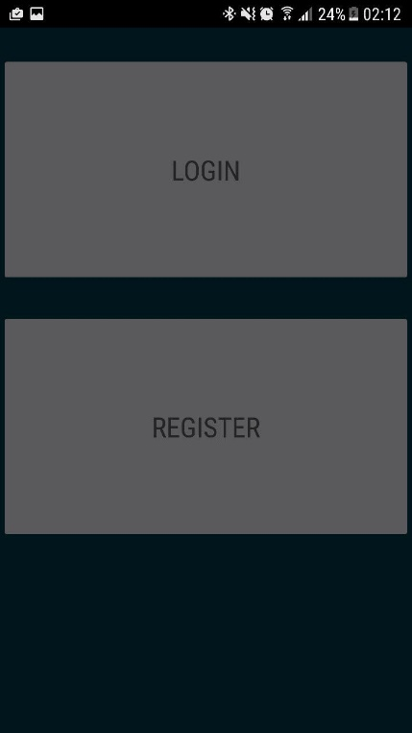

##### E3.1.1

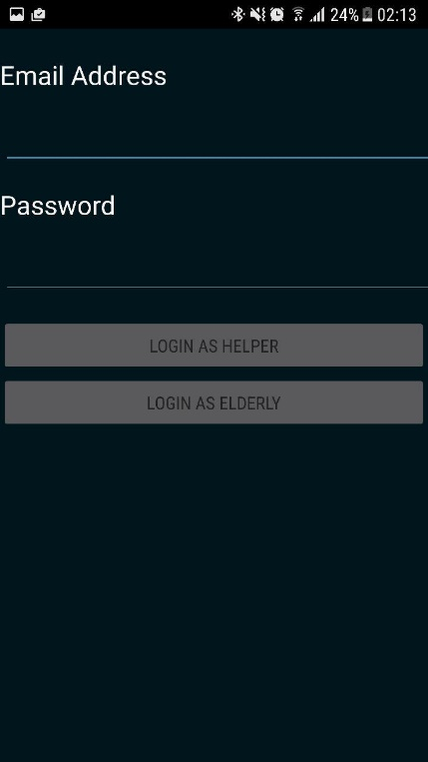

##### T3.1.2

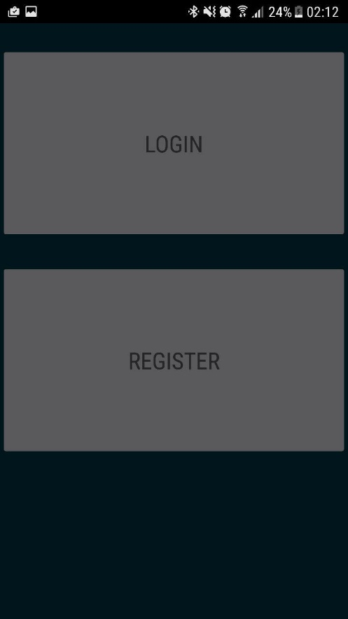

##### E3.1.2

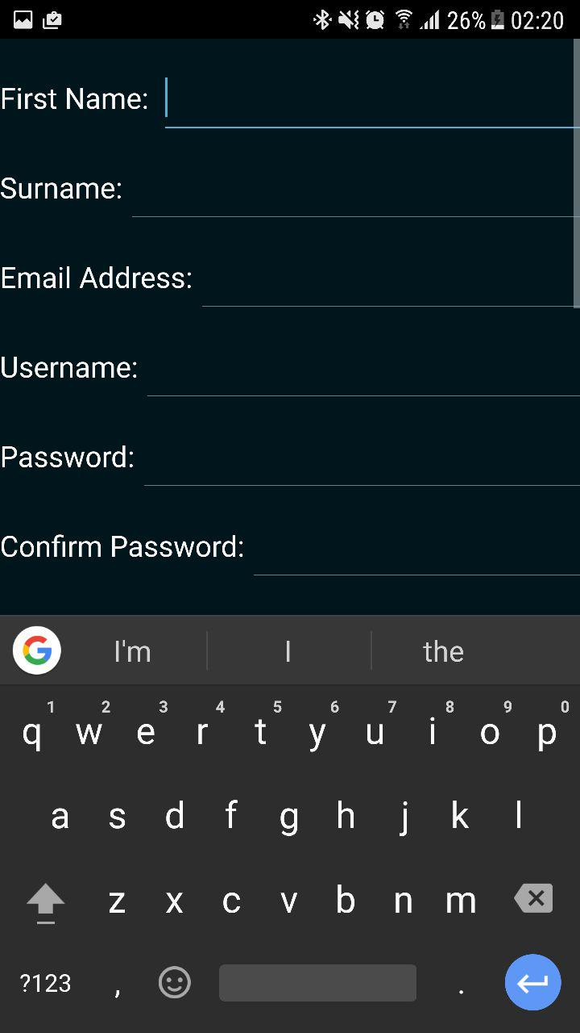

#### 3.2

##### T3.2.1

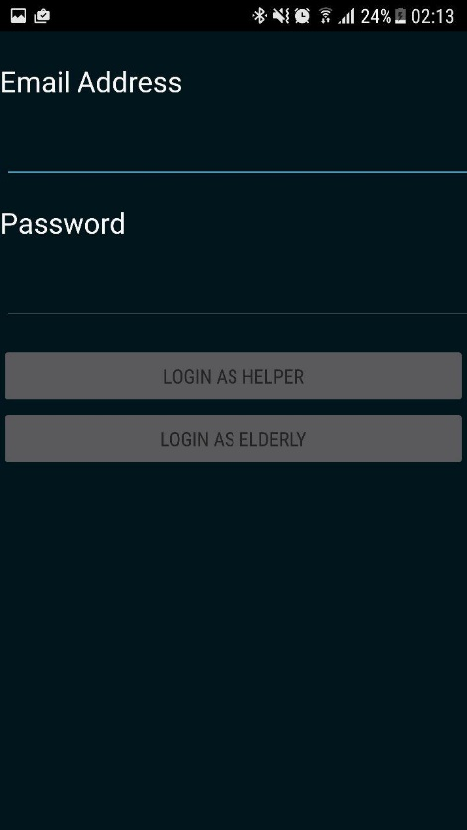

##### E3.2.1

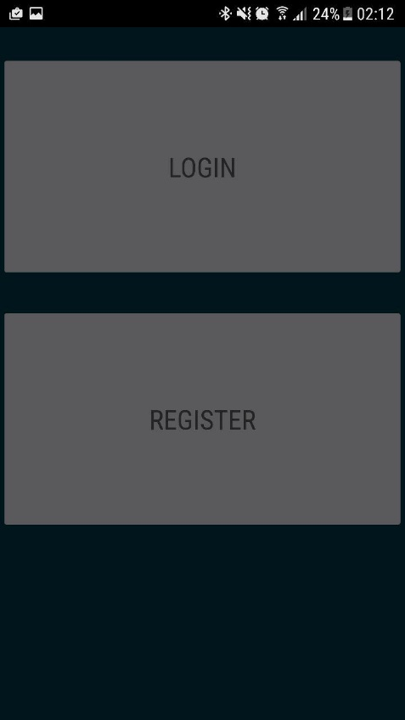

##### T3.2.2

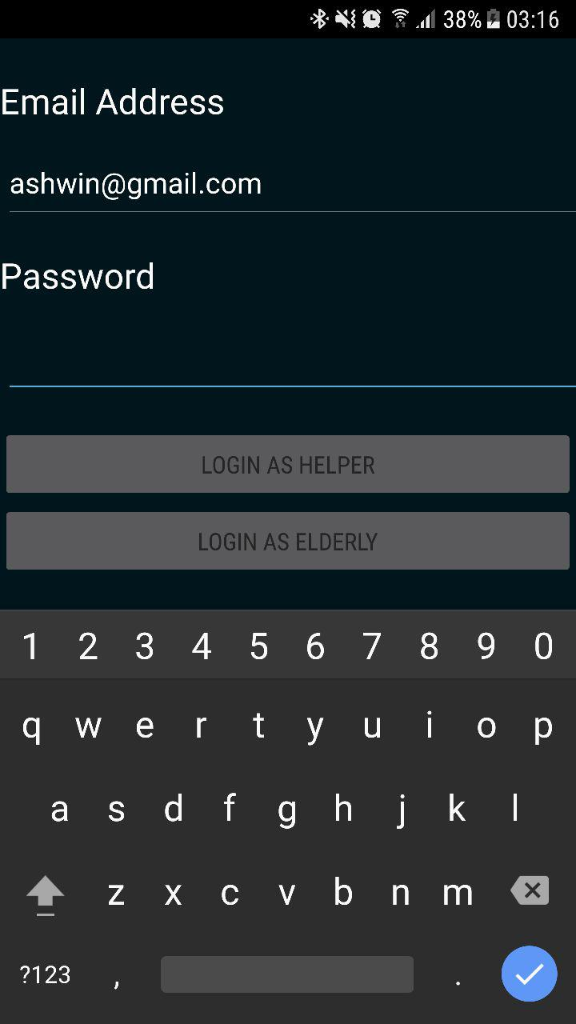

##### E3.2.2

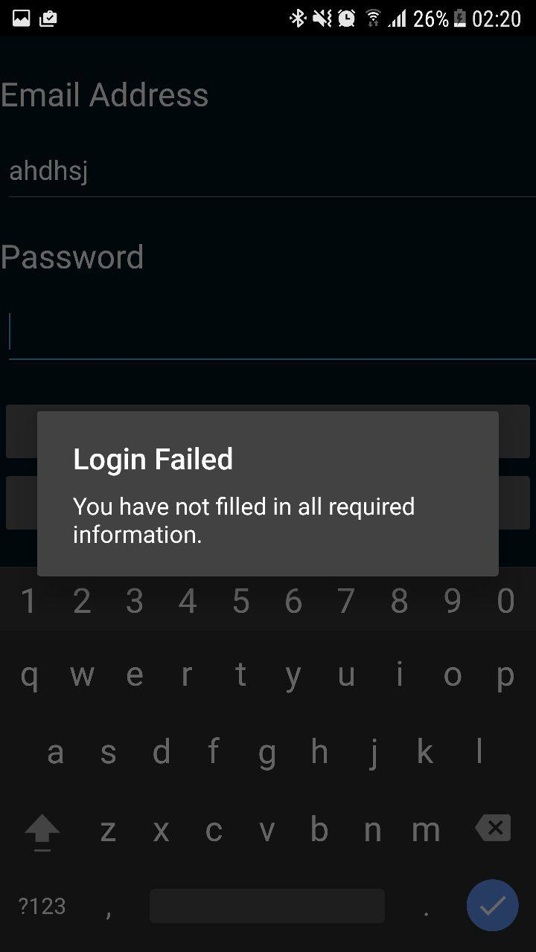

#### 3.3

##### T3.3.1

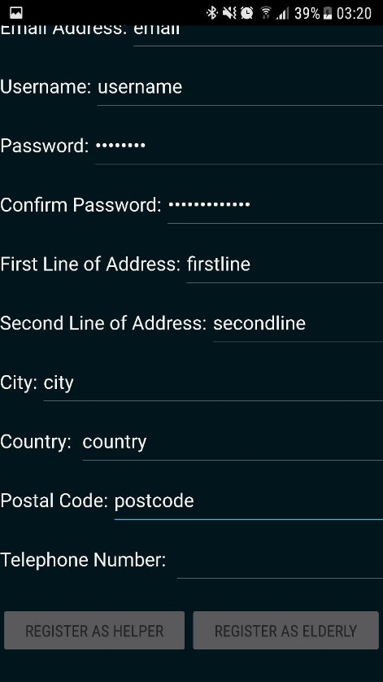

##### E3.3.1

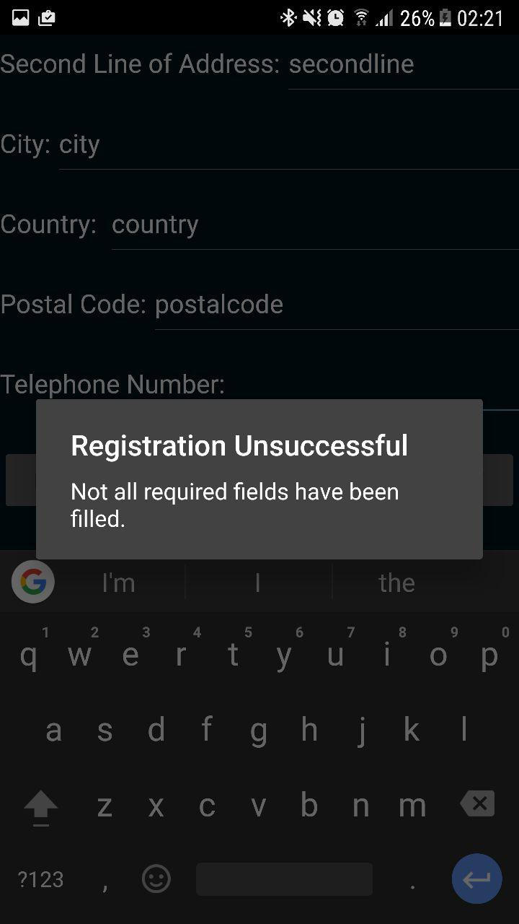

##### T3.3.2

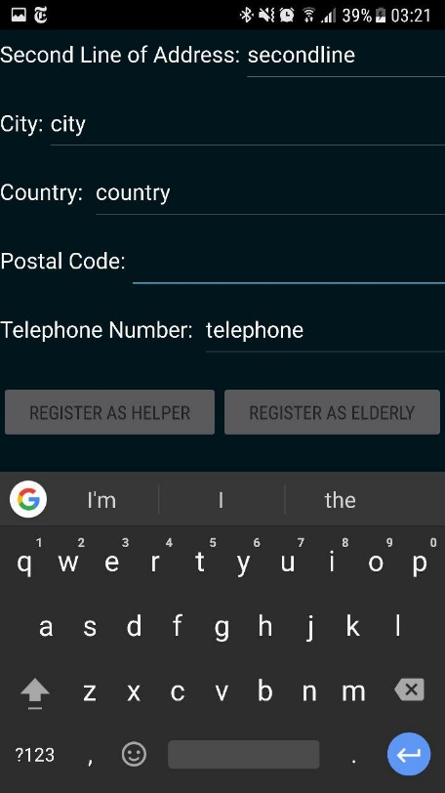

##### E3.3.2

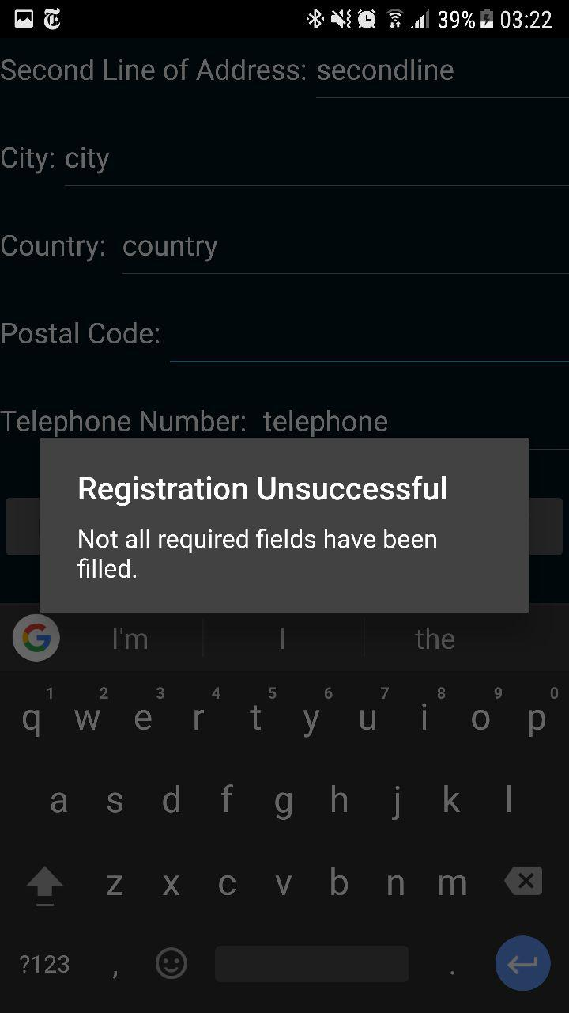

##### T3.3.3

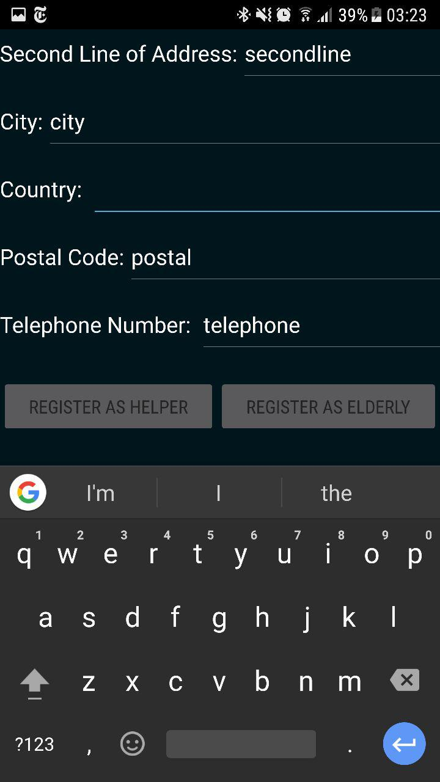

##### E3.3.3

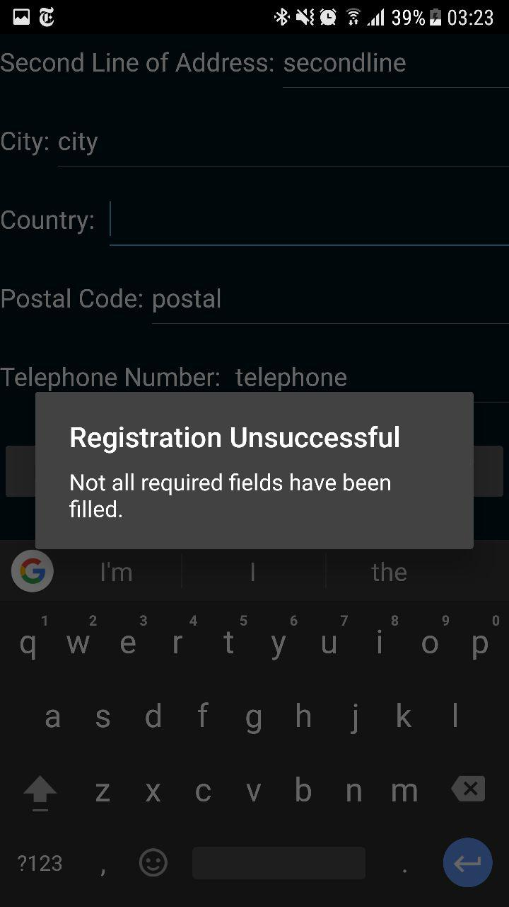

##### T3.3.4

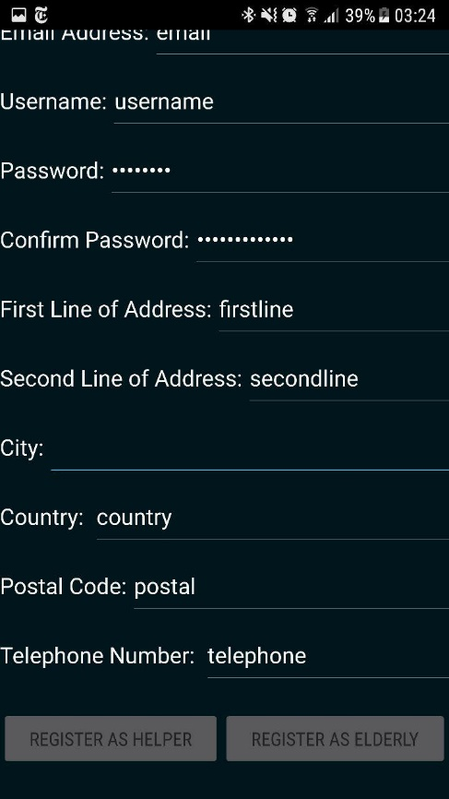

##### E3.3.4

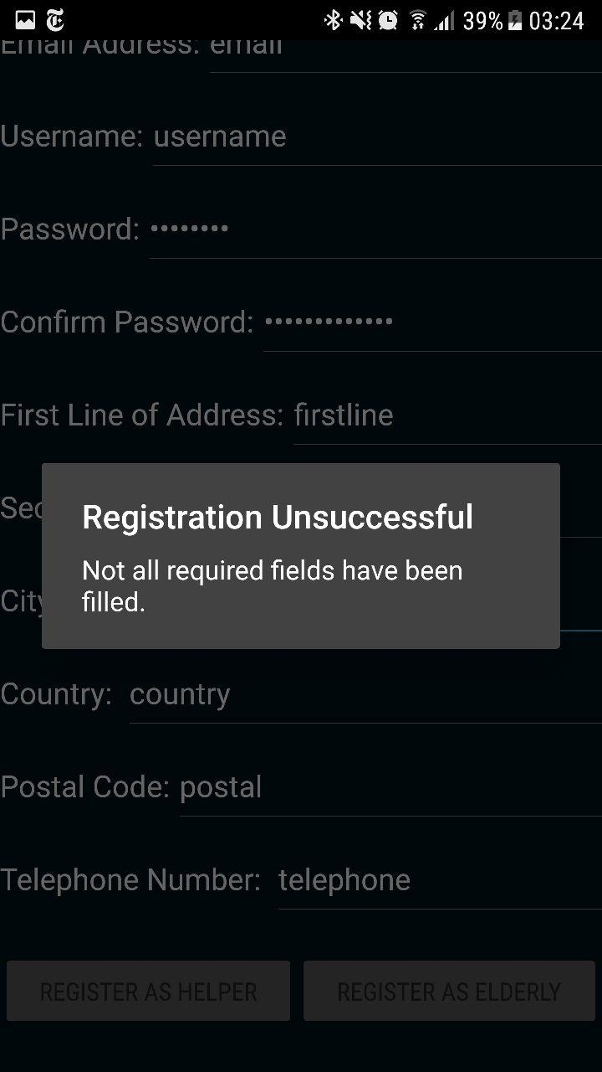

##### T3.3.5

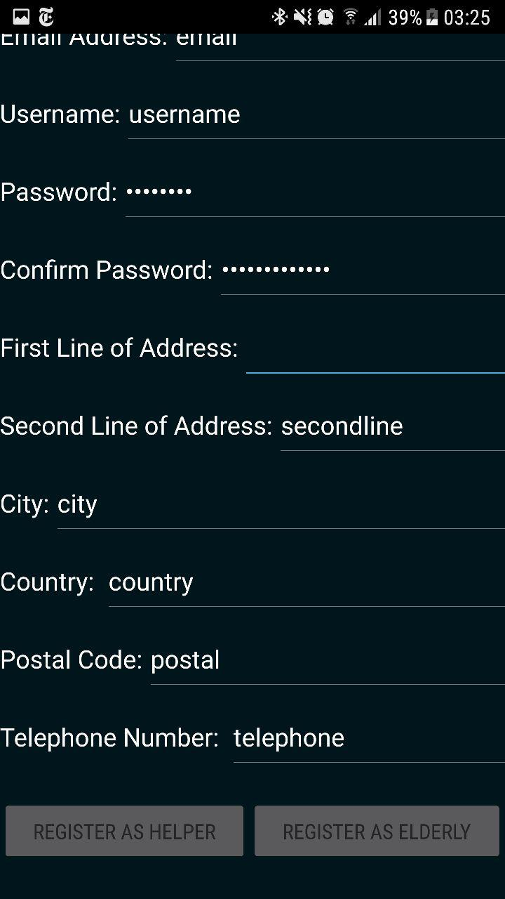

##### E3.3.5

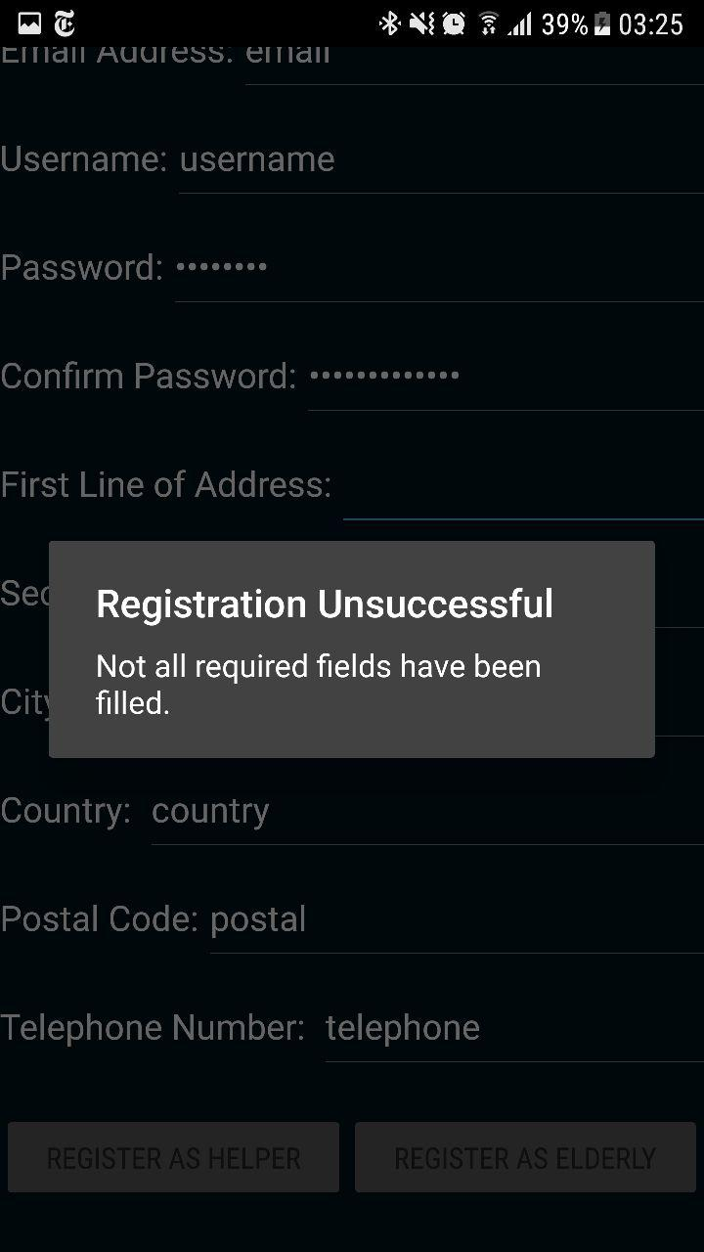

##### T3.3.6

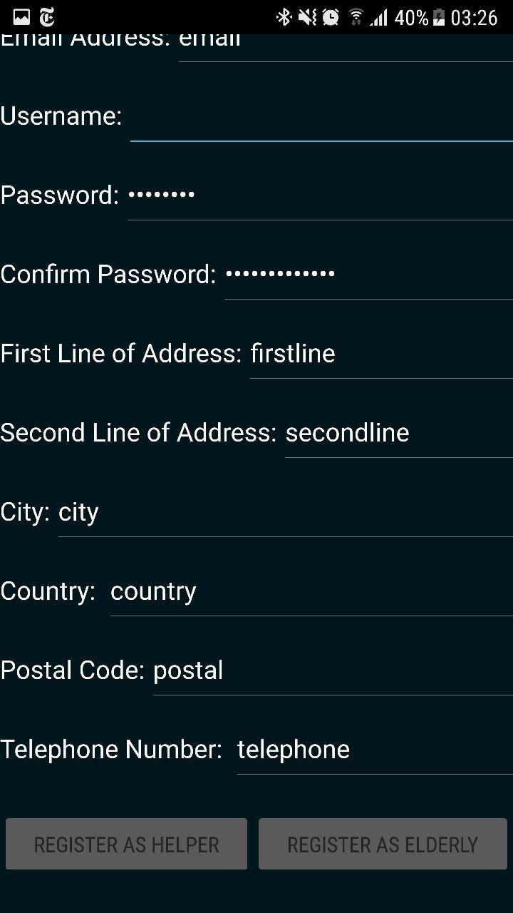

##### E3.3.6

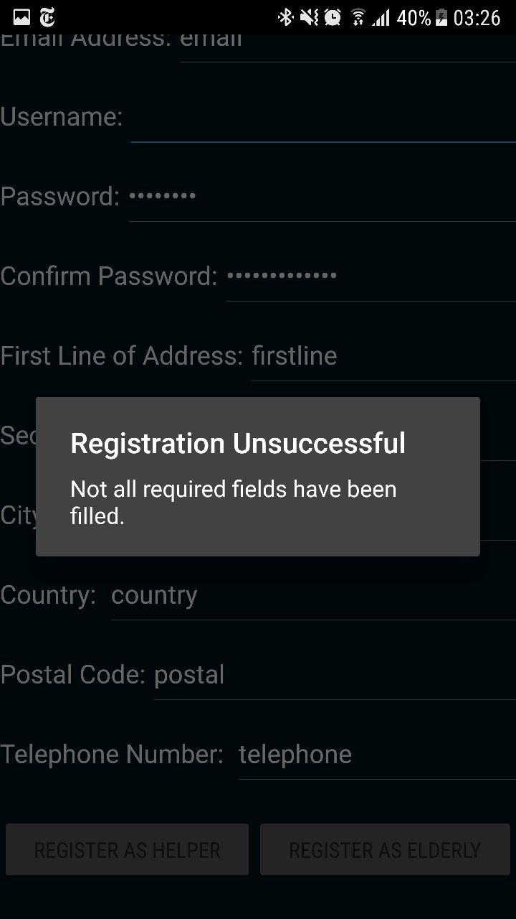

##### T3.3.7

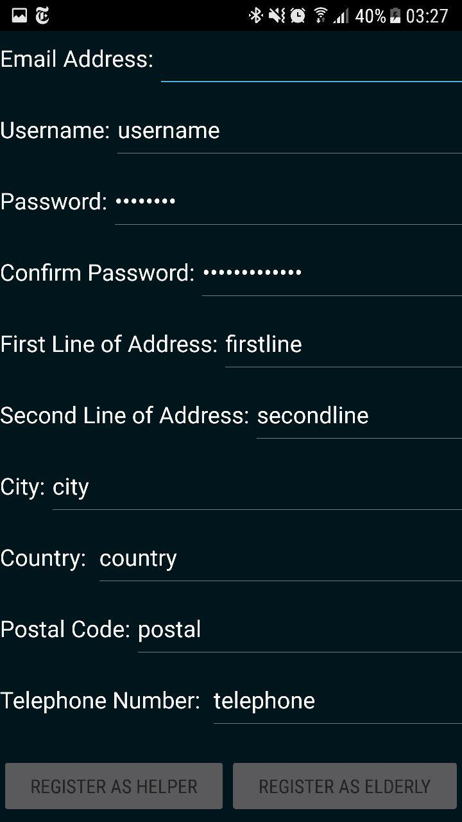

##### E3.3.7

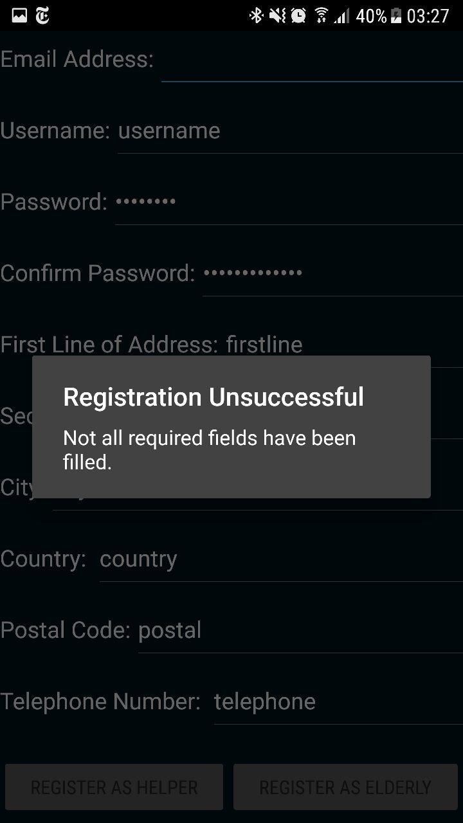

##### T3.3.8

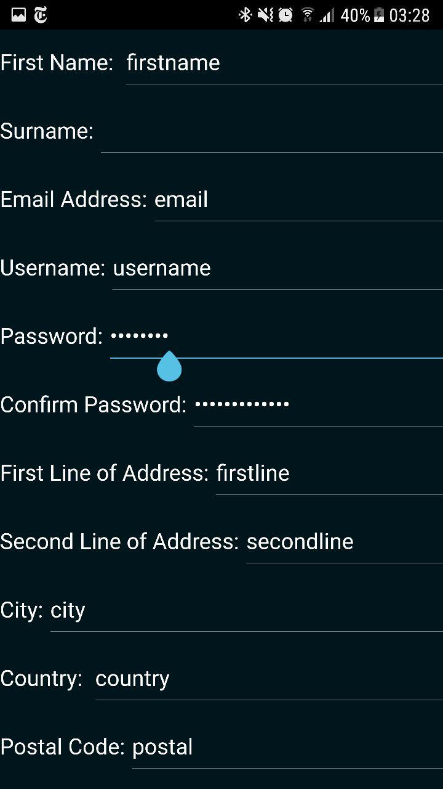

##### E3.3.8

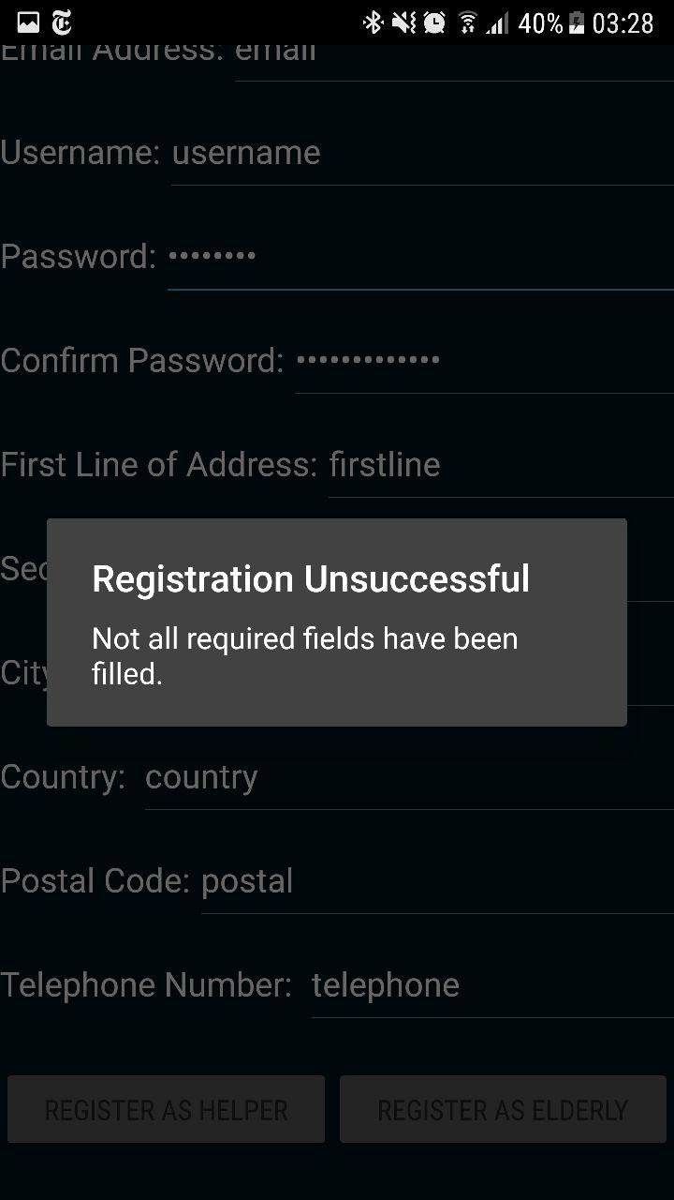

##### T3.3.9

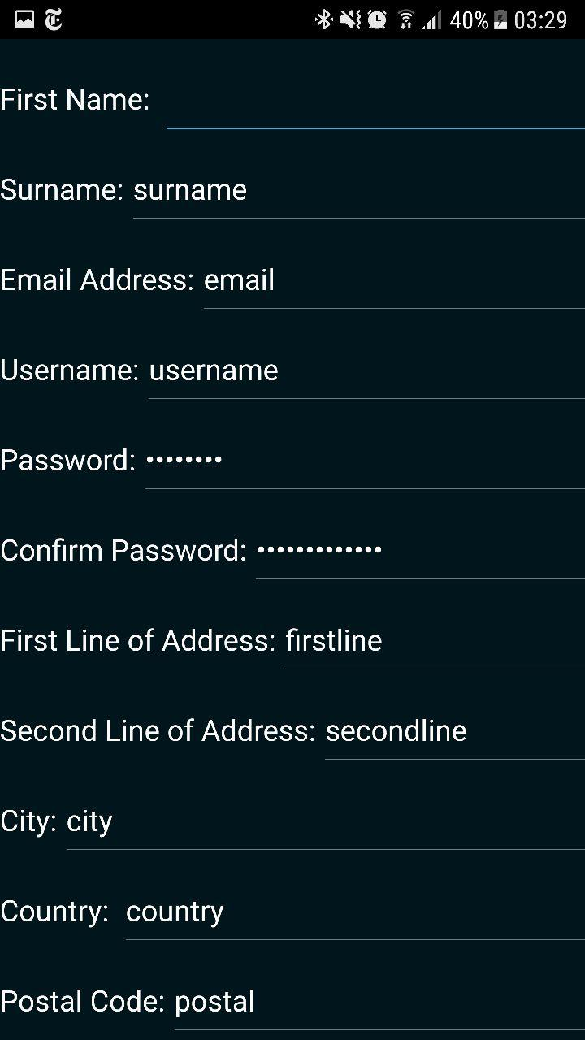

##### E3.3.9

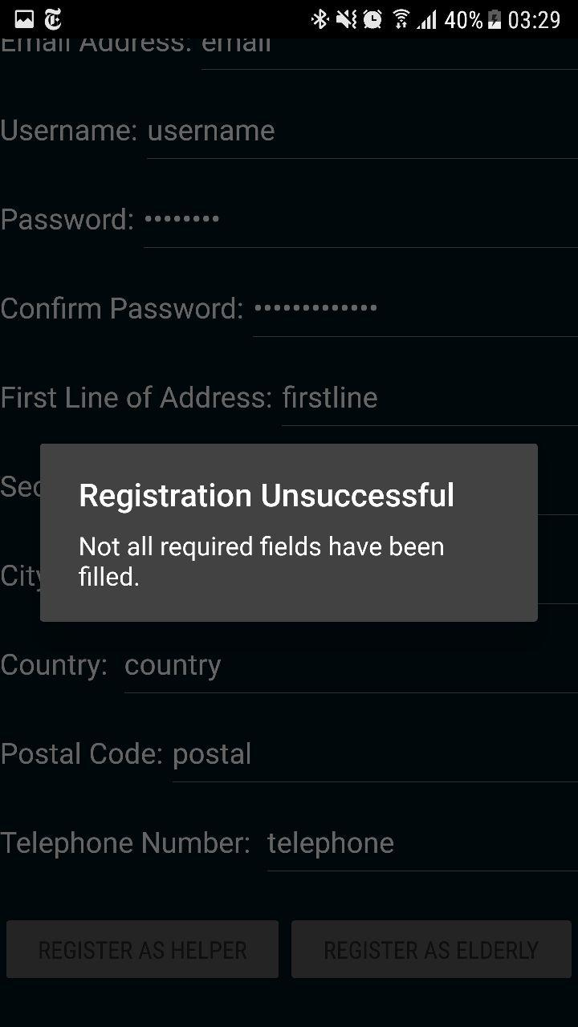

##### T3.3.11

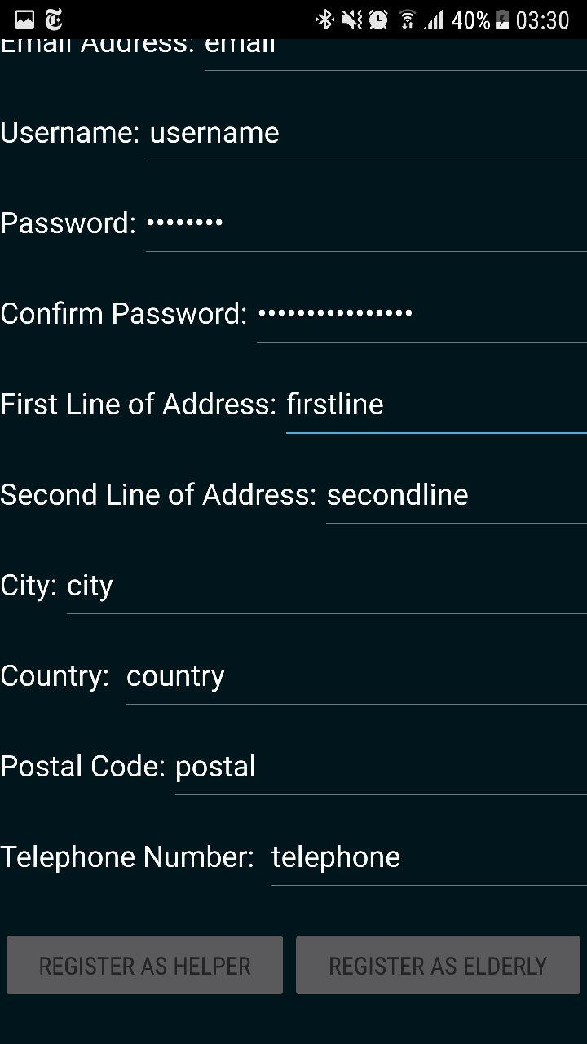

##### E3.3.11

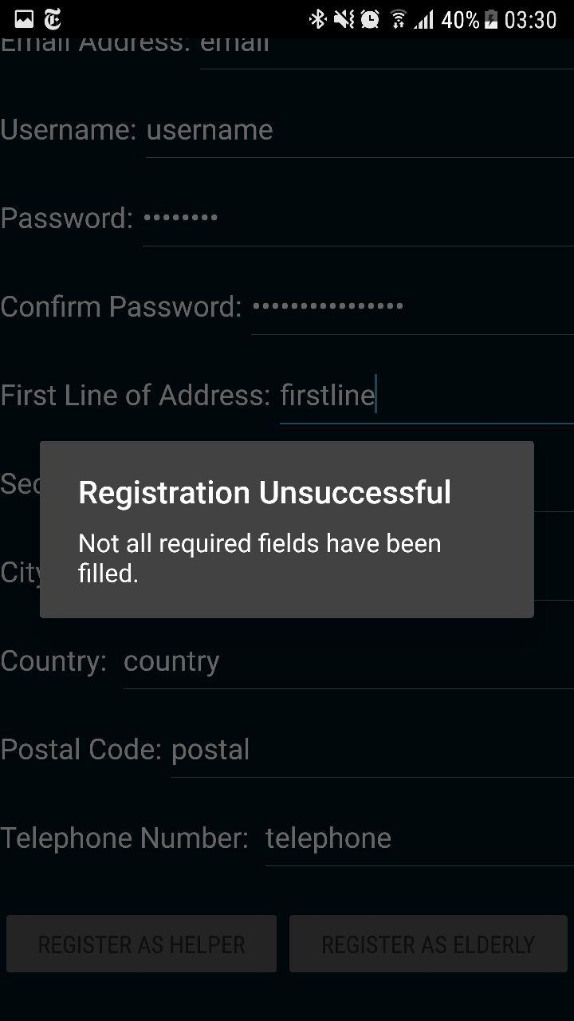

##### T3.3.12

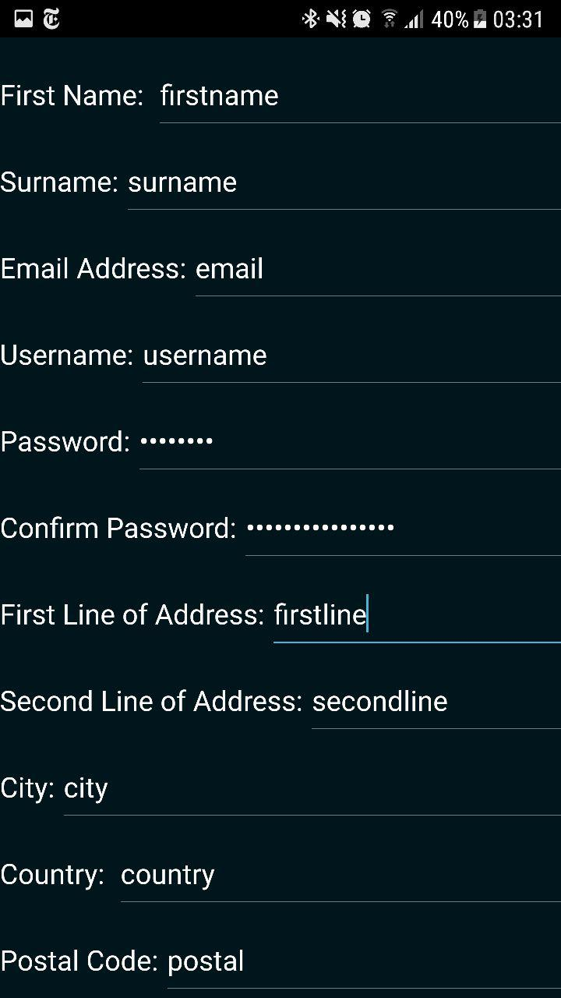

##### E3.3.12

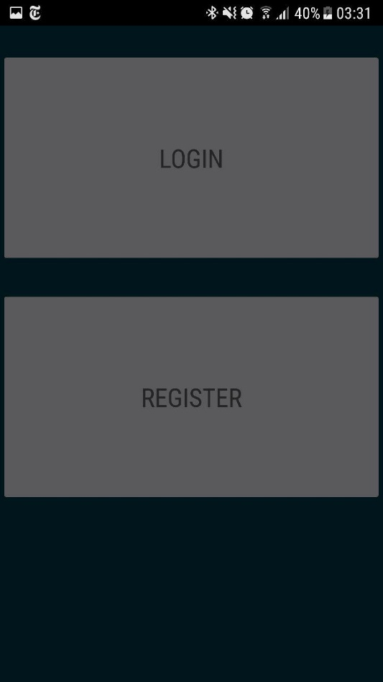

#### 3.4

##### T3.4.1

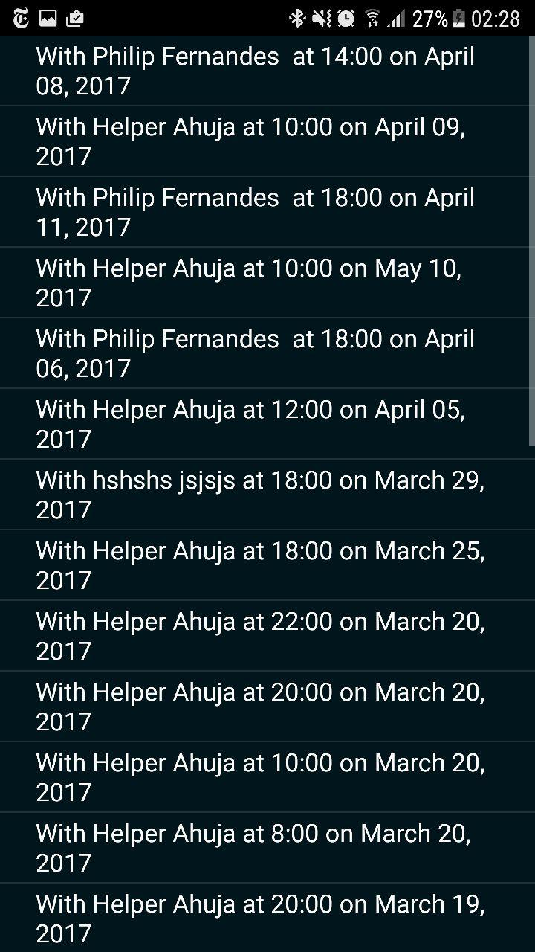

##### E3.4.1

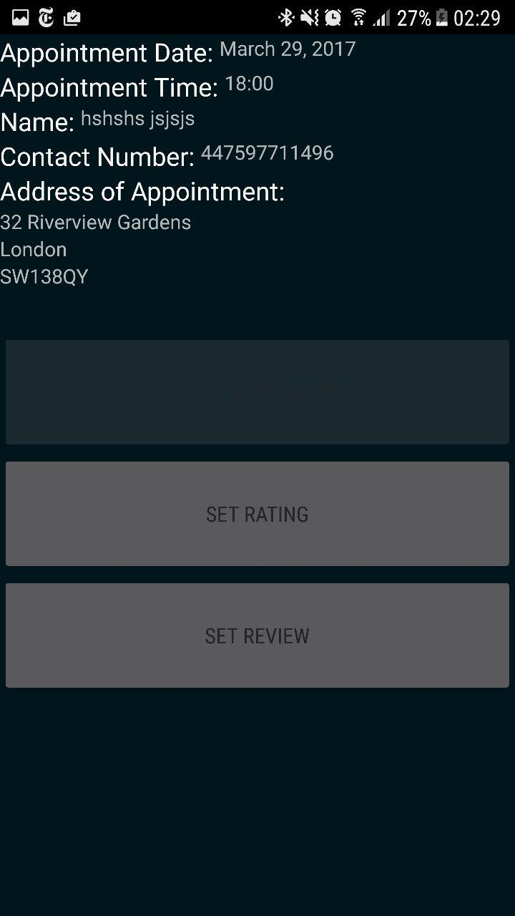

##### T3.4.2

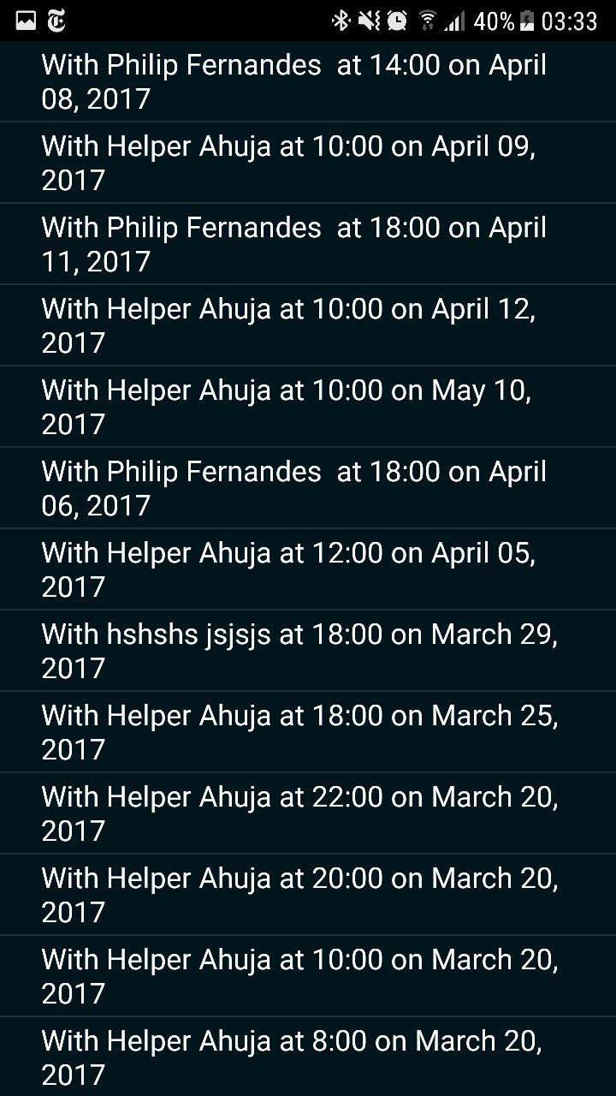

##### E3.4.2

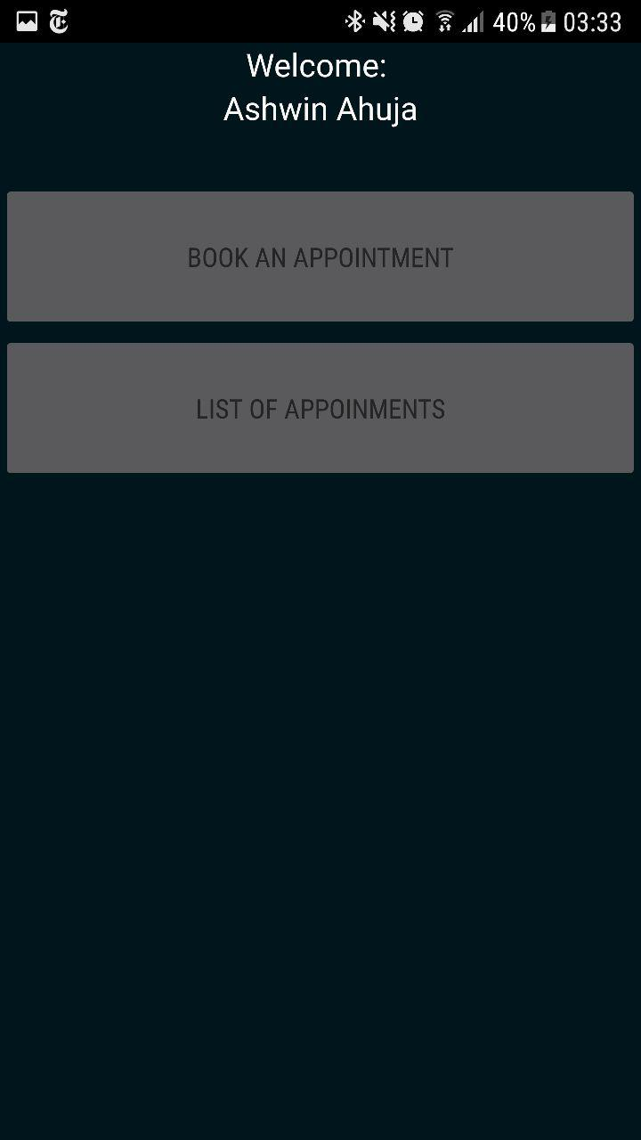

#### 3.5

##### T3.5.1

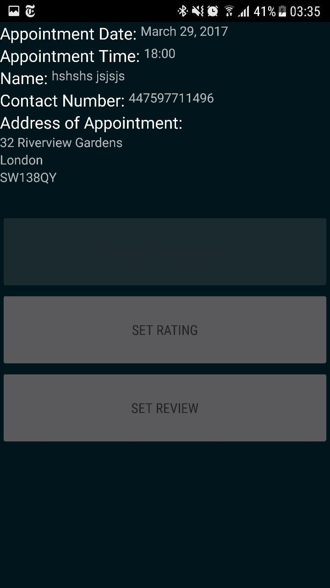

##### E3.5.1



##### T3.5.2



##### E3.5.2

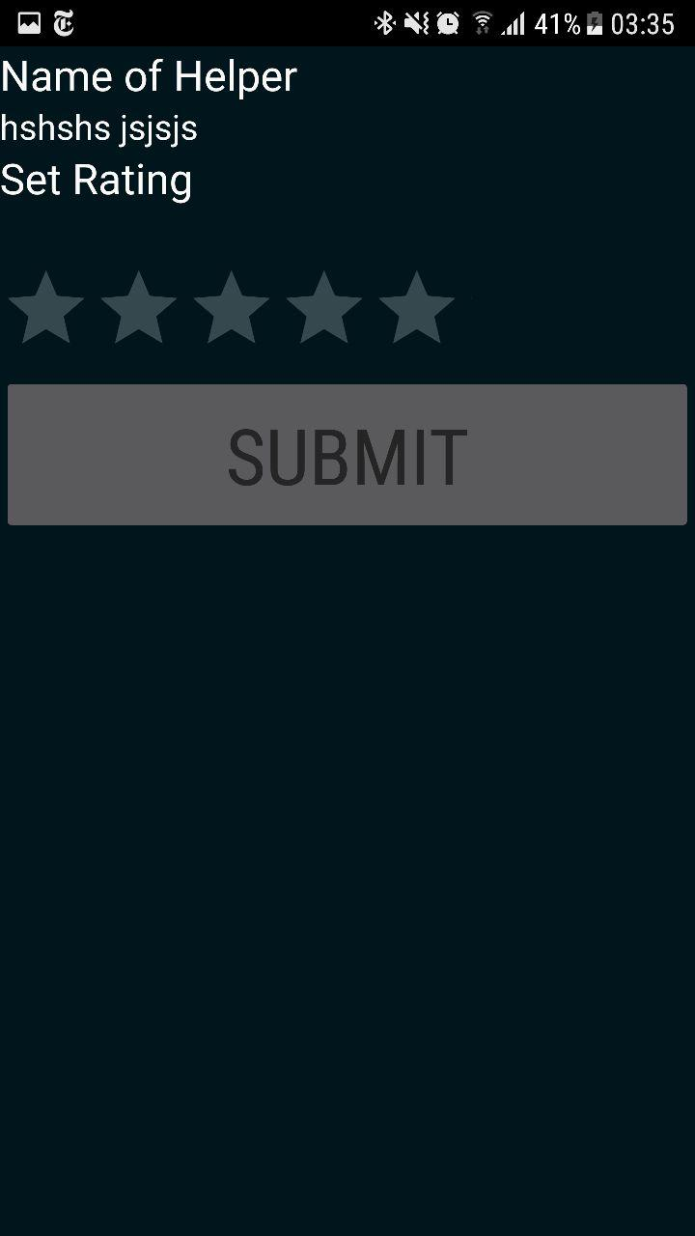

##### T3.5.3



##### E3.5.3

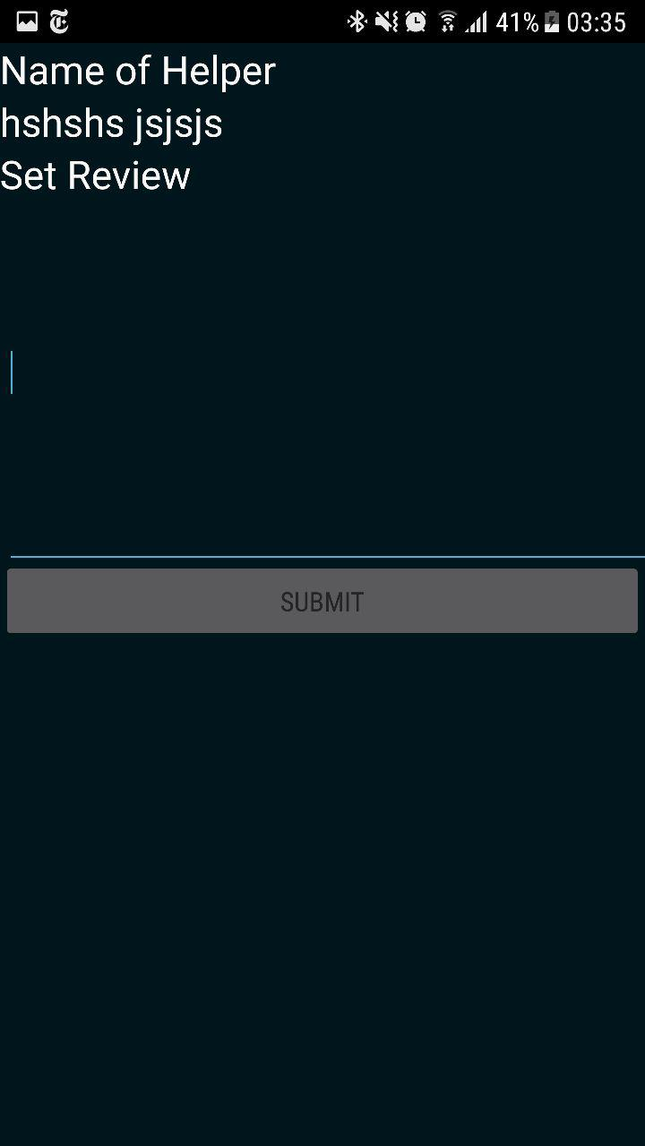

#### 3.6

##### T3.6.1



##### E3.6.1



#### 3.7

##### T3.7.1



##### E3.7.1



#### 3.8

##### T3.8.1

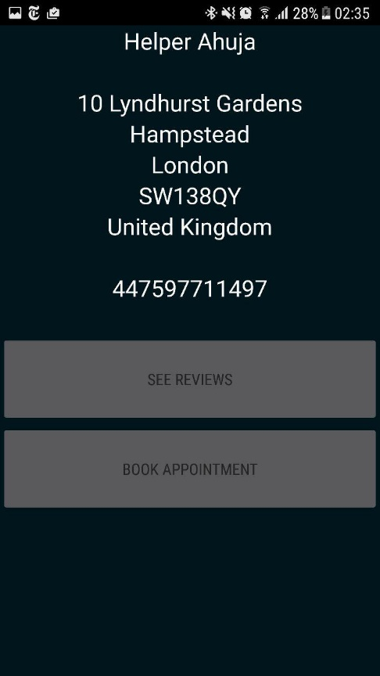

##### E3.8.1

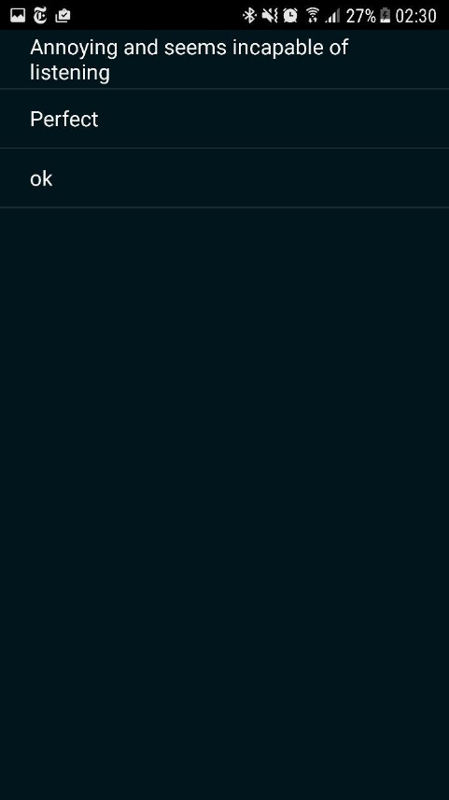

#### 3.9

##### T3.9.1

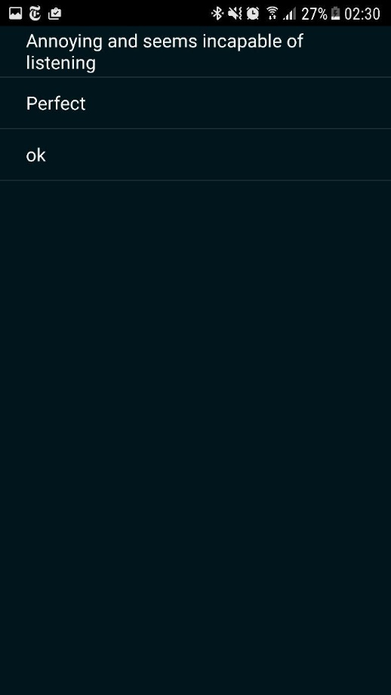

##### E3.9.1

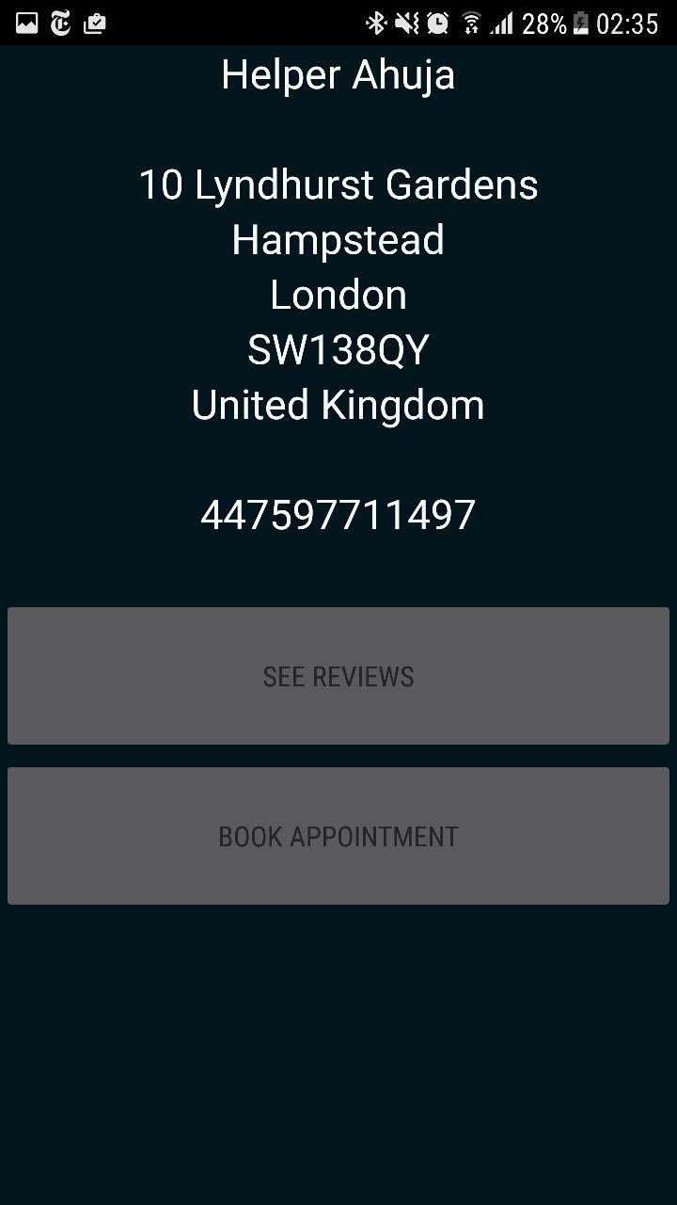

#### 3.10

##### T3.10.1

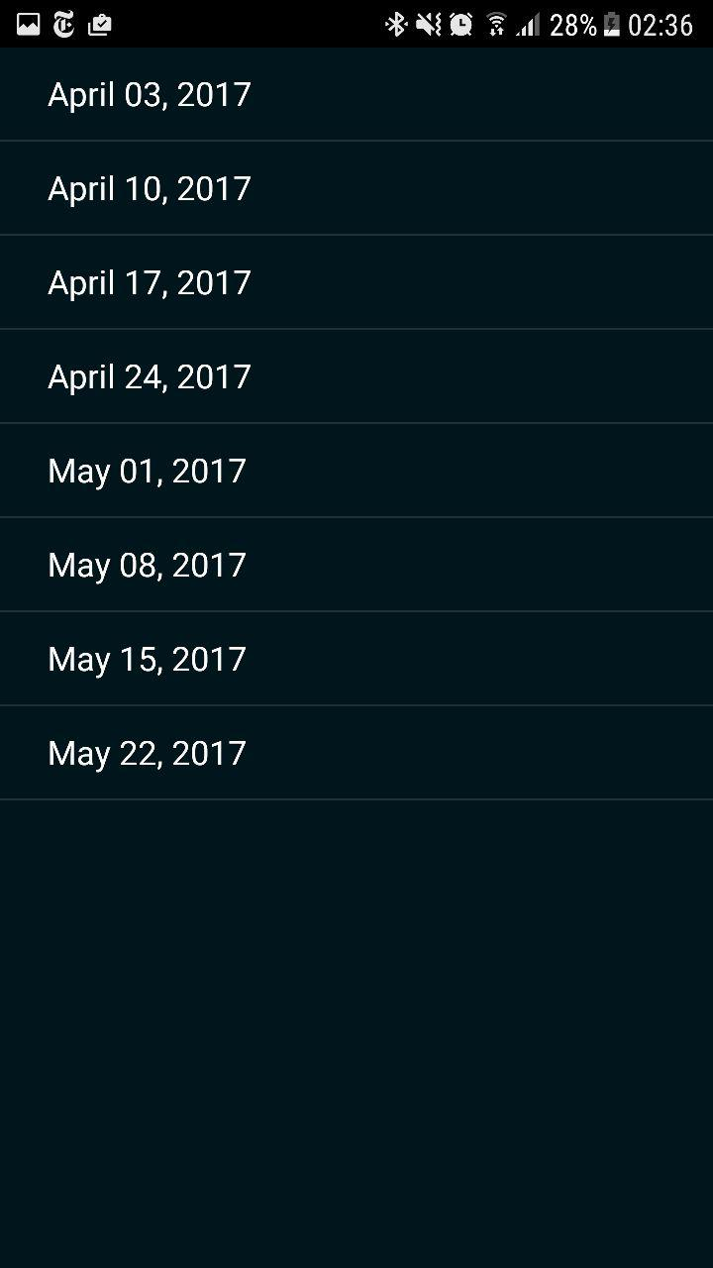

##### E3.10.1



##### T3.10.2

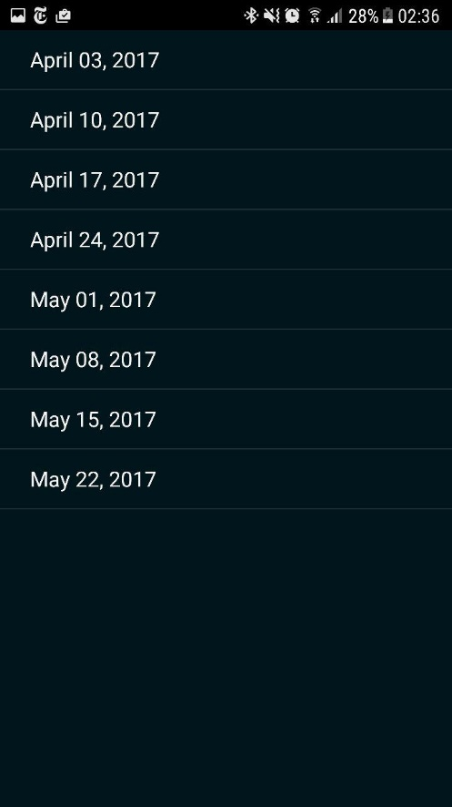

##### E3.10.2

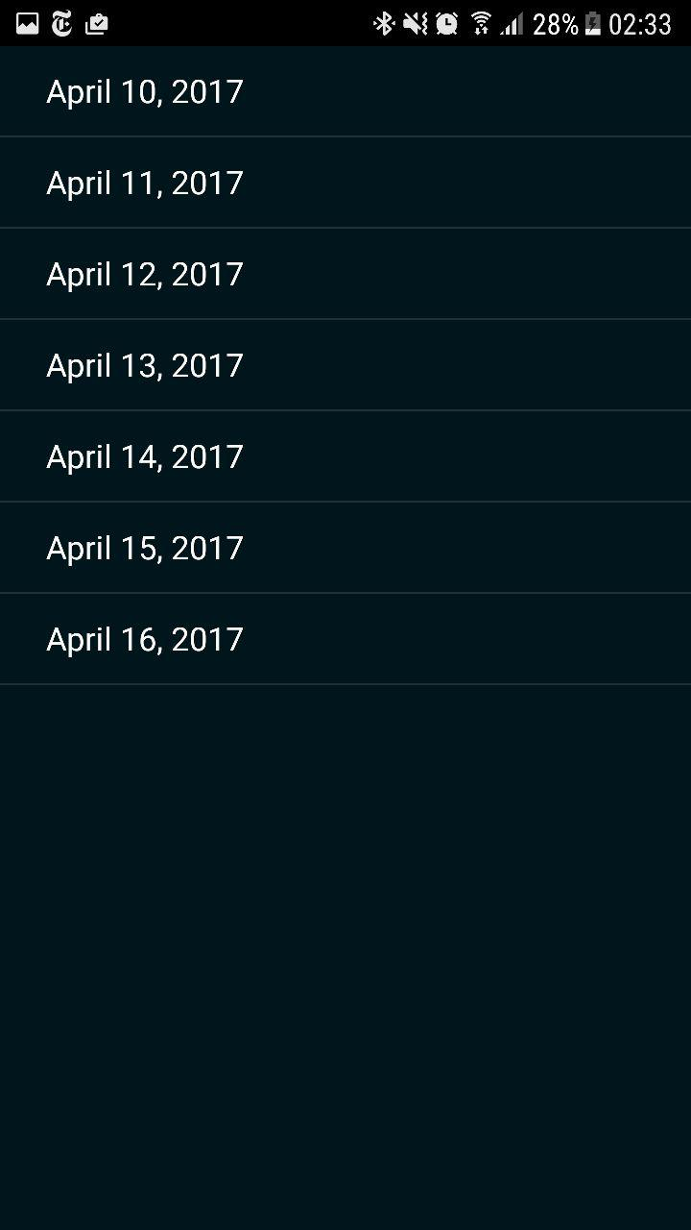

#### 3.11

##### T3.11.1



##### E3.11.1



##### T3.11.2



##### E3.11.2

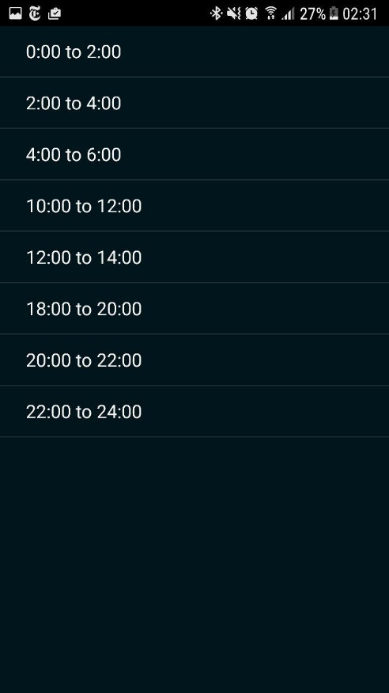

#### 3.12

##### T3.12.1

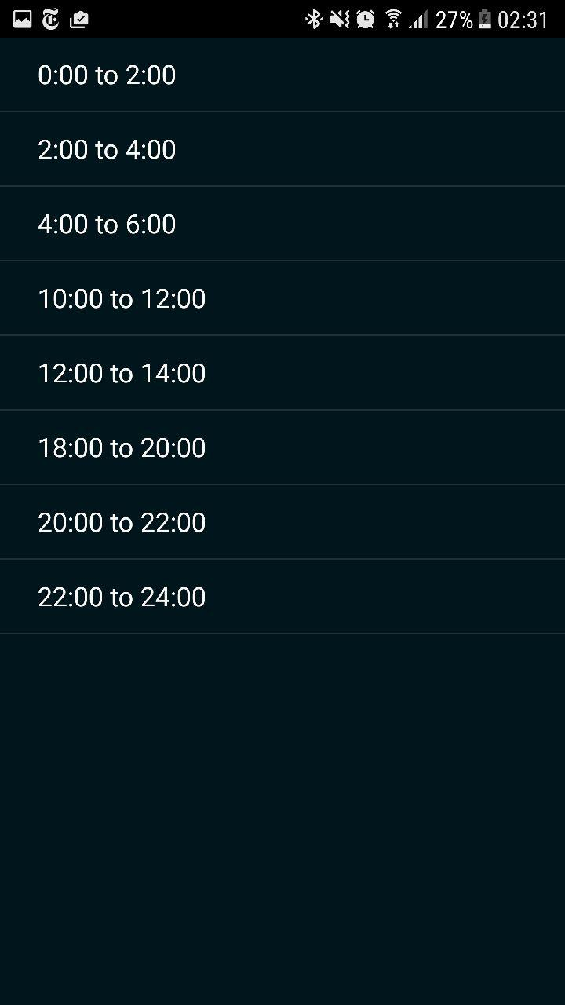

##### E3.12.1



##### T3.12.2



##### E3.12.2

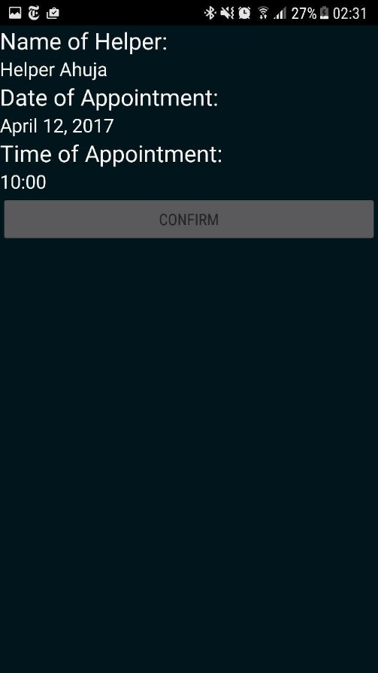

#### 3.13

##### T3.13.1

\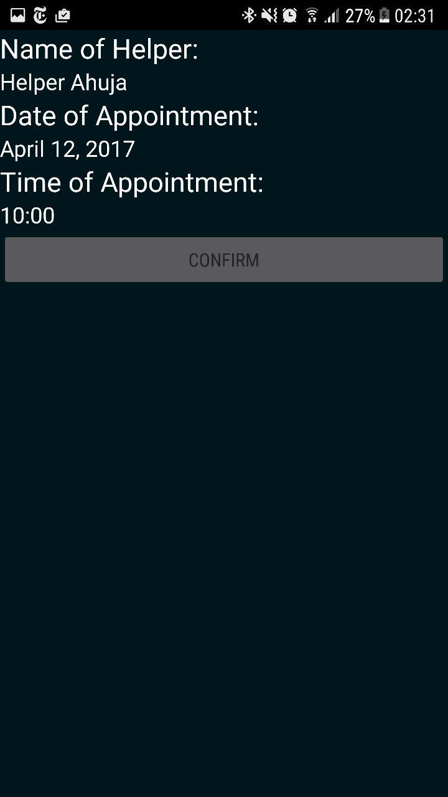

##### E3.13.1



#### 3.14

##### T3.14.1

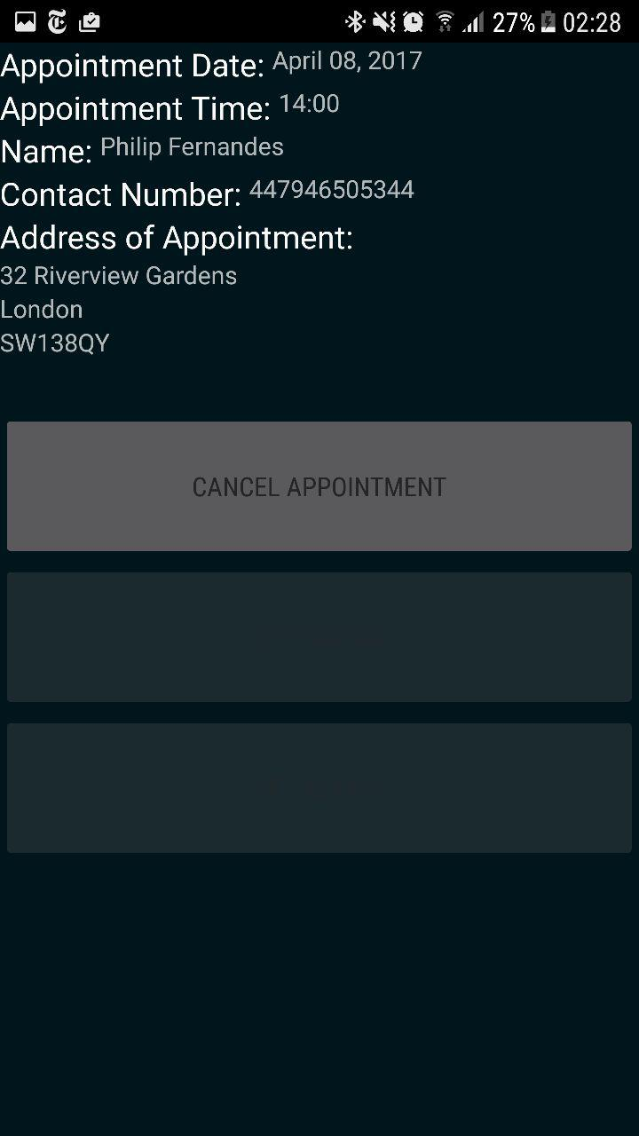

##### E3.14.1

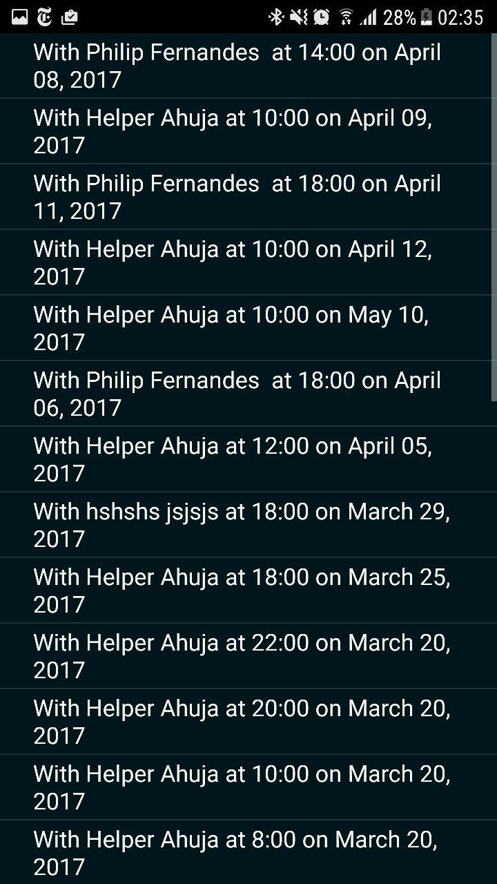

#### 3.15

##### T3.15.1

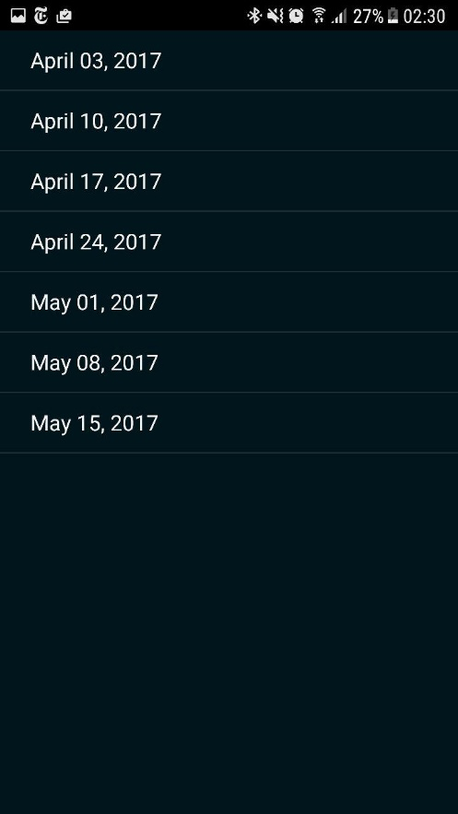

##### E3.15.1

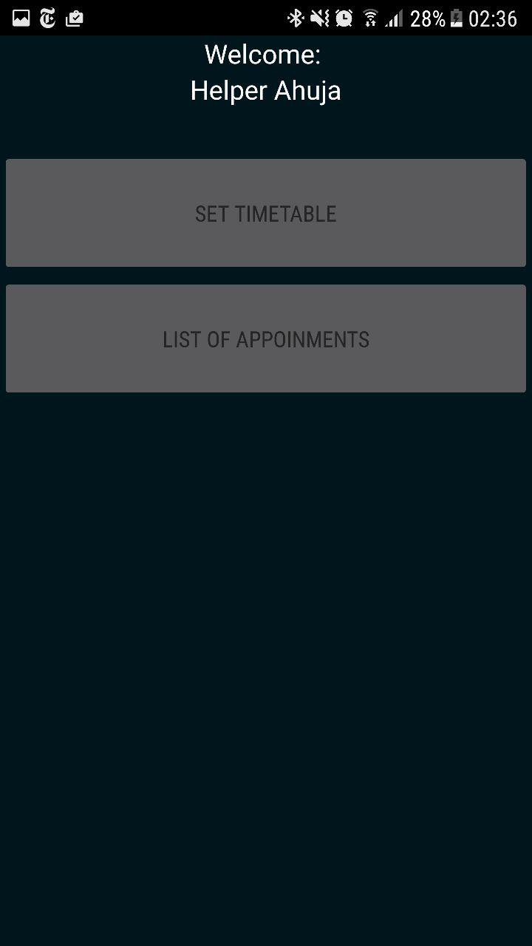

##### T3.15.2

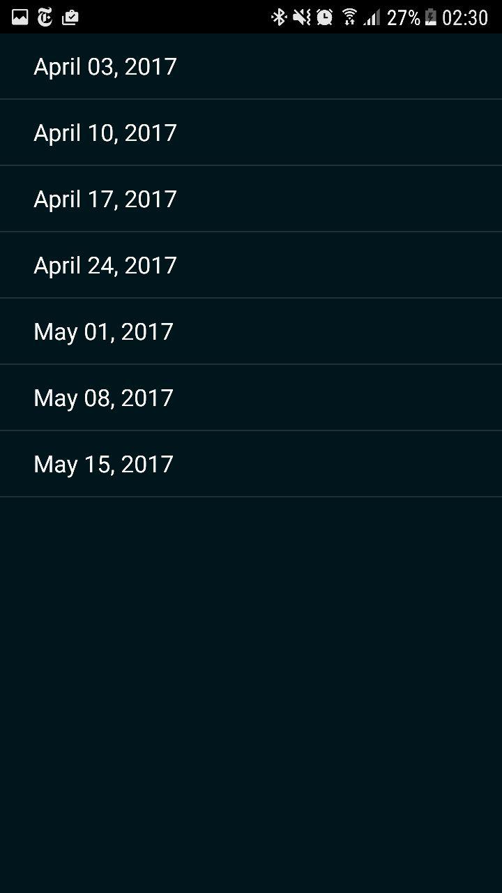

##### E3.15.2



#### 3.16

##### T3.16.1

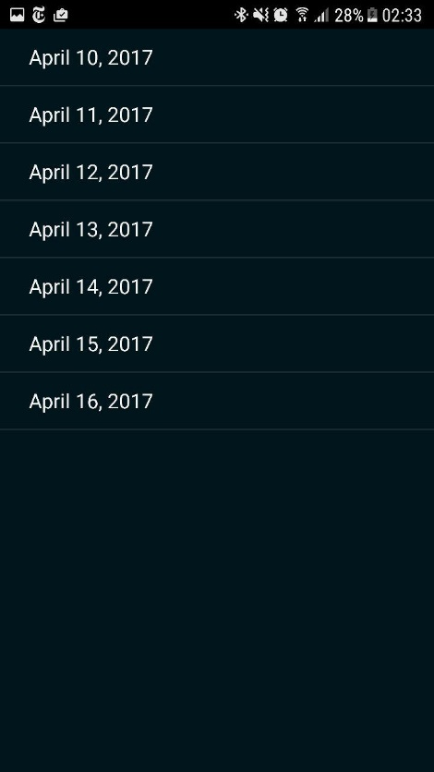

##### E3.16.1



##### T3.16.2



##### E3.16.2

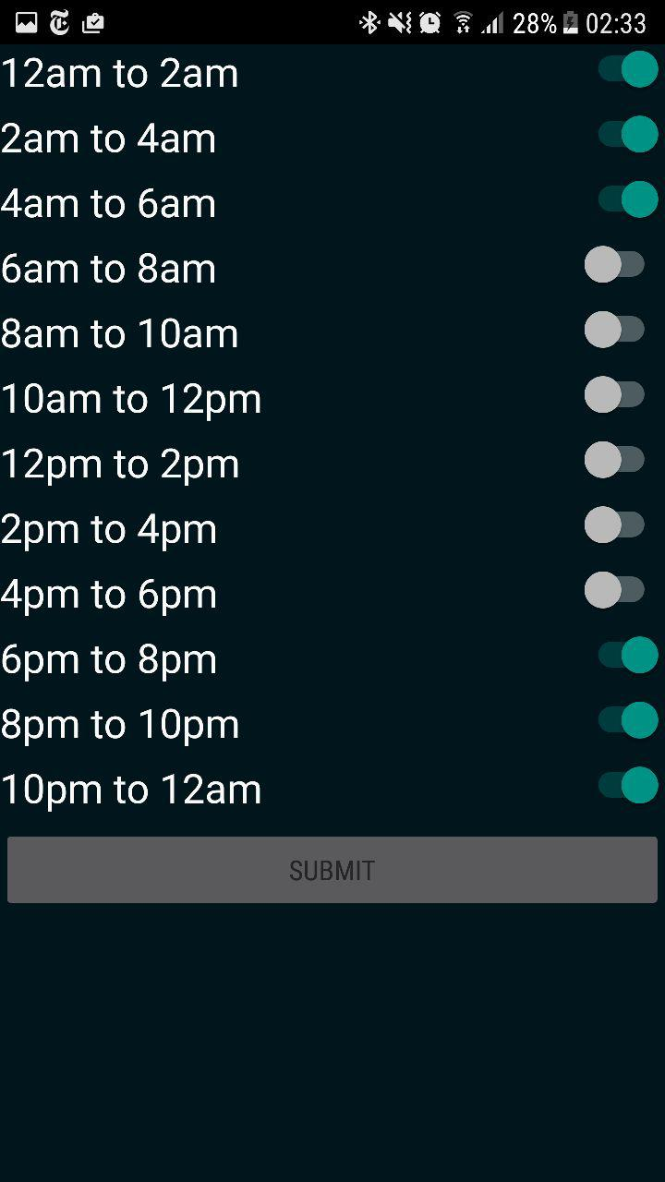

#### 3.17

##### T3.17.1



##### E3.17.1



#### 3.18

##### T3.18.1



##### E3.18.1



##### T3.18.2

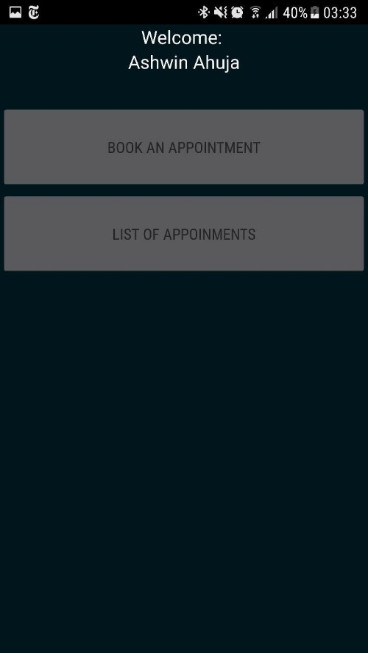

##### E3.18.2

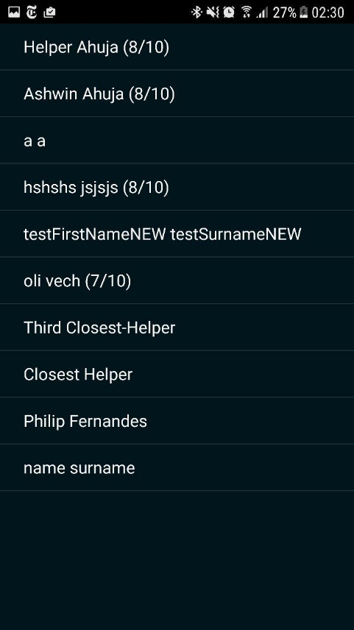

#### 3.19

##### T3.19.1

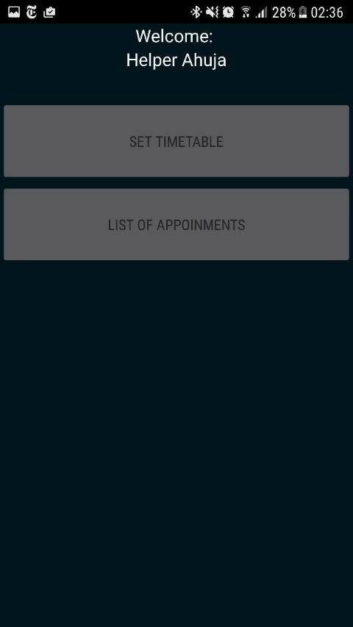

##### E3.19.1



##### T3.19.2



##### E3.19.2

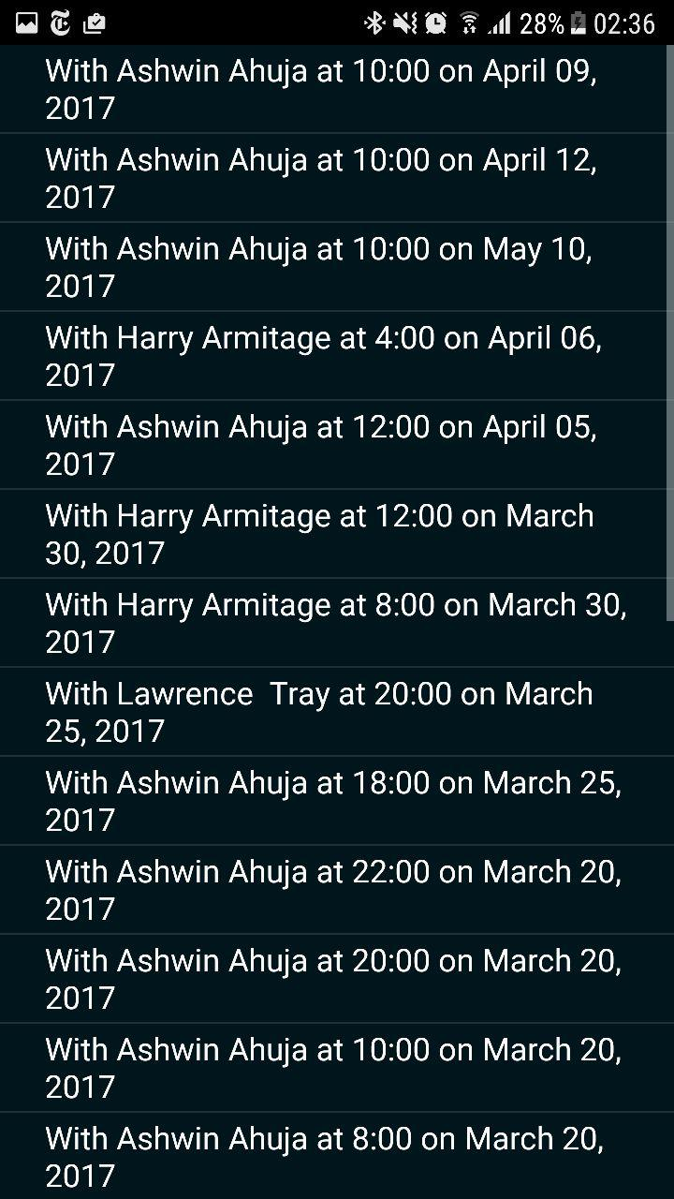

#### 3.20

##### T3.20.1

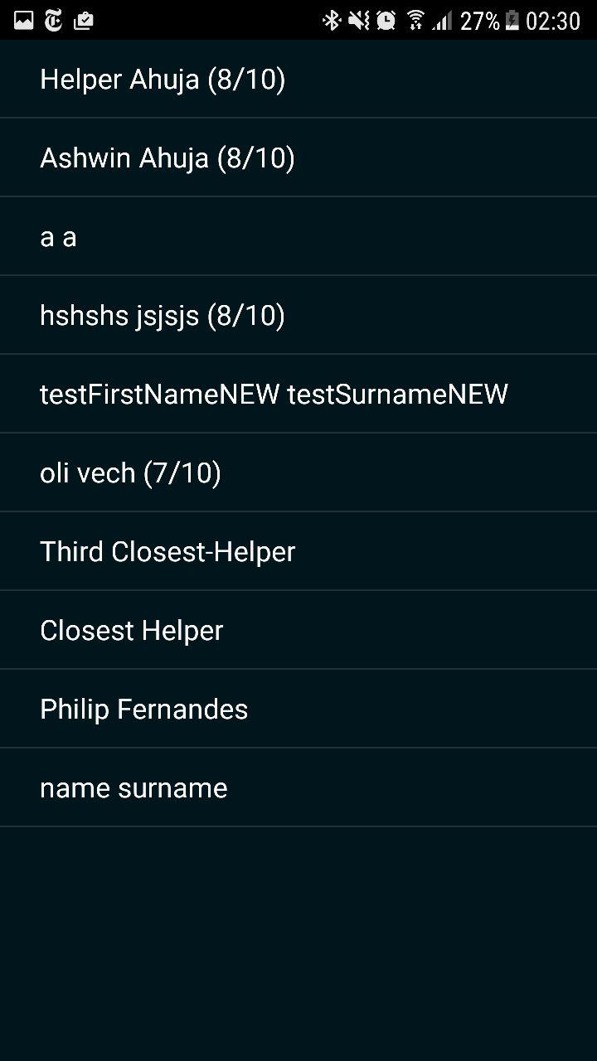

##### E3.20.1



##### T3.20.2



##### E3.20.2



### Test Series 4

#### 4.1

##### T4.1.1

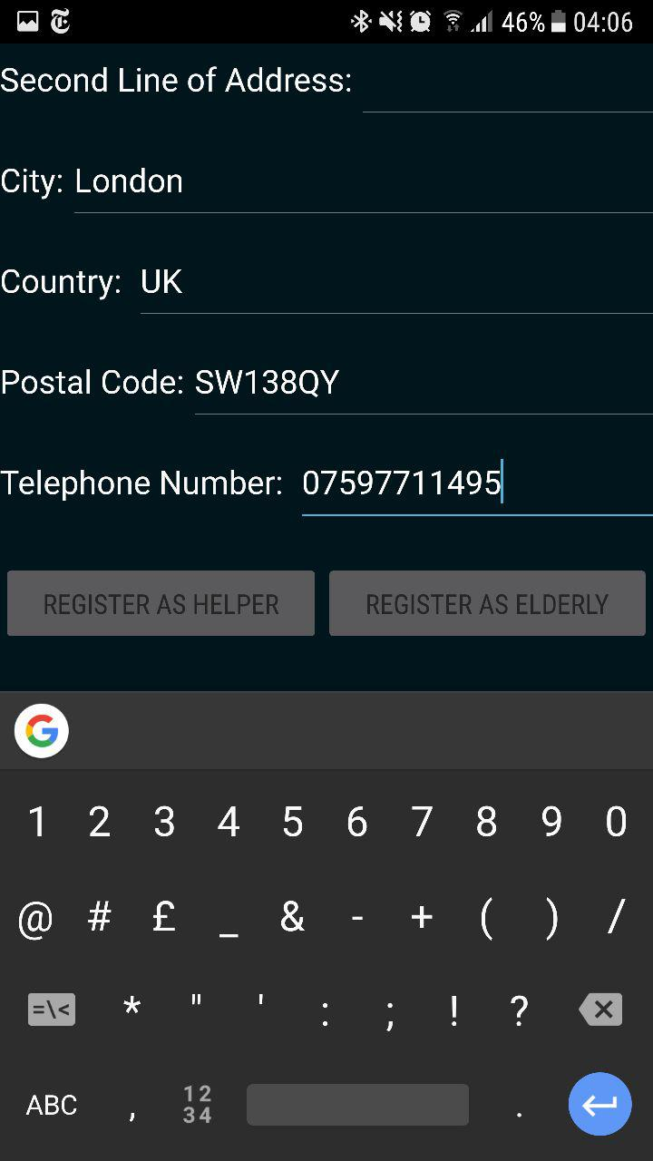

##### E4.1.1

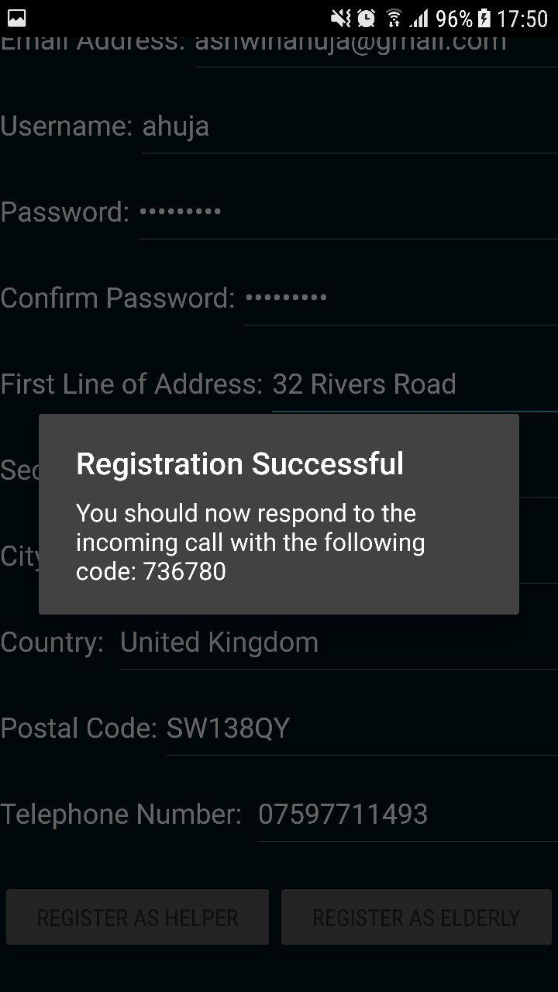

##### T4.1.2

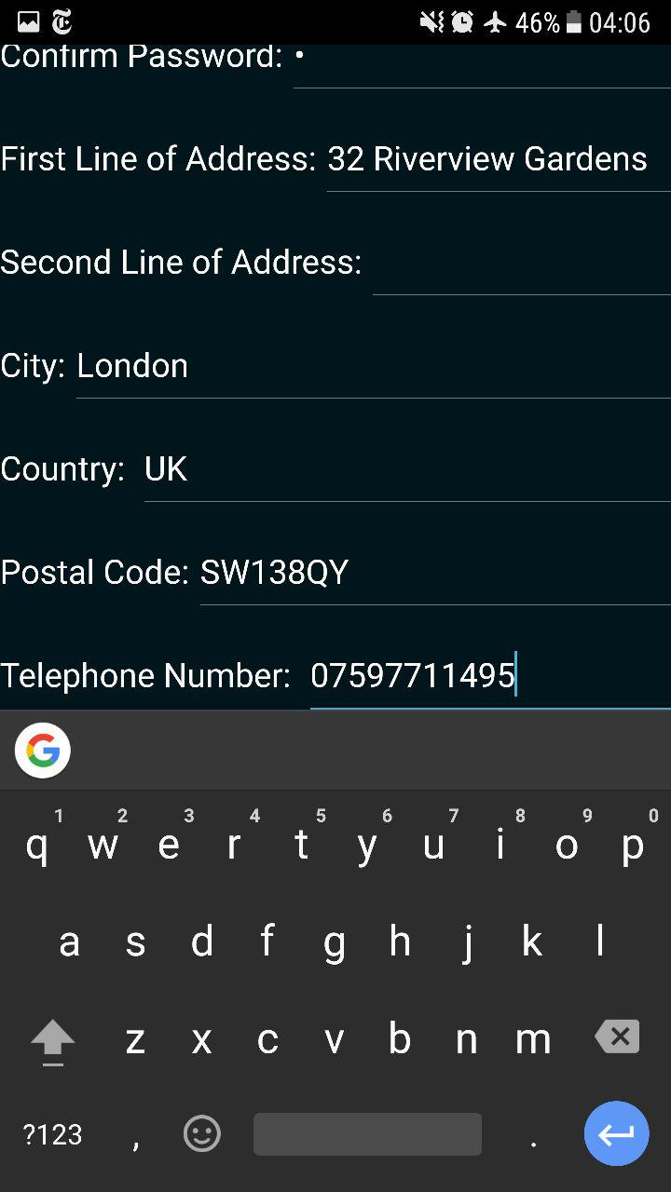

##### E4.1.2

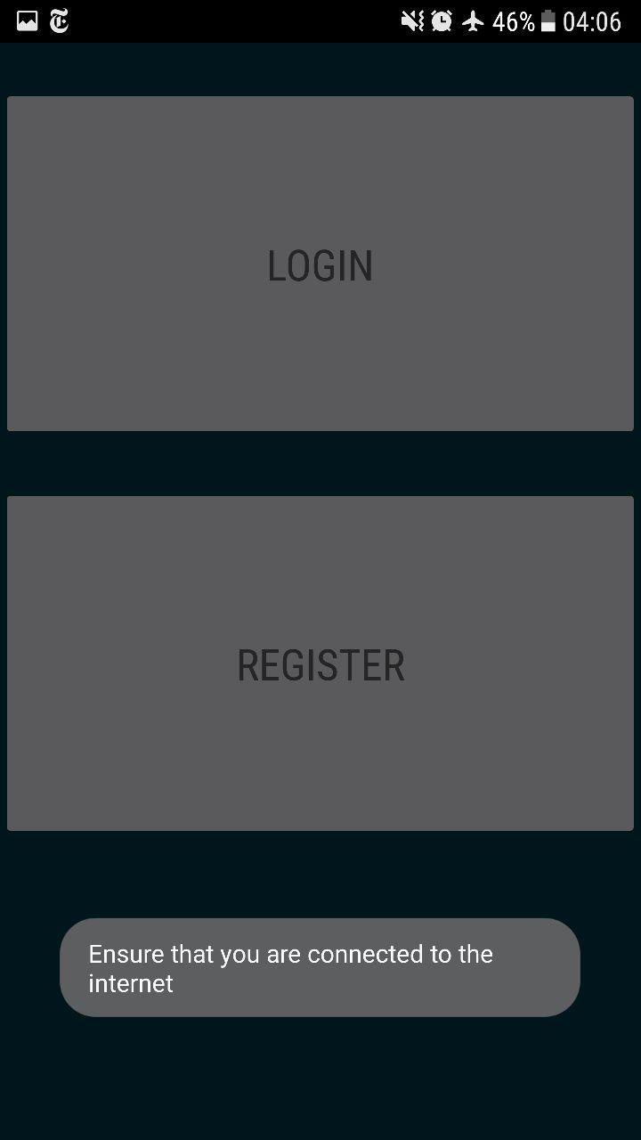

#### 4.2

##### T4.2.1

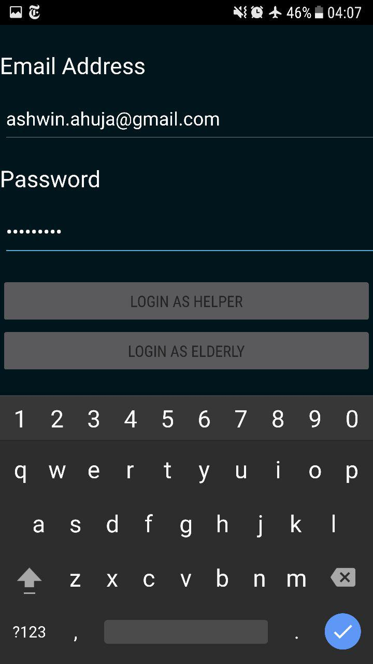

##### E4.2.1



##### T4.2.2

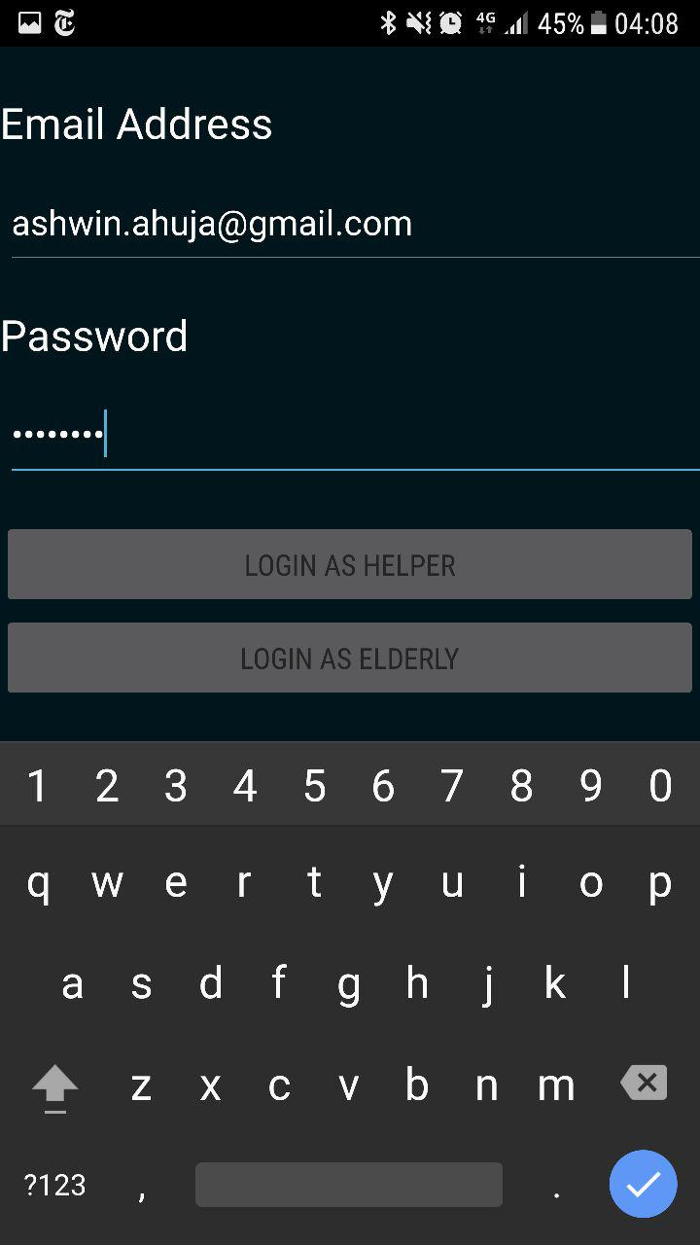

##### E4.2.2

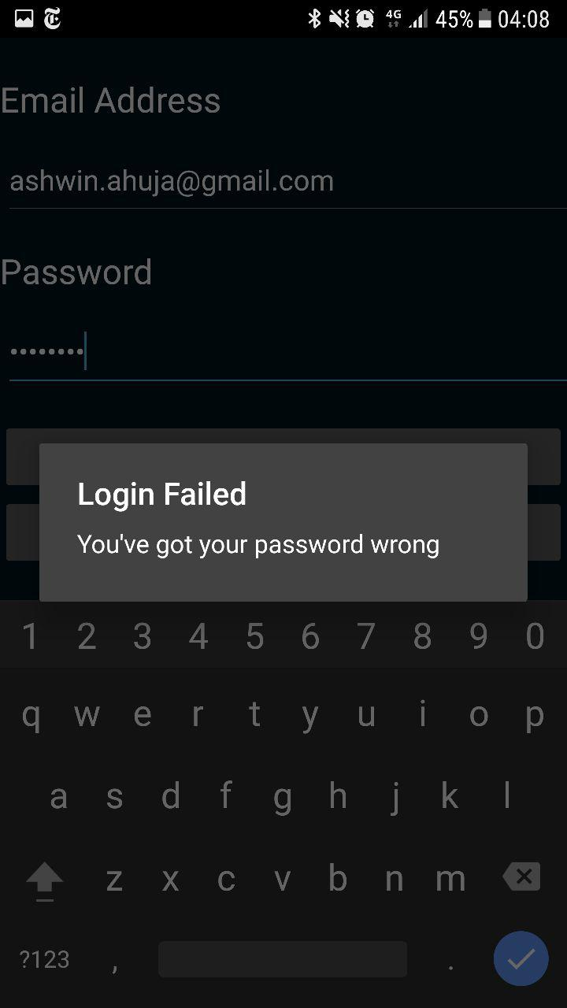

##### T4.2.3

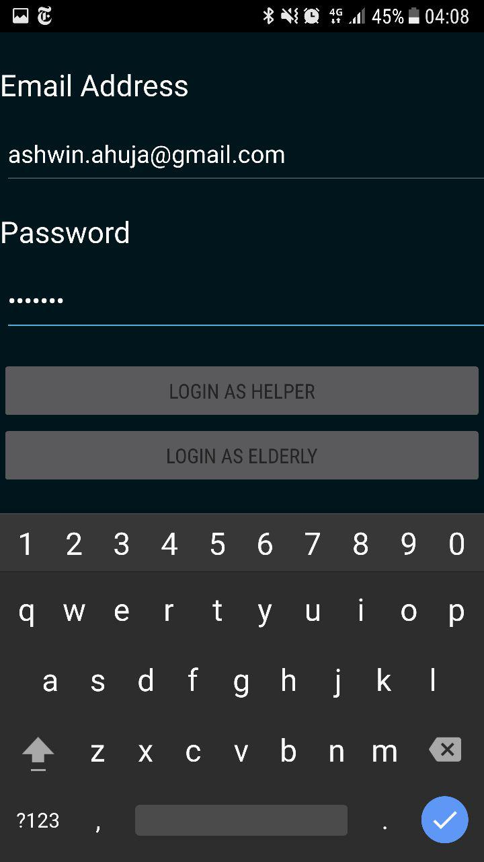

##### E4.2.3

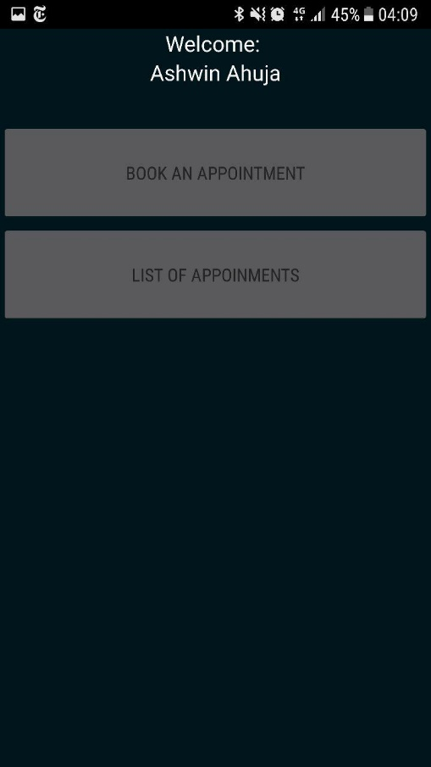

##### T4.2.4

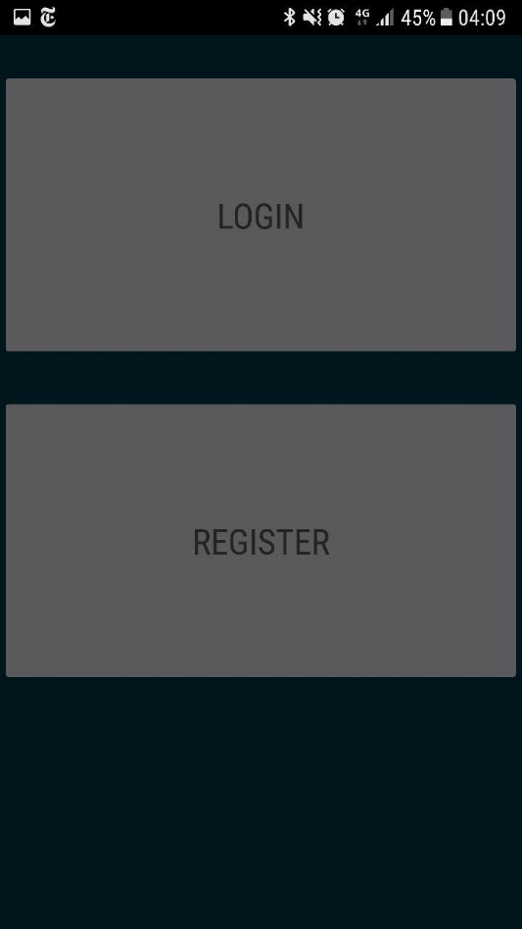

##### E4.2.4

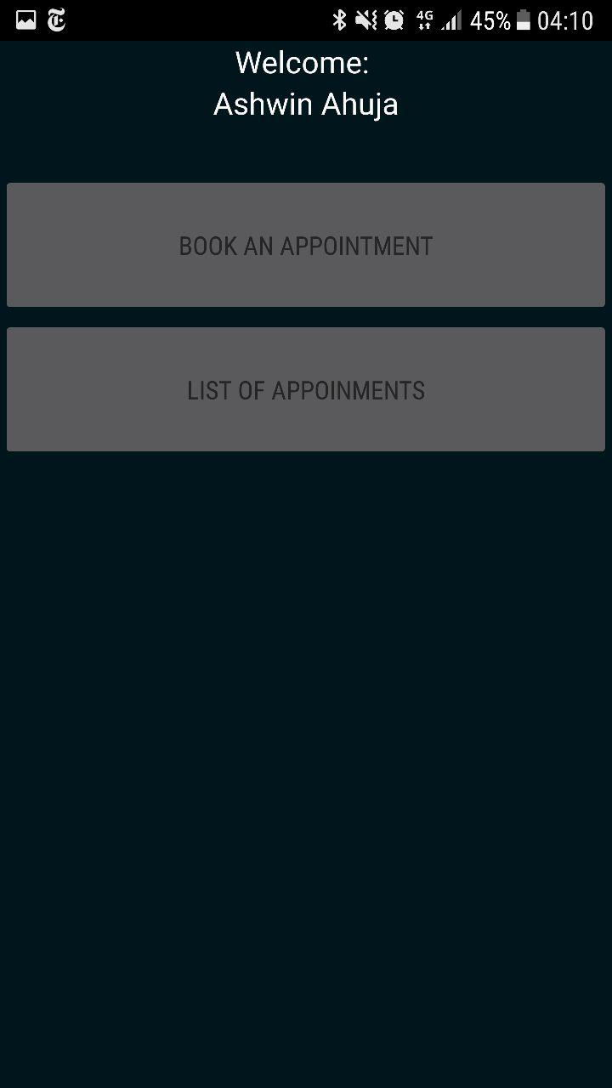

#### 4.4

##### T4.4.1



##### E4.4.1

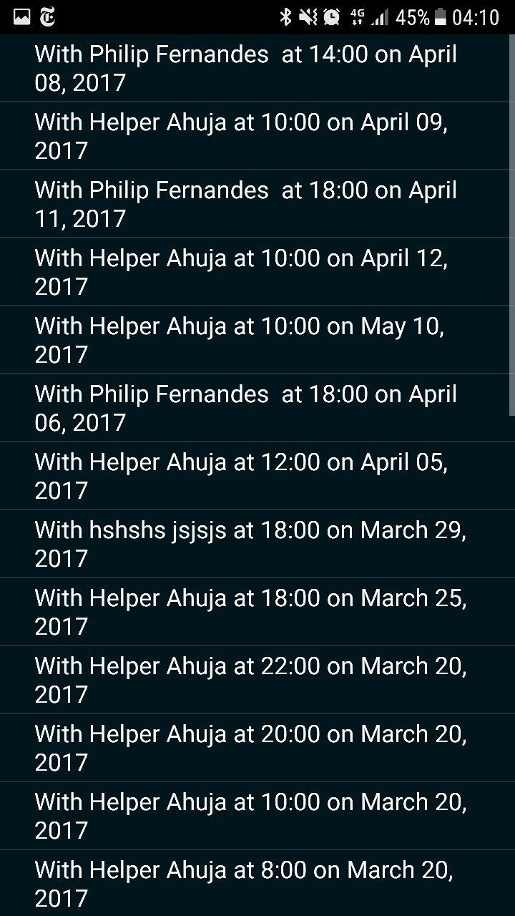

#### 4.5

##### T4.5.1

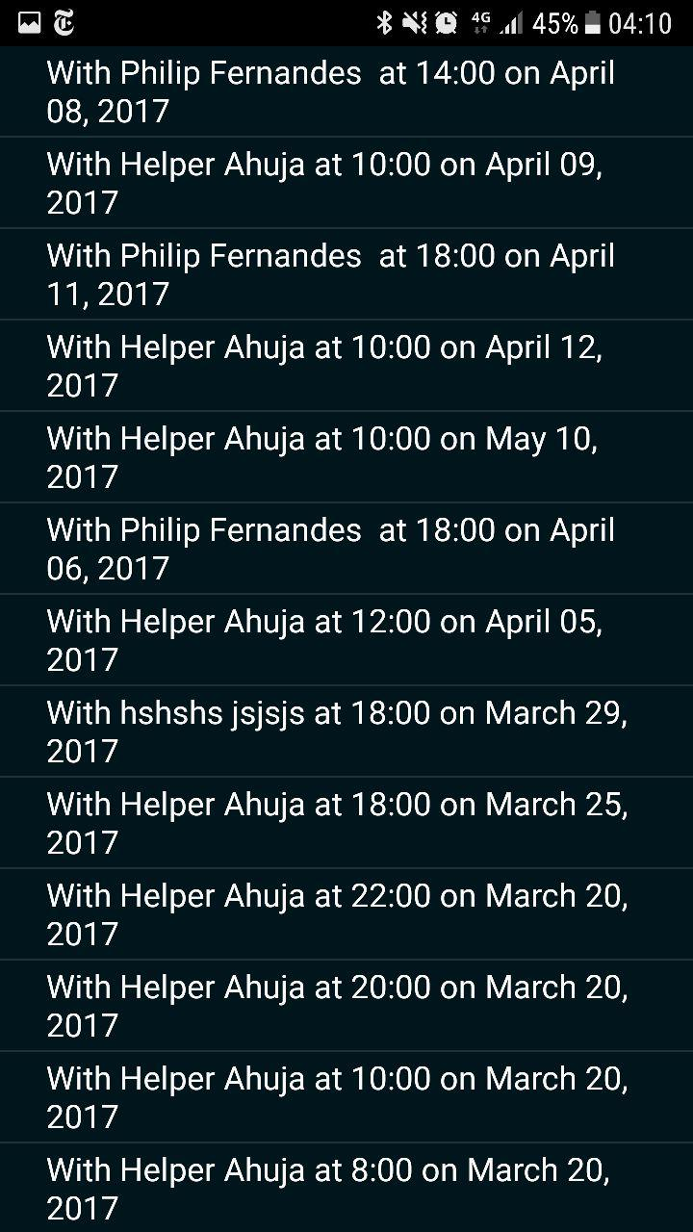

##### E4.5.1

#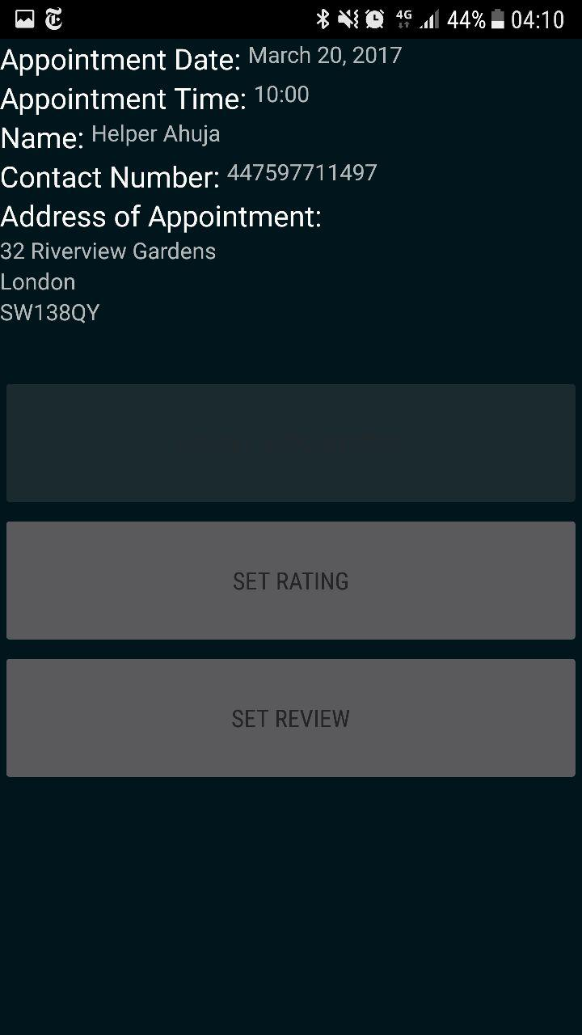

##### T4.5.2



##### E4.5.2



##### T4.5.3

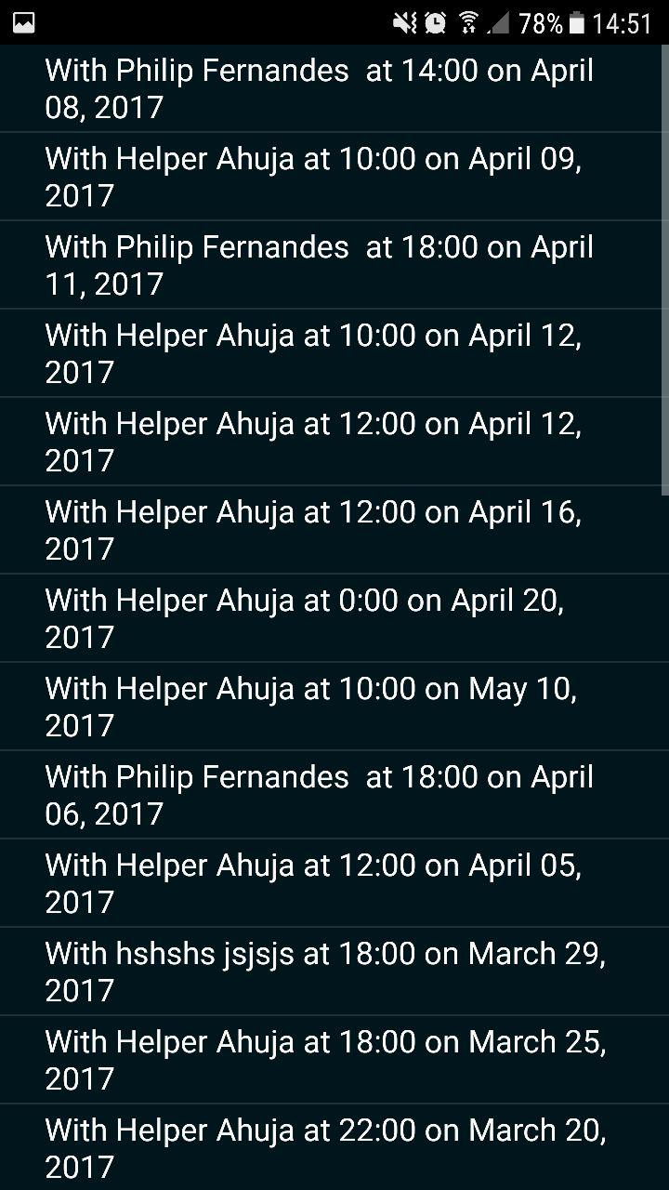

##### E4.5.3

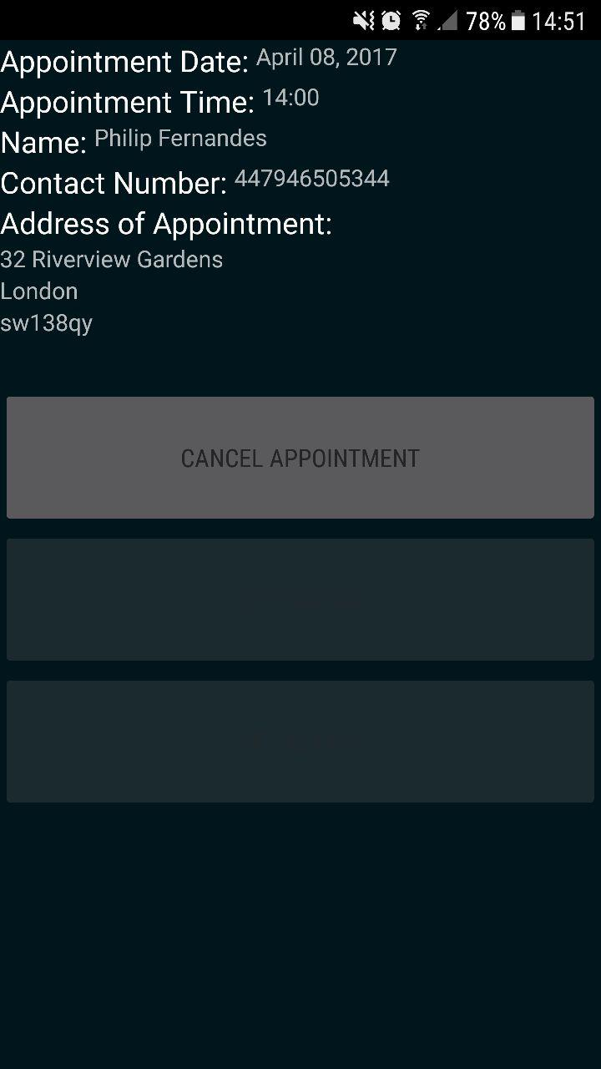

#### 4.6

##### T4.6.1



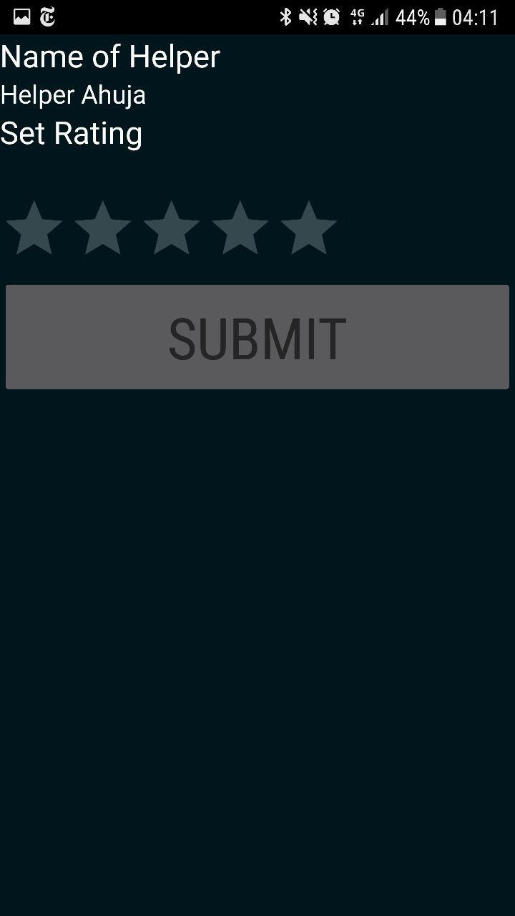

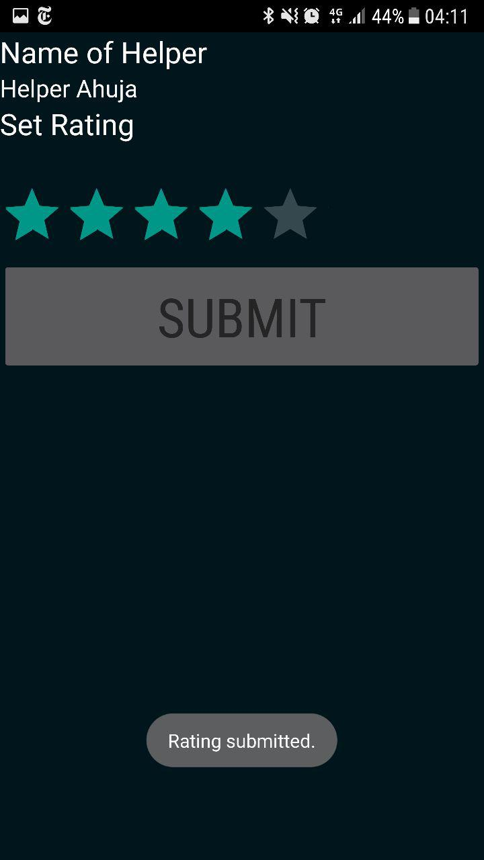

##### E4.6.1

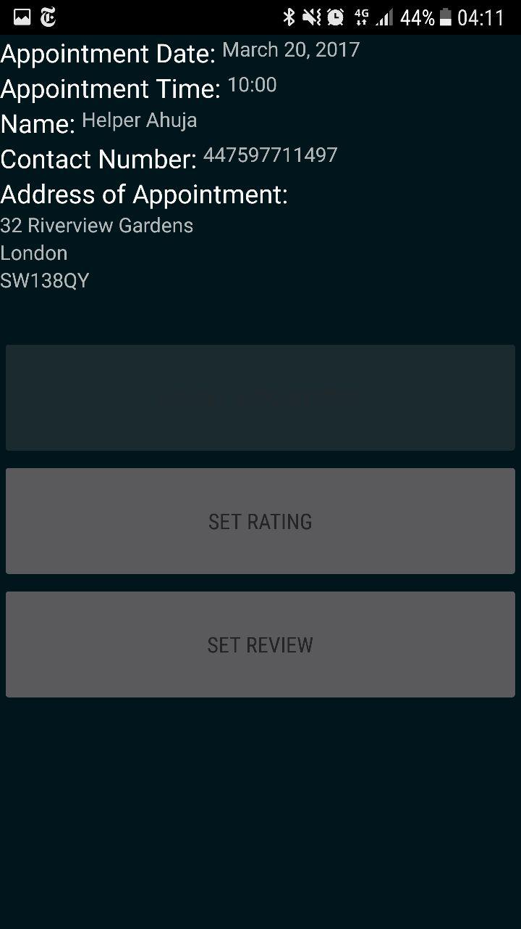

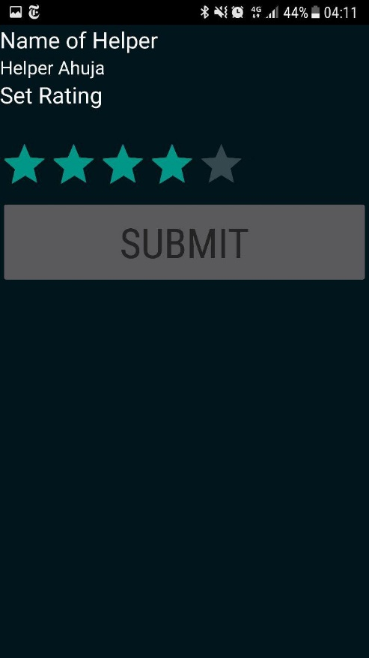

#### 4.7

##### T4.7.1

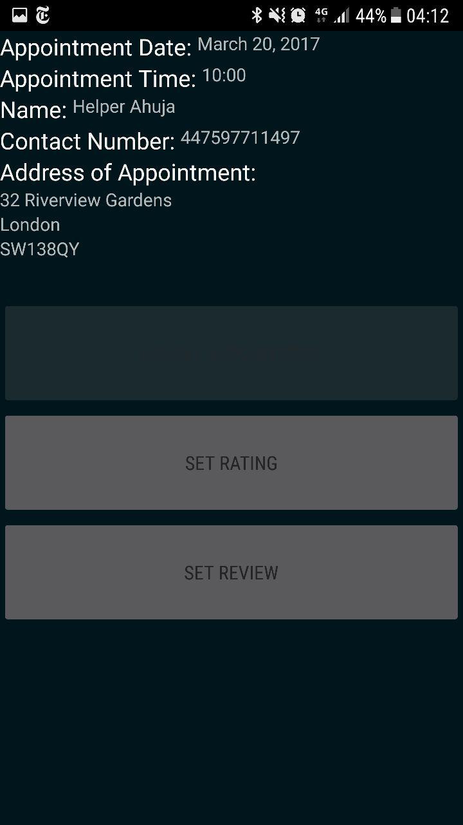

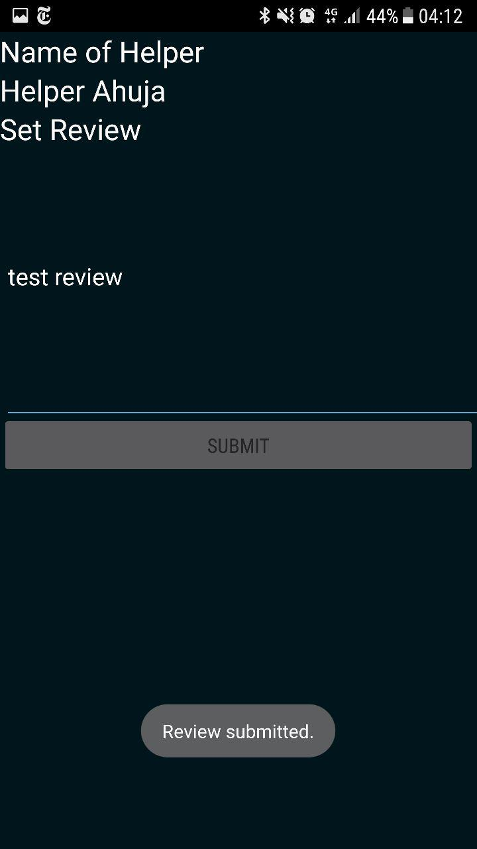

##### E4.7.1

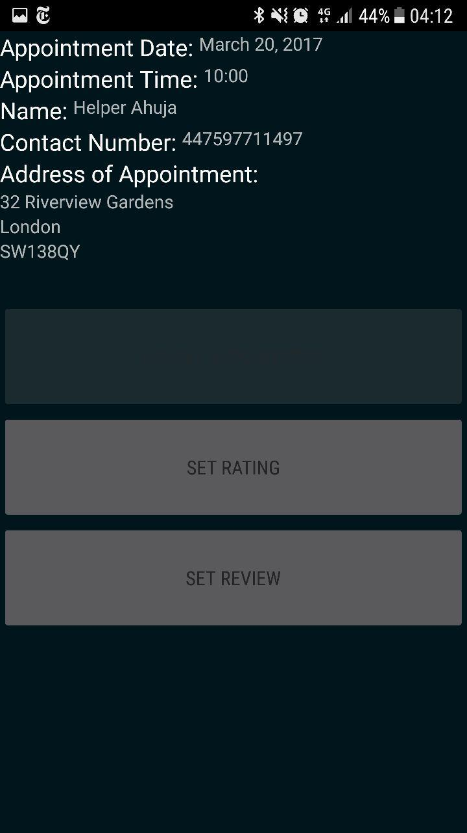

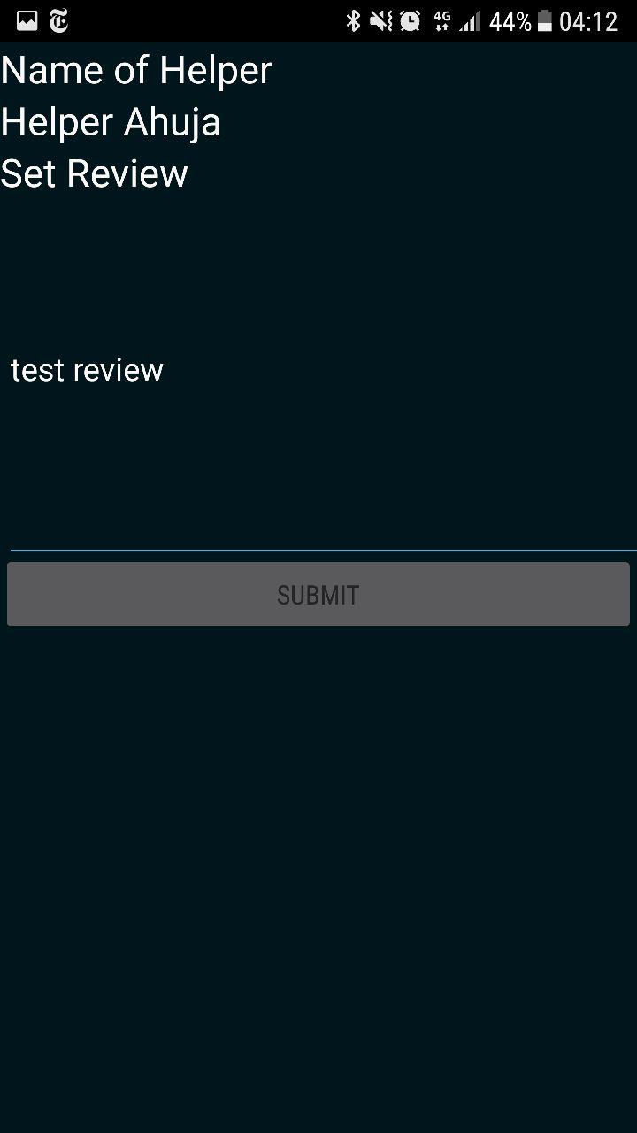

#### 4.9

##### T4.9.1

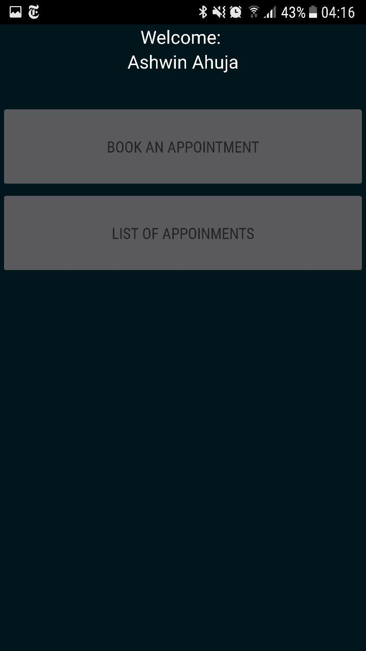

##### E4.9.1

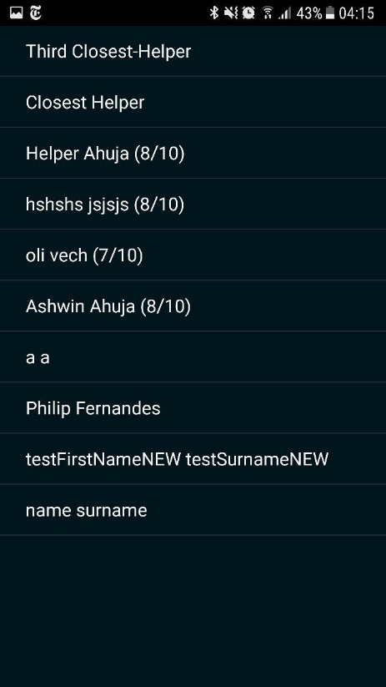

##### T4.9.2

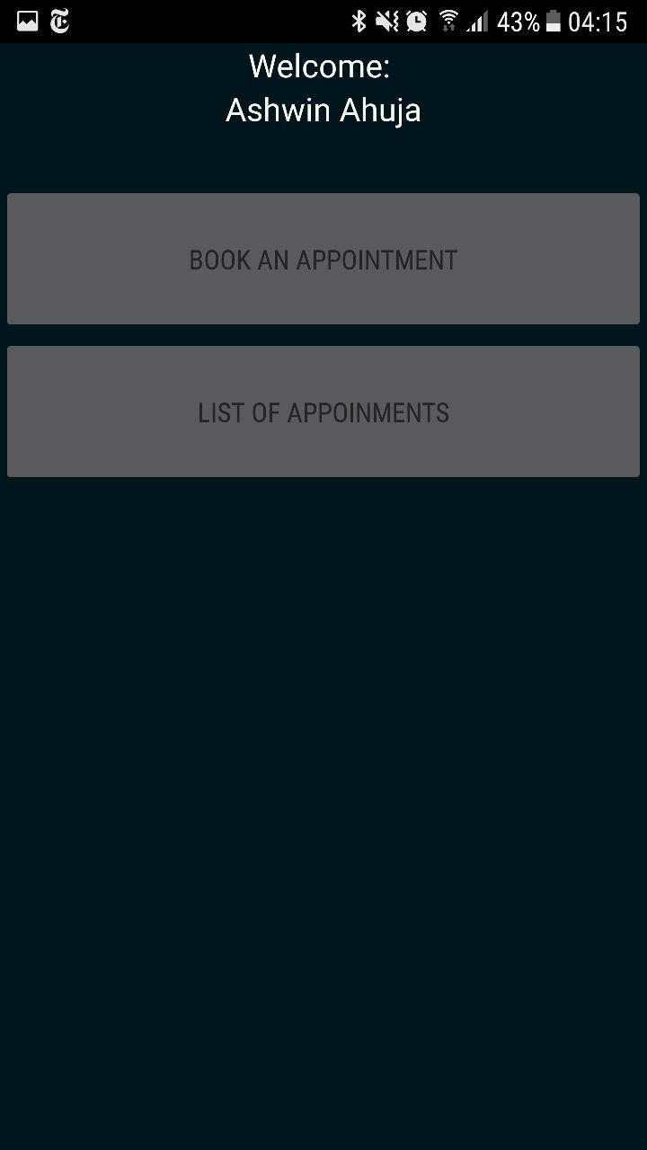

##### E4.9.2

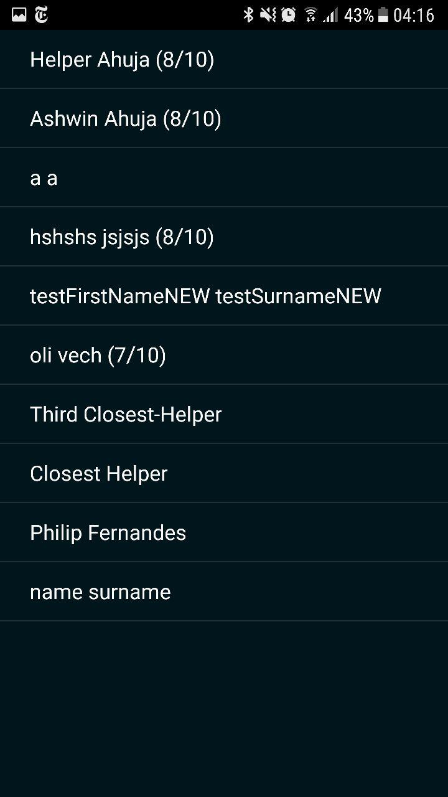

#### 4.10

##### T4.10.1

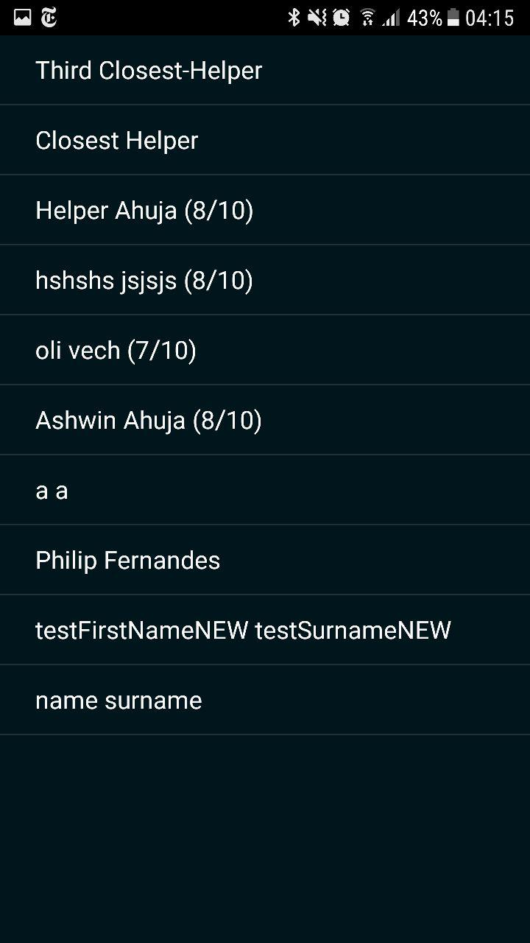

##### E4.10.1

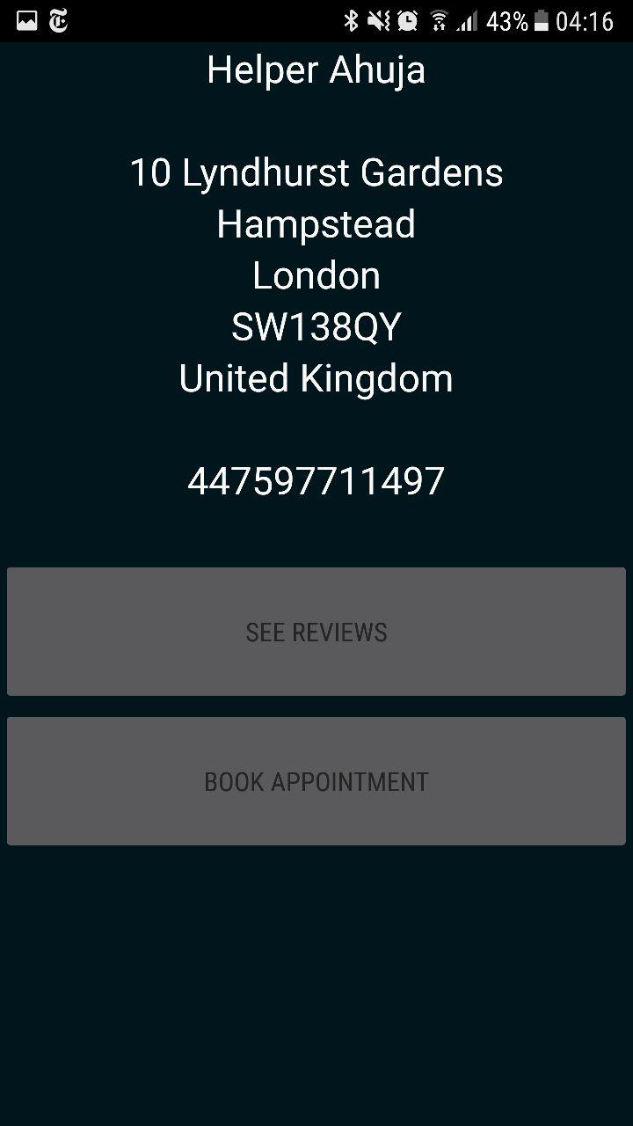

##### T4.10.2



##### E4.10.2

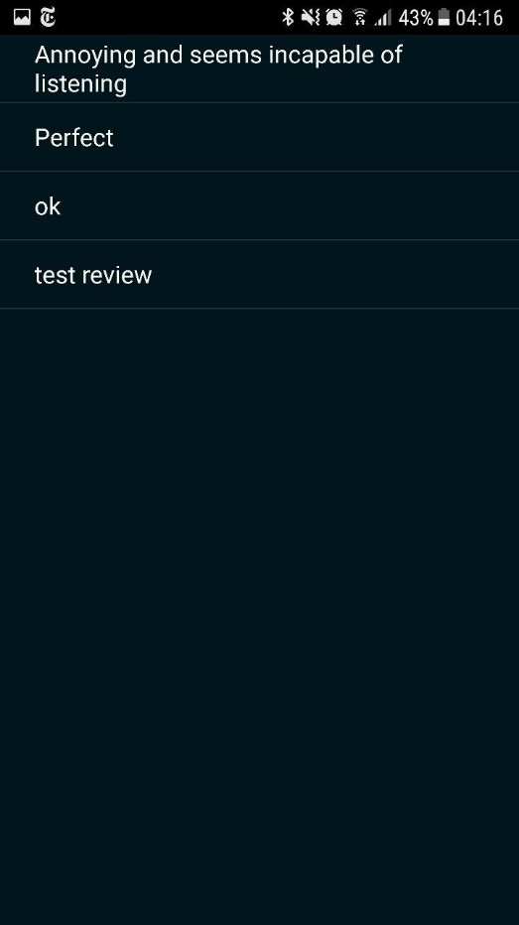

#### 4.11

##### T4.11.1

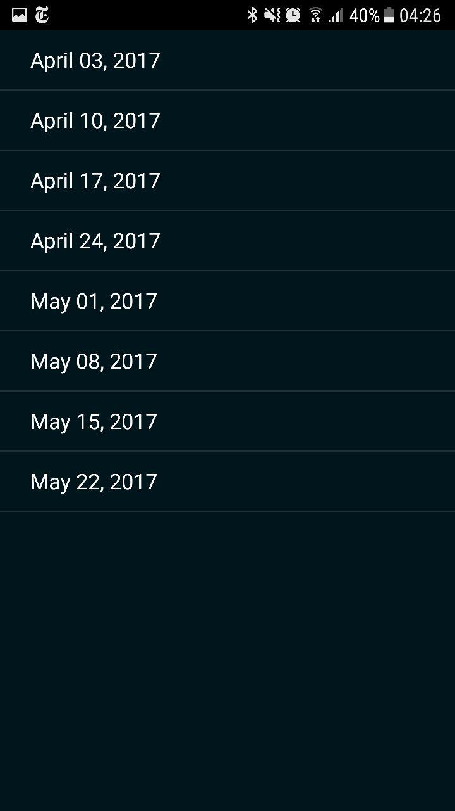

##### E4.11.1

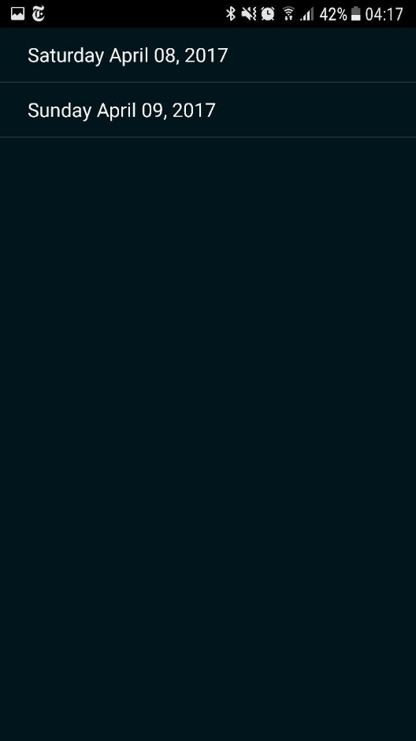

##### T4.11.2



##### E4.11.2

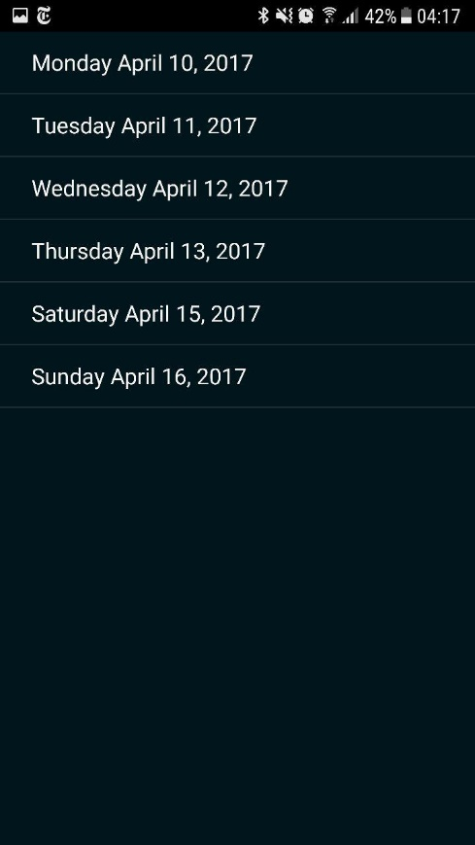

##### T4.11.3

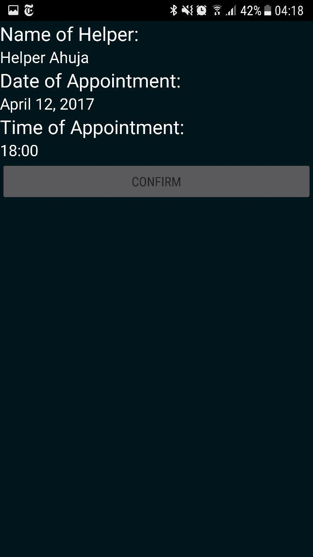

##### E4.11.3

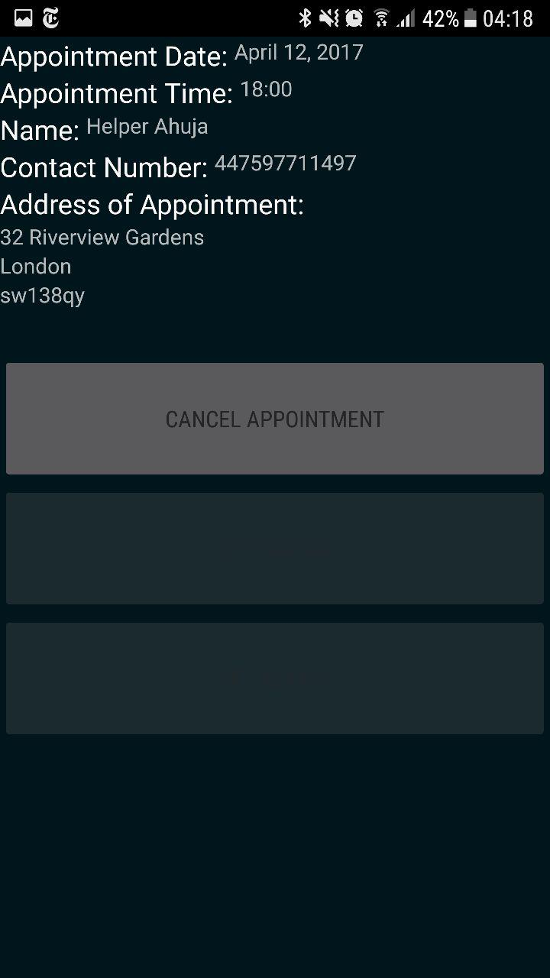

##### T4.11.4





##### E4.11.4

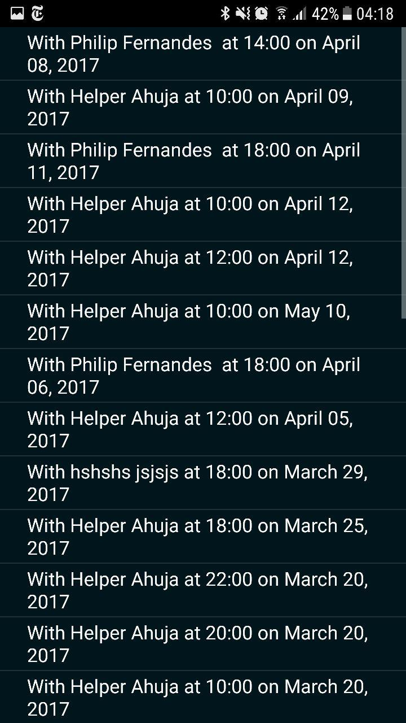

##### T4.11.5



##### E4.11.5



#### 4.13

##### T4.13.1

##### E4.13.1

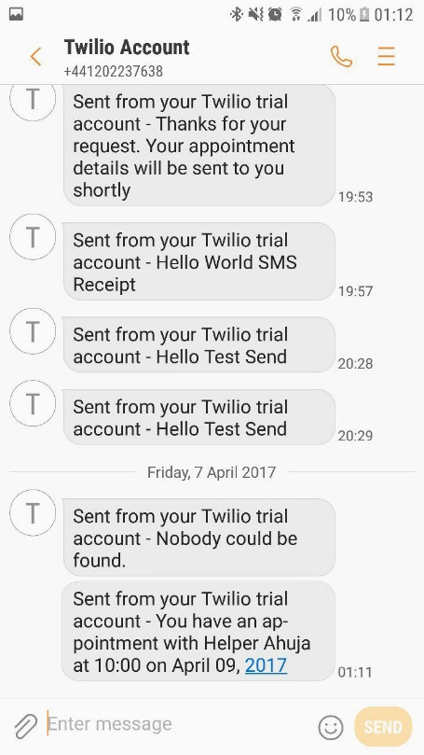

##### T4.13.2

##### E4.13.2

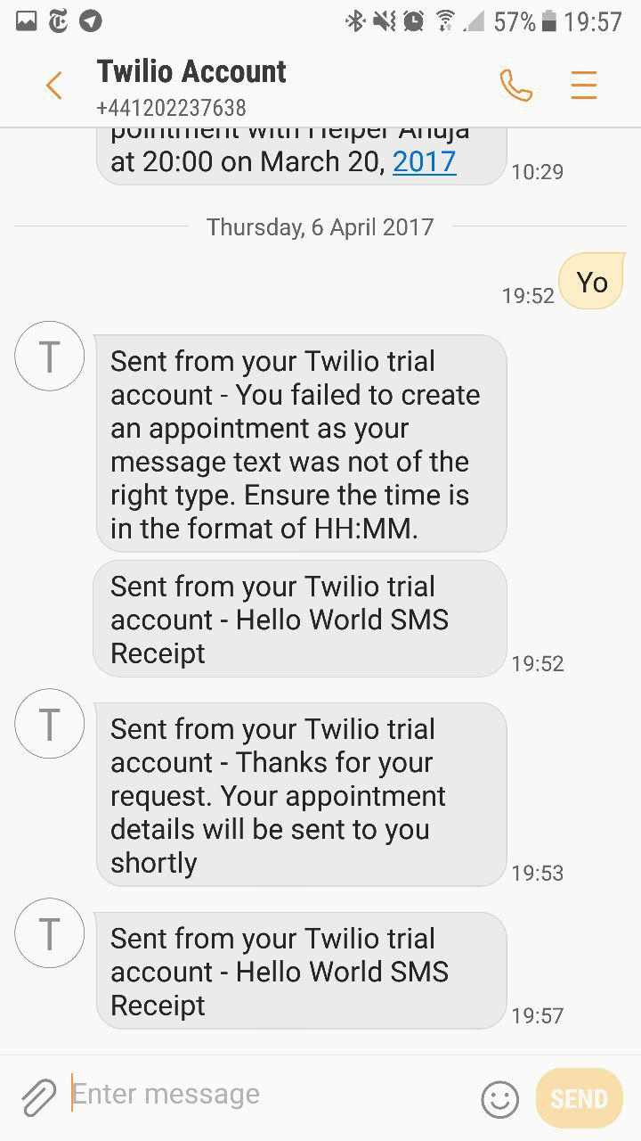

##### T4.13.3

##### E4.13.3

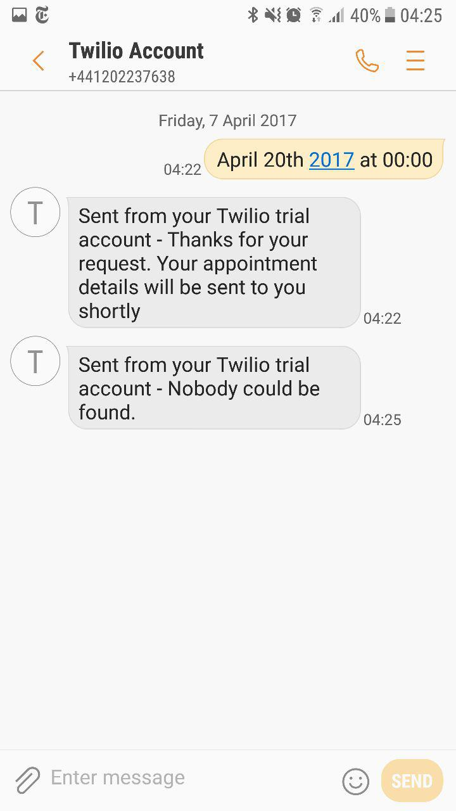

#### 4.14

##### T4.14.1

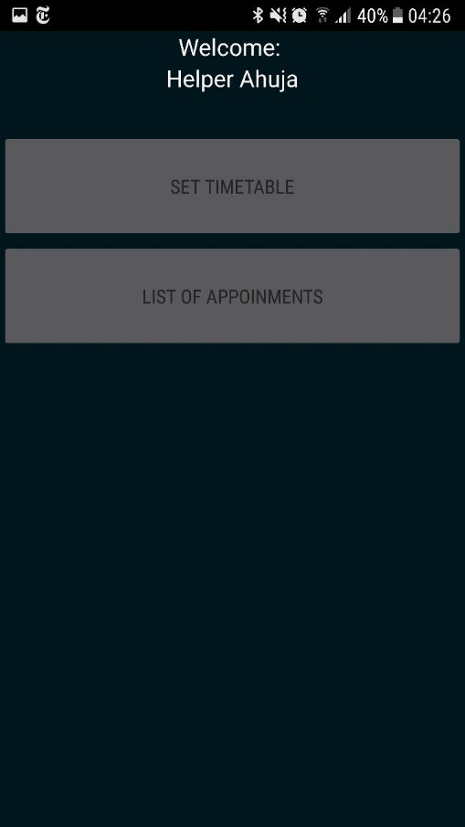

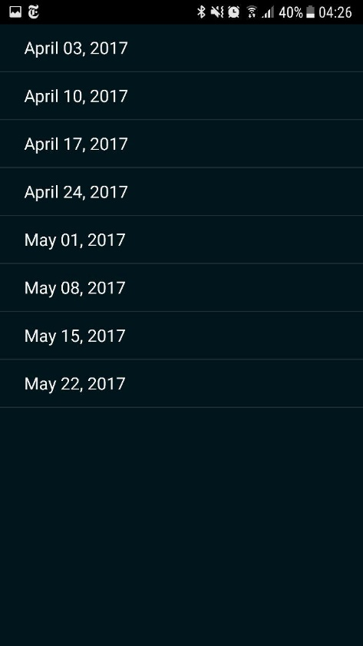

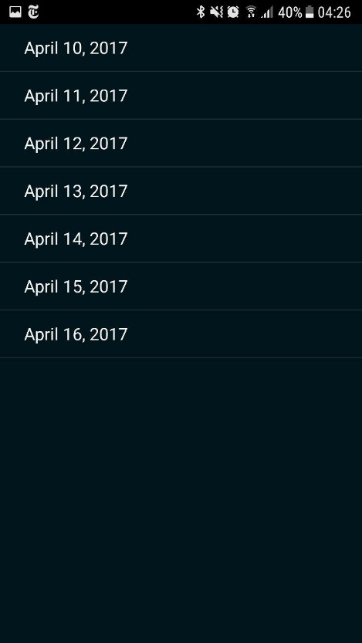

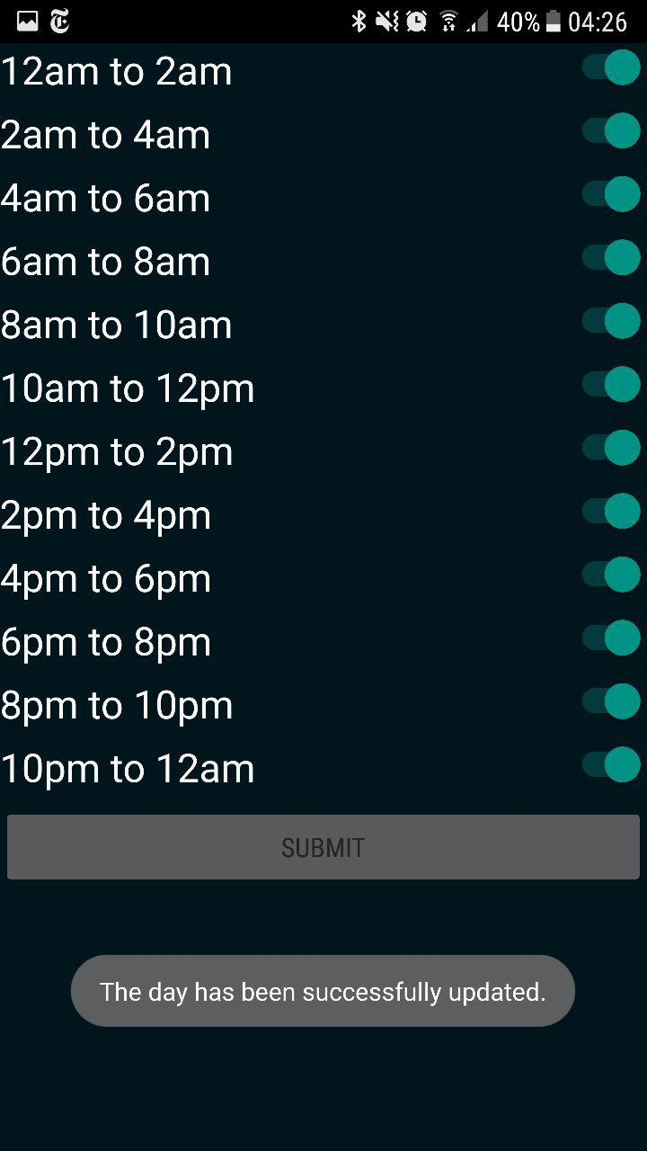

##### E4.14.1

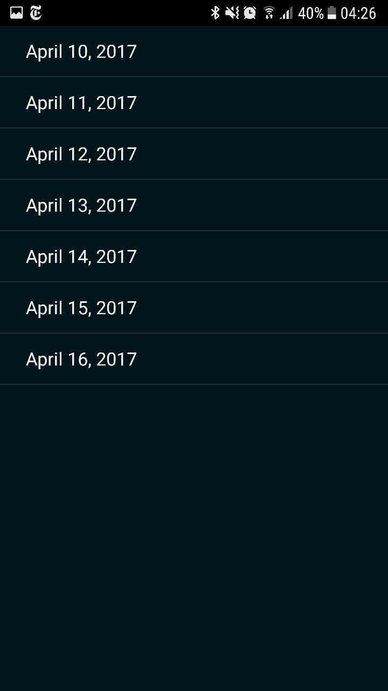

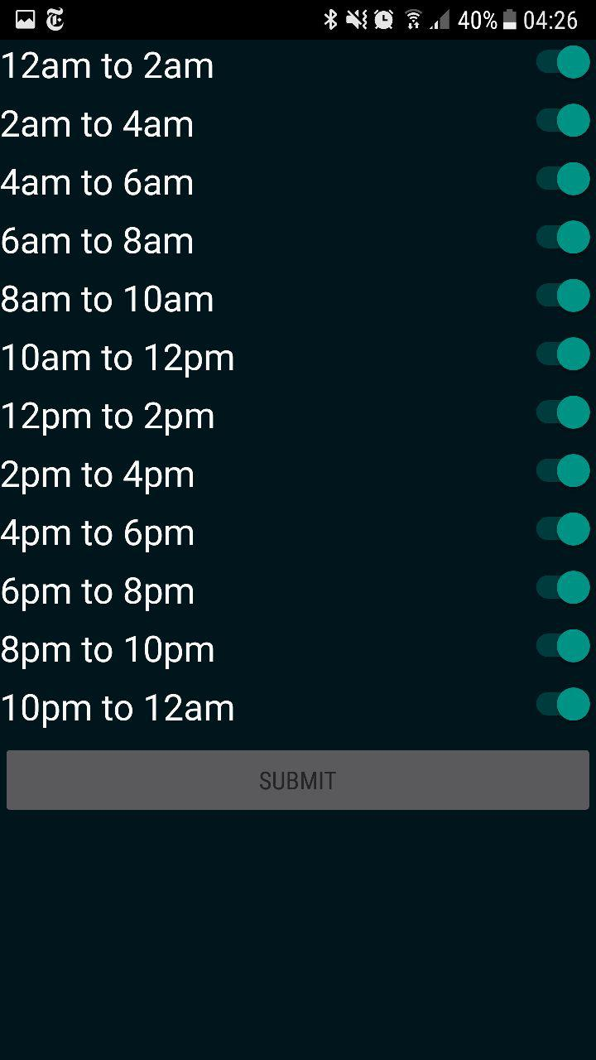

##### T4.14.2

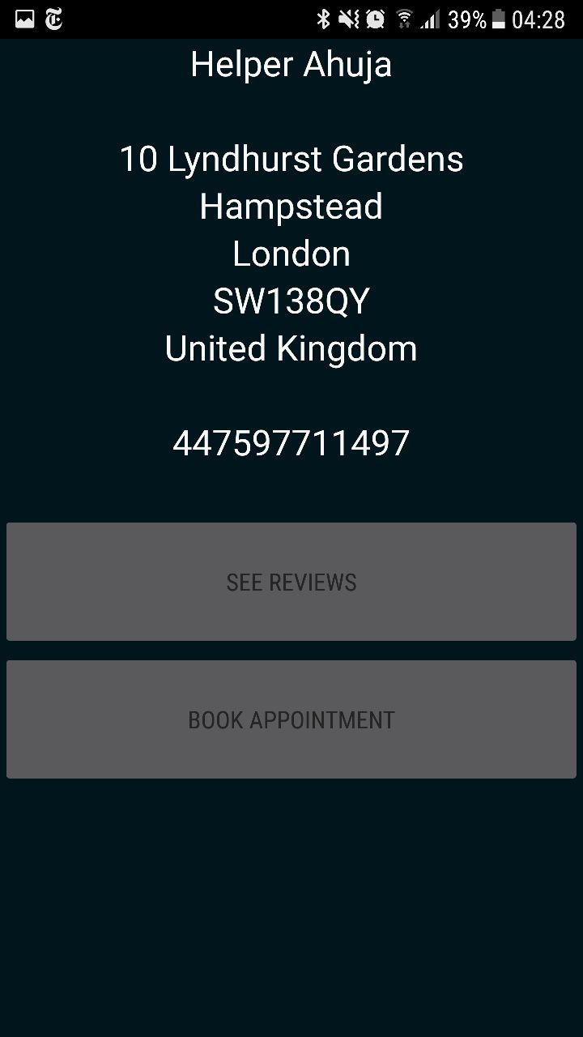

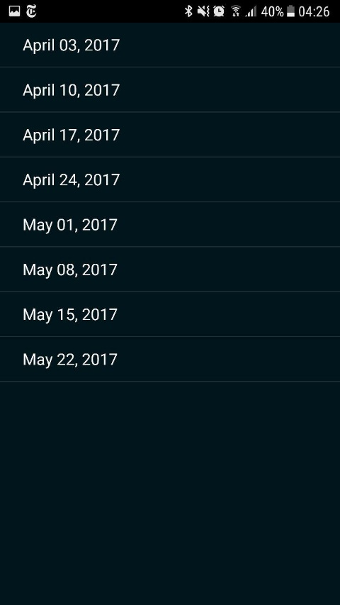

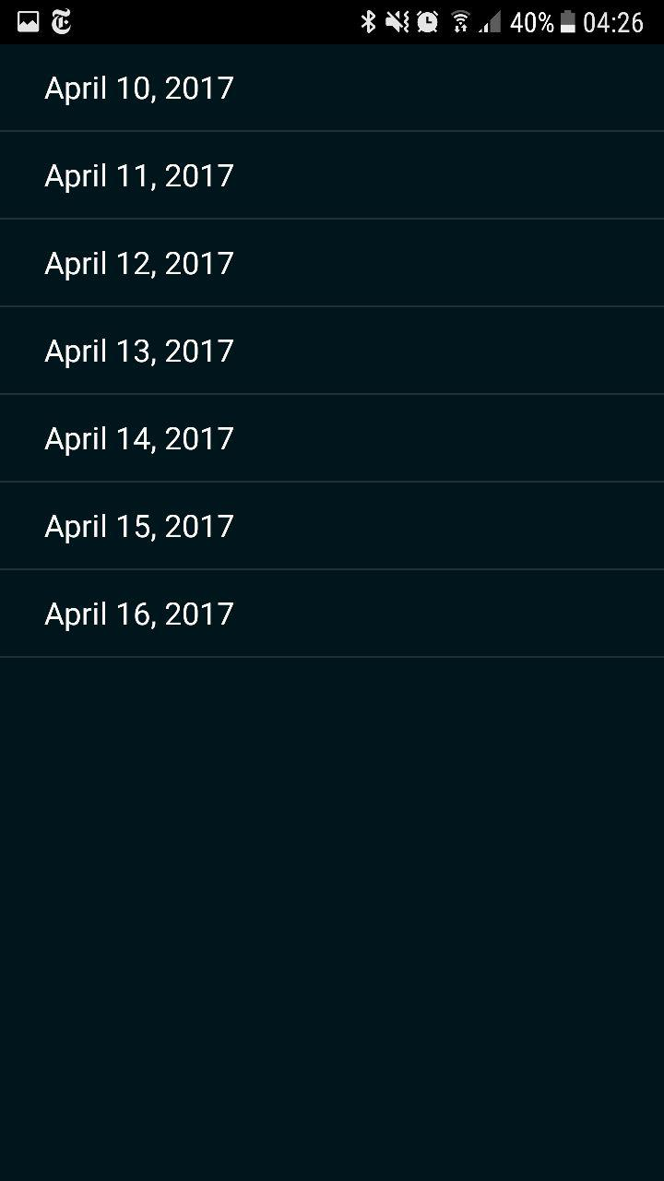

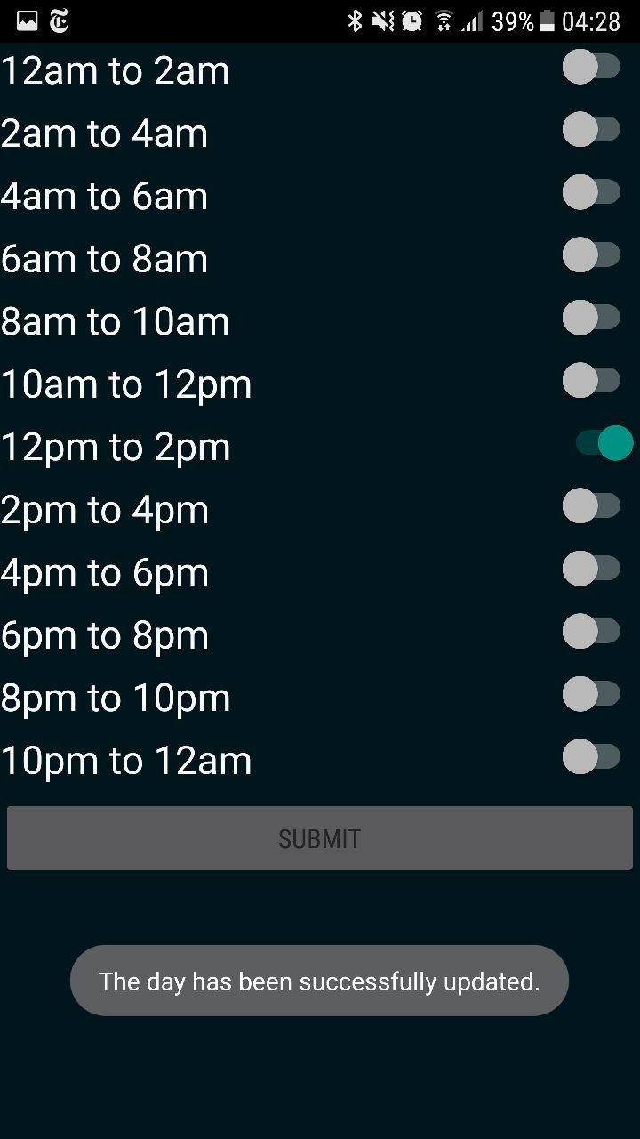

##### E4.14.2

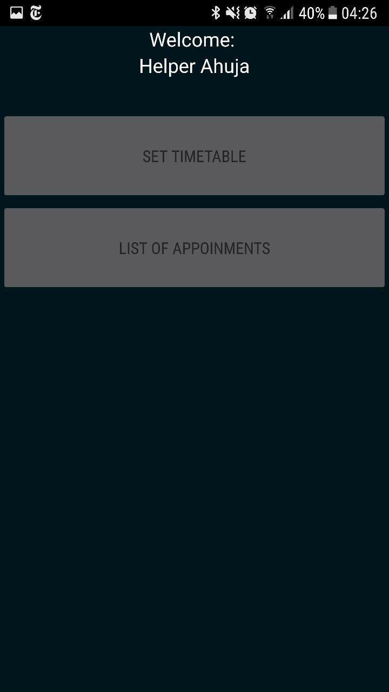







## Appendix E – Bibliography